Garmin R10 HelpBot
FAQ Chatbot Using LangChain and an LLM API

Loren Hobbs
Study.com CS 311: Artificial Intelligence
Project #2
May 2026

1. Name and Purpose of the Chatbot
Garmin R10 HelpBot is a Python-based FAQ chatbot for the Garmin Approach R10 portable golf launch monitor. The purpose of the chatbot is to answer common setup, pairing, battery, LED status, simulator, and troubleshooting questions using a small product-support knowledge base. I chose the Approach R10 because it is a real consumer product with enough setup detail to make the chatbot useful, but it is still narrow enough for a clean course project. The chatbot is not meant to replace Garmin Support. It is meant to show how a product FAQ assistant can retrieve relevant product information and use an LLM to turn that information into a direct customer answer. Garmin describes the Approach R10 as a portable launch monitor that works with Garmin Golf app features, and the owner manual and support pages provide realistic source material for the FAQ dataset (Garmin, n.d.-a, n.d.-b).

2. NLP/LLM Methods Used
The chatbot uses a retrieval-augmented generation workflow. In plain terms, the program first looks up the most relevant FAQ records, then sends those records to the language model as context. This is a better fit than asking the model to answer from memory because product support answers need to stay grounded in product data. Retrieval-augmented generation is commonly used for knowledge-heavy question answering because it combines a language model with outside retrieved information (Lewis et al., 2020).
The NLP approach has four main parts. First, each FAQ row is converted into a LangChain Document. Second, the documents are embedded into vectors so similar questions can be found by meaning, not just by exact keywords. Third, FAISS stores the embedded documents and returns the closest matches for a user question. Fourth, the retrieved context and user question are passed into the LLM through a LangChain prompt. LangChain is used because it provides the pieces needed to connect documents, prompts, vector stores, retrievers, and LLM calls in one workflow (LangChain, n.d.-a; IBM, n.d.).
The main model path uses OpenAI through LangChain. The code also has a local fallback mode so the program can still demonstrate retrieval if an API key is not available during testing. That fallback does not replace the LLM API. It is just a practical way to keep the project runnable while still showing the assignment design: product FAQ data, LangChain, vector retrieval, and an LLM response step.

3. Dataset Information

3.1 Dataset Source
The dataset is a manually built FAQ dataset about the Garmin Approach R10. The records are based on Garmin official product, owner manual, and support content. The dataset uses official Garmin sources for product facts such as pairing steps, LED meanings, battery life, setup placement, Garmin Golf app use, and Home Tee Hero simulator features. Garmin states that the device pairs with the Garmin Golf app, and the owner manual explains that the app displays shot statistics and syncs with a Garmin Connect account (Garmin, n.d.-b). Garmin support also recommends placing the Approach R10 6 to 8 feet behind the ball (Garmin, n.d.-d).

3.2 Number of Records
The dataset contains 28 FAQ records. Each record represents one realistic customer question and one grounded answer about the Garmin Approach R10.

3.3 Number of Features
The dataset has 4 columns: question, answer, category, and source. The chatbot uses the question and answer fields for retrieval. The category and source fields are kept as metadata so the program can show where the answer came from.

3.4 Description of Features
Feature Name | Description | Data Type
question | A realistic customer question about the Garmin Approach R10. | Text
answer | A product-support answer based on the FAQ source material. | Text
category | Topic group such as Setup, Pairing, Battery, App, LED Status, Simulator, or Troubleshooting. | Text
source | The official or supporting source URL used to build or verify the FAQ record. | Text

3.5 Preprocessing Steps
The preprocessing is simple but important. The program loads the CSV file with pandas, checks that all required columns are present, drops rows with missing questions or answers, fills blank category and source values, trims extra spaces, and resets the row index. After that, each row is converted into a LangChain Document. The question, answer, and category fields become the searchable text. The source and category fields are also stored as metadata so the chatbot can print traceable sources after answering.
The embedding step is part of preprocessing for the chatbot. When an OpenAI API key is present, the code uses OpenAI embeddings through LangChain. Those vectors are stored in FAISS for similarity search. FAISS is a good fit here because it is designed for efficient similarity search over vectorized data (Johnson et al., 2019).

4. Libraries, Toolkits, and Frameworks
The project uses common Python libraries and a few LLM-specific tools. The goal was to keep the application understandable while still meeting the LangChain and LLM requirement.
Library or Tool | Role in the Application
pandas | Loads and cleans the FAQ CSV dataset.
python-dotenv | Loads the OpenAI API key from a local .env file.
LangChain | Connects documents, prompts, retrievers, vector stores, and the LLM workflow.
langchain-openai | Provides OpenAI chat model and embedding integrations.
FAISS | Stores embedded FAQ documents and performs similarity search.
scikit-learn | Supports the local TF-IDF fallback embedding mode when no API key is available.
OpenAI API | Generates final natural-language answers from retrieved product context.

5. Application Design and Implementation
The application follows a straightforward chatbot pipeline. First, the CSV file is loaded and cleaned. Second, each FAQ record is converted into a LangChain Document. Third, the documents are embedded and stored in a FAISS vector store. Fourth, the user enters a question. Fifth, the vector store retrieves the most relevant FAQ records. Sixth, the retrieved context is inserted into a prompt and sent to the LLM. Finally, the chatbot prints the answer and the FAQ records that were retrieved.
The prompt is intentionally restrictive. It tells the chatbot to answer only from the retrieved context. If the context does not clearly answer the question, the chatbot should say that the FAQ data does not answer it and recommend Garmin Support or the owner manual. This matters because product support chatbots should not invent setup instructions. A user asking about pairing, battery status, or indoor placement needs a practical answer, not a creative one.
The code is organized into functions instead of one long script. There are separate functions for loading data, building documents, selecting embeddings, building the vector store, creating the LLM, formatting context, answering a question, and printing sources. That structure makes the code easier to read and easier to debug.

6. Instructions for Running the Chatbot
To run the chatbot, place all project files in the same folder. Install Python 3 if it is not already installed. Open a terminal in the project folder and install the requirements with the command below:
pip install -r requirements.txt
To use the full LLM version, copy .env.example to a new file named .env and add an OpenAI API key. The file should include OPENAI_API_KEY and can optionally include OPENAI_MODEL. Then run the chatbot with this command:
python garmin_r10_helpbot.py
The program prints the number of FAQ records loaded, the embedding mode, and the LLM mode. Then it waits for user questions. Type quit, exit, or q to stop the chatbot.

7. Results
The chatbot was tested using the full API setup, not just the local fallback mode. The program loaded 28 FAQ records with 4 dataset columns. The terminal output also shows that the project used OpenAI embeddings and OpenAI API mode through LangChain. That is important because the assignment asks for a working NLP/LLM chatbot, not just a keyword search script. The test questions focused on realistic customer support issues for the Garmin Approach R10, including LED status, outdoor use, pairing, and placement behind the ball.
Test Question | Expected Retrieval Area | Result Summary
Red lights are flashing, what does that mean? | LED Status | Answered that flashing red means an error, then told the user to reset the launch monitor or contact Garmin Support.
Can I use this outside? | Setup and outdoor use | Answered that the R10 can be used outside when it is set up correctly, 6 to 8 feet behind the ball and aligned properly.
How do I pair the R10? | Pairing | Explained pairing mode, the Garmin Golf app, keeping the phone near the device, and adding it through Profile > My Devices > Add Device.
Where do I place the R10? | Setup and placement | Answered that the R10 should sit on the ground 6 to 8 feet behind the ball and line up with the target line.

The results show that the retrieval step did the main job it was supposed to do. For each question, the chatbot pulled FAQ records from the right general category and then used the retrieved context to write a direct answer. The terminal output is useful because it shows both the final chatbot answer and the specific FAQ records that were retrieved. That makes the output easier to review and keeps the chatbot from looking like a black box.
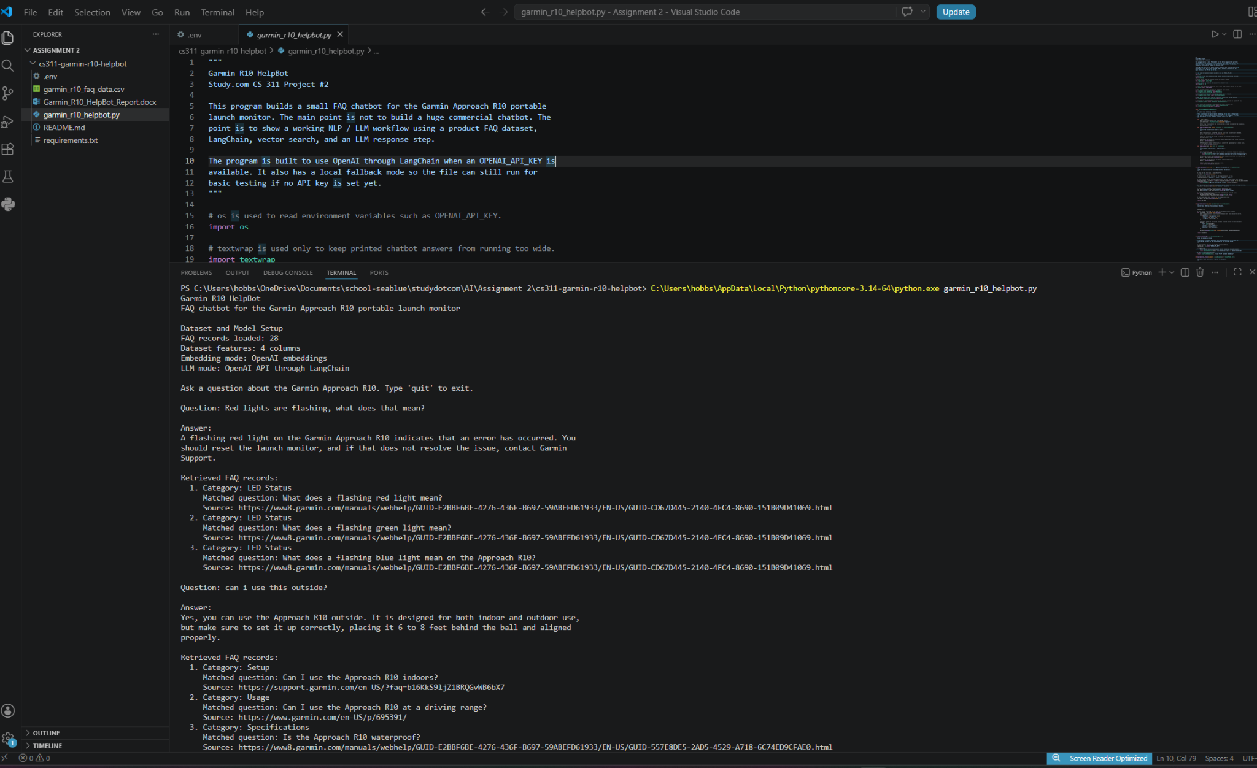
Figure 1. Garmin R10 HelpBot running in OpenAI API mode with LED status and outdoor-use test questions.
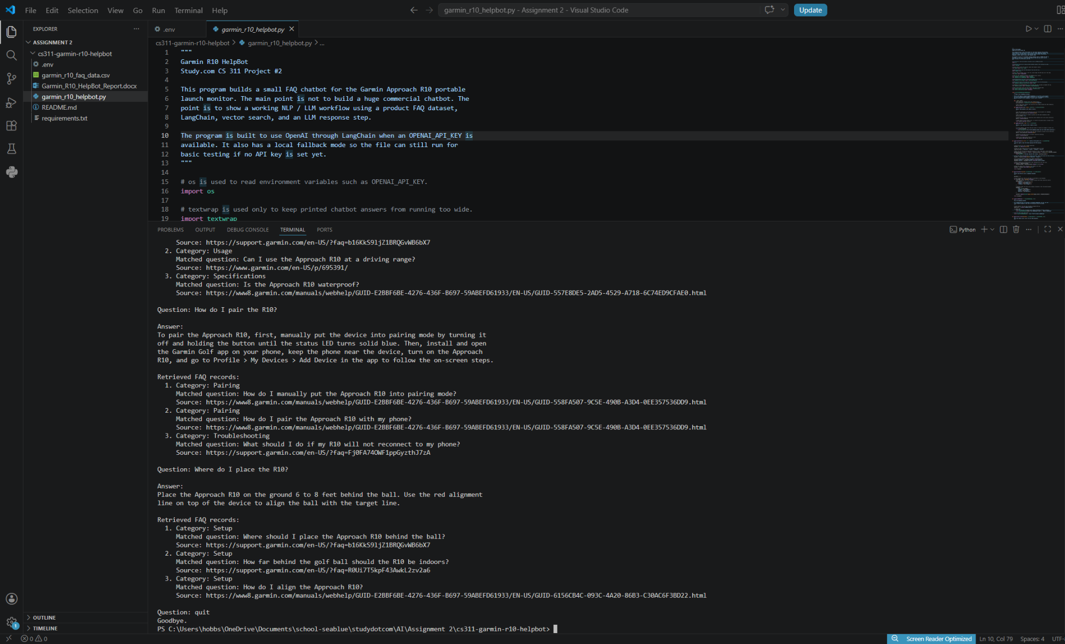
Figure 2. Garmin R10 HelpBot answering pairing and placement questions with retrieved FAQ records shown in the terminal.
These screenshots demonstrate the working chatbot in the submitted environment. They show the dataset setup, the use of OpenAI embeddings, the use of the OpenAI API through LangChain, the user questions, the chatbot answers, and the retrieved FAQ records used to support those answers.

8. Discussion and Insights
The main strength of this chatbot is that the answers are grounded in a small product dataset instead of relying only on the LLM. That is the right design for a product FAQ assistant. The user asks a question, the system retrieves relevant records, and the LLM turns those records into a clean answer. This keeps the response useful while reducing the chance that the model makes up details.
The biggest limitation is dataset size. The FAQ file has enough records to prove the concept, but it is not large enough to cover every Garmin R10 support situation. Another limitation is that the chatbot depends on the quality of the retrieved context. If the wrong records are retrieved, the LLM may produce a weak answer even if the answer style sounds good. A third limitation is that the application does not automatically update when Garmin changes product documentation.
The improvement plan is clear. A future version should add more official Garmin support records, include screenshots or manual sections as documents, add better evaluation tests, and compare OpenAI embeddings with other embedding models. I would also add a confidence threshold. If the best retrieved record is not close enough to the question, the chatbot should refuse to answer and direct the user to Garmin Support. That would make the tool safer and more realistic as a customer support assistant.

9. References
Garmin. (n.d.-a). Approach R10 portable golf launch monitor. https://www.garmin.com/en-US/p/695391/
Garmin. (n.d.-b). Approach R10 owner's manual: Garmin Golf app. https://www8.garmin.com/manuals/webhelp/GUID-E2BBF6BE-4276-436F-B697-59ABEFD61933/EN-US/GUID-9F63654F-9296-497C-A9FC-89ADC513235C.html
Garmin. (n.d.-c). Approach R10 owner's manual: Pairing your smartphone. https://www8.garmin.com/manuals/webhelp/GUID-E2BBF6BE-4276-436F-B697-59ABEFD61933/EN-US/GUID-558FA507-9C5E-490B-A3D4-0EE357536DD9.html
Garmin. (n.d.-d). Tips for indoor or outdoor Approach R10 placement. https://support.garmin.com/en-US/?faq=b16KkS9ljZ1BRQGvWB6bX7
Garmin. (n.d.-e). Approach R10 owner's manual: Specifications. https://www8.garmin.com/manuals/webhelp/GUID-E2BBF6BE-4276-436F-B697-59ABEFD61933/EN-US/GUID-557E8DE5-2AD5-4529-A718-6C74ED9CFAE0.html
IBM. (n.d.). What is LangChain? IBM Think. https://www.ibm.com/think/topics/langchain
Johnson, J., Douze, M., & Jegou, H. (2019). Billion-scale similarity search with GPUs. IEEE Transactions on Big Data, 7(3), 535-547. https://arxiv.org/abs/1702.08734
LangChain. (n.d.-a). Vector store integrations. https://docs.langchain.com/oss/python/integrations/vectorstores
LangChain. (n.d.-b). Retriever integrations. https://docs.langchain.com/oss/python/integrations/retrievers
Lewis, P., Perez, E., Piktus, A., Petroni, F., Karpukhin, V., Goyal, N., Kuttler, H., Lewis, M., Yih, W., Rocktaschel, T., Riedel, S., & Kiela, D. (2020). Retrieval-augmented generation for knowledge-intensive NLP tasks. Advances in Neural Information Processing Systems, 33, 9459-9474. https://arxiv.org/abs/2005.11401

