Developing a Reinforcement Learning Agent for CartPole Balance Control
CS311 Assignment 3: Developing a Reinforcement Learning Agent
Loren Hobbs
Study.com
May 13, 2026

Developing a Reinforcement Learning Agent for CartPole Balance Control

1. Name and Purpose of the Application
The application developed for this assignment is the CartPole Q-Learning Agent. The purpose of the application is to train a reinforcement learning agent to balance a pole on a moving cart in the CartPole-v1 simulation environment. The agent observes the current state of the cart and pole, chooses whether to push the cart left or right, receives feedback from the environment, and updates its decision-making policy through trial and error. This project was selected because CartPole is a standard reinforcement learning control problem and because it provides clear evidence of whether the agent is improving over time.
In the CartPole task, the goal is to keep the pole upright for as long as possible. The agent receives a reward for each time step that it keeps the pole balanced. The task is useful for this assignment because it includes states, actions, rewards, exploration, and performance measurement in a simple simulated environment.

2. Algorithms Used
The main algorithm used in this project is Q-learning. Q-learning is a reinforcement learning algorithm that allows an agent to learn the value of actions in different states. Instead of being directly told which action is correct, the agent learns by trying actions, receiving rewards, and updating a Q-table. Watkins and Dayan (1992) describe Q-learning as a method that improves estimates of the quality of actions in particular states and can converge toward optimal action values when actions are repeatedly sampled and represented discretely.
The Q-learning update equation used in the program is:
Q(s, a) = Q(s, a) + α [r + γ max Q(s', a') - Q(s, a)]
In this equation, Q(s, a) is the current Q-value for a state and action, α is the learning rate, r is the reward, γ is the discount factor, and max Q(s', a') is the best expected future reward from the next state. The agent uses this formula after each step to update its estimate of how useful an action is in a particular state.
The project also uses an epsilon-greedy exploration strategy. Early in training, epsilon is high, so the agent often explores by selecting random actions. As training continues, epsilon decreases, and the agent relies more on the Q-table. This approach balances exploration and exploitation. Exploration allows the agent to discover useful actions, while exploitation allows it to use the best actions it has already learned. Sutton and Barto (2018) describe reinforcement learning as learning to maximize reward through interaction with an environment, and the epsilon-greedy strategy supports that process.

3. Dataset Information
This project does not use a static dataset such as a CSV file. Instead, the data is generated dynamically through interaction with the CartPole-v1 simulation environment. Each training step produces an observation, an action, a reward, and a next observation. This makes the environment itself the data source.
The CartPole-v1 environment provides four observation features:
Feature Name | Description | Data Type
Cart position | Horizontal position of the cart | Float
Cart velocity | Speed and direction of cart movement | Float
Pole angle | Angle of the pole from vertical | Float
Pole angular velocity | Speed and direction of pole rotation | Float

The action space has two possible actions:
Action | Meaning
0 | Push cart left
1 | Push cart right

The main preprocessing step was state discretization. CartPole observations are continuous, but a basic Q-table requires discrete state indexes. To solve this, the program divided each observation feature into bins. The continuous values were converted into discrete bin numbers so the agent could store and update Q-values in a table.
The program used the following binning approach: cart position used 10 bins, cart velocity used 10 bins, pole angle used 18 bins, and pole angular velocity used 18 bins. More bins were used for pole angle and pole angular velocity because those values are especially important for balancing the pole. This preprocessing step made the Q-learning algorithm easier to implement, although it also reduced some precision from the original continuous state space.

4. Libraries, Toolkits, and Frameworks
The project used the following Python libraries:
Library | Role in the Project
Gymnasium | Provides the CartPole-v1 simulation environment
NumPy | Creates arrays, stores the Q-table, and performs numerical operations
random | Supports random action selection during exploration
Matplotlib | Creates and saves the reward chart

Gymnasium was used because it provides a standard interface for reinforcement learning environments. Towers et al. (2024) describe Gymnasium as an open-source library that provides a standard API for reinforcement learning environments and supports interoperability between environments and training algorithms.

5. Application Design and Implementation
The application was designed as a tabular Q-learning system. The program begins by creating the CartPole-v1 environment and defining bins for the four observation values. Since CartPole gives continuous observations, the discretize_state() function converts each observation into a tuple of discrete values. This tuple is used as an index into the Q-table.
The Q-table stores the expected value of each action for each discrete state. At first, the Q-table is filled with zeros because the agent has not learned anything. During each episode, the agent observes the current state, chooses an action using epsilon-greedy selection, receives a reward, and updates the Q-table using the Q-learning formula.
The program also tracks the best 100-episode average reward during training. When the agent reaches a new best average, the program saves a copy of the best Q-table. This is useful because Q-learning performance can vary during long training runs. A policy can improve and then drift lower later because the agent continues exploring and updating values.
The main functions in the program are:

Function | Purpose
create_bins() | Creates bins for discretizing continuous observations
discretize_state() | Converts continuous observations into Q-table indexes
choose_action() | Chooses actions using epsilon-greedy logic
moving_average() | Smooths reward data for the chart
train_agent() | Trains the Q-learning agent
plot_rewards() | Creates and saves the reward chart
test_agent() | Tests the trained agent
main() | Runs the full program

The source code is organized into functions and includes comments explaining each major step. This structure makes the implementation easier to read, test, and explain.

6. Instructions for Running the Agent
To run the project, Python must be installed along with the required libraries. The project was run in Visual Studio Code using a PowerShell terminal.
Step 1: Install dependencies.
python -m pip install "gymnasium[classic-control]" numpy matplotlib
Step 2: Save the Python source file as:
cartpole_q_learning_agent.py
Step 3: Run the program from the assignment folder.
python .\cartpole_q_learning_agent.py
Step 4: Review the outputs. The program prints training progress in the terminal every 1,000 episodes. It also saves a chart named cartpole_training_rewards.png. The chart can be used in the Results section of the report.

7. Results
The agent completed 30,000 training episodes in the CartPole-v1 environment. The training output showed that the agent improved over time, although the results were not perfectly stable. The best 100-episode training average reached 328.05. The final 100-episode training average was 187.06. This difference between the best average and final average shows that the tabular Q-learning policy continued to vary during later training.
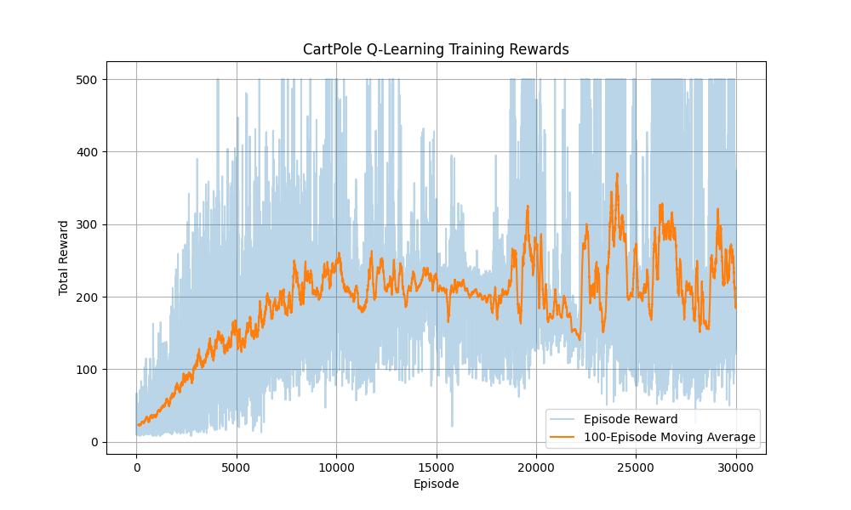
Figure 1. CartPole Q-learning training rewards.
The reward chart shows that early rewards were low, then the 100-episode moving average increased as the agent learned better actions. The moving average later fluctuated, which is expected because this project uses a discretized Q-table for a continuous-control problem.
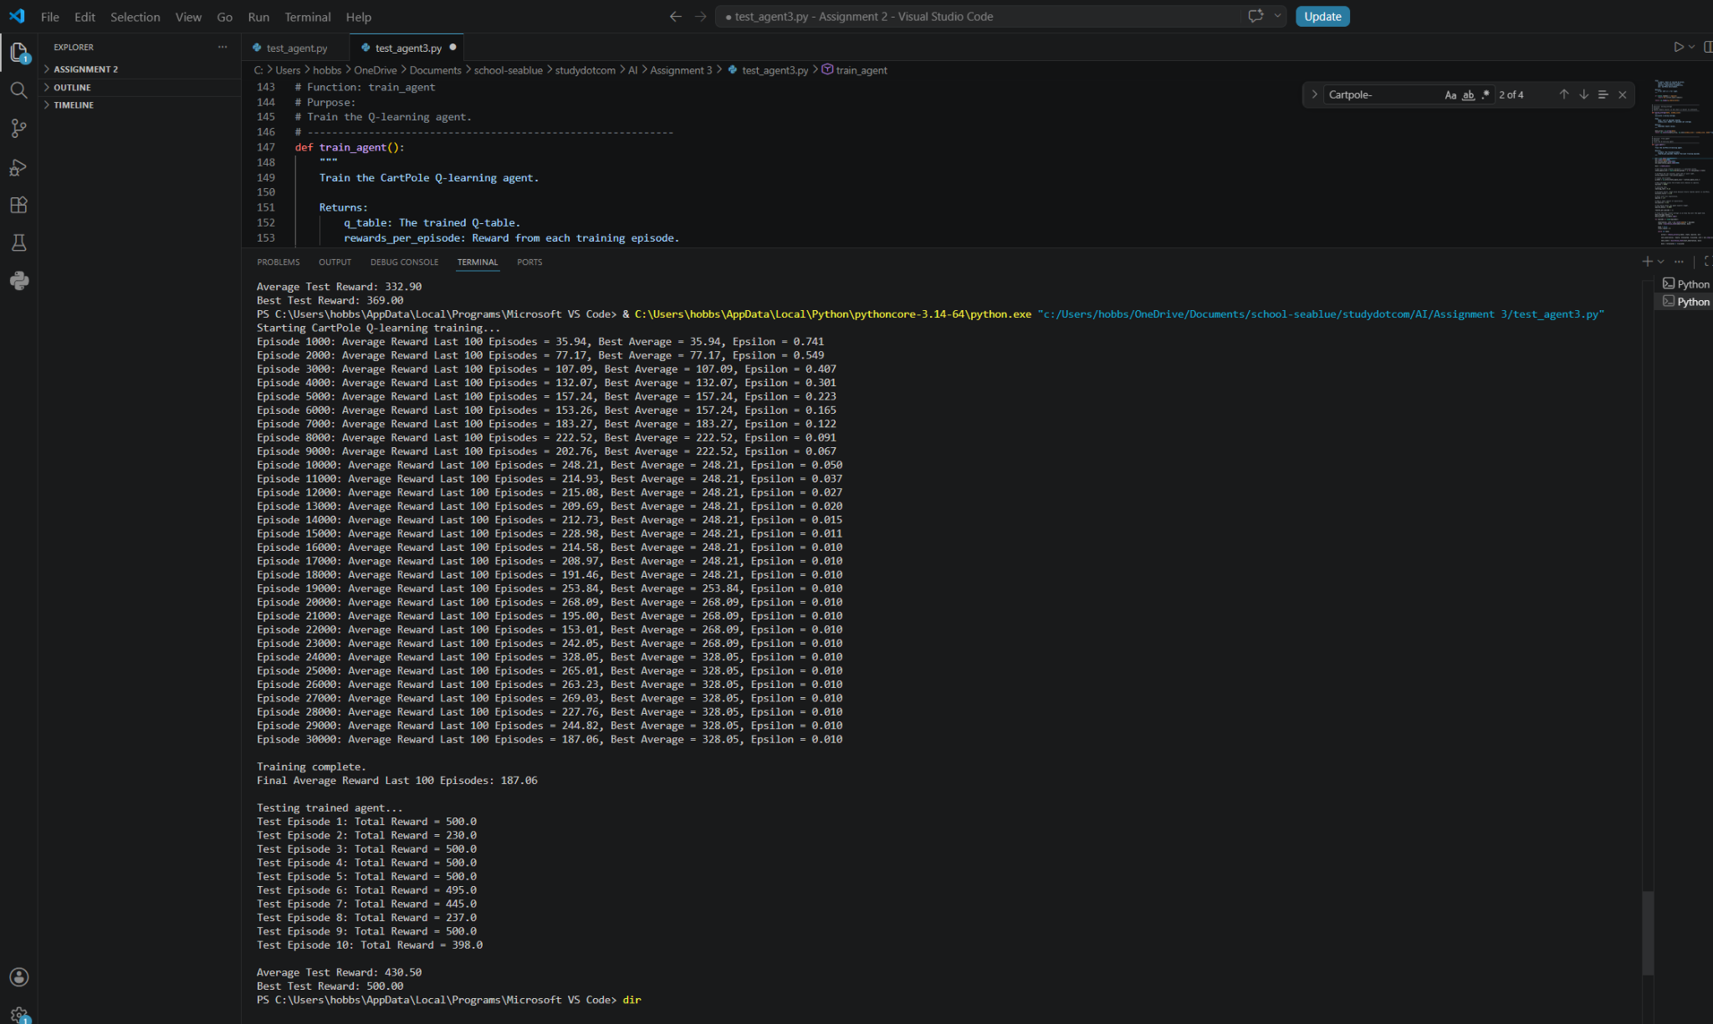
Figure 2. Training and testing output in Visual Studio Code.
During testing, the trained agent performed well. The test results were:
Test Episode | Reward
1 | 500.0
2 | 230.0
3 | 500.0
4 | 500.0
5 | 500.0
6 | 495.0
7 | 445.0
8 | 237.0
9 | 500.0
10 | 398.0

The average test reward was 430.50, and the best test reward was 500.00. Since CartPole-v1 can run for up to 500 time steps in one episode, the test results show that the agent successfully learned a strong balancing policy. The agent reached the maximum score in five of the ten test episodes.

8. Discussion and Insights
The results show that the Q-learning agent learned through trial and error. Early in training, the agent explored many actions, which led to lower rewards. As epsilon decreased, the agent relied more on its learned Q-values. This allowed the agent to balance the pole for longer periods of time and eventually reach the maximum reward of 500 in several test episodes.
The strongest result was the test phase. The trained agent achieved an average test reward of 430.50 and a best reward of 500.00. These results show that the agent learned an effective policy for the CartPole task. The test results are stronger than the final 100-episode training average because the program preserved the strongest learned Q-table and used that table during testing.

The main limitation of the project is that CartPole has continuous observation values, while this implementation uses a discrete Q-table. The discretization step makes Q-learning easier to implement and explain, but it loses detail from the original state space. This can cause unstable performance because slightly different continuous states may be grouped into the same bin. A future improvement would be to use a Deep Q-Network instead of a Q-table. A DQN could approximate Q-values directly from the continuous observation values and would likely produce more stable results.

Another limitation is that reinforcement learning can produce different results across training runs. The agent’s starting conditions, exploratory actions, and Q-value updates can vary. This explains why multiple runs of the same program may produce different training averages and test results. However, the final selected run clearly demonstrated learning and achieved the maximum CartPole-v1 score multiple times.

9. References
Farama Foundation. (n.d.). Cart Pole. Gymnasium documentation. https://gymnasium.farama.org/environments/classic_control/cart_pole/

Sutton, R. S., & Barto, A. G. (2018). Reinforcement learning: An introduction (2nd ed.). MIT Press. http://incompleteideas.net/book/the-book-2nd.html

Towers, M., Kwiatkowski, A., Terry, J. K., Balis, J. U., De Cola, G., Deleu, T., Goulão, M., Kallinteris, A., Krimmel, M., KG, A., Perez-Vicente, R., Pierré, A., Schulhoff, S., Tai, J. J., Tan, H., & Younis, O. G. (2024). Gymnasium: A standard interface for reinforcement learning environments. arXiv. https://arxiv.org/abs/2407.17032

Watkins, C. J. C. H., & Dayan, P. (1992). Q-learning. Machine Learning, 8, 279-292. https://doi.org/10.1007/BF00992698

