Oil Price Predictor
A Machine Learning Application for Brent Crude Oil Price Prediction

Loren Hobbs
Study.com CS 311: Artificial Intelligence
Project #1
May 2026

1. Name and Purpose of the Application
Oil Price Predictor is a Python-based machine learning application that predicts the next trading day closing price of Brent crude oil futures. The purpose of the application is to demonstrate how supervised machine learning can be used to analyze historical commodity price data and generate a short-term price forecast. The application downloads historical Brent crude oil futures data, creates price-based features such as moving averages and daily returns, trains a Random Forest Regression model, evaluates model performance, and produces a predicted next-day closing price. Brent was selected because it is widely used as a global crude oil benchmark (ICE, n.d.).

2. Algorithms Used
The primary algorithm used in this application is Random Forest Regression. Random Forest Regression is an ensemble learning method that trains many decision tree regressors and averages their results. This approach was selected because commodity prices often show nonlinear behavior, and a random forest model can capture interactions among multiple price-based features without requiring a complicated neural network setup. The model is also practical for a course project because it works well with tabular data and is easier to explain than a deep learning model. Scikit-learn documents RandomForestRegressor as an estimator that fits multiple decision trees and averages their predictions (Scikit-learn developers, n.d.).
The application uses supervised learning because the model is trained with historical input features and a known target value. The target value is the next trading day closing price. After training, the model receives the latest available feature values and produces a price prediction for the next trading day.

3. Dataset Information

3.1 Dataset Source
The dataset is historical Brent crude oil futures market data for ticker BZ=F. The data is downloaded from Yahoo Finance through the yfinance Python package. Yahoo Finance lists BZ=F as Brent Crude Oil Last Day Financial, and CME Group lists Brent Last Day Financial as a crude oil futures-related product (CME Group, n.d.; Yahoo Finance, n.d.). This project uses historical price and volume fields, including Open, High, Low, Close, and Volume.

3.2 Number of Records
After preprocessing, the submitted program used 2,495 historical Brent crude oil futures records. The exact value can change slightly if the program is run later because the data is downloaded at runtime and new market data may become available.

3.3 Number of Features
The model uses 10 input features after preprocessing: Open, High, Low, Volume, Previous_Close, MA_5, MA_10, MA_20, Daily_Return, and Volatility_5. The target variable is the next trading day closing price.

3.4 Description of Features
Feature Name | Description | Data Type
Open | Opening price for the trading day. | Float
High | Highest price reached during the trading day. | Float
Low | Lowest price reached during the trading day. | Float
Volume | Number of contracts traded for the day. | Integer or Float
Previous_Close | Closing price from the prior trading day. | Float
MA_5 | Five-day moving average of the closing price. | Float
MA_10 | Ten-day moving average of the closing price. | Float
MA_20 | Twenty-day moving average of the closing price. | Float
Daily_Return | Percentage change in closing price from the prior trading day. | Float
Volatility_5 | Five-day rolling standard deviation of daily returns. | Float
Target | Next trading day closing price used as the supervised learning label. | Float

3.5 Preprocessing Steps
The application preprocesses the dataset by keeping only the columns needed for the model, dropping rows with missing values, creating lagged and rolling features, and shifting the closing price column upward by one row to create the Target variable. Rows with missing values created by the rolling calculations are removed. The final cleaned dataset is saved as cleaned_brent_crude_oil_data.csv so that the preprocessing output can be reviewed.

4. Libraries, Toolkits, and Frameworks
The application uses pandas for data cleaning and feature engineering, NumPy for numerical calculations, yfinance for downloading Yahoo Finance market data, scikit-learn for training and evaluating the Random Forest Regression model, and Matplotlib for creating the actual vs. predicted price plot. These libraries support the full workflow from data acquisition to model evaluation and visualization.
Library | Role in the Application
pandas | Loads, cleans, and prepares the dataset.
NumPy | Performs numerical calculations such as root mean squared error.
yfinance | Downloads historical Brent crude oil futures data from Yahoo Finance.
scikit-learn | Provides the Random Forest model and evaluation metrics.
Matplotlib | Creates the actual vs. predicted price chart.

5. Application Design and Implementation
The application follows a simple machine learning pipeline. First, it downloads Brent crude oil futures data using the BZ=F ticker. Second, it cleans the dataset and creates engineered features, including moving averages, prior close, daily return, and short-term volatility. Third, it creates the supervised learning target by shifting the closing price so that each row points to the next trading day closing price. Fourth, it splits the data by time, using the earlier 80 percent of records for training and the most recent 20 percent for testing. This time-based split is more appropriate than a random split because financial time series data has a natural chronological order.
After the data is prepared, the application trains a Random Forest Regression model with 200 decision trees. The model is evaluated on the test set using Mean Absolute Error, Root Mean Squared Error, and R-squared. The app then uses the latest available data row to predict the next trading day closing price. Finally, it saves a chart called actual_vs_predicted_brent_crude_oil.png that compares actual and predicted prices on the test set.

6. Instructions for Running the App
To run the application, install Python 3 and place all project files in the same folder. Open a terminal or command prompt in the project folder. Install the required libraries with the command pip install -r requirements.txt. Then run the program with python oil_price_predictor.py. The program will download the dataset, train the model, print the model performance metrics, print the next-day prediction, save the cleaned dataset, and save the results chart.
Run commands:
pip install -r requirements.txt
python oil_price_predictor.py

7. Results
After preprocessing the historical Brent crude oil futures dataset, the application used 2,495 records and 10 input features to train and test the machine learning model. The features used by the model included daily price data, trading volume, prior closing price, moving averages, daily return, and short-term volatility. The target variable was the next trading day closing price.
Metric | Result
Rows used after preprocessing | 2,495
Features used by model | 10
Mean Absolute Error | $1.42
Root Mean Squared Error | $2.30
R-squared Score | 0.9610
Predicted next trading day closing price | $108.85
The Mean Absolute Error of $1.42 means that, on average, the model prediction was about $1.42 away from the actual closing price in the test data. The Root Mean Squared Error of $2.30 shows that larger prediction errors were still relatively limited. The R-squared score of 0.9610 means that the model explained a high percentage of the variation in the test data.
The application also generated a prediction for the next trading day closing price of Brent crude oil futures. Based on the trained model and the most recent available data, the predicted next trading day closing price was $108.85.
The program created two output files. The first file, cleaned_brent_crude_oil_data.csv, contains the cleaned and preprocessed dataset used by the model. The second file, actual_vs_predicted_brent_crude_oil.png, shows a plot comparing actual Brent crude oil closing prices against the model predicted values. This visual comparison helps show how closely the model followed the general pattern of the test data.
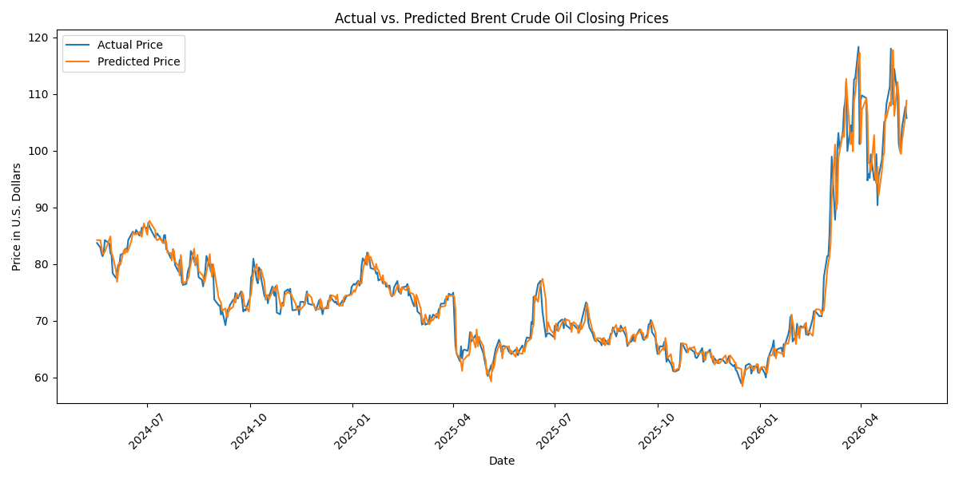
Figure 1. Actual vs. predicted Brent crude oil closing prices.
Overall, the results show that the application successfully downloaded historical Brent crude oil data, prepared the dataset, trained a supervised machine learning model, evaluated the model, and produced a short-term commodity price prediction. The model performed well on the test data, but the prediction should still be treated as an estimate rather than a guaranteed market forecast. Brent crude oil prices can be affected by many external factors, including global supply decisions, geopolitical events, petroleum inventories, transportation demand, and broader economic conditions.

8. Discussion and Insights
The results should be interpreted as a short-term machine learning forecast, not a guaranteed prediction of crude oil prices. Brent crude oil prices are affected by many real-world factors that are not fully captured by historical price data alone, including global supply and demand, petroleum inventories, OPEC policy, geopolitical events, interest rates, transportation constraints, and market sentiment. The model can learn patterns from recent price behavior, but it cannot know about unexpected news events that happen after the training data ends.
One strength of this application is that it uses a complete applied AI workflow, including data acquisition, preprocessing, feature engineering, model training, model evaluation, prediction, and visualization. Another strength is that the Random Forest model can capture nonlinear relationships among the input features. A limitation is that the model only uses historical market data and does not include macroeconomic variables such as inflation, exchange rates, oil inventories, production data, or demand forecasts. A future version could improve the model by adding Energy Information Administration inventory data, interest rate data, geopolitical indicators, or multiple model comparisons such as Support Vector Regression and Neural Networks.

9. References
Aroussi, R. (n.d.). yfinance documentation. https://ranaroussi.github.io/yfinance/
CME Group. (n.d.). Brent Last Day Financial overview. https://www.cmegroup.com/markets/energy/crude-oil/brent-crude-oil-last-day.html
ICE. (n.d.). Brent: The global benchmark for navigating crude oil markets. https://www.ice.com/brent-crude
Scikit-learn developers. (n.d.). RandomForestRegressor. Scikit-learn. https://scikit-learn.org/stable/modules/generated/sklearn.ensemble.RandomForestRegressor.html
Yahoo Finance. (n.d.). Brent crude oil last day financial: BZ=F. https://finance.yahoo.com/quote/BZ=F/

