Oil Price Predictor
Machine Learning Application for Brent Crude Oil Price Prediction

Loren Hobbs
Study.com CS 311: Artificial Intelligence
Project #1
May 2026

1. Name and Purpose of the Application
Oil Price Predictor is a Python-based machine learning app that predicts the next trading day closing price of Brent crude oil futures. I kept the purpose direct: use historical commodity price data, build a few practical price-based features, train a supervised learning model, and produce a short-term price estimate. The app downloads Brent crude oil data, calculates moving averages, daily returns, and short-term volatility, trains a Random Forest Regression model, evaluates the model, and prints the next-day prediction. Brent was selected because it is widely used as a global crude oil benchmark (ICE, n.d.).

2. Algorithms Used
The main algorithm used in this application is Random Forest Regression. A random forest trains many decision tree regressors and averages their results. I chose this model because commodity prices do not usually move in a clean straight line. A random forest can handle nonlinear relationships between the price features without making the project more complicated than it needs to be. It also fits the course material well because it connects directly to decision tree methods. Scikit-learn describes RandomForestRegressor as an estimator that fits multiple decision trees and averages their predictions (Scikit-learn developers, n.d.).
This is a supervised learning problem. The model is trained with input features from historical Brent crude oil data and a known target value. The target is the next trading day closing price. Once the model is trained, it uses the most recent feature values to make a new next-day price prediction.

A simpler model, such as Linear Regression, could also be used for this problem. Linear Regression is easy to understand and can work well when the relationship between input variables and the target value is mostly straight-line. However, crude oil prices do not usually move in a simple linear pattern. Price movement can be affected by short-term momentum, volatility, trading volume, and recent price trends. Because of that, Random Forest Regression was a better choice for this application. It can model nonlinear relationships and interactions between features such as moving averages, prior close, daily return, and volatility. Random Forest also works well with tabular datasets and does not require the more complex setup of a neural network.

3. Dataset Information

3.1 Dataset Source
The dataset is historical Brent crude oil futures market data for ticker BZ=F. The data is downloaded from Yahoo Finance through the yfinance Python package. Yahoo Finance lists BZ=F as Brent Crude Oil Last Day Financial, and CME Group lists Brent Last Day Financial as a crude oil futures-related product (CME Group, n.d.; Yahoo Finance, n.d.). The fields used in this project are Open, High, Low, Close, and Volume, along with features created from those fields.

3.2 Number of Records
After preprocessing, the submitted program used 2,495 historical Brent crude oil futures records. This number may change slightly if the program is run later because the data is downloaded at runtime and new market data can be added.

3.3 Number of Features
The model uses 10 input features after preprocessing: Open, High, Low, Volume, Previous_Close, MA_5, MA_10, MA_20, Daily_Return, and Volatility_5. The target variable is the next trading day closing price.

3.4 Description of Features
Feature Name | Description | Data Type
Open | Opening price for the trading day. | Float
High | Highest price reached during the trading day. | Float
Low | Lowest price reached during the trading day. | Float
Volume | Number of contracts traded for the day. | Integer or Float
Previous_Close | Closing price from the prior trading day. | Float
MA_5 | Five-day moving average of the closing price. | Float
MA_10 | Ten-day moving average of the closing price. | Float
MA_20 | Twenty-day moving average of the closing price. | Float
Daily_Return | Percentage change in closing price from the prior trading day. | Float
Volatility_5 | Five-day rolling standard deviation of daily returns. | Float
Target | Next trading day closing price used as the supervised learning label. | Float

3.5 Preprocessing Steps
The preprocessing step keeps only the columns needed for the model, drops rows with missing values, creates lagged and rolling features, and shifts the closing price column up by one row to create the Target value. The rolling features create a few blank rows at the beginning of the dataset, and the shifted target creates one blank row at the end. Those rows are removed before training. The cleaned dataset is saved as cleaned_brent_crude_oil_data.csv so the final model input can be checked.

4. Libraries, Toolkits, and Frameworks
The project uses a small set of standard Python libraries. pandas handles the data table, NumPy supports numerical calculations, yfinance downloads the market data, scikit-learn trains and evaluates the machine learning model, and Matplotlib creates the results chart. Together, these libraries cover the full workflow from downloading the dataset to saving the model output.
Library | Role in the Application
pandas | Loads, cleans, and prepares the dataset.
NumPy | Performs numerical calculations such as root mean squared error.
yfinance | Downloads historical Brent crude oil futures data from Yahoo Finance.
scikit-learn | Provides the Random Forest model and evaluation metrics.
Matplotlib | Creates the actual vs. predicted price chart.

5. Application Design and Implementation
The application follows a basic machine learning pipeline. First, it downloads Brent crude oil futures data using the BZ=F ticker. Second, it cleans the data and creates engineered features, including moving averages, prior close, daily return, and short-term volatility. Third, it creates the supervised learning target by shifting the closing price so each row points to the next trading day closing price.
The program uses a time-based split instead of a random split. The earlier 80 percent of records are used for training, and the most recent 20 percent are used for testing. That matters because financial data has a natural time order. Using newer data to predict older data would not match the way this app would be used in the real world.
After the data is prepared, the application trains a Random Forest Regression model with 200 decision trees. The model is evaluated with Mean Absolute Error, Root Mean Squared Error, and R-squared. The app then uses the latest available row to predict the next trading day closing price. Finally, it saves a chart called actual_vs_predicted_brent_crude_oil.png that compares actual and predicted prices on the test set.

6. Instructions for Running the App
To run the application, install Python 3 and place all project files in the same folder. Open a terminal or command prompt in that folder. Install the required libraries first, then run the Python file.
Run commands:
pip install -r requirements.txt
python oil_price_predictor.py
When the program runs, it downloads the dataset, prepares the features, trains the model, prints the results, saves the cleaned dataset, and saves the chart image.

7. Results
After preprocessing the historical Brent crude oil futures dataset, the application used 2,495 records and 10 input features to train and test the model. The target variable was the next trading day closing price.
Metric | Result
Rows used after preprocessing | 2,495
Features used by model | 10
Mean Absolute Error | $1.42
Root Mean Squared Error | $2.30
R-squared Score | 0.9610
Predicted next trading day closing price | $108.85

The Mean Absolute Error of $1.42 means the model prediction was about $1.42 away from the actual closing price on average in the test data. The Root Mean Squared Error of $2.30 gives more weight to larger errors, so it is a useful check for bigger misses. The R-squared score of 0.9610 shows that the model tracked a large amount of the variation in the test data.
The application also generated a next-day prediction. Based on the trained model and the most recent available data, the predicted next trading day closing price for Brent crude oil futures was $108.85.
The terminal output below shows the program results after the script was run.
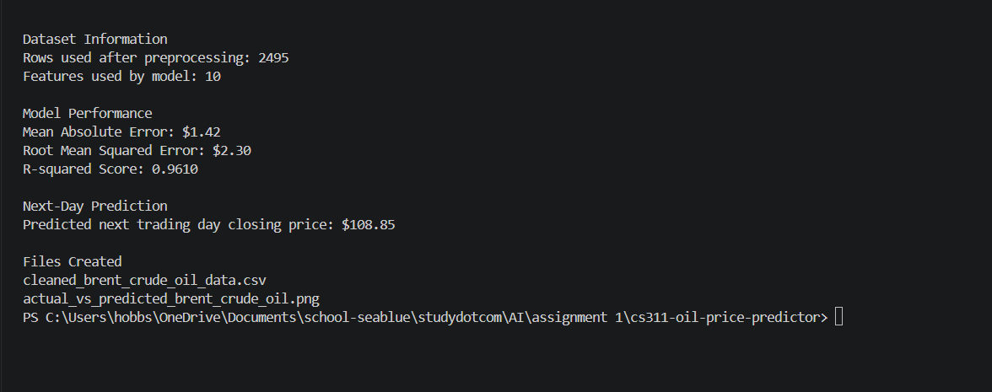
Figure 1. Terminal output from the Brent crude oil prediction run.
The program also created two output files. The first file, cleaned_brent_crude_oil_data.csv, contains the cleaned dataset used by the model. The second file, actual_vs_predicted_brent_crude_oil.png, shows a plot comparing actual Brent crude oil closing prices against the model predictions.
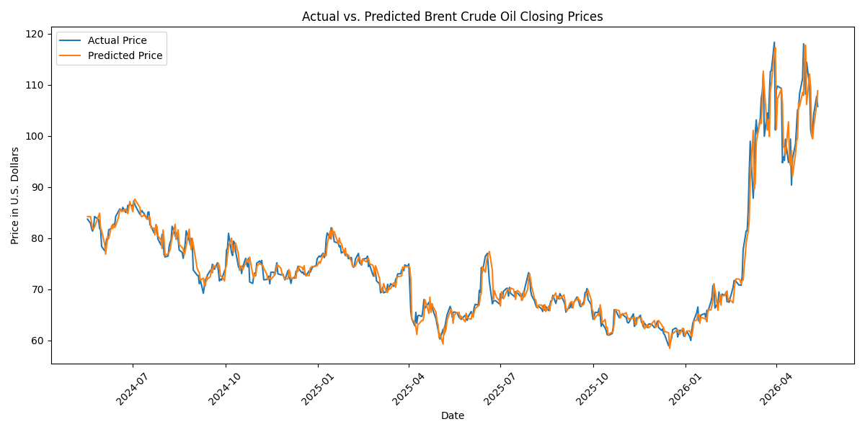
Figure 2. Actual vs. predicted Brent crude oil closing prices.
The model followed the general direction of the test data closely. That is a good result for this project because the goal was to build a complete machine learning app, not a production trading system. The prediction should be treated as a short-term estimate, not a guarantee.

8. Discussion and Insights
The results are useful, but they need to be read with common sense. This project predicts Brent crude oil prices from historical price behavior. That means the model can learn patterns from recent market data, but it cannot know about breaking news, sudden supply disruptions, policy announcements, or geopolitical events that happen after the data ends.
The strongest part of the application is that it completes the full applied AI workflow: data download, cleaning, feature engineering, model training, model evaluation, prediction, and visualization. The Random Forest model is also a good fit because it can handle nonlinear relationships among the input features and does not require the setup of a neural network.
The main limitation is that the model only uses historical market data. Brent crude oil prices are also affected by supply and demand, OPEC policy, petroleum inventories, interest rates, transportation constraints, exchange rates, and market sentiment. A stronger future version could add Energy Information Administration inventory data, macroeconomic data, or compare Random Forest Regression against Support Vector Regression and a simple neural network.
Overall, the project shows that a Python machine learning pipeline can be used to make a short-term commodity price forecast. The model performed well on the test data, but the output should still be treated as one input into analysis rather than a standalone decision tool.

9. References
Aroussi, R. (n.d.). yfinance documentation. https://ranaroussi.github.io/yfinance/
CME Group. (n.d.). Brent Last Day Financial overview. https://www.cmegroup.com/markets/energy/crude-oil/brent-crude-oil-last-day.html
ICE. (n.d.). Brent: The global benchmark for navigating crude oil markets. https://www.ice.com/brent-crude
Scikit-learn developers. (n.d.). RandomForestRegressor. Scikit-learn. https://scikit-learn.org/stable/modules/generated/sklearn.ensemble.RandomForestRegressor.html
Yahoo Finance. (n.d.). Brent crude oil last day financial: BZ=F. https://finance.yahoo.com/quote/BZ=F/

