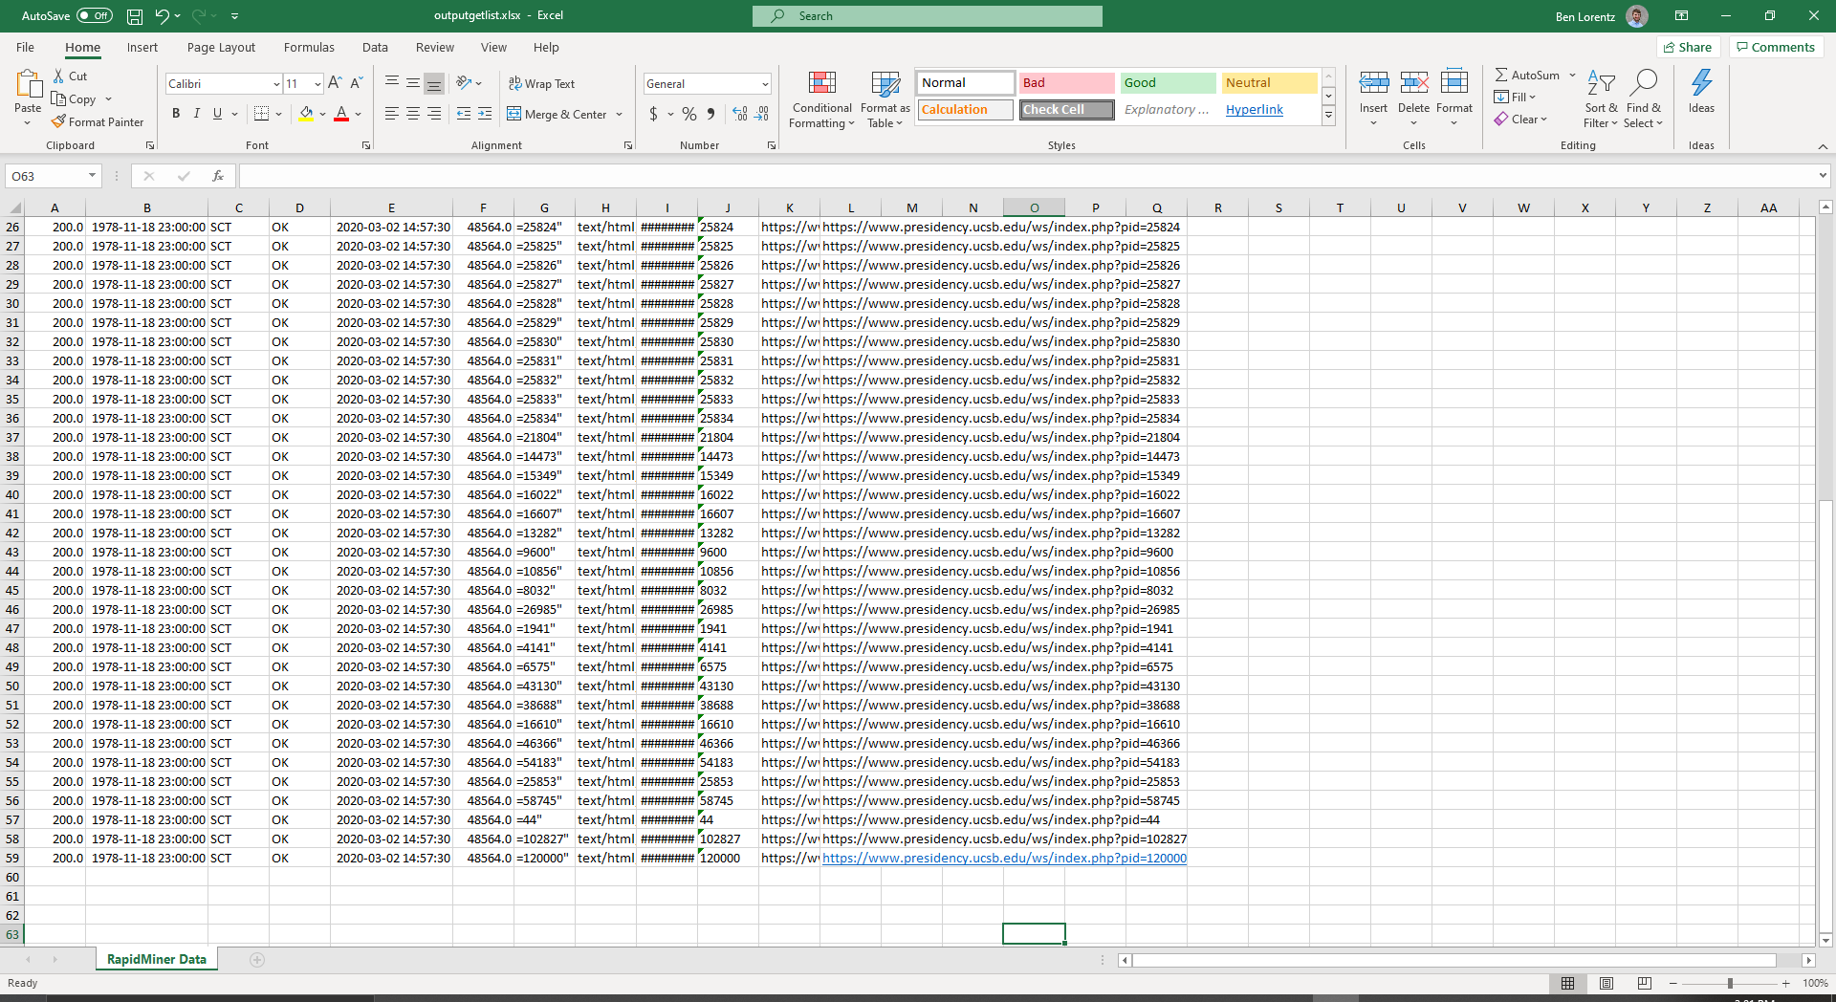1

2 Theodore Roosevelt 1905

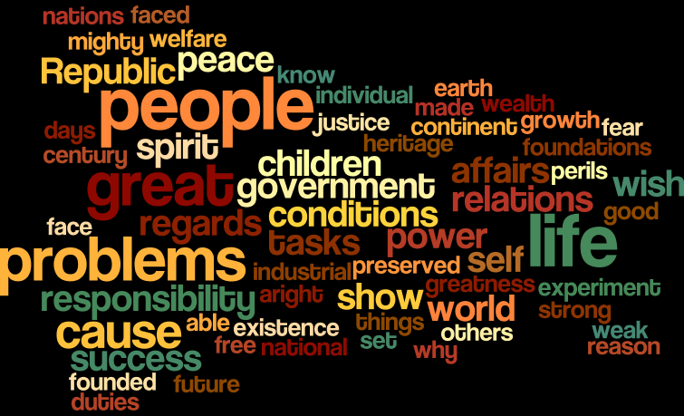

Donald Trump

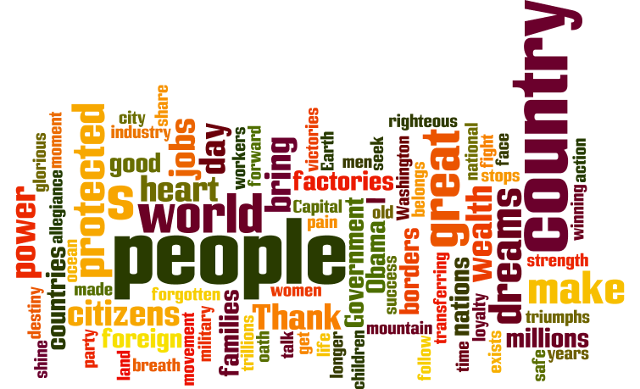

Words to be removed could be people, day, face, government, industry. Trumps cloud has more words about work, industry and a global focus with words like foreign. Roosevelt’s has more of an internal focus and notably has less words that are repeated as often.

3 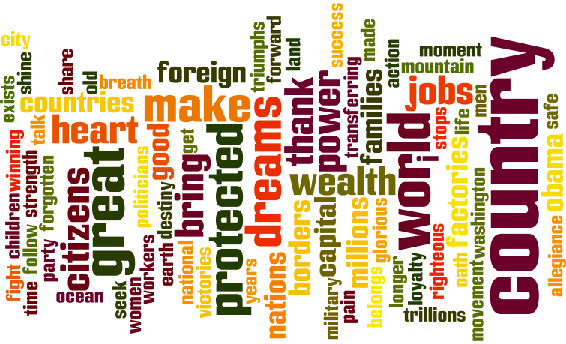Trump2

Roosevelt 2

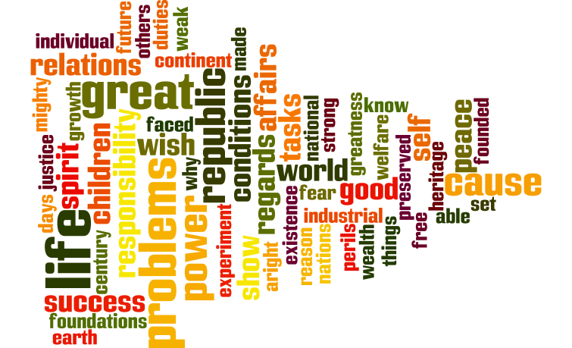

4 Eisenhower1

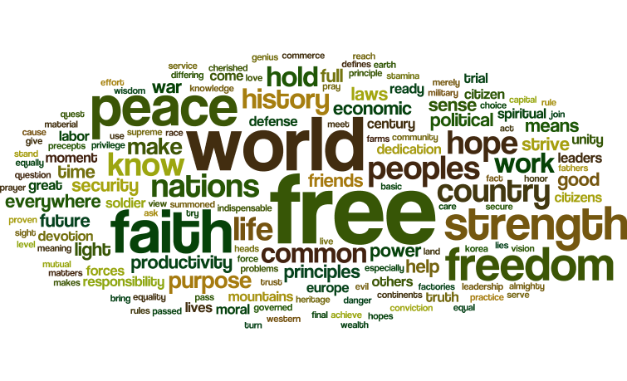

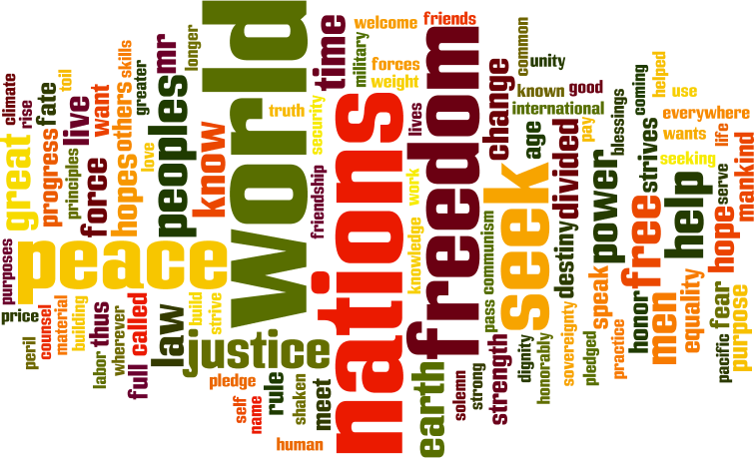Eisenhower2

I think its interesting the amount of global words used in both speeches. Phrases like free, world, nation, peace. It does sound like there was a shift from being strong and militarily powerful in the first speech and more people-focused in the second speech. This could be in response to the Korean war which was slowly ending by the end of the 1953 which is the year of the first speech.