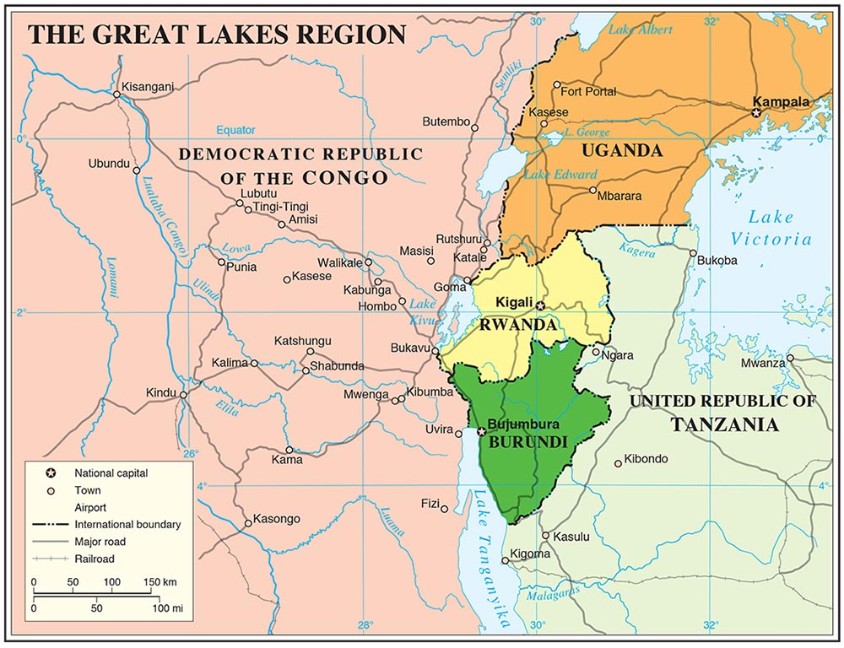

**Burundi**

and the **Arusha Peace and Reconciliation Agreement**

**Conflict Actors:**

* FRODEBU, Hutu-led political party that is in government
* Forces Armees Burundaises, Burundi’s army, but Tutsi-led
* Forces pour la Defense de la Democratie (FDD), Hutu-led rebel group, armed faction of Conseil National pour la defense de la democratie (CNDD)

**People**

* Sylvestre Ntibantunganya, Third President of Burundi, Hutu-led FRODEBU party
* Pierre Buyoya, leader of Tutsi Union Nationale pour le Progres (UPRONA) party
* Cyprien Ntaryamira, Hutu-led FRODEBU party
* Ahmedou Ould-Abdallah, UN Special Envoy, Mediator

The conflict in Burundi was triggered by the 1993 assassination of President Melchior Ndadaye the first democratically elected leader of Front pour la Democratie au Burundi (FRODEBU) party, a political wing of the Hutu ethnic group, the divide and rule system during the colonial era created deeper ethnic cleavages among the Hutu and Tutsi people of Burundi before independence in 1962, the Belgium colonial masters favoured the Tutsi in political administration over the Hutu and the marginalized Twa People. This sowed the seeds of division and rivalry among the majority Hutu and minority Tutsi. The assassination of President Ndadaye presented a moment that triggered already existing ethnic divisions into violent clashes in 1994 and claimed an estimated 300,000 lives.

**Q: With over 300,000 dead, do you think durable peace was more or less likely?**

The violence in Burundi has, therefore, been fuelled by the Tutsi power monopoly, inequalities in wealth, opportunities and land. A genocide happening in neighbouring Rwanda during the same time almost influenced similar events in Burundi but the efforts of diplomacy by Ould-Abdallah a UN special envoy under the United Nations Office of Burundi (UNOB) paid off and prevented a similar catastrophe in Burundi. Sylvestre Ntibantunganya then became the third FRODEBU President and he tried to appease conflicting parties; however, his moderate and inclusive overtures antagonized radical elements in his party who split and formed a rebel group Forces pour la Defense de la Democratie (FDD), an armed faction of Conseil National pour la defense de la democratie (CNDD). In 1996 Ntibantunganya was ousted in a military coup by former President Pierre Buyoya of the mainly Tutsi Union Nationale pour le Progres (UPRONA) party.

**The Mediation and Negotiation Process**

The assassination of President Ndadaye prompted the international efforts for intervention in what was observed as a precarious situation in Burundi. Whereas the majority Hutu parties called for an international intervention in order to restore their civilian rule, the Tusti dominated military responsible for the sparking the crisis initially resisted any form of intervention, but, after international pressure and diplomacy, in November 1993 the army agreed to an international force of observers.

**Q: Why would the Hutus have preferred international intervention and why might the Tusti military have resisted it?**

The UN Secretary-General, Boutros Boutros-Ghali appointed Ahmedou Ould-Abdallah as his Special Envoy and established the United Nations Office in Burundi (UNOB) to facilitate the process of restoration of constitutional rule. Ould-Abdallah worked closely with the OAU, in providing good offices, sharing information and holding meetings with Burundian parties.

**Q: What mediation strategy did Ahmedou Ould-Abdallah follow**?

In November 1995, the Presidents of Burundi, Rwanda, Uganda, and Zaire had announced the formation of a “Regional Peace Initiative on Burundi”. On 31 July 1996, at a Regional Summit in Arusha, this Regional Initiative sought and adopted sanctions on the Buyoya government in Burundi for conducting an abortive coup d'etat.

**Q: How did the Regional Peace Initiative on Burundi influence the negotiations? What did this do to the bargaining range? What type of mediation strategy is this?**

Buyoya succumbed to regional pressure and lifted a ban on political parties and convened direct negotiations with the National Council for the Defense of Democracy (CNDD) in September 1996. He also initiated an inclusive government in May 1998 by encouraging members of the FRODEBU within the country to join his Government.

In June 1998, Nyerere convened Arusha II for further negotiations on what would become the Arusha Peace and Reconciliation Agreement, signed by representatives from UPRONA, FRODEBU, and several other small parties. Nyerere's untimely death in 1999 gave way for former South African President Mandela Nelson Mandela to take up role as Regional Facilitator, adding more international and regional pressure on the parties to the conflict. Some Burundian participants and observers of the Arusha talks felt that Mandela’s high regional and international standing made him too confident about imposing his own ideas. Nevertheless, On 28th August 2000, the Arusha Peace and Reconciliation Agreement was signed by the then government of Burundi, the National Assembly, 13 of the Arusha parties including UPRONA and FRODEBU, and 6 Tutsi parties.

**Q: What was the mediation strategy of Nelson Mandela?**

The Arusha Agreement consisted of a peace accord followed by five protocols, which form an integral part of the agreement. The transition period was to be one of three years (eventually extended to four years) during which the presidency was to alternate between FRODEBU and UPRONA, and Burundi was to be governed by a transitional government until new general elections were held.

For the mediators, as for the parties, the regional context was also difficult. The situation in DRC and Rwanda made it easier for the armed parties to continue or revert to violence by seeking shelter and support from regional allies who used them as proxy forces.

**Q: How did the regional context impact the bargaining range?**

Of the five protocols in the peace accord – the ‘Nature of the Burundi Conflict, Problems of Genocide and Exclusion, and Their Solutions’, ‘Democracy and Good Governance’, ‘Peace and Security for All’, ‘Reconstruction and Development’, and ‘Guarantees on the Implementation of the Agreement’ – two are important for this class:

1. **Protocol 2: Democracy and Good Governance.**

This protocol stipulated a framework for power sharing to enhance political inclusion in order to address historical imbalances created by the colonial establishment that favoured the minority Tutsi over majority Hutu. For instance, in public administration and the military, contribution from a single ethnic group was limited to 67 percent and to less than 50 percent respectively, it strongly emphasized upholding democratic governance through social justice, gender equality, freedom of expression, property rights, freedom of association, unfettered political participation, decentralisation of power, judicial independence.

1. **Protocol 5: Guarantees on the Implementation of the Agreement.**

This protocol focused on the mechanism of implementing and monitoring of the agreement and stipulates a timeframe to be followed. A 29-member Implementing Monitoring Commission (IMC) was formed to monitor this process. Its membership included 18 “Arusha parties, civil society organisations, regional powers, the OAU/AU, donors, and other members of the international community.

**Q: How many of the four elements of power sharing were included in the deal? Were these the most important elements?**

**Q: What role did the Implementing Monitoring Commission play, and do you think this would have had a positive role?**

**Global Ceasefire Agreement: Dar es Salaam**

Addressing the UN Security Council in July 2003, Ndayizeye spoke of forward momentum in the peace process, though fighting and confrontation still existed between FDD and FNL near Bujumbura, forcing an estimated 47,500 civilians to flee their homes. On 8th October 2003, Nkurunziza’s CNDD-FDD and the TGoB signed an agreement on the implementation of the December 2002 ceasefire and, on 16 November 2003, the two signed a Global Ceasefire Agreement in Dar es Salaam. This breakthrough gave some assurance to international community and the UNSC recommitting to establishing a United Nations Peace Keeping Operation and on 21 May 2004 the Security Council adopted Resolution 1545, establishing the United Nations Operation in Burundi (ONUB). ONUB became operational on 1 June 2004 with 5,500 military and civilian staff (including more than 1,000 civilians).

**Q:**  **How was the UN involved? Was this a good idea in your opinion?**

Sources:

Nsubuga, Bright T. (2013). “Forms of Peaceful Conflict Resolution”, unpublished manuscript, available at: <https://www.academia.edu/19664726/Negotiation_and_Mediation_of_violent_Conflicts_A_case_study_of_Burundi_and_Kenya>

Barltrop, Richard (2008). “The Negotiation of Security Issues in the Burundi Peace Talks”, *Negotiating Disarmament*, Centre for Humanitarian Dialogue.