Student Name: Lorenzo McDaniel
Class and Section CSCI 3033-001
Due: October 25, 2020, at 11:59

Homework:

CSCI 3033 Introduction to Java Programming Language

Problem Description:
Solve the following Programming Exercises from chapter 14
14.5, 14.11, 14.18, and 14.19

You are to write a program to solve each exercise. Add your last name to the stage title. Use a different color for filling in exercise 14.5 and 14.11

Here are sample runs of the program:

Sample run 14.5:
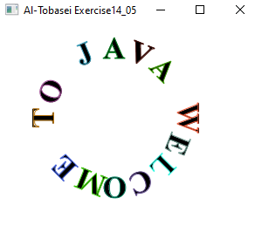

Sample run 14.11:
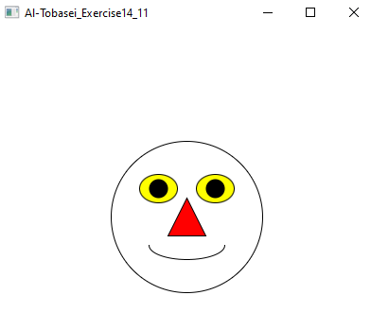

Sample 14.18:
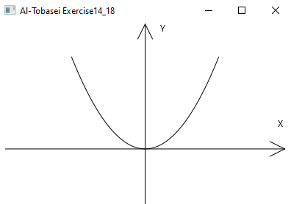

Sample 14.19:
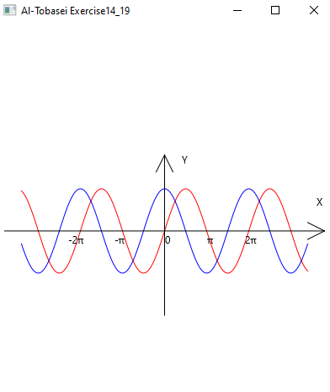

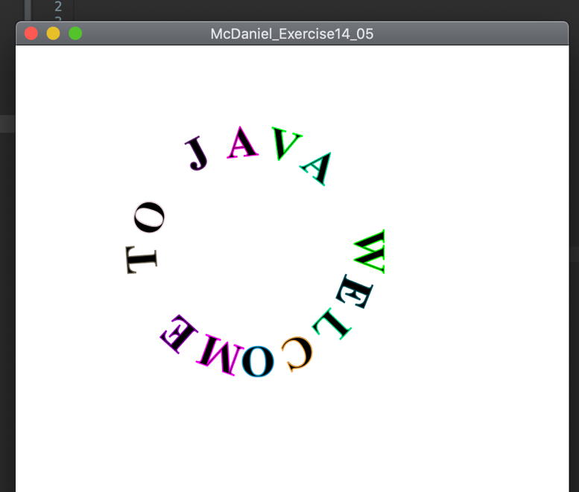

import javafx.application.Application;

import javafx.geometry.Point2D;
import javafx.scene.Scene;
import javafx.scene.layout.*;
import javafx.scene.paint.Color;
import javafx.scene.shape.Circle;
import javafx.scene.text.*;
import javafx.stage.Stage;
import javafx.scene.control.*;

public class McDaniel_Exercise14_05 extends Application{

@Override // override the start method
public void start(Stage primaryStage) {

Pane pane = new Pane();
pane.setPrefSize(500, 500);

// Welcome to Java string
String[] welcome = "WELCOME TO JAVA".split("");

double angle = 0;
double rotate = 90;
double radius = 100;

Point2D center = new Point2D(200,200);
for (int i = 0; i < welcome.length; i++, angle+=22, rotate+=22)
{
double x = center.getX() + radius * Math.cos(Math.toRadians(angle));

double y = center.getY() + radius * Math.sin(Math.toRadians(angle));

Text text = new Text(x,y,welcome[i]);
text.setRotate(rotate);
text.setFont(Font.font("Times New Roman", FontWeight.BOLD, 40));
text.setFill(Color.BLACK);
text.setStroke(Color.color(Math.random(),Math.random(), Math.random()));

pane.getChildren().add(text);

}

Scene scene = new Scene(pane);
primaryStage.setTitle("McDaniel_Exercise14_05");
primaryStage.setScene(scene);
primaryStage.show();

}

public static void main(String[] args) {

launch(args);
}

}

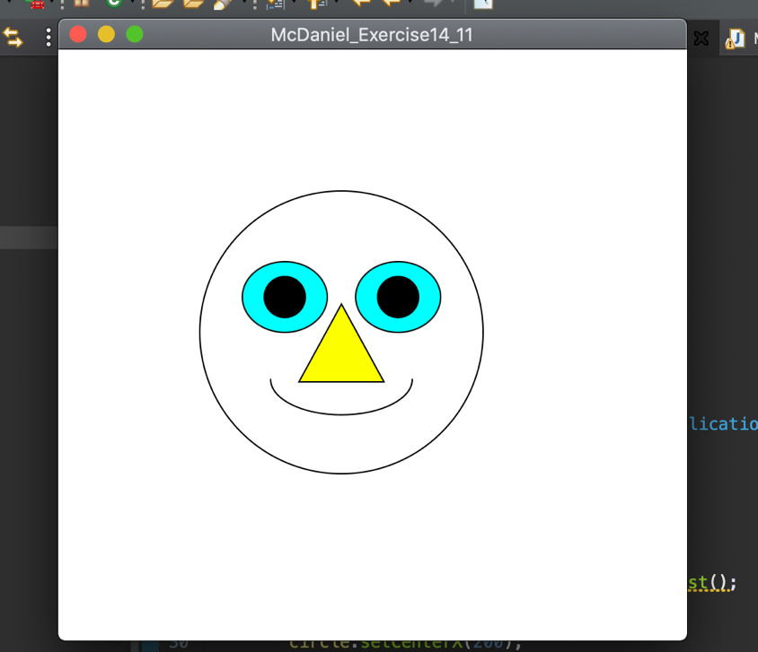

import java.util.ArrayList;

import javafx.application.Application;
import javafx.collections.ObservableList;
import javafx.geometry.Point2D;
import javafx.scene.Scene;
import javafx.scene.layout.Pane;
import javafx.scene.paint.Color;
import javafx.scene.shape.Arc;
import javafx.scene.shape.ArcType;
import javafx.scene.shape.Circle;
import javafx.scene.shape.Ellipse;
import javafx.scene.shape.Polygon;
import javafx.scene.shape.Shape;
import javafx.scene.text.Font;
import javafx.scene.text.Text;
import javafx.stage.Stage;

public class McDaniel_Exercise14_11 extends Application {

@Override // override the start method
public void start(Stage primaryStage) {

// smile face head
Pane pane = new Pane();
ArrayList< Shape > shapes = new ArrayList();

Circle circle = new Circle();
circle.setCenterX(200);
circle.setCenterY(200);
circle.setRadius(100);
circle.setFill(Color.TRANSPARENT);
circle.setStroke(Color.BLACK);

shapes.add(circle);

int center_x = 200;
int center_y = 200;
int radius = 100;

// smile face eye
double x = center_x - (radius / 2.8);
double y = center_y - (radius /2.8);

// eye and pupil one
Ellipse oval1 = new Ellipse(25,25,30,25);
oval1.setCenterX(160);
oval1.setCenterY(175);
oval1.radiusXProperty();

oval1.setStroke(Color.BLACK);
oval1.setFill(Color.CYAN);
shapes.add(oval1);

// eye 2 and pupil 2

Ellipse oval2 = new Ellipse(25 ,25,30,25);
oval2.setCenterX(240);
oval2.setCenterY(175);
oval2.setStroke(Color.BLACK);
oval2.setFill(Color.CYAN);
shapes.add(oval2);

Circle eye = new Circle(oval1.getCenterX(), oval1.getCenterY(), oval1.getRadiusX()/ 2);
shapes.add(eye);

Circle eye2 = new Circle(oval2.getCenterX(), oval2.getCenterY(), oval2.getRadiusX()/ 2);
shapes.add(eye2);

// nose
Polygon tri = new Polygon();
tri.setStroke(Color.BLACK);
tri.setFill(Color.YELLOW);

ObservableList<Double> list = tri.getPoints();

list.add(200.0);
list.add(180.0);

list.add(230.0);
list.add(235.0);

list.add(170.0);
list.add(235.0);

shapes.add(tri);

// smile
Arc smile = new Arc(

circle.getCenterX(),
circle.getCenterY() + (circle.getRadius()/3),
circle.getRadius()/2 ,
circle.getRadius() /2 /2,
180,180);

smile.setFill(Color.TRANSPARENT);
smile.setStroke(Color.BLACK);

shapes.add(smile);

pane.getChildren().addAll(shapes);
Scene scene = new Scene(pane,600,600);
primaryStage.setTitle("McDaniel_Exercise14_11");
primaryStage.setScene(scene);
primaryStage.show();

}

public static void main(String[] args) {

launch(args);
}

}

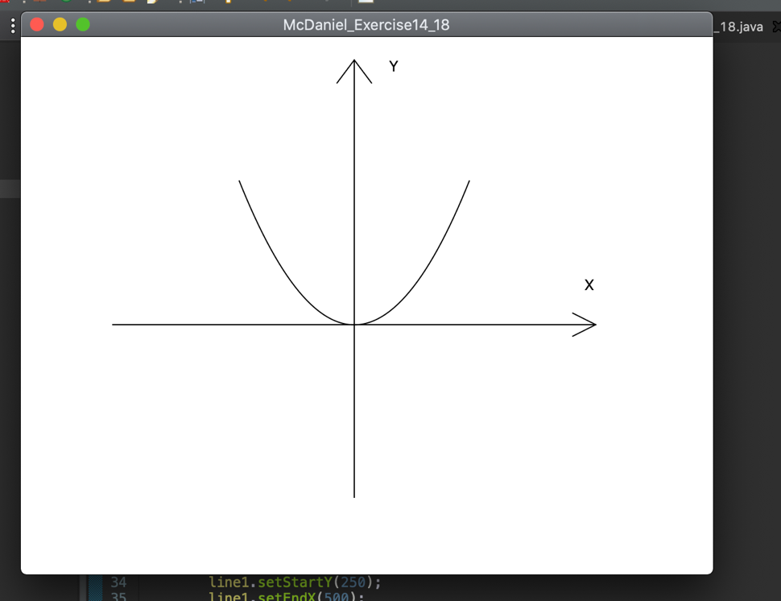

import java.util.ArrayList;

import javafx.application.Application;
import javafx.collections.ObservableList;
import javafx.scene.Scene;
import javafx.scene.layout.Pane;
import javafx.scene.paint.Color;
import javafx.scene.shape.Arc;
import javafx.scene.shape.Circle;
import javafx.scene.shape.Ellipse;
import javafx.scene.shape.Line;
import javafx.scene.shape.Polygon;
import javafx.scene.shape.Polyline;
import javafx.scene.shape.Shape;
import javafx.scene.text.Text;
import javafx.stage.Stage;

public class McDaniel_Exercise14_18 extends Application{

@Override // override the start method
public void start(Stage primaryStage) {

// create pane
Pane pane = new Pane();

ArrayList< Shape > shapes = new ArrayList();

// create x axis line

Line line1 = new Line();
line1.setStartX(80);
line1.setStartY(250);
line1.setEndX(500);
line1.setEndY(250);

line1.setStroke(Color.BLACK);

shapes.add(line1);

// arrow head x axis

Line arrow1 = new Line();
arrow1.setStartX(480);
arrow1.setStartY(240);
arrow1.setEndX(500);
arrow1.setEndY(250);

arrow1.setStroke(Color.BLACK);

shapes.add(arrow1);

Line arrow2 = new Line();
arrow2.setStartX(480);
arrow2.setStartY(260);
arrow2.setEndX(500);
arrow2.setEndY(250);

arrow2.setStroke(Color.BLACK);

shapes.add(arrow2);

// create y axis line
Line line2 = new Line();

line2.setStartX(290);
line2.setStartY(20);
line2.setEndX(290);
line2.setEndY(400);
line2.setStroke(Color.BLACK);

shapes.add(line2);

// arrow head y axis

Line arrow3 = new Line();
arrow3.setStartX(275);
arrow3.setStartY(40);
arrow3.setEndX(290);
arrow3.setEndY(20);
arrow3.setStroke(Color.BLACK);
shapes.add(arrow3);

Line arrow4 = new Line();
arrow4.setStartX(305);
arrow4.setStartY(40);
arrow4.setEndX(290);
arrow4.setEndY(20);
arrow4.setStroke(Color.BLACK);
shapes.add(arrow4);

// print the X and Y axis text

Text text1 = new Text(320,30,"Y");
pane.getChildren().add(text1);

Text text2 = new Text(490,220,"X");
pane.getChildren().add(text2);

Polyline polyline = new Polyline();
ObservableList<Double> list = polyline.getPoints();
double scaleFactor = 0.0125;
for( int x = -100; x<=100; x++)
{
list.add(x+290.0);
list.add(scaleFactor * x * x);
}

polyline.setRotate(180);
polyline.setLayoutY(125);
shapes.add(polyline);

pane.getChildren().addAll(shapes);

Scene scene = new Scene(pane,600,600);
primaryStage.setTitle("McDaniel_Exercise14_18");
primaryStage.setScene(scene);
primaryStage.show();

}

public static void main(String[] args) {

launch(args);
}

}

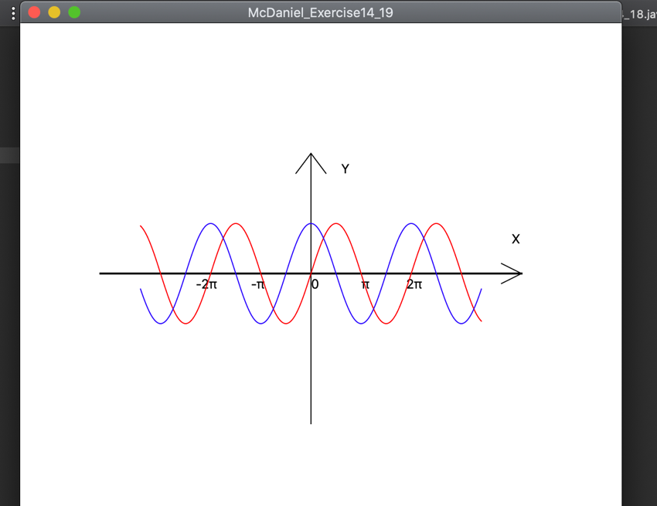

import java.util.ArrayList;

import javafx.application.Application;
import javafx.collections.ObservableList;
import javafx.scene.Scene;
import javafx.scene.layout.Pane;
import javafx.scene.paint.Color;
import javafx.scene.shape.Line;
import javafx.scene.shape.Polyline;
import javafx.scene.shape.Shape;
import javafx.scene.text.Text;
import javafx.stage.Stage;

public class McDaniel_Exercise14_19 extends Application {

@Override // override the start method
public void start(Stage primaryStage) {

// create pane
Pane pane = new Pane();

ArrayList< Shape > shapes = new ArrayList();

// create x axis line
Line line1 = new Line();
line1.setStartX(80);
line1.setStartY(250);
line1.setEndX(500);
line1.setEndY(250);

line1.setStroke(Color.BLACK);
line1.setStrokeWidth(2.0f);

shapes.add(line1);

// arrow heads for x axis
Line arrow1 = new Line();
arrow1.setStartX(480);
arrow1.setStartY(240);
arrow1.setEndX(500);
arrow1.setEndY(250);
arrow1.setStroke(Color.BLACK);
shapes.add(arrow1);

Line arrow2 = new Line();
arrow2.setStartX(480);
arrow2.setStartY(260);
arrow2.setEndX(500);
arrow2.setEndY(250);
arrow2.setStroke(Color.BLACK);
shapes.add(arrow2);

// create y axis line
Line line2 = new Line();
line2.setStartX(290);
line2.setStartY(130);
line2.setEndX(290);
line2.setEndY(400);
line2.setStroke(Color.BLACK);
shapes.add(line2);

// arrow head y axis
Line arrow3 = new Line();
arrow3.setStartX(275);
arrow3.setStartY(150);
arrow3.setEndX(290);
arrow3.setEndY(130);
arrow3.setStroke(Color.BLACK);
shapes.add(arrow3);

Line arrow4 = new Line();
arrow4.setStartX(305);
arrow4.setStartY(150);
arrow4.setEndX(290);
arrow4.setEndY(130);
arrow4.setStroke(Color.BLACK);
shapes.add(arrow4);

// print the X and Y axis text
Text text1 = new Text(320,150,"Y");
pane.getChildren().add(text1);

Text text2 = new Text(490,220,"X");
pane.getChildren().add(text2);

// print the math symbols along the x axis

Text text3 = new Text(290,265, "0");

Text text4 = new Text(230, 265, "-\u03c0");

Text text5 = new Text(175,265,"-2\u03c0");

Text text6 = new Text(340,265,"\u03c0");

Text text7 = new Text(385,265,"2\u03c0");

pane.getChildren().add(text3);
pane.getChildren().add(text4);
pane.getChildren().add(text5);
pane.getChildren().add(text6);
pane.getChildren().add(text7);

// sine

Polyline polyline = new Polyline();
ObservableList<Double> list = polyline.getPoints();
//double scaleFactor = 50;
for( int x = -170; x<=170; x++)
{
list.add(x+290.0);
list.add(100 - 50 * Math.sin((x / 100.0) * 2 * Math.PI));
}

polyline.setRotate(180);
polyline.setLayoutY(150);
polyline.setStroke(Color.RED);
shapes.add(polyline);

// cosine

Polyline polyline2 = new Polyline();
ObservableList<Double> list2 = polyline2.getPoints();
//double scaleFactor = 50;
for( int x = -170; x<=170; x++)
{
list2.add(x+290.0);
list2.add(100 - 50 * Math.cos((x / 100.0) * 2 * Math.PI));
}

polyline2.setLayoutY(150);
polyline2.setStroke(Color.BLUE);
shapes.add(polyline2);

pane.getChildren().addAll(shapes);

Scene scene = new Scene(pane,600,600);
primaryStage.setTitle("McDaniel_Exercise14_19");
primaryStage.setScene(scene);
primaryStage.show();

}

public static void main(String[] args) {

launch(args);
}

}

Coding: (Copy and Paste Source Code here.)
Copy and paste your sample run for each exercise.

Submit word document to D2L Dropbox

