**Week 4- Activity 2: Activity diagram**

Design an activity diagram that illustrates two main activities for your college project. Share your GitHub link.

Use case 1: **Enroll Course**

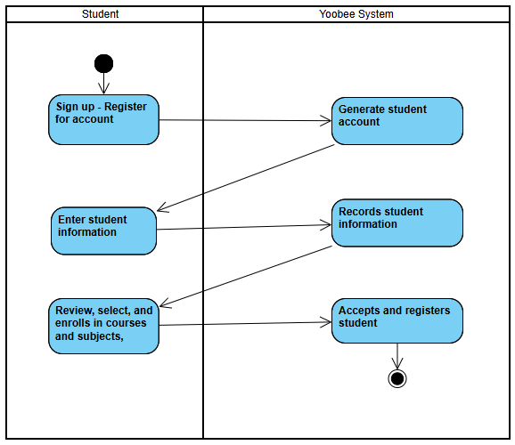

Use Case 2: **Enter Course Details**

