ESEMBLE

SD1  
 Group Accuracy TPR TNR FPR FNR

1 0 1 1 1 0 0

2 1 1 1 1 0 0

|  |
| --- |
|  |
| **F_Epis**  <dbl> | **F_Alea**  <dbl> | **F_Pred**  <dbl> |  |  |
| 1.08 | 1.2 | 1.19 |  |  |

SD2

Group Accuracy TPR TNR FPR FNR

1 0 0.88 0.8 0.96 0.04 0.2

2 1 1.00 1.0 1.00 0.00 0.0

|  |
| --- |
|  |
| **F_Epis**  <dbl> | **F_Alea**  <dbl> | **F_Pred**  <dbl> |  |  |
| 1.91 | 2.03 | 2.02 |  |  |

SD3

Group Accuracy TPR TNR FPR FNR

1 0 0.86 0.80 0.92 0.08 0.20

2 1 0.90 0.88 0.93 0.07 0.12

|  |
| --- |
|  |
| **F_Epis**  <dbl> | **F_Alea**  <dbl> | **F_Pred**  <dbl> |  |  |
| 1.71 | 1.68 | 1.68 |  |  |

BNN

SD1

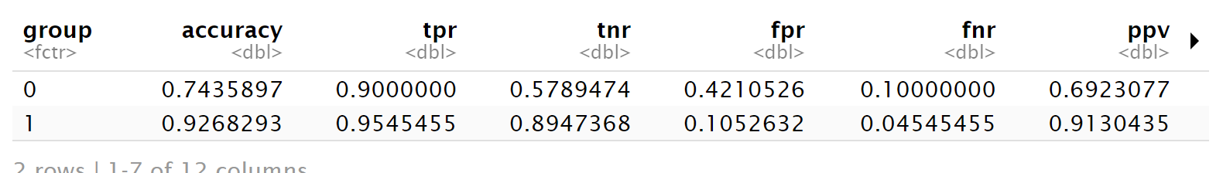

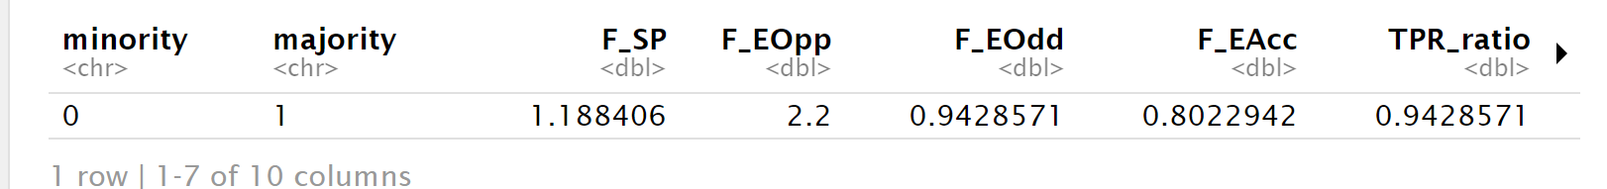

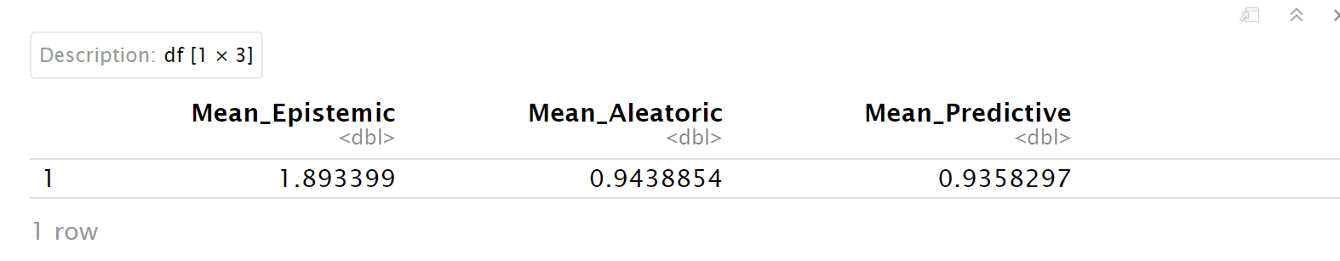

SD2

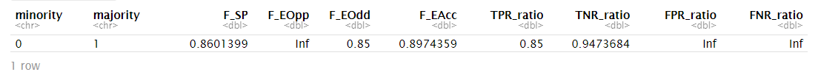



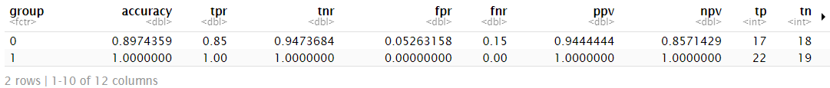

SD3

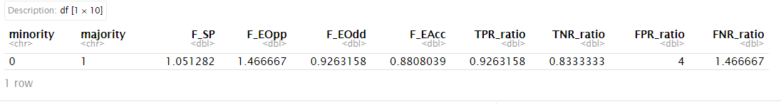



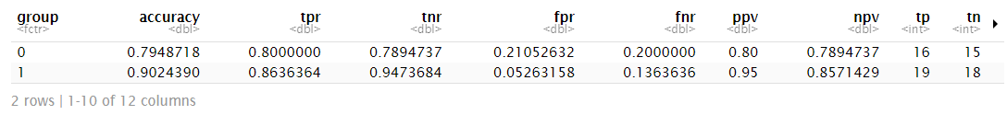

Bozza adjusted

SD1

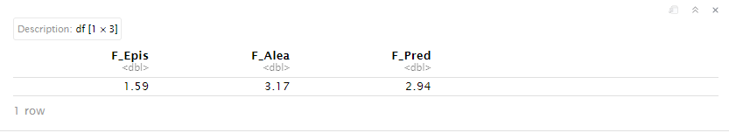

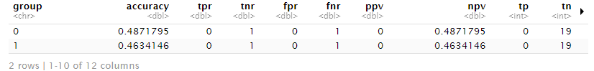

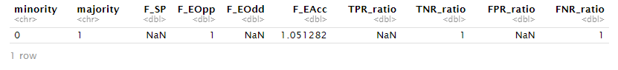

SD2