QR CODE

QR code is the trademark for a type of matrix barcode (or two-dimensional barcode). A barcode is a machine-readable optical label that contains information about the item to which is attached. In practice, a QR code often contain data for a locator, identifier, or tracker that point to a website or application. A QR code consists of black squares arranged in a square grid on a white background, which can be read by an imaging device such as a camera, and processed using Reed–Solomon error correction until the image can be appropriately interpreted. The required data is then extracted from patterns that are present in both horizontal and vertical components of the image.

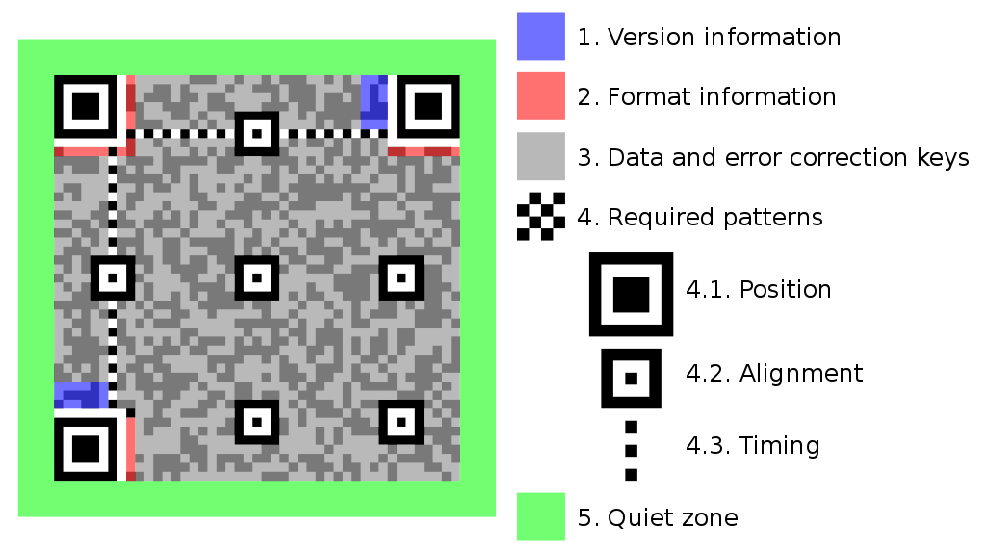

All QR codes have a square shape and include three square outlines in the bottom-left, top-left, and top-right corners. These square outlines define the orientation of the code. The dots within the QR code contain format and version information as well as the content itself. QR codes also include a certain level of error correction, defined as L, M, Q, or H. A low amount of error correction (L) allows the QR code to contain more content, while higher error correction (H) makes the code easier to scan.

QR codes have two significant benefits over traditional UPCs – the barcodes commonly used in retail packaging. First, since QR codes are two-dimensional, they can contain significantly more data than a one-dimensional UPC. While a UPC may include up to 25 different characters, a 33x33 (version 4) QR code, can contain 640 bits or 114 alphanumeric characters. A 177x177 (version 40) QR code can store up to 23,648 bits or 4,296 characters.

Another advantage of QR codes is that they can be scanned from a screen. Standard UPC scanners use a laser to scan barcodes, which means they typically cannot scan a UPC from a screen (like a smartphone). QR scanners, however, are designed to capture 2D images printed on paper or displayed on a screen. This makes it possible to use a QR code on your smartphone as a boarding pass at the airport or as a ticket for an event.

# How to create a QR Code

For create a QR code is not difficult. We will not create it manually but we will use tools available on the internet. The website for create QR Code is qr-code-monkey.com. A simple website allows you to create QR codes by changing the style to make it more aesthetically beautiful.

# QR Code Floors

We will have one QR Code for each floor for a total of four Codes.

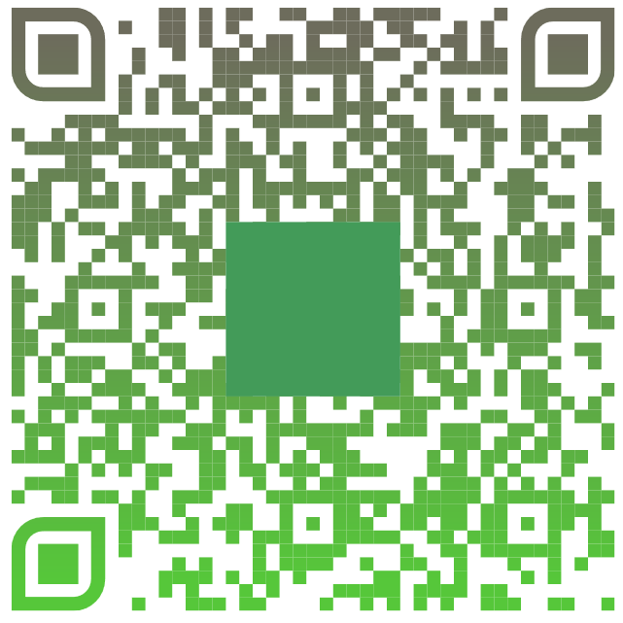

The green rectangle model represents the first floor.

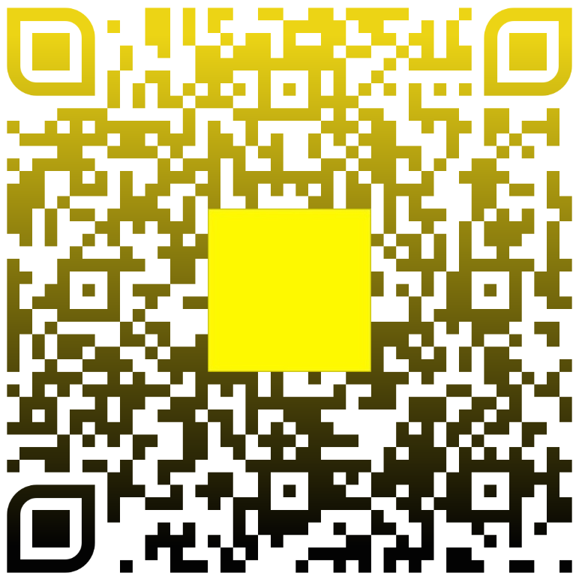

The yellow rectangle model represents the second floor.

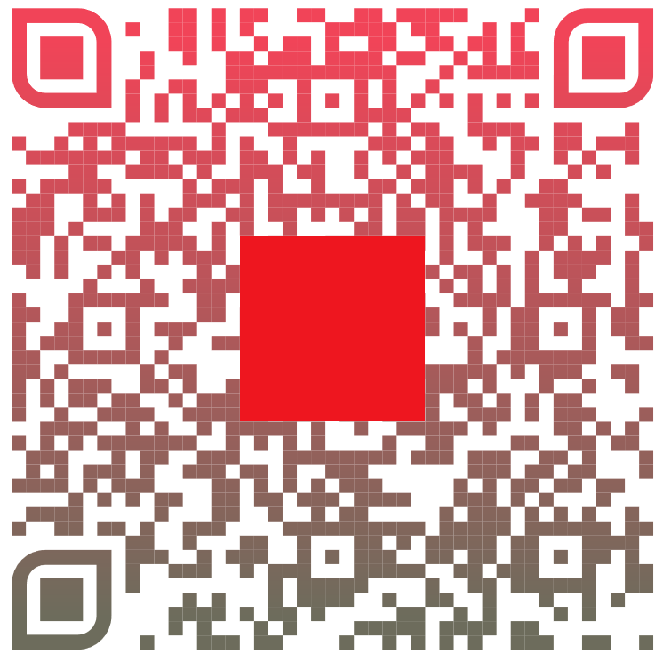

The red rectangle model represents the third floor.

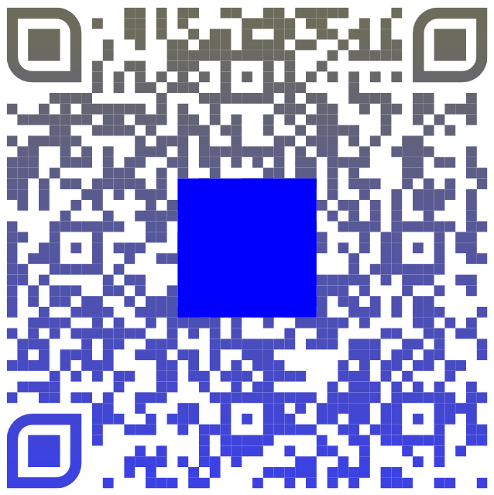

The blue rectangle model represents the four floor.