Plain Text Workflow

ED class

20 novembre 2022

# Intro

Go ahead, play around with the editor! Be sure to check out **bold** and *italic* styling, or even [links](https://google.com). You can type the Markdown syntax, use the toolbar, or use shortcuts like cmd-b or ctrl-b.

## Lists

Unordered lists can be started using the toolbar or by typing *, -, or +. Ordered lists can be started by typing 1..

#### Unordered

* Lists are a piece of cake
* They even auto continue as you type
* A double enter will end them
* Tabs and shift-tabs work too

#### Ordered

1. Numbered lists…
2. …work too!

Some sentence that needs citation [1] argues that too

## What about images?

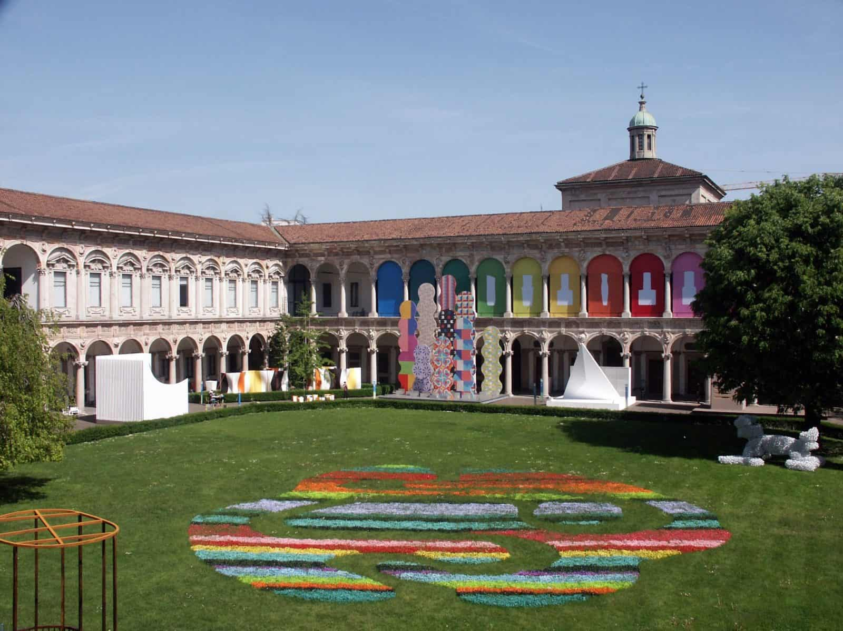

UNIMI

## Bibliography

[1] S. Barbon Junior, P. Ceravolo, E. Damiani, and G. Marques Tavares, “Evaluating trace encoding methods in process mining,” in *International symposium: From data to models and back*, 2020, pp. 174–189.