TABLEAU AUTOMATION

lAST uPDATED: August 7, 2018

STONY bROOK mEDICINE

Contents

Purpose 2

Scope 2

Assumptions 3

Workflow Diagram 4

Requirements 4

Python Package Requirements 5

How to Run 5

# Purpose

The purpose of this program is to create users, give site roles (Interactor or Publisher), and to add users to specific groups in Tableau. This program retrieves user information from Smartsheet.

# Scope

This program will:

1. 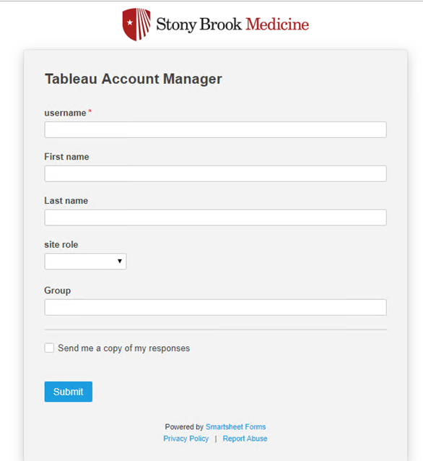Smartsheet will be populated by users filling out the Tableau Account Manager Form. Data will be stored in Smartsheet.

Link to Form: <https://app.smartsheet.com/b/form/87bd17ed09b9478e8b69f7d3d7ed3065>

1. Retrieve data from Smartsheet.
2. Create users written in Smartsheet with the proper site role. (Interactor or Publisher)
3. Add users to groups that are specified in Smartsheet.
4. Create a timestamp of when the user information is entered and after this program runs.
5. Create a status update on the spreadsheet.
6. Only run the task that are not completed.
   1. Smartsheet will indicate if the task has been completed with a green highlight over the row and when the “Task Column” is checked.
   2. 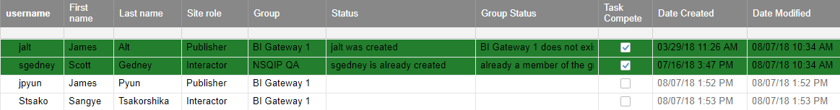Tasks will be automatically checked as complete after this program runs.

### Assumptions

1. Users that exist in SBM Active directory will be created on Tableau.
2. Users will be added to existing groups in Tableau.
3. Username must be filled (required field)
4. Group field must be filled (required field)
5. Site Role Must be filled (required field)
6. Group must exist in Tableau

# Workflow Diagram

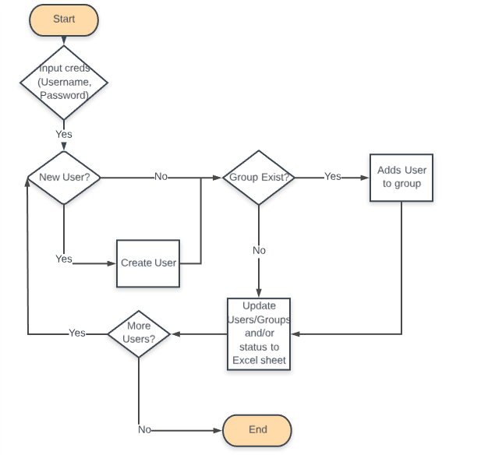

# Requirements

* Tableau Server 10.4 or higher - Must have server administrator credentials to run automation scripts.
* Python 3.3 or later is required to use automation scripts. Python Download link: <https://www.python.org/downloads>
* Tableau Server Client package in Python is also required to run these automation scripts. Pip is the recommended means of installing TSC.

Tableau server client python library link: <https://tableau.github.io/server-client-python/docs>.

* Pip Smartsheet - Smartsheet API library package in Python. Documentation link: <https://smartsheet-platform.github.io/api-docs/>.

### Python Package Requirements

Install the following packages into the console terminal. Use ‘pip install <package name>’ to install python packages.

1. argparse
2. smartsheet-python-sdk
3. tableauserverclient

# How to Run

To run this script input ‘python’ followed by the path directory in the console terminal where the API resides under. API is currently called Dev_tabsignin_api.py

Input

|  |
| --- |
| Terminal  python E:\Tableau_API\Tab_addusers.py |

Output (for now)

|  |
| --- |
| Terminal  Username: <username>  Password: <Hidden> |