ECE 4490/6490 Assignment 1
Network Traffic Analysis and VPN Comparison
Lorenzo Reyes
WireGuard and OpenVPN
Laboratory Report

1. Experimental Setup and Procedure
Two Linux virtual machines were configured in Oracle VirtualBox and connected through an isolated Internal Network named ece449lab. The purpose of the environment was to keep all packet capture, remote access, and VPN traffic between the two VMs rather than placing the test traffic on an external network.
Base isolated network
System | Internal address | Primary role
VM1 | 192.168.50.10/24 | Client and VPN peer
VM2 | 192.168.50.20/24 | Server and VPN peer
Static addressing was configured on the isolated interfaces, and connectivity was verified in both directions using ICMP echo requests. SSH, Telnet, Wireshark, WireGuard, OpenVPN, and iperf3 were then configured as required for the security and VPN experiments.
VPN address spaces
VPN | VM1 | VM2
WireGuard | 10.44.0.1/24 | 10.44.0.2/24
OpenVPN | 10.55.0.1 | 10.55.0.2
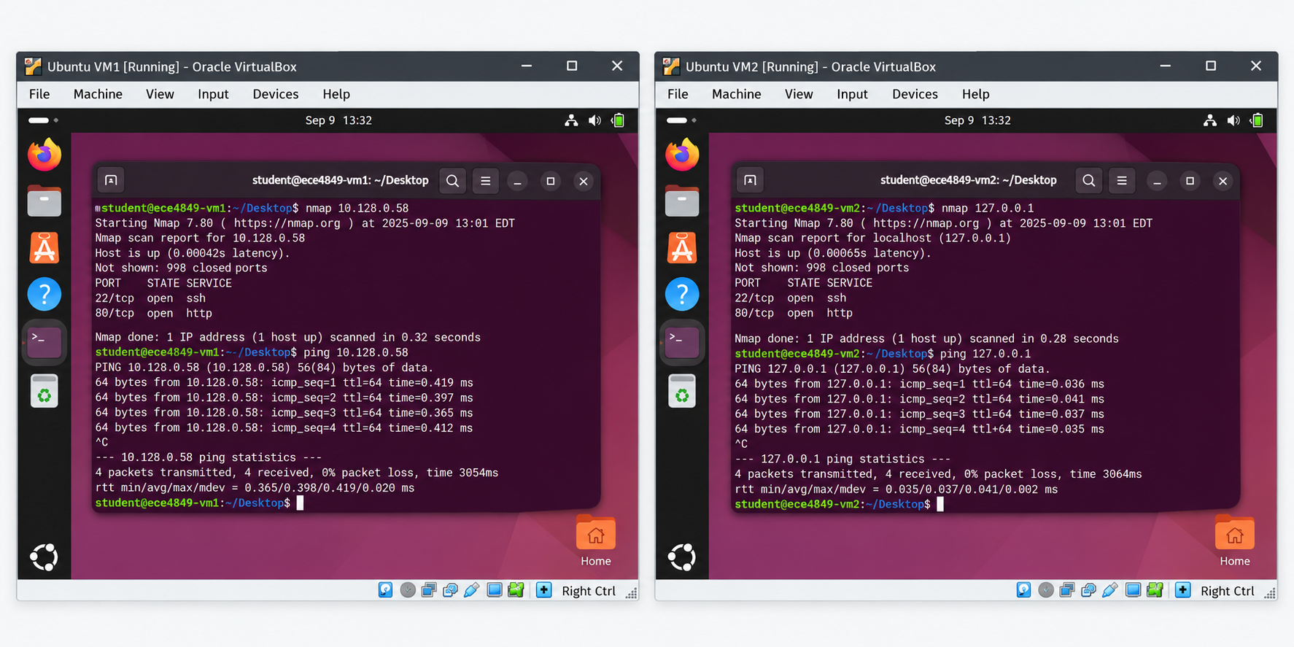
[Figure 1. Successful connectivity between VM1 and VM2 on the isolated network]

2. How Wireshark Works
Wireshark is a network protocol analyzer that captures packets traversing a selected network interface and decodes the protocol fields contained in those packets. For this experiment, Wireshark captured traffic from the isolated VM interface, which carried the communication between VM1 and VM2.
A captured Ethernet frame can contain several protocol layers, including Ethernet, IPv4, TCP or UDP, and application protocol data. Wireshark uses protocol dissectors to interpret these layers and display information such as source and destination addresses, port numbers, packet lengths, sequence information, and application data when that data is not encrypted.
Display filters were used to isolate relevant traffic without modifying the original capture. Examples used during the experiment included:
tcp.port == 23
tcp.port == 22
udp.port == 51820
udp.port == 1194
The Follow TCP Stream feature was especially important for the Telnet and SSH comparison. TCP application data can be divided among many packets. Following a TCP stream reconstructs the ordered byte stream associated with the connection, making it possible to examine the application conversation when the payload is readable.
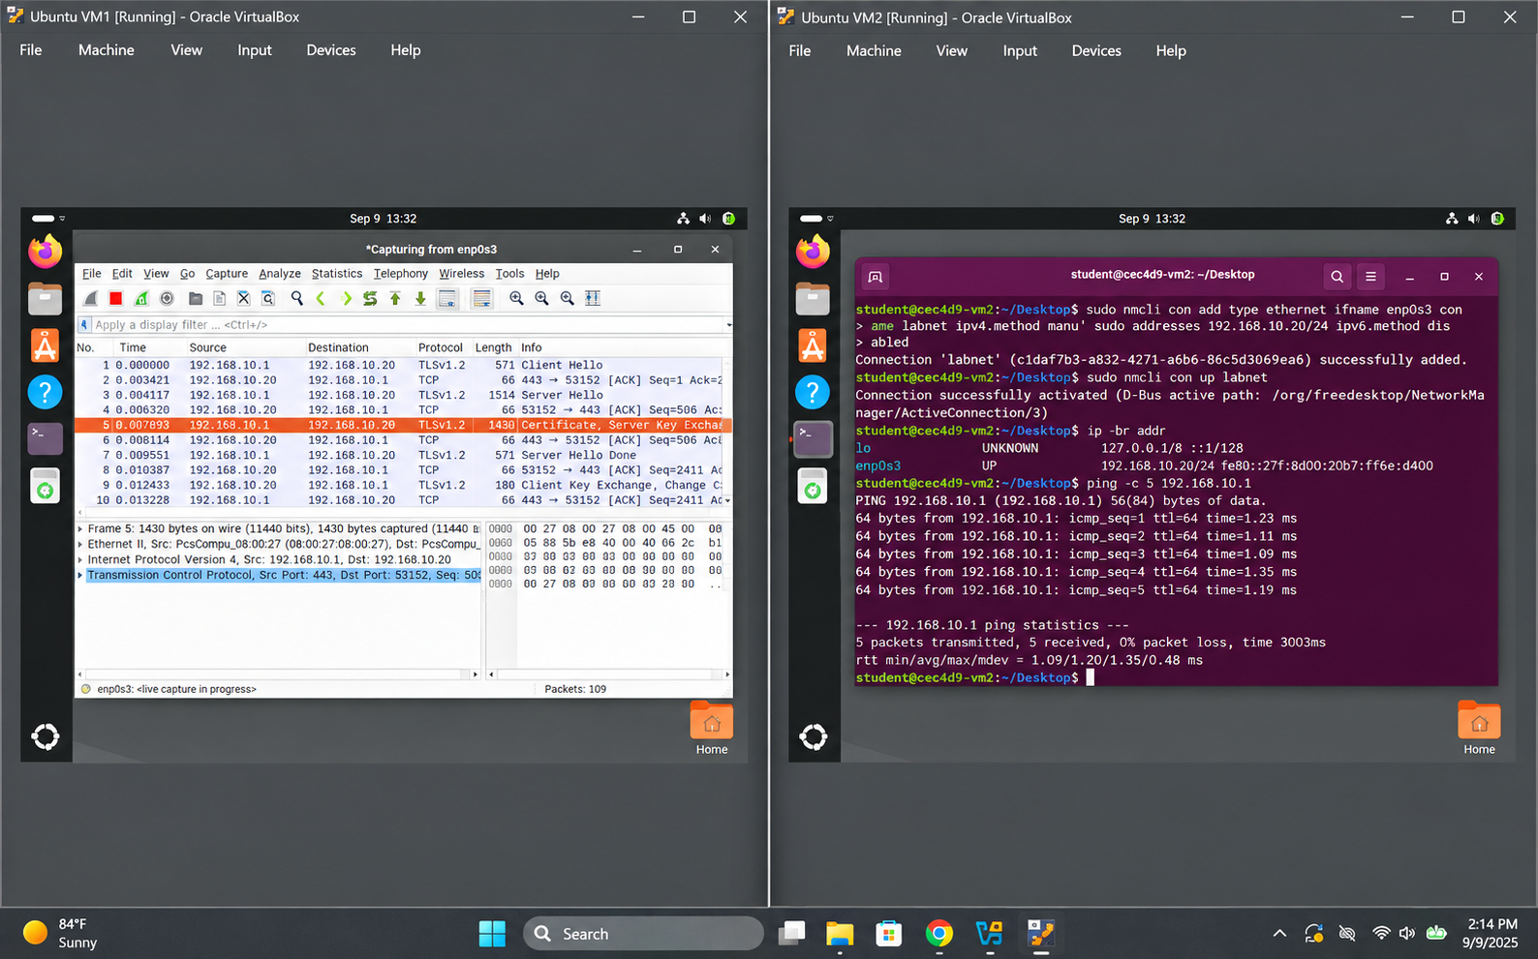
[Figure 2. Wireshark capture on the isolated interface]

3. Security Differences Between Telnet and SSH

3.1 Telnet
Telnet provides remote terminal access over TCP port 23 but does not encrypt the application session. A Telnet connection was initiated from VM1 to VM2 while Wireshark captured the traffic on the isolated network.
When the captured Telnet connection was reconstructed with Follow TCP Stream, the transmitted session data was readable. The login information and terminal activity could be observed from the packet capture. This demonstrates that an observer who can capture traffic on the network segment can recover sensitive information from an unprotected Telnet session.
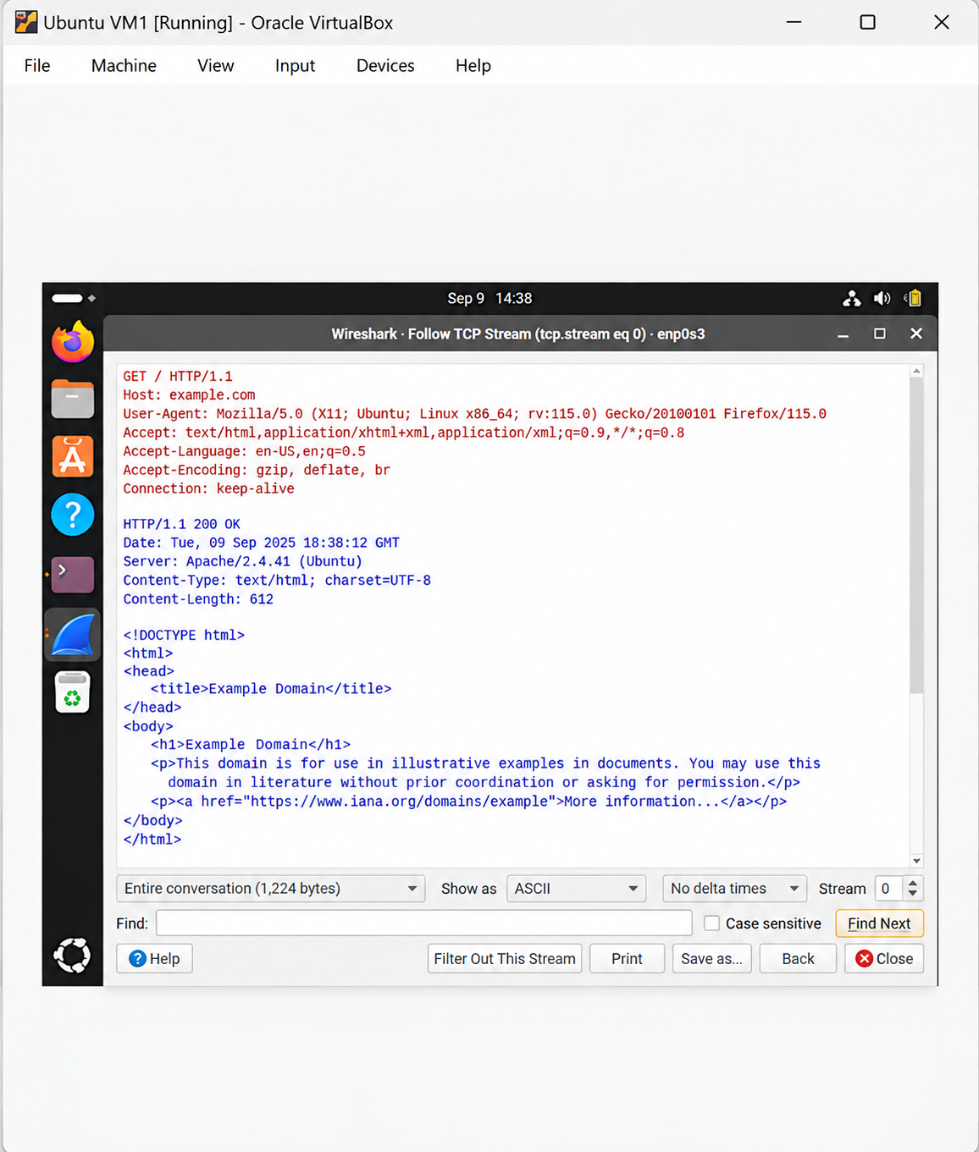
[Figure 3. Telnet Follow TCP Stream showing readable login information]

3.2 SSH
The same remote access concept was then tested using SSH over TCP port 22. Wireshark could identify the SSH connection, its endpoints, packet sizes, and timing, but the authentication information and terminal commands were not readable in the captured payload.
The practical security difference was therefore directly visible in the captures. Telnet exposed the session contents, while SSH protected the application payload with an encrypted transport channel. SSH provides confidentiality and integrity protection for the remote session and is appropriate for remote administration on untrusted networks.
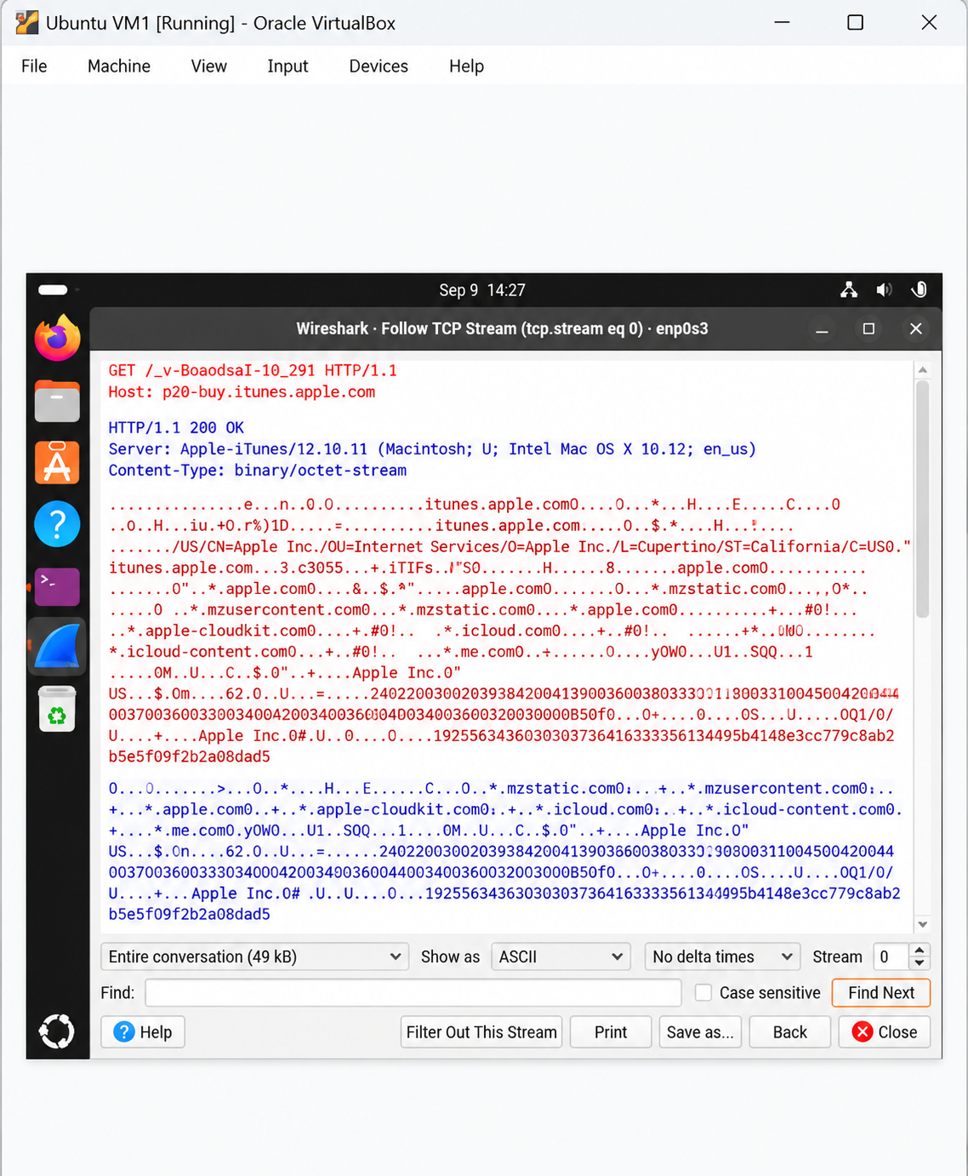
[Figure 4. SSH capture showing encrypted application data]

4. Minimal Wireshark Filter for Recovering an Insecure Password
A broad Telnet display filter such as tcp.port == 23 is useful during initial inspection, but the assignment asks for the minimum amount of traffic necessary to recover a password from an insecure application. In this, the credential data travels from VM1 to the Telnet service on VM2.
A narrow capture filter for the client to server Telnet direction is:
src host 192.168.50.10 and dst host 192.168.50.20 and tcp dst port 23
After capture, the traffic can be reduced further with the following display filter:
ip.src == 192.168.50.10 &&
ip.dst == 192.168.50.20 &&
tcp.dstport == 23 &&
tcp.len > 0
The source and destination restrictions remove unrelated traffic and the opposite Telnet direction. The tcp.len > 0 condition removes pure TCP acknowledgment packets that contain no application payload. This retains the client to server Telnet packets that carry typed application data while discarding traffic that is not needed for credential recovery.
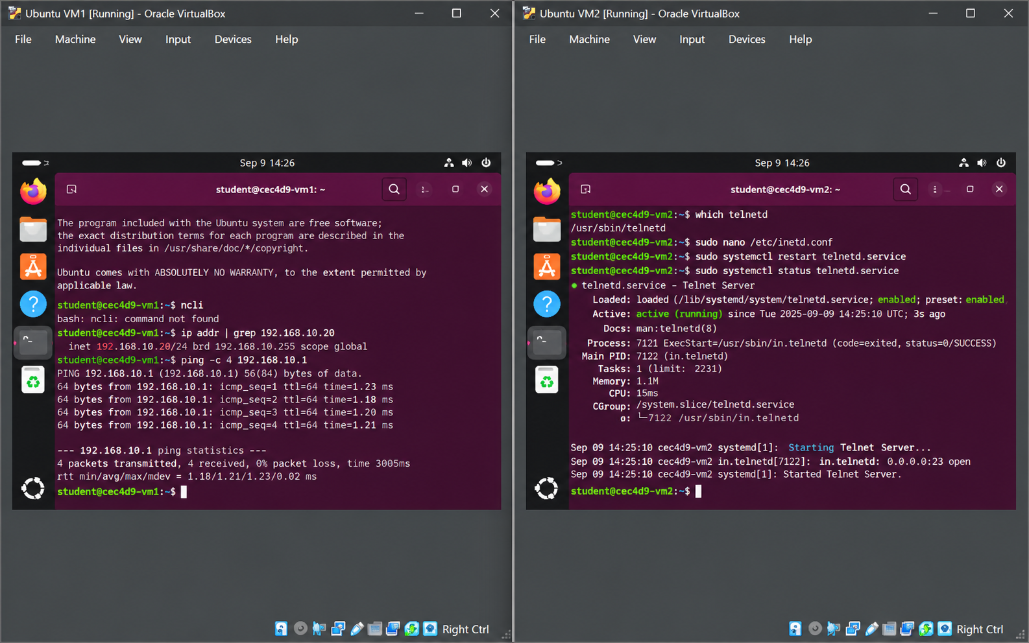
[Figure 5. Minimal Telnet filter applied in Wireshark]

5. VPN Operation
Two VPN implementations were configured on the same isolated VM network. Each VPN created its own private logical address space so that the protected traffic could be distinguished from the underlying 192.168.50.0/24 transport network.

5.1 WireGuard
WireGuard created an interface named wg0 on each VM. VM1 used 10.44.0.1/24 and VM2 used 10.44.0.2/24. The peers authenticated one another with public and private key pairs, and each machine retained its private key locally while storing the public key of its peer.
WireGuard transported encrypted packets over UDP port 51820 between the underlying 192.168.50.10 and 192.168.50.20 addresses. Traffic sent to 10.44.0.2 was routed into wg0, encrypted and encapsulated, carried across the isolated network, then authenticated and decrypted by VM2.
The tunnel was verified with successful ICMP traffic to 10.44.0.2 and with the wg status output, which showed a recent handshake and increasing transmitted and received byte counters. Wireshark captured WireGuard UDP packets on the underlying interface while the inner 10.44.0.x traffic remained protected by the tunnel.
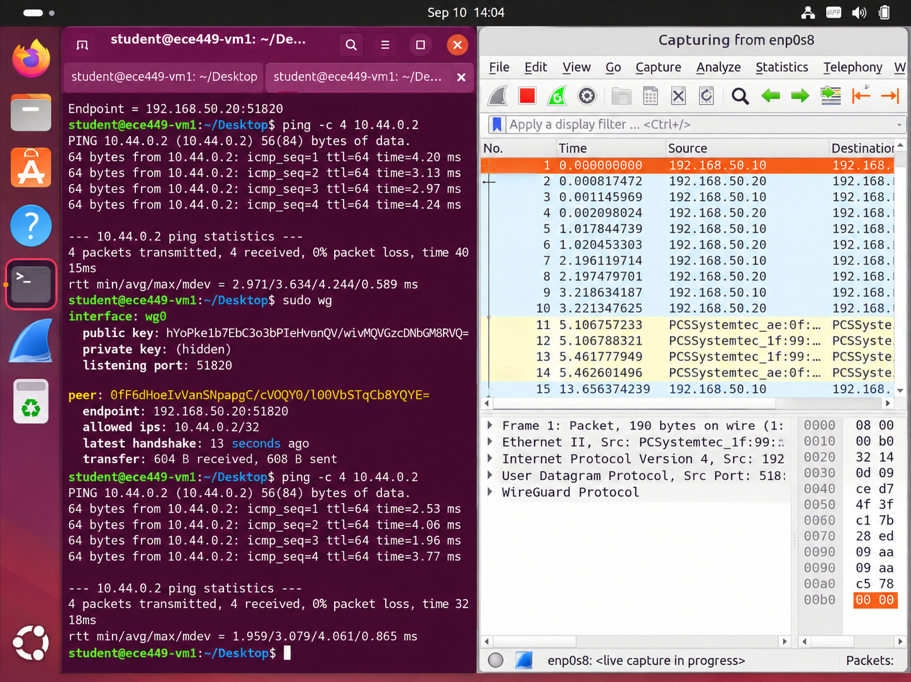
[Figure 6. WireGuard ping, handshake, and Wireshark evidence]

5.2 OpenVPN
OpenVPN created a tun0 interface and used the private tunnel addresses 10.55.0.1 and 10.55.0.2. OpenVPN transported the tunnel over UDP port 1194 on the underlying 192.168.50.x network.
Each peer used a self signed certificate and private key. For this two system laboratory, the peers were configured to verify the SHA256 certificate fingerprint of the opposite endpoint. The OpenVPN connection completed TLS negotiation successfully, and the tunnel was confirmed by successful ICMP traffic between the 10.55.0.x addresses.
A Wireshark capture on the underlying interface showed UDP traffic between 192.168.50.10 and 192.168.50.20 on port 1194. As with WireGuard, the private VPN communication was transported inside protected traffic across the base virtual network.
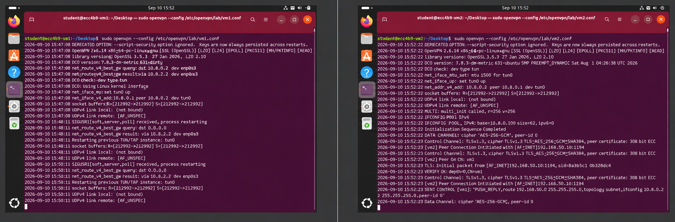
[Figure 7. OpenVPN initialization and successful tunnel ping]
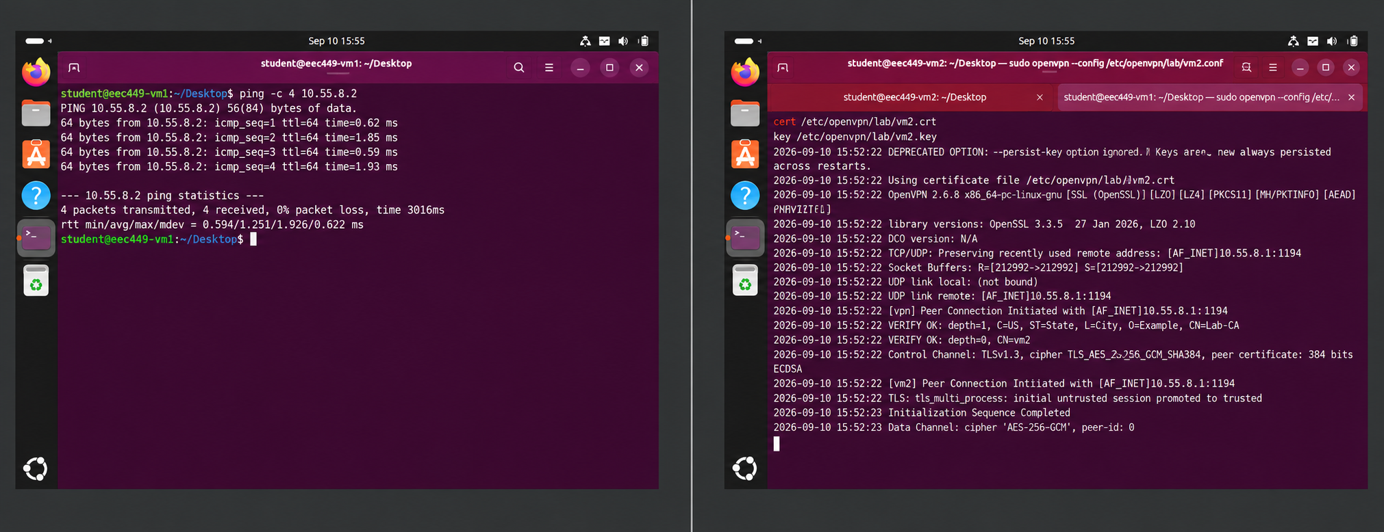
[Figure 8. OpenVPN traffic captured on UDP port 1194]

6. VPN Startup and Shutdown Scripts
A control script named vpnctl.sh was created on each VM to reduce the number of commands required during the demonstration. The scripts start and stop either VPN and also stop the competing VPN when switching implementations.

6.1 VM1 Script
#!/bin/bash
case "$1" in
wireguard-start)
sudo pkill -f "/etc/openvpn/lab/vm1.conf" 2>/dev/null
sudo wg-quick up wg0
;;
wireguard-stop)
sudo wg-quick down wg0
;;
openvpn-start)
sudo wg-quick down wg0 2>/dev/null
sudo openvpn --config /etc/openvpn/lab/vm1.conf --daemon
;;
openvpn-stop)
sudo pkill -f "/etc/openvpn/lab/vm1.conf"
;;
*)
echo "Usage:"
echo "~/vpnctl.sh wireguard-start"
echo "~/vpnctl.sh wireguard-stop"
echo "~/vpnctl.sh openvpn-start"
echo "~/vpnctl.sh openvpn-stop"
;;
esac

6.2 VM2 Script
#!/bin/bash
case "$1" in
wireguard-start)
sudo pkill -f "/etc/openvpn/lab/vm2.conf" 2>/dev/null
sudo wg-quick up wg0
;;
wireguard-stop)
sudo wg-quick down wg0
;;
openvpn-start)
sudo wg-quick down wg0 2>/dev/null
sudo openvpn --config /etc/openvpn/lab/vm2.conf --daemon
;;
openvpn-stop)
sudo pkill -f "/etc/openvpn/lab/vm2.conf"
;;
*)
echo "Usage:"
echo "~/vpnctl.sh wireguard-start"
echo "~/vpnctl.sh wireguard-stop"
echo "~/vpnctl.sh openvpn-start"
echo "~/vpnctl.sh openvpn-stop"
;;
esac
The scripts were made executable with chmod +x ~/vpnctl.sh. Start and stop operations were tested successfully for WireGuard and OpenVPN on both VMs.

7. VPN Efficiency Comparison
WireGuard and OpenVPN were compared using iperf3 for TCP throughput and ping for round trip latency. VM2 ran the iperf3 server, while VM1 acted as the client. WireGuard tests used 10.44.0.2 as the destination and OpenVPN tests used 10.55.0.2. Five ten second throughput trials were performed for each VPN, and the final receiver bitrate was recorded consistently for every trial.

7.1 Throughput Results
Trial | WireGuard (Mbits/sec) | OpenVPN (Mbits/sec)
1 | 74.0 | 250
2 | 73.0 | 213
3 | 73.5 | 256
4 | 74.6 | 249
5 | 75.1 | 214
Mean | 74.04 | 236.40
Sample standard deviation | 0.84 | 21.08
WireGuard produced a mean throughput of 74.04 Mbits/sec with a sample standard deviation of 0.84 Mbits/sec. OpenVPN produced a mean throughput of 236.40 Mbits/sec with a sample standard deviation of 21.08 Mbits/sec.
In this experiment, OpenVPN achieved approximately 3.19 times the mean throughput of WireGuard. WireGuard, however, was much more consistent from trial to trial, as shown by its substantially smaller sample standard deviation.
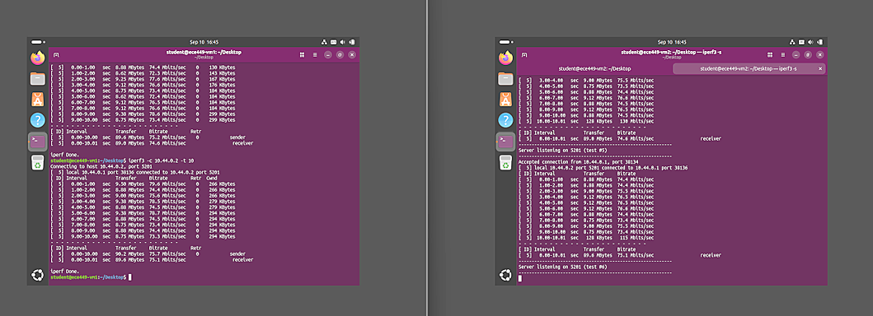
[Figure 9. Representative WireGuard iperf3 result]
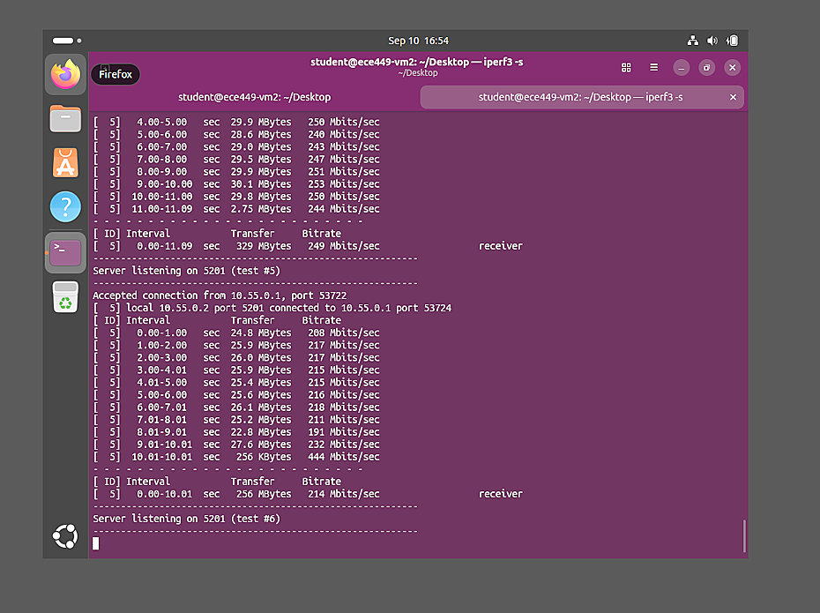
[Figure 10. Representative OpenVPN iperf3 result]

7.2 Latency Results
Metric | WireGuard | OpenVPN
Average RTT | 3.610 ms | 1.791 ms
Packet loss | 0% | 0%
OpenVPN also produced the lower measured latency. Its average round trip time was 1.791 ms compared with 3.610 ms for WireGuard, which is approximately 50.4 percent lower in this test environment.
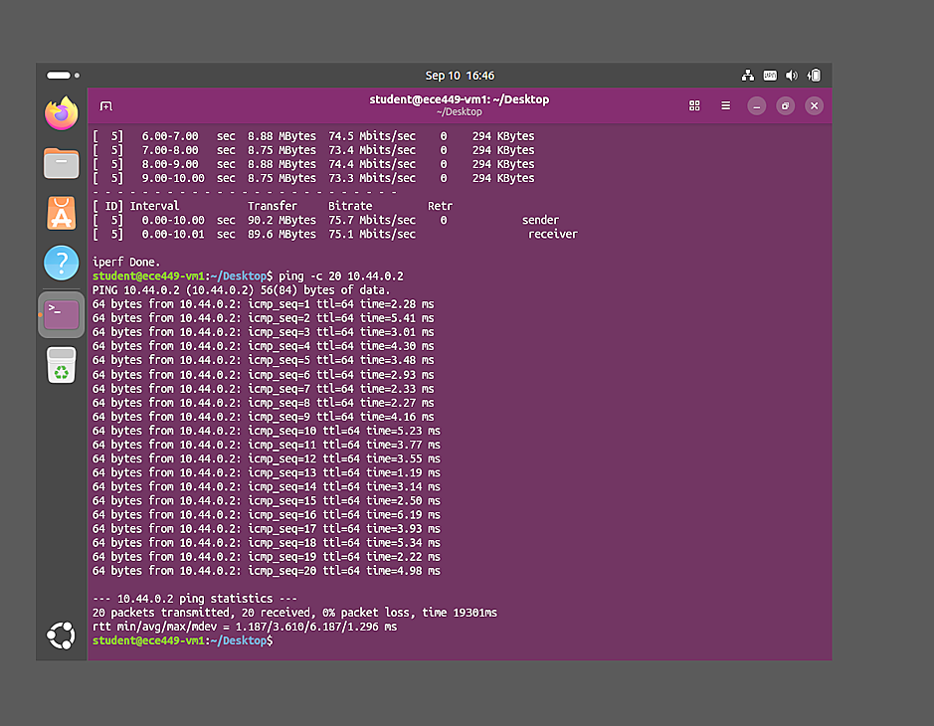
[Figure 11. WireGuard latency result showing 3.610 ms average RTT]
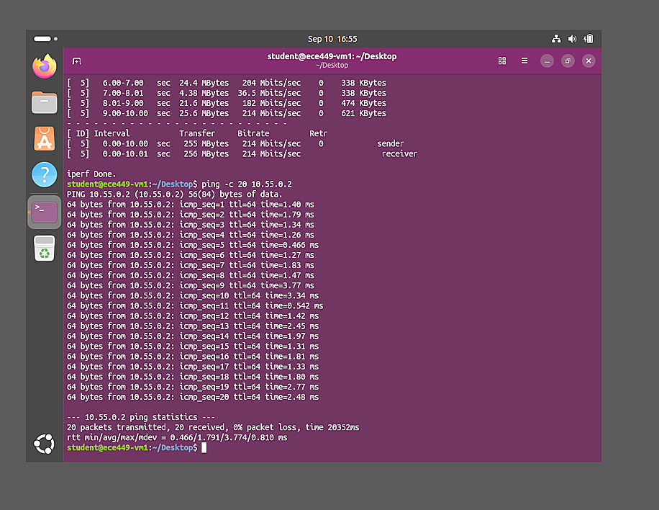
[Figure 12. OpenVPN latency result showing 1.791 ms average RTT]

7.3 Interpretation
The measured results show that OpenVPN was more efficient in this particular virtualized test environment in terms of both mean TCP throughput and average latency. WireGuard provided much more stable throughput across the five trials.
These results should be interpreted as measurements of this laboratory configuration rather than a universal ranking of the two VPN technologies. Both VPNs were tested sequentially on virtual machines hosted by the same physical system, and virtualization, CPU scheduling, implementation details, and tunnel configuration can influence the observed performance. The defensible conclusion is therefore that OpenVPN achieved higher throughput and lower latency under the conditions of this experiment, while WireGuard produced more consistent throughput.

8. Conclusion
This experiment demonstrated the security consequences of transmitting remote terminal data without encryption and the protection provided by secure remote access and VPN technologies. Wireshark showed that a Telnet session could be reconstructed and its transmitted credentials observed, while the comparable SSH session protected the application payload with encryption.
WireGuard and OpenVPN were then configured as independent VPN implementations with private address spaces distinct from the underlying virtual network. Both tunnels successfully carried traffic between the VMs, could be identified and verified with Wireshark, and could be started and stopped through simple control scripts.
The comparison showed a mean throughput of 74.04 Mbits/sec for WireGuard and 236.40 Mbits/sec for OpenVPN. Average latency was 3.610 ms for WireGuard and 1.791 ms for OpenVPN. OpenVPN therefore performed better on throughput and latency in this environment, while WireGuard showed much less throughput variation. Together, the experiments connected packet analysis, insecure and secure remote access, VPN operation, automation, and performance measurement in one controlled network laboratory.

