# How to start the application:

Copy the zip file on your Desktop. Unzip the file and run the file “Friburg-Experiment.exe”.

#### Windows 8 Smart Screen

It might be that the file is detected as “suspicious”.

If the screen looks like below click on **“More Info”** and “**Run Anyway**”.

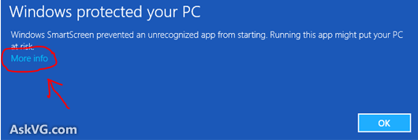

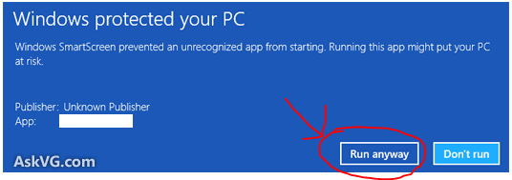

# How to change the experimental condition:

Click on the gear in the welcome page, then type **0101** as pin and change the condition.

# What is the structure of the log file

Log files are stored in the folder **logs**. For each experiment two files are created, one for the experiment and one for the final questionnaire.

## Experiment log file structure

The file has csv extension and can be imported in Excel .

* First row contains the user action. Actions are
  + **Reading_Instructions:** the user is reading the instruction page
  + **Start_experiment:** the user has started the experiment
  + **Select_exercise:** the user has clicked on an exercise. Usually this action is preceded by the action *Exercise_answer*
  + **Exercise_answer:** this action is written to record the answers of the user for the current exercise.
  + **Select_Avatar:** the user has selected a new avatar or modified the secondary icons (livre, friends, telephone, sport)
  + **Update_Online_Avatars:** a new avatar has appeared in the top banner (only in avatar experimental conditions)
  + **Finish:** the user has clicked on “Deconnexion”
* Second row contains the time since the user started reading the instruction.
* Third row contains the time since the user started the experiment.
* Forth row contains the last avatar appeared in the top banner (only in avatar experimental conditions)
* 5th row : the id of the current avatar selected by the user. The id are listed below.
* 6th,7th,8th,9th rows contains “true” when the user adds respectively the friend, livre, sport and telephone mini-icons or “false” when those are not enabled.
* 10th row: the current exercise the user is working on
* 11th row: “true” if the current exercise has been completed, otherwise “false”;
* 12Th row: the answer to the current exercise. More details the format below.

### Avatar Ids

|  |  |  |  |  |
| --- | --- | --- | --- | --- |
| 1.png  **id:**1 | 2.png  **id:2** | 3.png  **id:3** | 4.png **Id:4** | 5.png  **id:5** |
| 6.png  **id:6** | 7.png  **id:7** | 8.png  **id:8** | 9.png  **id:9** | 10.png **id:10** |

### Answers format

* **Exercise tres facile:** the six answers are stored with this format **{q1-q2-q3-q4-q5-q6}**
* **Exercise facile:** here answers are pairs of antonyms. Those are stored as **{w1-w2}{w3-w4}{w5-w6}….** **{w19-w20}. Example {dark-light}{hot-cold}{black-white}**
* **Exercise difficile:** the single answer is stored as it is.
* **Exercise tres difficile: :** the four answers are stored with this format **{q1-q2-q3-q4 }**

## Questionnaire file structure

The file has csv extension and can be imported in Excel . It is just a 3 column table, with the questions and the answers (third column is for optional extra info such as “Niveau en français: Autre”).