# How to start the application:

Copy the zip file on your Desktop. Unzip the file and run the file **“Friburg-Experiment_Math.exe” for the math condition** and **“Friburg-Experiment_French.exe” for the French condition**.

#### Windows 8 Smart Screen

It might be that the file is detected as “suspicious”.

If the screen looks like below click on **“More Info”** and “**Run Anyway**”.

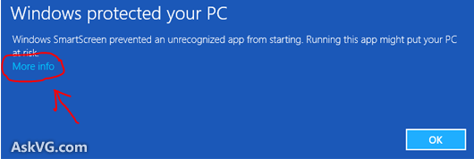

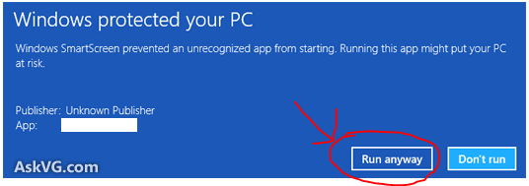

# What is the structure of the log file

Log files are stored in the folder **logs**. For each experiment two files are created, one for the experiment and one for the final questionnaire.

## Experiment log file structure

The file has csv extension and can be imported in Excel .

* First Column contains the code of the student
* Second column contains the user action. Actions are
  + **Reading_Instructions:** the user is reading the instruction page
  + **Start_experiment:** the user has started an experiment step
  + **Select_exercise:** the user has clicked on an exercise. Usually this action is preceded by the action *Exercise_answer*
  + **Exercise_answer:** this action is written to record the answers of the user for the current exercise.
  + **Select_Avatar:** the user has selected a new avatar or modified the secondary icons (livre, friends, telephone, sport)
  + **Update_Online_Avatars:** a new avatar has appeared in the top banner (only in avatar experimental conditions)
  + **Finish:** the user has clicked on “Deconnexion” or “Passer à l’étape suivante”
  + **Typing:** the user is typing something in text field(details in the 13th column )
  + **Mouse_Select:** the user is clicking on a text field (usually for typing something afterwards, details in the 13th column)
  + **Scrolling_Avatars :** the user is scrolling the avatars list. This action records events every 10 seconds, which means that if the user is scrolling up to 10 seconds, there will be only one entry in the log file; if the user is scrolling up to 20 seconds, there will be two entries and so on.
* Third Column contains the condition either 1 or 2
* Forth Column contains the current step: 0 for instruction, 1 for Math, 2 and 3 for French
* 5th column contains the time since the user started reading the instruction.
* 6th column contains the time since the user started the experiment.
* 7th column is always empty
* 8th column : the id of the current avatar selected by the user. The id are listed below.
* 9th,10th,11th,12th columns contains “true” when the user adds respectively the friend, livre, sport and telephone mini-icons or “false” when those are not enabled.
* 13th column: the current exercise the user is working on.
* 14th column: “true” if the current exercise has been completed, otherwise “false”;
* 15Th column: the answer to the current exercise. More details the format below;
* 16Th column: the details of the actions **Typing** and **Mouse_Select** . If the exercise contains only on filed for the answer, this column is empty (such as for the exercise about the clock); if there are multiple text field, the columns contains the name of the text field(for example, Question_1 for the exercise of the matrix). The **Typing** action records events from keyboard every 5 seconds, which means that if the user is typing something up to 5 seconds, there will be only one entry in the log file; if the user is typing something up to 10 seconds, there will be two entries and so on. For the exercise about the number matrix the details include what the user has typed so far.

### Avatar Ids

|  |  |  |  |  |
| --- | --- | --- | --- | --- |
| 1.png  **id:**1 | 2.png  **id:2** | 3.png  **id:3** | 4.png **Id:4** | 5.png  **id:5** |
| 6.png  **id:6** | 7.png  **id:7** | 8.png  **id:8** | 9.png  **id:9** | 10.png **id:10** |

### Answers format

#### French Condition

* **Exercise blu (tres facile,** ***intruder*):** the ten answers are stored with this format **q1-q2-q3-q4-q5-q6- q7-q8-q9-q10** . Example: *S’immobiliser- embarrassé- aggraver* etc
* **Exercise black( tres difficile, *Ecris la suite de l’histoire*):** just the text, no special format. Note: the special word “<br>” means an indent (new paragraph) at that point.

#### Math Condition

* **Exercise blu (tres facile,** ***fractions*):** the 6 answers are stored with this format **q1-q2-q3-q4-q5-q6** . Example: *2/3-3/7- 4/5* etc
* **Exercise green (facile, *clock*):** just the text, no special format . Note: the special word “<br>” means an indent (new paragraph) at that point.