Laboratorio 10 - Entrega de resultados
Generado el 15/05/2026 18:38. Los MAE de diferencias estan reconstruidos sobre la serie original.
Resumen MAE
Modelo | Mejor lab9 original | MAE lab9 | Mejor lab10 diferencias | MAE lab10 | Mejora?
Recta regresion | PH=12, lr=0.05, zscore | 14.041879 | PH=24, lr=0.03, minmax | 7.189529 | Si
kNN correlacion | PH=48, k=5 | 6.845120 | PH=24, k=5 | 11.389868 | No
kNN heuristica | PH=48, k=5 | 6.491298 | PH=24, k=5 | 15.821450 | No

MAE completos
Recta de regresion
PH | Tasa | Normalizacion | MAE val | MAE test | MAE lab9
12 | 1e-07 | ninguna | 21.095259 | 23.025424 | 16.807851
24 | 1e-07 | ninguna | 19.776149 | 21.731748 | 13.816402
12 | 0.03 | minmax | 10.014451 | 13.176111 | 14.305248
24 | 0.03 | minmax | 10.001011 | 7.189529 | 12.093180
12 | 0.05 | zscore | 11.688460 | 12.553016 | 14.041879
24 | 0.05 | zscore | 13.271445 | 7.145261 | 8.826340

kNN correlacion
PH | K | MAE val | MAE test | MAE lab9
6 | 1 | 28.536588 | 15.497607 | 21.460553
6 | 3 | 48.960606 | 55.561542 | 24.942604
6 | 5 | 47.032857 | 62.136979 | 21.023249
12 | 1 | 17.306495 | 15.497607 | 21.460553
12 | 3 | 12.675059 | 15.177043 | 22.220398
12 | 5 | 29.780740 | 12.075518 | 18.774739
24 | 1 | 11.778852 | 18.786525 | 6.418939
24 | 3 | 13.910283 | 14.894628 | 20.264276
24 | 5 | 8.742223 | 11.389868 | 19.523289
48 | 1 | 11.738374 | 7.915700 | 6.418939
48 | 3 | 9.808703 | 8.434832 | 6.231750
48 | 5 | 11.586009 | 17.357560 | 6.845120

kNN heuristica
PH | K | MAE val | MAE test | MAE lab9
24 | 1 | 9.189521 | 8.797374 | -
24 | 3 | 5.946675 | 28.109301 | -
24 | 5 | 5.740203 | 15.821450 | -

Deteccion de anomalias
Pares correlacionados en el dia 1 con umbral 0.8: 40.
Umbral ruptura | Separacion maxima | Duracion minima | Dia | Variable 1 | Variable 2 | Inicio | Fin | Duracion
0.15 | 15 | 3 | 2 | V_0 | V_1 | 585 | 738 | 154
0.15 | 15 | 3 | 2 | V_0 | V_2 | 585 | 738 | 154
0.15 | 15 | 3 | 2 | V_1 | V_3 | 584 | 739 | 156
0.15 | 15 | 3 | 2 | V_1 | V_4 | 584 | 740 | 157
0.15 | 15 | 3 | 2 | V_2 | V_3 | 585 | 740 | 156
0.15 | 15 | 3 | 2 | V_2 | V_4 | 584 | 740 | 157
0.15 | 15 | 3 | 3 | V_5 | V_6 | 245 | 415 | 171
0.15 | 15 | 3 | 3 | V_5 | V_7 | 242 | 415 | 174
0.15 | 15 | 3 | 3 | V_6 | V_8 | 245 | 415 | 171
0.15 | 15 | 3 | 3 | V_6 | V_9 | 242 | 413 | 172
0.15 | 15 | 3 | 3 | V_7 | V_8 | 242 | 415 | 174
0.15 | 15 | 3 | 3 | V_7 | V_9 | 241 | 413 | 173
0.15 | 15 | 3 | 3 | V_10 | V_11 | 1138 | 1314 | 177
0.15 | 15 | 3 | 3 | V_10 | V_12 | 1139 | 1314 | 176
0.15 | 15 | 3 | 3 | V_11 | V_13 | 1138 | 1314 | 177
0.15 | 15 | 3 | 3 | V_11 | V_14 | 1138 | 1314 | 177
0.15 | 15 | 3 | 3 | V_12 | V_13 | 1138 | 1314 | 177
0.15 | 15 | 3 | 3 | V_12 | V_14 | 1138 | 1314 | 177
0.15 | 15 | 3 | 4 | V_15 | V_16 | 724 | 862 | 139
0.15 | 15 | 3 | 4 | V_15 | V_17 | 722 | 863 | 142
0.15 | 15 | 3 | 4 | V_16 | V_18 | 724 | 864 | 141
0.15 | 15 | 3 | 4 | V_16 | V_19 | 722 | 862 | 141
0.15 | 15 | 3 | 4 | V_17 | V_18 | 724 | 865 | 142
0.15 | 15 | 3 | 4 | V_17 | V_19 | 721 | 862 | 142
0.15 | 15 | 5 | 2 | V_0 | V_1 | 585 | 738 | 154
0.15 | 15 | 5 | 2 | V_0 | V_2 | 585 | 738 | 154
0.15 | 15 | 5 | 2 | V_1 | V_3 | 584 | 739 | 156
0.15 | 15 | 5 | 2 | V_1 | V_4 | 584 | 740 | 157
0.15 | 15 | 5 | 2 | V_2 | V_3 | 585 | 740 | 156
0.15 | 15 | 5 | 2 | V_2 | V_4 | 584 | 740 | 157
0.15 | 15 | 5 | 3 | V_5 | V_6 | 245 | 415 | 171
0.15 | 15 | 5 | 3 | V_5 | V_7 | 242 | 415 | 174
0.15 | 15 | 5 | 3 | V_6 | V_8 | 245 | 415 | 171
0.15 | 15 | 5 | 3 | V_6 | V_9 | 242 | 413 | 172
0.15 | 15 | 5 | 3 | V_7 | V_8 | 242 | 415 | 174
0.15 | 15 | 5 | 3 | V_7 | V_9 | 241 | 413 | 173
0.15 | 15 | 5 | 3 | V_10 | V_11 | 1138 | 1314 | 177
0.15 | 15 | 5 | 3 | V_10 | V_12 | 1139 | 1314 | 176
0.15 | 15 | 5 | 3 | V_11 | V_13 | 1138 | 1314 | 177
0.15 | 15 | 5 | 3 | V_11 | V_14 | 1138 | 1314 | 177
0.15 | 15 | 5 | 3 | V_12 | V_13 | 1138 | 1314 | 177
0.15 | 15 | 5 | 3 | V_12 | V_14 | 1138 | 1314 | 177
0.15 | 15 | 5 | 4 | V_15 | V_16 | 724 | 862 | 139
0.15 | 15 | 5 | 4 | V_15 | V_17 | 722 | 863 | 142
0.15 | 15 | 5 | 4 | V_16 | V_18 | 724 | 864 | 141
0.15 | 15 | 5 | 4 | V_16 | V_19 | 722 | 862 | 141
0.15 | 15 | 5 | 4 | V_17 | V_18 | 724 | 865 | 142
0.15 | 15 | 5 | 4 | V_17 | V_19 | 721 | 862 | 142
0.15 | 20 | 3 | 2 | V_0 | V_1 | 585 | 738 | 154
0.15 | 20 | 3 | 2 | V_0 | V_2 | 585 | 738 | 154
0.15 | 20 | 3 | 2 | V_1 | V_3 | 584 | 739 | 156
0.15 | 20 | 3 | 2 | V_1 | V_4 | 584 | 740 | 157
0.15 | 20 | 3 | 2 | V_2 | V_3 | 585 | 740 | 156
0.15 | 20 | 3 | 2 | V_2 | V_4 | 584 | 740 | 157
0.15 | 20 | 3 | 3 | V_5 | V_6 | 245 | 415 | 171
0.15 | 20 | 3 | 3 | V_5 | V_7 | 242 | 415 | 174
0.15 | 20 | 3 | 3 | V_6 | V_8 | 245 | 415 | 171
0.15 | 20 | 3 | 3 | V_6 | V_9 | 242 | 413 | 172
0.15 | 20 | 3 | 3 | V_7 | V_8 | 242 | 415 | 174
0.15 | 20 | 3 | 3 | V_7 | V_9 | 241 | 413 | 173
0.15 | 20 | 3 | 3 | V_10 | V_11 | 1138 | 1314 | 177
0.15 | 20 | 3 | 3 | V_10 | V_12 | 1139 | 1314 | 176
0.15 | 20 | 3 | 3 | V_11 | V_13 | 1138 | 1314 | 177
0.15 | 20 | 3 | 3 | V_11 | V_14 | 1138 | 1314 | 177
0.15 | 20 | 3 | 3 | V_12 | V_13 | 1138 | 1314 | 177
0.15 | 20 | 3 | 3 | V_12 | V_14 | 1138 | 1314 | 177
0.15 | 20 | 3 | 4 | V_15 | V_16 | 724 | 862 | 139
0.15 | 20 | 3 | 4 | V_15 | V_17 | 722 | 863 | 142
0.15 | 20 | 3 | 4 | V_16 | V_18 | 724 | 864 | 141
0.15 | 20 | 3 | 4 | V_16 | V_19 | 722 | 862 | 141
0.15 | 20 | 3 | 4 | V_17 | V_18 | 724 | 865 | 142
0.15 | 20 | 3 | 4 | V_17 | V_19 | 721 | 862 | 142
0.15 | 20 | 5 | 2 | V_0 | V_1 | 585 | 738 | 154
0.15 | 20 | 5 | 2 | V_0 | V_2 | 585 | 738 | 154
0.15 | 20 | 5 | 2 | V_1 | V_3 | 584 | 739 | 156
0.15 | 20 | 5 | 2 | V_1 | V_4 | 584 | 740 | 157
0.15 | 20 | 5 | 2 | V_2 | V_3 | 585 | 740 | 156
0.15 | 20 | 5 | 2 | V_2 | V_4 | 584 | 740 | 157
0.15 | 20 | 5 | 3 | V_5 | V_6 | 245 | 415 | 171
0.15 | 20 | 5 | 3 | V_5 | V_7 | 242 | 415 | 174
0.15 | 20 | 5 | 3 | V_6 | V_8 | 245 | 415 | 171
0.15 | 20 | 5 | 3 | V_6 | V_9 | 242 | 413 | 172
0.15 | 20 | 5 | 3 | V_7 | V_8 | 242 | 415 | 174
0.15 | 20 | 5 | 3 | V_7 | V_9 | 241 | 413 | 173
0.15 | 20 | 5 | 3 | V_10 | V_11 | 1138 | 1314 | 177
0.15 | 20 | 5 | 3 | V_10 | V_12 | 1139 | 1314 | 176
0.15 | 20 | 5 | 3 | V_11 | V_13 | 1138 | 1314 | 177
0.15 | 20 | 5 | 3 | V_11 | V_14 | 1138 | 1314 | 177
0.15 | 20 | 5 | 3 | V_12 | V_13 | 1138 | 1314 | 177
0.15 | 20 | 5 | 3 | V_12 | V_14 | 1138 | 1314 | 177
0.15 | 20 | 5 | 4 | V_15 | V_16 | 724 | 862 | 139
0.15 | 20 | 5 | 4 | V_15 | V_17 | 722 | 863 | 142
0.15 | 20 | 5 | 4 | V_16 | V_18 | 724 | 864 | 141
0.15 | 20 | 5 | 4 | V_16 | V_19 | 722 | 862 | 141
0.15 | 20 | 5 | 4 | V_17 | V_18 | 724 | 865 | 142
0.15 | 20 | 5 | 4 | V_17 | V_19 | 721 | 862 | 142
0.0 | 15 | 3 | 2 | V_0 | V_1 | 596 | 736 | 141
0.0 | 15 | 3 | 2 | V_0 | V_2 | 596 | 736 | 141
0.0 | 15 | 3 | 2 | V_1 | V_3 | 595 | 736 | 142
0.0 | 15 | 3 | 2 | V_1 | V_4 | 595 | 736 | 142
0.0 | 15 | 3 | 2 | V_2 | V_3 | 595 | 736 | 142
0.0 | 15 | 3 | 2 | V_2 | V_4 | 590 | 736 | 147
0.0 | 15 | 3 | 3 | V_5 | V_6 | 249 | 412 | 164
0.0 | 15 | 3 | 3 | V_5 | V_7 | 248 | 410 | 163
0.0 | 15 | 3 | 3 | V_6 | V_8 | 249 | 413 | 165
0.0 | 15 | 3 | 3 | V_6 | V_9 | 248 | 410 | 163
0.0 | 15 | 3 | 3 | V_7 | V_8 | 248 | 413 | 166
0.0 | 15 | 3 | 3 | V_7 | V_9 | 245 | 409 | 165
0.0 | 15 | 3 | 3 | V_10 | V_11 | 1140 | 1311 | 172
0.0 | 15 | 3 | 3 | V_10 | V_12 | 1143 | 1310 | 168
0.0 | 15 | 3 | 3 | V_11 | V_13 | 1139 | 1309 | 171
0.0 | 15 | 3 | 3 | V_11 | V_14 | 1139 | 1310 | 172
0.0 | 15 | 3 | 3 | V_12 | V_13 | 1139 | 1309 | 171
0.0 | 15 | 3 | 3 | V_12 | V_14 | 1139 | 1309 | 171
0.0 | 15 | 3 | 4 | V_15 | V_16 | 738 | 855 | 118
0.0 | 15 | 3 | 4 | V_15 | V_17 | 737 | 855 | 119
0.0 | 15 | 3 | 4 | V_16 | V_18 | 743 | 855 | 113
0.0 | 15 | 3 | 4 | V_16 | V_19 | 737 | 854 | 118
0.0 | 15 | 3 | 4 | V_17 | V_18 | 739 | 855 | 117
0.0 | 15 | 3 | 4 | V_17 | V_19 | 733 | 855 | 123
0.0 | 15 | 5 | 2 | V_0 | V_1 | 596 | 736 | 141
0.0 | 15 | 5 | 2 | V_0 | V_2 | 596 | 736 | 141
0.0 | 15 | 5 | 2 | V_1 | V_3 | 595 | 736 | 142
0.0 | 15 | 5 | 2 | V_1 | V_4 | 595 | 736 | 142
0.0 | 15 | 5 | 2 | V_2 | V_3 | 595 | 736 | 142
0.0 | 15 | 5 | 2 | V_2 | V_4 | 590 | 736 | 147
0.0 | 15 | 5 | 3 | V_5 | V_6 | 249 | 412 | 164
0.0 | 15 | 5 | 3 | V_5 | V_7 | 248 | 410 | 163
0.0 | 15 | 5 | 3 | V_6 | V_8 | 249 | 413 | 165
0.0 | 15 | 5 | 3 | V_6 | V_9 | 248 | 410 | 163
0.0 | 15 | 5 | 3 | V_7 | V_8 | 248 | 413 | 166
0.0 | 15 | 5 | 3 | V_7 | V_9 | 245 | 409 | 165
0.0 | 15 | 5 | 3 | V_10 | V_11 | 1140 | 1311 | 172
0.0 | 15 | 5 | 3 | V_10 | V_12 | 1143 | 1310 | 168
0.0 | 15 | 5 | 3 | V_11 | V_13 | 1139 | 1309 | 171
0.0 | 15 | 5 | 3 | V_11 | V_14 | 1139 | 1310 | 172
0.0 | 15 | 5 | 3 | V_12 | V_13 | 1139 | 1309 | 171
0.0 | 15 | 5 | 3 | V_12 | V_14 | 1139 | 1309 | 171
0.0 | 15 | 5 | 4 | V_15 | V_16 | 738 | 855 | 118
0.0 | 15 | 5 | 4 | V_15 | V_17 | 737 | 855 | 119
0.0 | 15 | 5 | 4 | V_16 | V_18 | 743 | 855 | 113
0.0 | 15 | 5 | 4 | V_16 | V_19 | 737 | 854 | 118
0.0 | 15 | 5 | 4 | V_17 | V_18 | 739 | 855 | 117
0.0 | 15 | 5 | 4 | V_17 | V_19 | 733 | 855 | 123
0.0 | 20 | 3 | 2 | V_0 | V_1 | 596 | 736 | 141
0.0 | 20 | 3 | 2 | V_0 | V_2 | 596 | 736 | 141
0.0 | 20 | 3 | 2 | V_1 | V_3 | 595 | 736 | 142
0.0 | 20 | 3 | 2 | V_1 | V_4 | 595 | 736 | 142
0.0 | 20 | 3 | 2 | V_2 | V_3 | 595 | 736 | 142
0.0 | 20 | 3 | 2 | V_2 | V_4 | 590 | 736 | 147
0.0 | 20 | 3 | 3 | V_5 | V_6 | 249 | 412 | 164
0.0 | 20 | 3 | 3 | V_5 | V_7 | 248 | 410 | 163
0.0 | 20 | 3 | 3 | V_6 | V_8 | 249 | 413 | 165
0.0 | 20 | 3 | 3 | V_6 | V_9 | 248 | 410 | 163
0.0 | 20 | 3 | 3 | V_7 | V_8 | 248 | 413 | 166
0.0 | 20 | 3 | 3 | V_7 | V_9 | 245 | 409 | 165
0.0 | 20 | 3 | 3 | V_10 | V_11 | 1140 | 1311 | 172
0.0 | 20 | 3 | 3 | V_10 | V_12 | 1143 | 1310 | 168
0.0 | 20 | 3 | 3 | V_11 | V_13 | 1139 | 1309 | 171
0.0 | 20 | 3 | 3 | V_11 | V_14 | 1139 | 1310 | 172
0.0 | 20 | 3 | 3 | V_12 | V_13 | 1139 | 1309 | 171
0.0 | 20 | 3 | 3 | V_12 | V_14 | 1139 | 1309 | 171
0.0 | 20 | 3 | 4 | V_15 | V_16 | 738 | 855 | 118
0.0 | 20 | 3 | 4 | V_15 | V_17 | 737 | 855 | 119
0.0 | 20 | 3 | 4 | V_16 | V_18 | 743 | 855 | 113
0.0 | 20 | 3 | 4 | V_16 | V_19 | 737 | 854 | 118
0.0 | 20 | 3 | 4 | V_17 | V_18 | 739 | 855 | 117
0.0 | 20 | 3 | 4 | V_17 | V_19 | 733 | 855 | 123
0.0 | 20 | 5 | 2 | V_0 | V_1 | 596 | 736 | 141
0.0 | 20 | 5 | 2 | V_0 | V_2 | 596 | 736 | 141
0.0 | 20 | 5 | 2 | V_1 | V_3 | 595 | 736 | 142
0.0 | 20 | 5 | 2 | V_1 | V_4 | 595 | 736 | 142
0.0 | 20 | 5 | 2 | V_2 | V_3 | 595 | 736 | 142
0.0 | 20 | 5 | 2 | V_2 | V_4 | 590 | 736 | 147
0.0 | 20 | 5 | 3 | V_5 | V_6 | 249 | 412 | 164
0.0 | 20 | 5 | 3 | V_5 | V_7 | 248 | 410 | 163
0.0 | 20 | 5 | 3 | V_6 | V_8 | 249 | 413 | 165
0.0 | 20 | 5 | 3 | V_6 | V_9 | 248 | 410 | 163
0.0 | 20 | 5 | 3 | V_7 | V_8 | 248 | 413 | 166
0.0 | 20 | 5 | 3 | V_7 | V_9 | 245 | 409 | 165
0.0 | 20 | 5 | 3 | V_10 | V_11 | 1140 | 1311 | 172
0.0 | 20 | 5 | 3 | V_10 | V_12 | 1143 | 1310 | 168
0.0 | 20 | 5 | 3 | V_11 | V_13 | 1139 | 1309 | 171
0.0 | 20 | 5 | 3 | V_11 | V_14 | 1139 | 1310 | 172
0.0 | 20 | 5 | 3 | V_12 | V_13 | 1139 | 1309 | 171
0.0 | 20 | 5 | 3 | V_12 | V_14 | 1139 | 1309 | 171
0.0 | 20 | 5 | 4 | V_15 | V_16 | 738 | 855 | 118
0.0 | 20 | 5 | 4 | V_15 | V_17 | 737 | 855 | 119
0.0 | 20 | 5 | 4 | V_16 | V_18 | 743 | 855 | 113
0.0 | 20 | 5 | 4 | V_16 | V_19 | 737 | 854 | 118
0.0 | 20 | 5 | 4 | V_17 | V_18 | 739 | 855 | 117
0.0 | 20 | 5 | 4 | V_17 | V_19 | 733 | 855 | 123

Representaciones graficas
series_diferencias_grupo_01.png
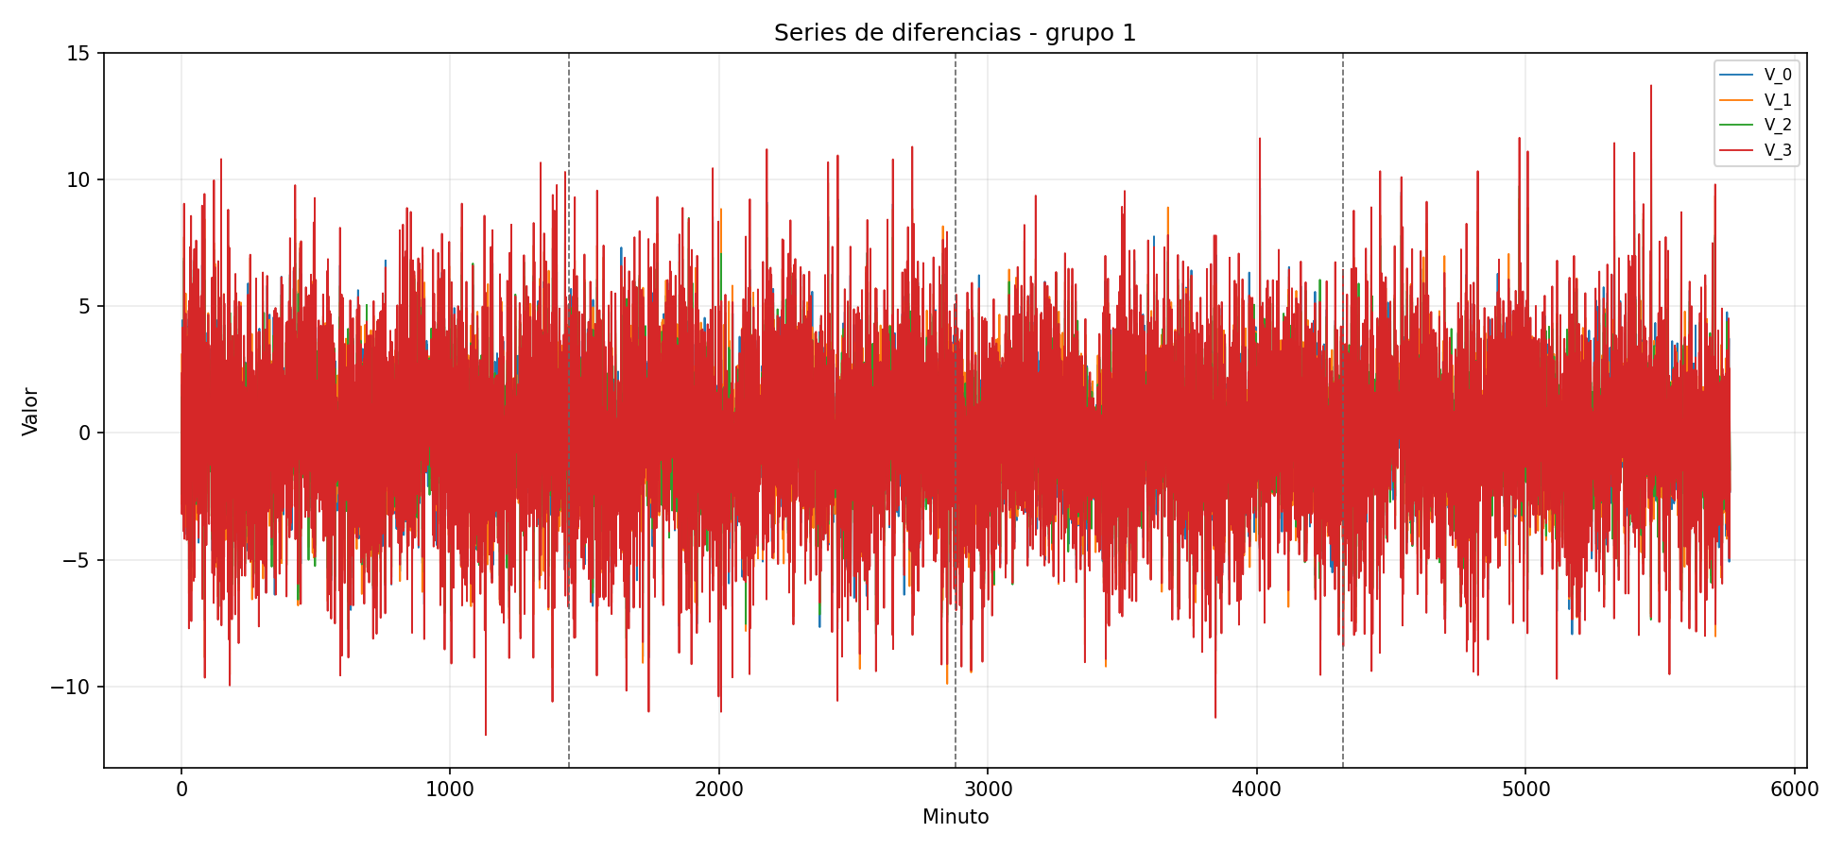
series_diferencias_grupo_02.png
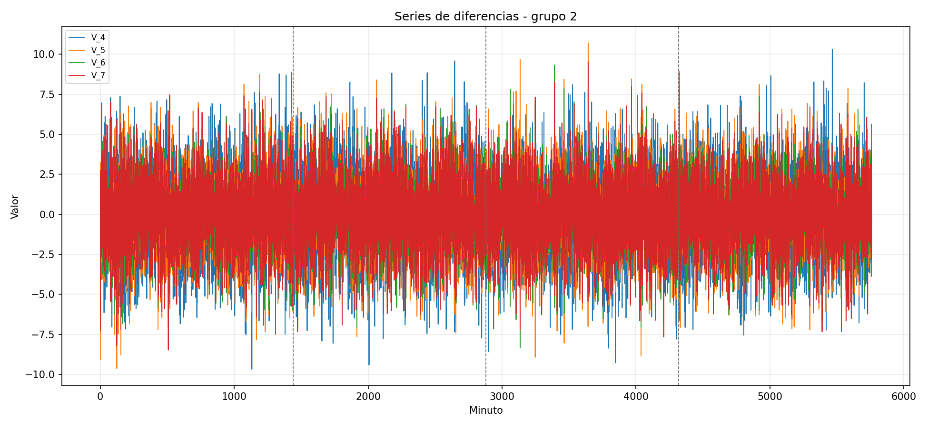
series_diferencias_grupo_03.png
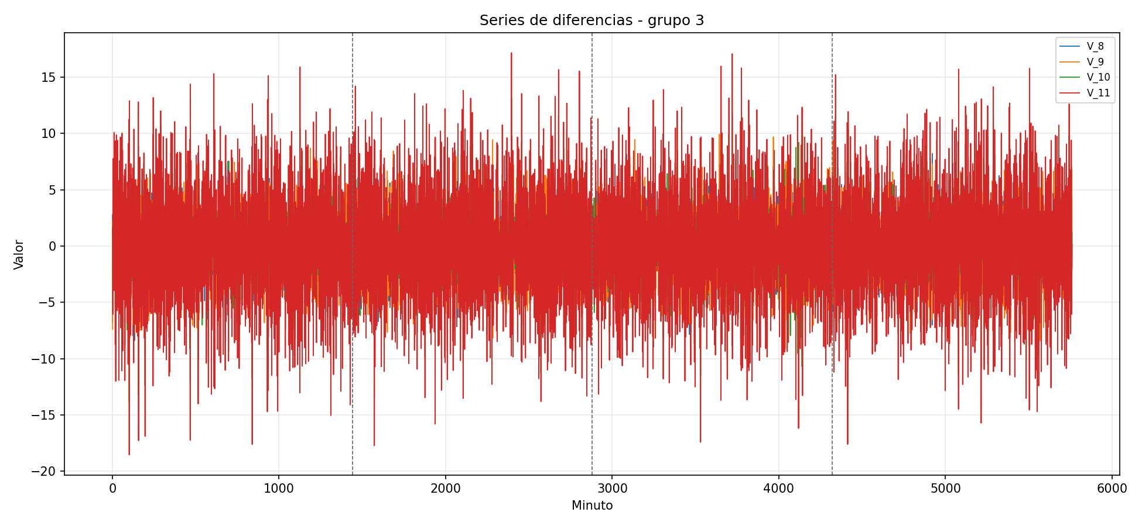
series_diferencias_grupo_04.png
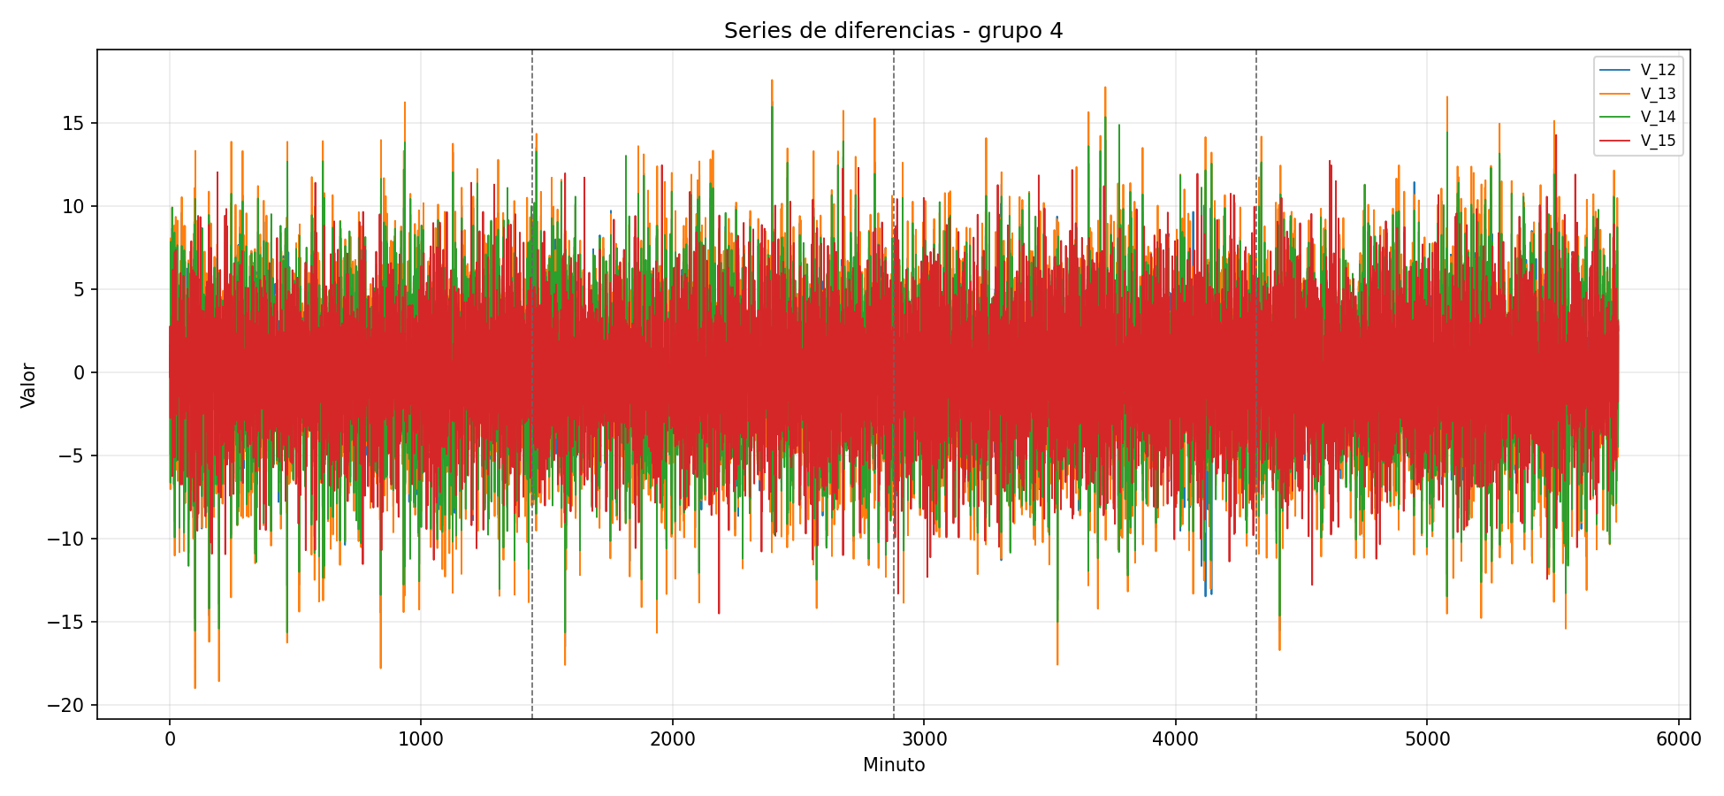
series_diferencias_grupo_05.png
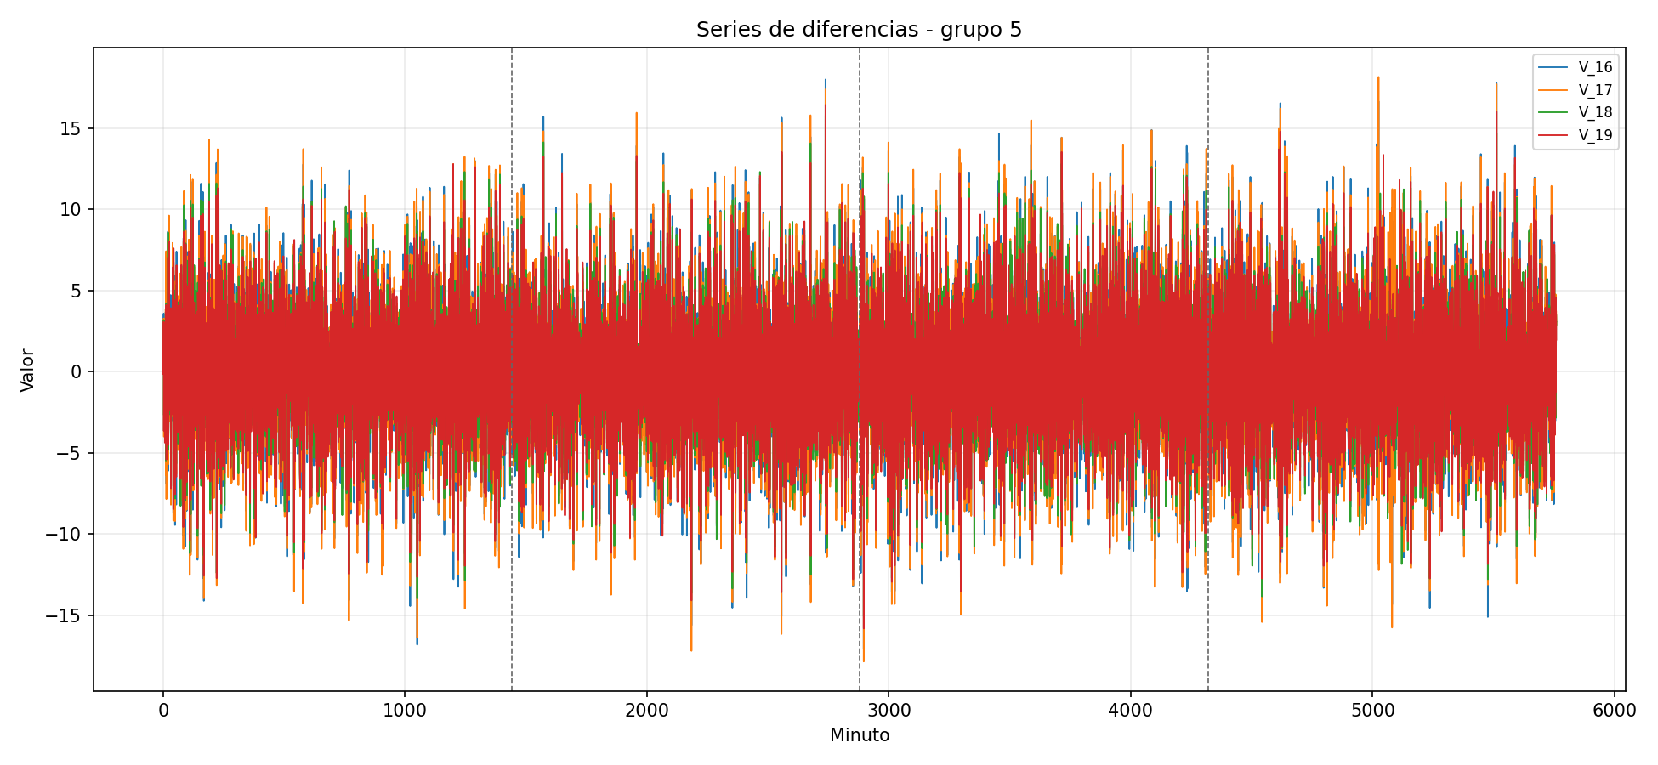
series_originales_grupo_01.png
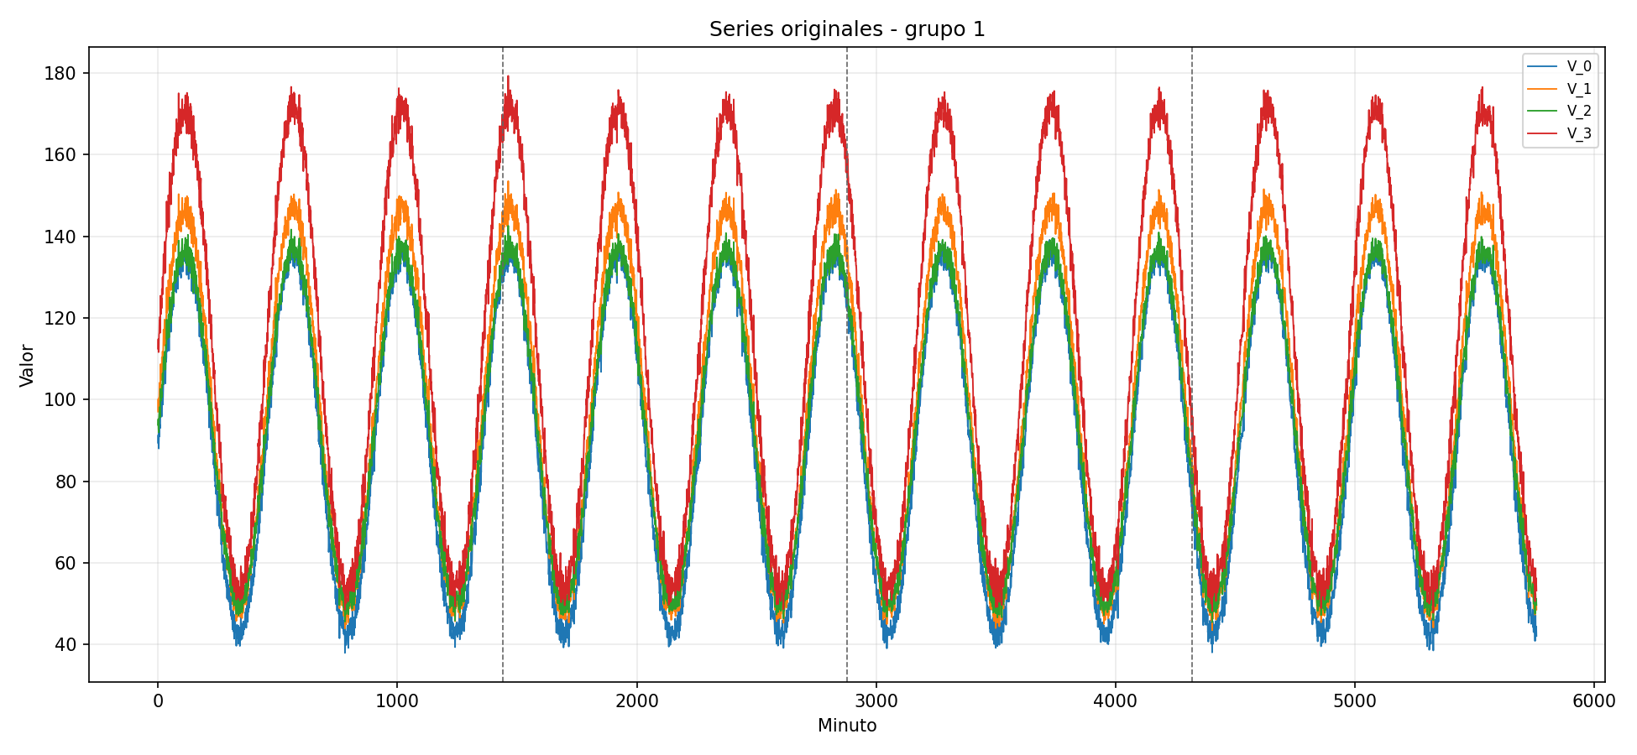
series_originales_grupo_02.png
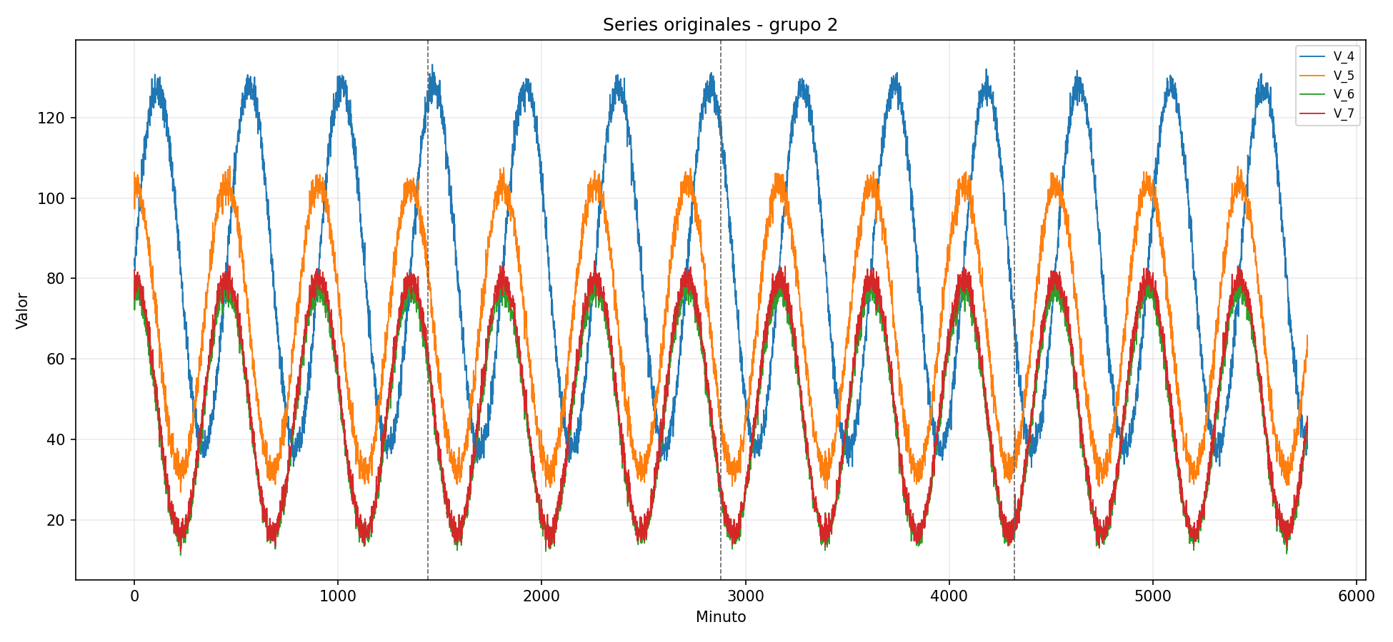
series_originales_grupo_03.png
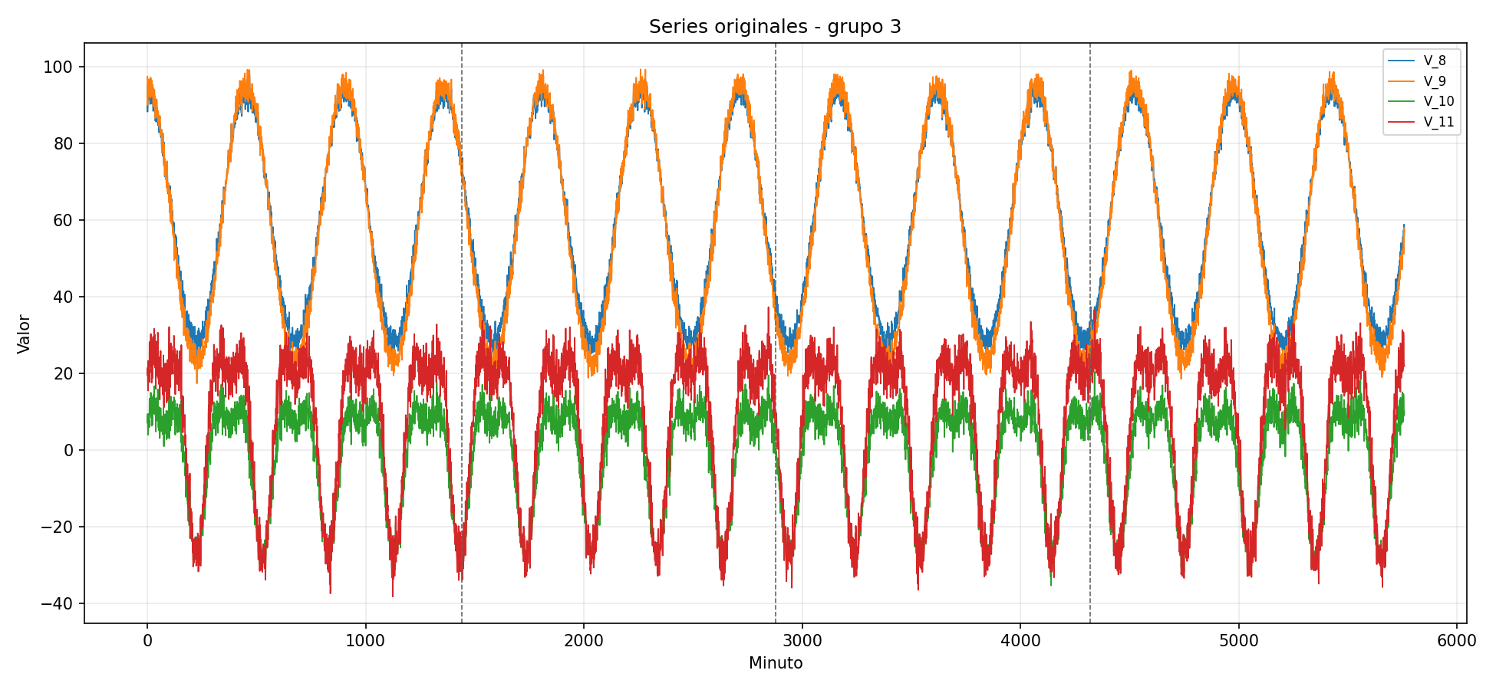
series_originales_grupo_04.png
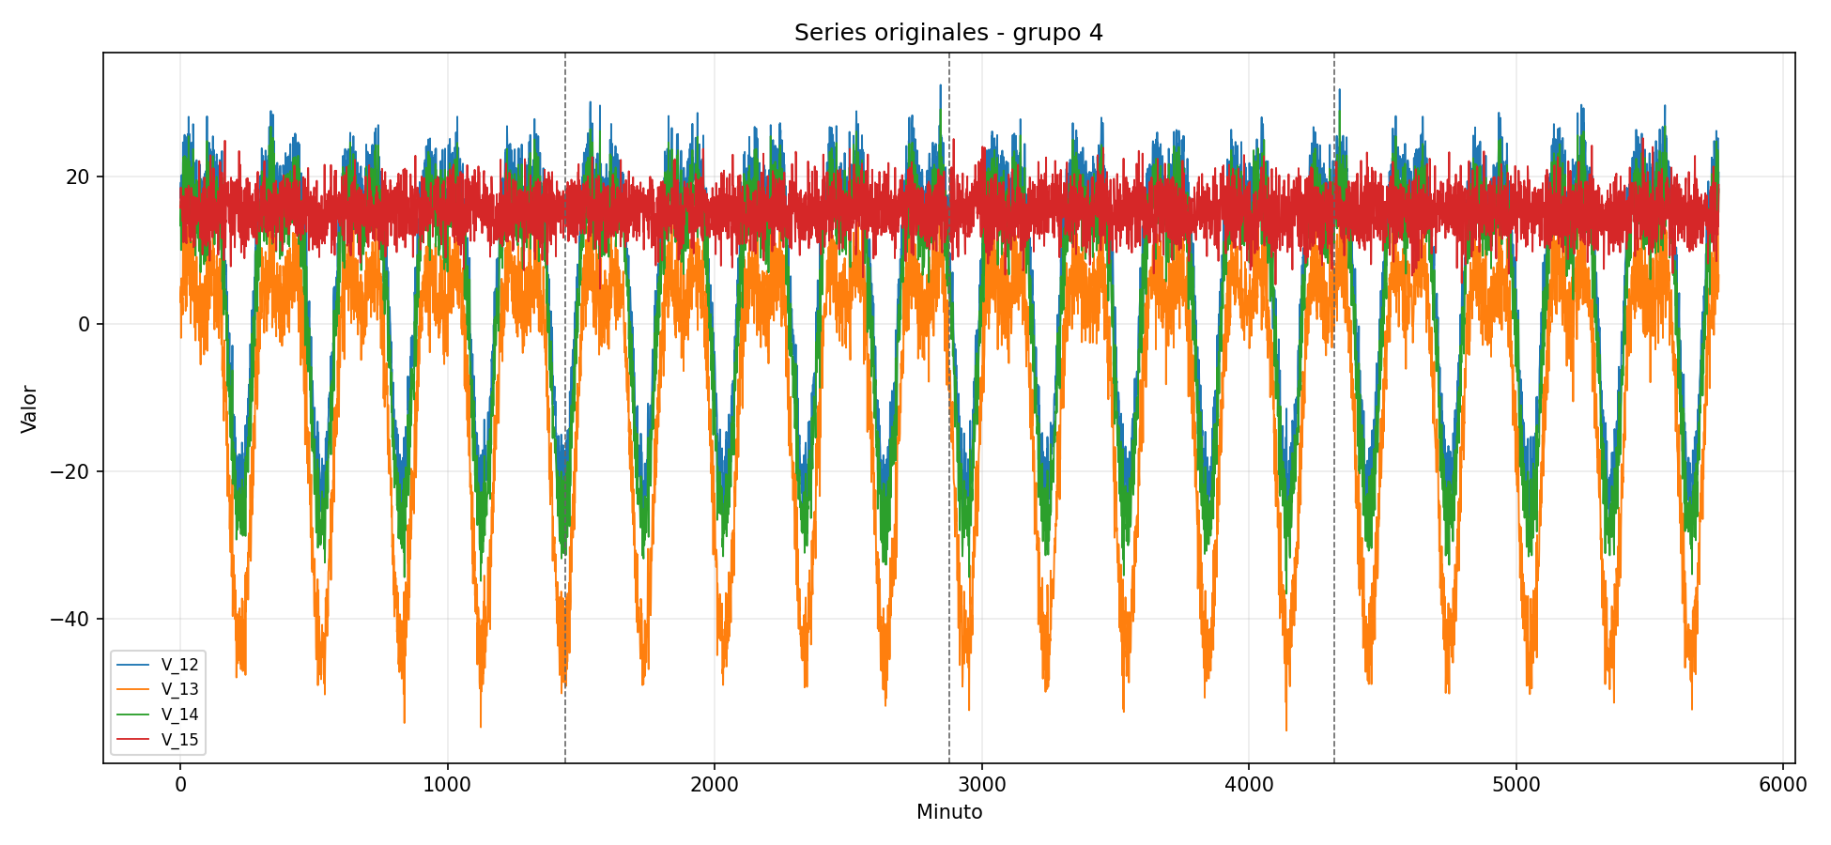
series_originales_grupo_05.png
