**Q.1**

The representative agent solves the following maximization problem:

$$\max_{{\left\{c_{t};h_{t}\right\}}_{t=1}^{∞}}E\left[\sum_{t=1}^{∞}{β^{t-1}}*U\left(c_{t}-G\left(h_{t}\right)\right)\right]$$

$$s.t. c_{t}=ο_{t}-i_{t}$$

where $U\left(c_{t}-G\left(h_{t}\right)\right)=\frac{{\left(c_{t}-G\left(h_{t}\right)\right)}^{1+γ}}{1+γ}$, $G\left(h_{t}\right)=\frac{h{}_{t}^{1+θ}}{1+θ}$, $ο_{t}=z_{t}*F\left(k_{t},h_{t}\right)=z_{t}*k_{t}^{α}*h_{t}^{1-α}$ and

$i_{t}=k_{t+1}-\left(1-δ\right)*k_{t}$.

Replacing this in the objective function of the agent we get:

$$\max_{{\left\{c_{t};h_{t}\right\}}_{t=1}^{∞}}E\left[\sum_{t=1}^{∞}{β^{t-1}}*U\left(z_{t}*k_{t}^{α}*h_{t}^{1-α}+\left(1-δ\right)*k_{t}-k_{t+1}-G\left(h_{t}\right)\right)\right]$$

Or, equivalently,

$$\max_{{\left\{c_{t};h_{t}\right\}}_{t=1}^{∞}}E\left[\sum_{t=1}^{∞}{β^{t-1}}*\frac{{\left(z_{t}*k_{t}^{α}*h_{t}^{1-α}+\left(1-δ\right)*k_{t}-k_{t+1}-\frac{h{}_{t}^{1+θ}}{1+θ}\right)}^{1+γ}}{1+γ}\right]$$

$z_{t}$ follows an AR(1) process in log: ${ln⁡(z}_{t+1})=ρ*\ln\left(z_{t}\right)+ε{}_{t+1}$ where $ε{}_{t}$ is normally distributed with mean 0 and variance $σ^{2}.$ Thus, taking the antilog $z_{t+1}=z_{t}^{ρ}*exp⁡(ε{}_{t+1})$. (note that, in the code, I simulate the shocks drawing random number from a standard normal distribution (mean=0 and variance=1); consequently, the standard deviation is factored out: : ${ln⁡(z}_{t+1})=ρ*\ln\left(z_{t}\right)+σ*ε{}_{t+1}$ and $z_{t+1}=z_{t}^{ρ}*exp⁡(σ*ε{}_{t+1})$).

The solution to the maximization problem is given by the F.O.C. w.r.t $h_{t}$ and $k_{t+1}$

F.O.C. w.r.t $h_{t}$

$$U_{1}\left(.t\right)*\left(z_{t}*F_{2}\left(k_{t},h_{t}\right)-G_{1}\left(h_{t}\right)\right)=0$$

Or, equivalently,

$$\left(z_{t}*(1-α)*k_{t}^{α}*h_{t}^{-α}-h_{t}^{θ}\right)=0$$

Which gives us a formula for the labor effort, given the current values of the productivity and the capital stock.

$${h_{t}=(z}_{t}*(1-α)*k_{t}^{α})^(\frac{1}{θ+α}) =H(k_{t},z_{t})$$

F.O.C. w.r.t $k_{t+1}$

$$-U_{1}\left(.t\right)+β*E\left[U_{1}\left(.t+1\right)*\left(z_{t}^{ρ}*\exp\left(ε{}_{t+1}\right)*F_{1}\left(k_{t+1},h_{t+1}\right)+\left(1-δ\right)\right)\right]=0$$

Or, equivalently,

$$-U_{1}\left(.t\right)+β*E\left[U_{1}\left(.t+1\right)*\left(z_{t}^{ρ}*\exp\left(ε{}_{t+1}\right)*α*k_{t}^{α-1}*h_{t}^{1-α}+\left(1-δ\right)\right)\right]=0$$

Which is the stochastic stochastic equation that governs the savings investment decision.

Plugging in the Euler equation the formula for labor, that we previously derived, we get the stochastic Euler equation that characterize the equilibrium:

$$-U_{1}\left(.t\right)+β*E\left[U_{1}\left(.t+1\right)*\left(z_{t}^{ρ}*\exp\left(ε{}_{t+1}\right)*α*k_{t}^{α-1}*H{\left(k_{t},z_{t}\right)}^{1-α}+\left(1-δ\right)\right)\right]=0$$

Defining the following function

$$Λ\left(k_{t},k_{t+1},k_{t+2 },z_{t},ε_{t}\right)=U_{1}\left(z_{t}*F\left(k_{t},h_{t}\right)+\left(1-δ\right)*k_{t}-k_{t+1}-G\left(H(k_{t},z_{t})\right)\right)-β*U_{1}\left(z_{t}^{ρ}*exp⁡(ε_{t+1})*F\left(k_{t+1},h_{t+1}\right)+\left(1-δ\right)*k_{t+1}-k_{t+1}-G\left(H(k_{t+1},z_{t+1})\right)\right)*\left(z_{t}^{ρ}*\exp\left(ε{}_{t+1}\right)*F_{1}\left(k_{t+1},H(k_{t+1},z_{t+1})\right)+\left(1-δ\right)\right)$$

$$=U_{1}\left(z_{t}*k_{t}^{α}*{(z}_{t}*(1-α)*k_{t}^{α})^(\frac{1-α}{θ+α}) +\left(1-δ\right)*k_{t}-k_{t+1}-\frac{{(z}_{t}*(1-α)*k_{t}^{α})^(\frac{1+θ}{θ+α}) }{1+θ}\right)$$

$$-β*U_{1}\left(z_{t}^{ρ}*\exp\left(ε{}_{t+1}\right)*k_{t+1}^{α}*{\left(z_{t}^{ρ}*\exp\left(ε{}_{t+1}\right)*\left(1-α\right)*k_{t+1}^{α}\right)}^{\frac{1-α}{θ+α}}+\left(1-δ\right)*k_{t+1}-k_{t+2}-\frac{{\left(z_{t}^{ρ}*\exp\left(ε{}_{t+1}\right)*\left(1-α\right)*k_{t+1}^{α}\right)}^{\frac{1+θ}{θ+α}}}{1+θ}\right)$$

$$*\left(z_{t}^{ρ}*\exp\left(ε{}_{t+1}\right)*α*k_{t}^{α-1}*(z_{t}^{ρ}*\exp\left(ε{}_{t+1}\right)*(1-α)*k_{t+1}^{α})^(\frac{1-α}{θ+α})+\left(1-δ\right)\right)$$

Which is equivalent to:

$$U_{1}\left({(z}_{t}*k_{t}^{α})^(θ+1)*(1-α)^(1-α))^(\frac{1}{θ+α}) +\left(1-δ\right)*k_{t}-k_{t+1}-\frac{{(z}_{t}*(1-α)*k_{t}^{α})^(\frac{1+θ}{θ+α}) }{1+θ}\right)$$

$$-β*U_{1}\left({\left(\left({\left(z_{t}^{ρ}*\exp\left(ε{}_{t+1}\right)*k_{t+1}^{α}\right)}^{θ+1}\right)*{\left(1-α\right)}^{\left(1-α\right)}\right)}^{\frac{1-α}{θ+α}}+\left(1-δ\right)*k_{t+1}-k_{t+2}-\frac{{\left(z_{t}^{ρ}*\exp\left(ε{}_{t+1}\right)*\left(1-α\right)*k_{t+1}^{α}\right)}^{\frac{1+θ}{θ+α}}}{1+θ}\right)$$

$$*\left(α*({\left(z_{t}^{ρ}*\exp{{\left(ε{}_{t+1}\right)}^{θ+1} }*{\left(1-α\right)}^{1-α}*k_{t+1}^{θ\left(α-1\right)}\right)}^{\frac{1}{θ+α}}+\left(1-δ\right)\right)$$

The Euler equation can be rewritten as $E\left[Λ\left(k_{t},k_{t+1},k_{t+2 },z_{t},ε_{t}\right)\right]=0$

**Q.2**

To deterministic steady state, we set $h_{t}=h_{t+1}=h^{*}$, $k_{t}=k_{t+1}=k_{t+2}=k^{*}$ and $z_{t}=z^{*}=1 ∀t$

$(ε{}_{t}=0 ∀t)$.

From the Labor formula we know the relationship between labor and capital in the steady state:

$$h^{*}=(z^{*}*(1-α)*k^{*α})^(\frac{1}{θ+α})$$

From the F.O.C. w.r.t $k_{t+1}$ we get:

$-1+βF_{1}\left(k^{*},h^{*}\right)+\left(1-δ\right)=0$

Or, equivalently,

$β*α*{\frac{h^{*}}{k^{*}}}^{1-α}+\left(1-δ\right)=1$

Because $U_{1}\left(.t\right)=U_{1}\left(.t+1\right)$ when labor and capital are constant.

Plugging in the formula for labor, we get: $β*α*{\frac{{(z}^{*}*(1-α)*k^{*α})^(\frac{1}{θ+α})}{k^{*}}}^{1-α}+\left(1-δ\right)=1$

From which we can derive:

$k^{*}={\left(\frac{α}{i+δ}\right)}^{\frac{α+θ}{\left(1-α\right)θ}}*{\left(1-α\right)}^{\frac{1}{θ}}$, recalling that $β=\frac{1}{1+i}$.

Plugging this value back in the formula for labor we can get the expression for the deterministic steady state value of labor:

$$h^{*}=(\left(1-α\right)*{\left({{\left(\frac{α}{i+δ}\right)}^{\frac{α+θ}{\left(1-α\right)θ}}*{\left(1-α\right)}^{\frac{1}{θ}})}^{α}\right)}^{\frac{1}{θ+α}}={\left(1-α\right)}^{\left(\frac{θ+1}{θ+α}\right)}*{\left(\frac{α}{i+δ}\right)}^{\frac{α}{θ*\left(1-α\right)}}$$

**Q.3**

Plugging the value of the parameters, we can compute the s.s. values of capital and labor:

$$k^{*}={\left(\frac{α}{\frac{1}{β}-(1-δ)}\right)}^{\frac{α+θ}{\left(1-α\right)θ}}*{\left(1-α\right)}^{\frac{1}{θ}}=3.9315$$

$h^{*}$ = ${\left(1-α\right)}^{\left(\frac{θ+1}{θ+α}\right)}*{\left(\frac{α}{i+δ}\right)}^{\frac{α}{θ*\left(1-α\right)}}=1.0618$

**Q.4**

Derivates of the Euler equation, computed in the deterministic steady state:

$$Λ_{1}\left(k_{t},k_{t+1},k_{t+2 },z_{t},ε_{t}\right)=$$

$$=U_{11}\left(*\right)*{\left(z^{*θ+1}*{\left(1-α\right)}^{1-α}*k^{*θ\left(α-1\right)}\right)}^{\frac{1}{θ+α}}α*\frac{θ+1}{θ+α}+1-δ+\frac{(z^{*}*(1-α))^(\frac{1+θ}{θ+α}) }{1+θ}*\frac{α}{θ+α}*{k^{*}}^{α*\frac{θ+1}{θ+α}}$$

$$Λ_{2}\left(k_{t},k_{t+1},k_{t+2 },z_{t},ε_{t}\right)=$$

$$={-U}_{11}\left(*\right)-β*U_{11}*\left(α*{\left((z_{t}^{ρ}*\exp{{\left(ε{}_{t+1}\right)) }^{θ+1} }*{\left(1-α\right)}^{1-α}*k_{t+1}^{θ\left(α-1\right)}\right)}^{\frac{1}{θ+α}}+\left(1-δ\right)\right)*{((\left(z^{*ρ}*\exp{ε^{*}}\right)}^{θ+1}*{\left(1-α\right))}^{\frac{1}{\left(θ+α\right)}}*α*\frac{θ+1}{θ+α}*k^{*θ*\frac{α-1}{θ+α}}+1-δ+$$

$${\left(\left(1-α\right){*z}^{*ρ}*\exp{ε^{*}}\right)}^{\frac{θ+1}{θ+α}}*\frac{1}{θ+α}*α*k^{*θ*\frac{α-1}{θ+α}})- β*U_{1}*(α*{\left(z^{*ρ}*\exp{ε^{*}}\right)}^{\frac{θ+1}{θ+α}}*{\left(1-α\right)}^{\frac{1-α}{θ+α}}*\left(-θ\right)*\frac{\left(1-α\right)}{θ+α}k^{*θ*\frac{α-1}{θ+α}-1})$$

$$Λ_{3}\left(k_{t},k_{t+1},k_{t+2 },z_{t},ε_{t}\right)=U_{11}(*)$$

$$Λ_{4}\left(k_{t},k_{t+1},k_{t+2 },z_{t},ε_{t}\right)=$$

$$U_{11}\left(*\right)*\left(k^{*α*\frac{1-α}{θ+α}}*{\left(1-α\right)}^{\frac{1-α}{θ+α}}*α*\frac{θ+1}{θ+α}*z^{*θ*\frac{α-1}{θ+α}}+{\left(\left(1-α\right)*k^{*α}\right)}^{\frac{θ+1}{θ+α}}*\frac{1}{\left(θ+1\right)*\left(θ+α\right)}{z^{*}}^{\frac{1-α}{θ+α}}\right)-βU_{11}\left(*\right)*\left(α*{\left((z_{t}^{ρ}*\exp{{\left(ε{}_{t+1}\right)) }^{θ+1} }*{\left(1-α\right)}^{1-α}*k_{t+1}^{θ\left(α-1\right)}\right)}^{\frac{1}{θ+α}}+\left(1-δ\right)\right)*\left({\left(k^{*α}*\exp{ε^{*}}\right)}^{\frac{\left(1-α\right)}{θ+α}}*ρ*\frac{θ+1}{θ+α}*z^{*ρ\frac{θ+1}{θ+α}-1}-{\left(\left(1-α\right){*k}^{*α}\right)}^{\frac{1-α}{θ+α}}*\frac{{z^{*}}^{\frac{1-α}{θ+α}}}{\left(θ+1\right)\left(θ+α\right)}\right)-βU_{1}\left(*\right)*(α*{\exp\left(ε^{*}\right)}^{\frac{θ+1}{θ+α}}*ρ*\frac{θ+1}{θ+α}*z^{*ρ\frac{θ+1}{θ+α}-1}*{\left(1-α\right)}^{\frac{\left(1-α\right)}{\left(θ+α\right)}}*k^{*θ*\frac{α-1}{θ+α}})$$

Or, in formula,

$$Λ_{1\left(k_{t},k_{t+1},k_{t+2 },z_{t},ε_{t}\right)}=U_{11}\left(*\right)*(F_{1}\left(*\right)+F_{2}\left(*\right)*H_{1}(k,z)+\left(1-δ\right)-{G_{1}\left(*\right)*H}_{1}(k^{*},z^{*}))$$

$$Λ_{2\left(k_{t},k_{t+1},k_{t+2 },z_{t},ε_{t}\right)}=-U_{11}\left(*\right)*(1+F_{1}\left(*\right)+F_{2}\left(*\right)*H_{1}(k,z)+\left(1-δ\right)-{G_{1}\left(*\right)*H}_{1}(k^{*},z^{*}))$$

$$Λ_{3\left(k_{t},k_{t+1},k_{t+2 },z_{t},ε_{t}\right)}=U_{11}(*)$$

$$Λ_{4\left(k_{t},k_{t+1},k_{t+2 },z_{t},ε_{t}\right)}=U_{11}\left(*\right)*\left(F\left(*\right)+F_{2}\left(*\right)*H_{2}\left(k^{*},z^{*}\right)-G_{1}\left(*\right)*H_{2}\left(k^{*},z^{*}\right)-ρ*F\left(*\right)-F_{2}\left(*\right)*H_{2}\left(k^{*},z^{*}\right)*\frac{∂z_{t+1}}{∂z_{t}}\left|z^{*}+G_{1}\left(*\right)*H_{2}\left(k^{*},z^{*}\right)*\frac{∂z_{t+1}}{∂z_{t}}\right|z^{*}\right)-β*U_{1}\left(*\right)*(ρ*F_{1}\left(*\right)+F_{12}(*)H_{2}\left(k^{*},z^{*}\right)*\frac{∂z_{t+1}}{∂z_{t}}|z^{*})$$

Where $U_{1}\left(*\right)$ and $U_{11}\left(*\right)$ are the first and second derivative of the utility function computed in the deterministic steady state, $F\left(*\right)=k^{*α}*h^{*1-α}$, $F_{1}\left(*\right)=α*{\left(\frac{h^{*}}{k^{*}}\right)}^{1-α}$, $F_{2}\left(*\right)=\left(1-α\right)*{\left(\frac{k^{*}}{h^{*}}\right)}^{α}$, $F_{11}\left(*\right)= α*\left(α-1\right)*{h^{*}}^{1-α}k^{*α-2}$, $F_{12}\left(*\right)= α*\left(1-α\right)*{h^{*}}^{-α}k^{*α-1}$, $H_{1}\left(k^{*},z^{*}\right)={\left(\left(1-α\right)\right)}^{\frac{1}{θ+α}}*k^{*\frac{α}{θ+α}-1}*\frac{α}{θ+α}$, $H_{2}\left(k^{*},z^{*}\right)={\left(\left(1-α\right)*k^{*α}\right)}^{\frac{1}{θ+α}}*\frac{1}{θ+α}$, $G_{1}\left(*\right)=h^{*θ}$ and $\frac{∂z_{t+1}}{∂z_{t}}|z^{*}=ρz^{*ρ-1}\exp\left(ε^{*}\right)=ρ$

**Q.5**

To calibrate the model, picking the values of $ρ$ and $σ$ such that the model replicates the statistics of output observed in the data, I created a function, called “calibration”. This function simulates the series of output in log for T=100 periods as function of $ρ$ and $σ$ and has two output; the first one is the autocorrelation of log series of output minus 0.66 (which is the autocorrelation of output found in the data), while the second one is the standard deviation of the output minus 3.5 (which is the std dev of output found in the data).

In the main script, I apply the fsolve operator to this function, solving for $ρ$ and $σ$ and passing the other imputs as parameters, so that I get the values of $ρ$ and $σ$ such that the model gives the same volatility and autocorrelation found in the data.

Moreover, in the main script, using the solution for $ρ$ and $σ$, I simulate a business cycle of T=100 periods. In computing the paths of capital, I imposed that the investments cannot be negative, therefore $k_{t+1}$ must be greater or equal than ${\left(1-δ\right)*k}_{t}$.

Here is the results that come out from my model.

**STATISTICS (log series)**

|  |  |  |  |
| --- | --- | --- | --- |
| VARIABLE | *Standard Deviation* | *Correlation with output* | *Autocorrelation* |
| Output | 3.5000 | 1 | 0.6600 |
| Consumption | 3.2942 | 0.9870 | 0.6555 |
| Investment | 7.7563 | 0.7553 | 0.4329 |
| Labor | 2.1875 | 1.0000 | 0.6600 |
| Productivity | 1.8044 | 0.9265 | 0.5905 |

**STATISTICS (no logs)**

|  |  |  |  |
| --- | --- | --- | --- |
| VARIABLE | *Standard Deviation* | *Correlation with output* | *Autocorrelation* |
| Output | 5901.7 | 1 | 0.0428 |
| Consumption | 5832.3 | 0.9981 | 0.0364 |
| Investment | 365.4 | 0.2199 | 0.3220 |
| Labor | 85.8 | 0.9530 | 0.1867 |
| Productivity | 17.2 | 0.9751 | 0.2358 |

*Plots of the distribution of capital and productivity*

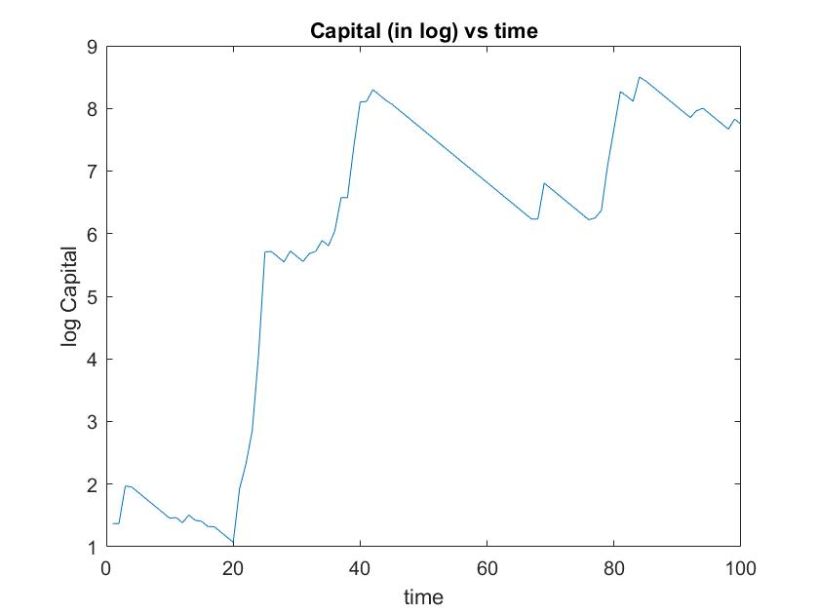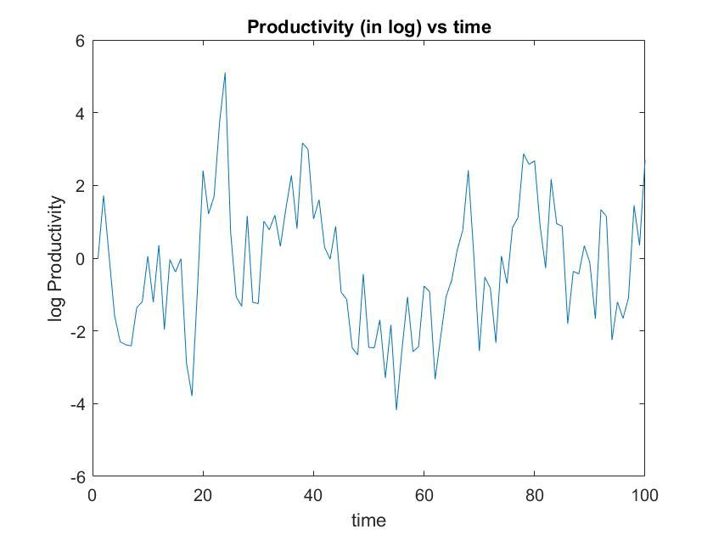

Mean values of capital: $\overline{k}=1335.3$ $\overline{log⁡(k)}=5.8235$

Mean values for productivity $\overline{z}=4.5191$ $\overline{log⁡(z)}=-0.2419$

Values of the coefficients of the log-linear solution:

$$a=0.0751$$

$$b=0.9451$$

$$f=0.3486$$

Values of the AR pf productivity

$ρ=0.6715$

$$σ=1.4596$$

Values of the derivates of the Euler equation

|  |  |  |
| --- | --- | --- |
|  | *Standard Method* | *Complex step differentiation* |
| $$Λ_{1}$$ | -6.325995515443773 | -6.325995512461892 |
| $$Λ_{2}$$ | 12.471100508038015 | 12.471100502303669 |
| $$Λ_{3}$$ | -6.113284562725419 | -6.113284559952789 |
| $$Λ_{4}$$ | -3.546623891281798 | -3.546623886049891 |

**Q.6**

After a quick glance at the statistics of the business cycle generated by the model (for the series in log), I would state that the model performs quite well in replicating patterns observed in the data. First of all, the standard deviation and the autocorrelation of the output are exactly equal to the one found in the data. This is due to the fact that the parameters $ρ$ and $σ$ are calibrated to make the model replicate the statistics of the output found in the data. Moreover, both in the model and in the data, the volatility of the investments is substantially higher than the one of output, whereas the volatility of consumption, labor and productivity is lower.

However, while the volatility of labor and productivity is very close between the model and the data, std deviation of investment is larger in the data than in the model (10.5 vs 7.5), and std deviation of consumption is lower (2.2 vs 3.2).

In addition, the model is less precise when it comes to correlation with output and autocorrelation. In particular, correlation with output of consumption, labor and productivity are substantially higher than the patterns found in the data. Finally, the model suggests higher autocorrelation coefficients for investment and labor and lower ones for consumption and productivity.

Looking at the statistics generated by the model, it is clear that all the variables considered are procyclical (that is they move toward the same direction of output). In particular, labor and consumption are the two variable that are more correlated with output: the former is perfectly correlated (corr(h,y)=1), the ladder is almost perfectly correlated (corr(c,y)=0.98). Therefore, any movement of labor is associated to a same change of output. Productivity is highly correlated with output (corr(z,y)=0.92); this might be due to the fact that productivity effects output directly (recall that , $ο_{t}=z_{t}*F\left(k_{t},h_{t}\right)$), and indirectly, raising labor (${h_{t}=(z}_{t}*(1-α)*k_{t}^{α})^(\frac{1}{θ+α})$), which in turns increases output.

Analyzing the volatility, it appears that investment level is much more volatile that output: this feature is consistent with patterns found in the data. Consumption is approximately as volatile as output (3.2 vs 3.5) while labor is less volatile. Besides, the productivity has the lowest volatility: its level depends on the values assigned to the parameters of the AR process.

As regards the autocorrelation, the variable with the lowest level is investment (0.43), which is consistent with the fact that it is the variable with the highest volatility. Labor, consumption and output show similar levels of autocorrelation (around 0.66), which is a remarkable figure and implies an important degree of dependence between these variables and their lagged values. Finally, the autocorrelation of the productivity of the productivity is 0.59 which is quite close to the value of $ρ$, which is the theoretical autocorrelation (increasing the number of periods the two figures would get closer).

(Note that the figures related to investments are sensible to the lower bound put on investments: since we take the log of the series I cannot be equal to zero but must be >0; for instance, decreasing the lower bound would increase the volatility)

***Plot of the business cycle in log***

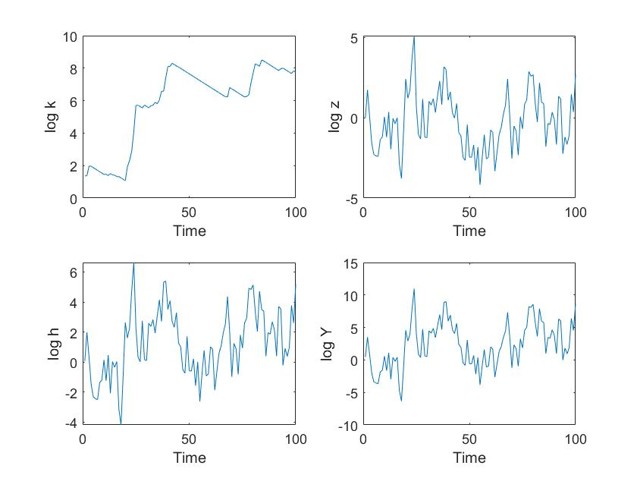

As we can see, the capital follows an upward trend over the period considered. However, its increase is not steady but it alternates sharp rises, with steady declines, representing periods where the investment is lower than the depreciation of capital ($I_{t}<δ*k_{t}$). The productivity shows some volatility without following a unique trend over the period (its mean is really close to the s.s. level (-0.24 vs 0); by the way, we can observe a certain degree of persistence.

Output and labor follow very close paths: in their plots, we can observe a slightly increasing trend over time and a remarkable decree of persistence. Nevetheless, there many changes in the directions of this variables: There are at least 4 booms (around t=25,t=40, t=65 and t=80) and many recession (for instance, around t=10-20, t=30 and t=50-60)

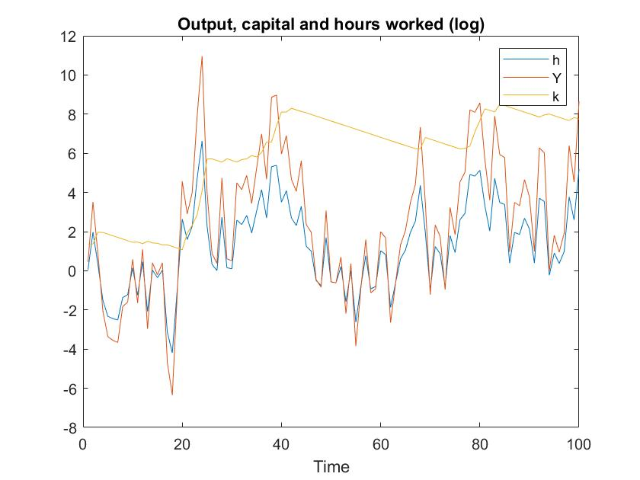

This figure shows the high correlation between labor and output. Moreover, we can see that, when capital increase, output, then to be higher than labor whereas, when capital decrease, output tend to be lower.

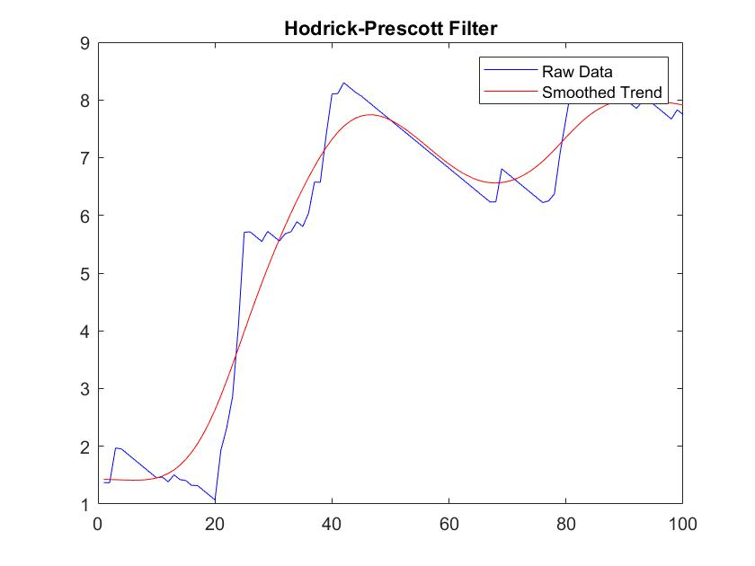

Plot of capital with the Hodrick-Prescott filter which penalizes the movement from the trend (penalty parameter=1000)

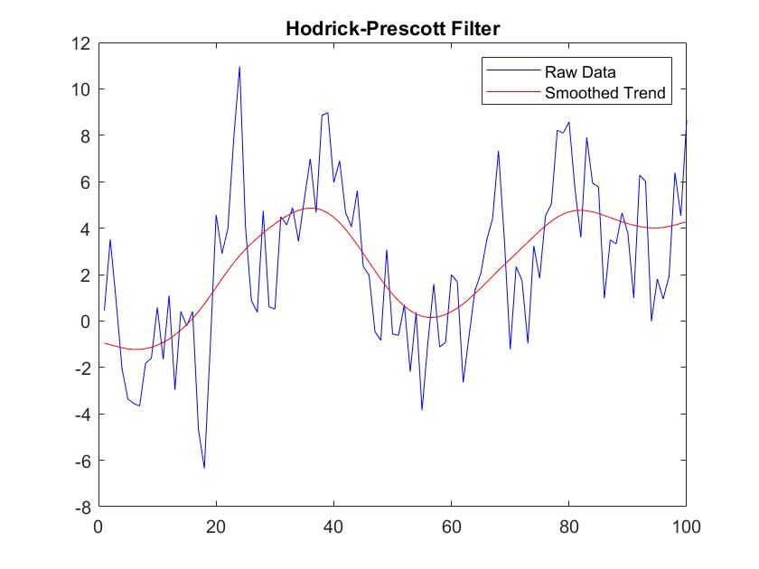

Plot of output with the Hodrick-Prescott filter which penalizes the movement from the trend (penalty parameter=1000)

Applying the Hodrick-Prescott filter to the series of output in log, we can see that the model simulates two complete cycles over T=100 periods. (peaks around t=40 and t=80; lowest levels around t=10 and t=60)