1. The Representative agent solves the following maximization problem

$$\max_{{\left(c_{t},h_{t}\right)}_{1}^{∞}}\sum_{t=1}^{∞}{U\left(c_{t}-G(h_{t})\right)}$$

where $U\left(c_{t}-G(h_{t})\right)=log⁡(c_{t}-G(h_{t}))$ and $G\left(h_{t}\right)=\frac{h_{t}^{1+θ}}{1+θ}$.

Consumption is equal to $c_{t}=\left(1-t_{h}\right)*w_{t}*h_{t}+\left(1-t_{k}\right)*r_{t}*k_{t}+t_{k}*δ*k_{t}-i+λ_{t}$, where $i_{t}=k_{t+1}-\left(1-δ\right)*k_{t}$, as $k_{t+1}=i_{t}+\left(1-δ\right)*k_{t}$.

Therefore, consumption is equal to:

$$c_{t}=\left(1-t_{h}\right)*w_{t}*h_{t}+\left(1-t_{k}\right)*r_{t}*k_{t}+t_{k}*δ*k_{t}+\left(1-δ\right)*k_{t}-k_{t+1}+λ_{t}$$

Or, equivalently,

$$c_{t}=\left(1-t_{h}\right)*w_{t}*h_{t}+(1+\left(1-t_{k}\right)*\left(r_{t}-δ\right))*k_{t}-k_{t+1}+λ_{t}$$

Note that the agent takes the wage, the rental rate and government transfers as given, since we assume that every single agent is too small to influence them. Consequently, we will substitute the formula for the wage, the rental rate and transfers only after having derived the F.O.C. of the agent

Deriving the FOC w.r.t $h_{t}$ and $k_{t+1}$, we can get the solution for the optimal $h_{t}$ and the decision rule for the capital accumulation.

FOC w.r.t $h_{t}$:

$$U_{1}\left(c_{t}-G(h_{t})\right)*\left(\left(1-t_{h}\right)*w_{t}-G_{1}\left(h_{t}\right)\right)=0$$

Or, equivalently,

$$\left(1-t_{h}\right)*w_{t}=G_{1}\left(h_{t}\right)=h_{t}^{θ}$$

FOC w.r.t $k_{t+1}$:

$${-U}_{1}\left(.t\right)+β*U_{1}\left(.t+1\right)*\left(1+\left(1+t_{h}\right)*\left(r_{t}-δ\right)\right)=0$$

Or, equivalently,

$$U_{1}\left(.t\right)=β*U_{1}\left(.t+1\right)*\left(1+\left(1-t_{k}\right)*\left(r_{t+1}-δ\right)\right)$$

The firm has a Cobb-Douglass production function and uses labor and capital to obtain output, paying a job salary to the RA for his work and a rental rate for the rented capital.

The firm maximizes profits, solving the following maximization problem:

$$\max_{k_{t},h_{t}}{{F_{t}\left(k_{t},h_{t}\right)-h_{t}*w_{t}-k_{t}*r_{t}=k}_{t}^{α}*h_{t}^{1-α}}-h_{t}*w_{t}-k_{t}*r_{t}$$

Deriving the FOC of the profit function, we can get the expressions for the hourly wage $w_{t}$ and the rental rate of capital $r_{t}$.

FOC w.r.t $w_{t}$:

$$F_{1}\left(k_{t},h_{t}\right)-r_{t}=0$$

Or, equivalently,

$$r_{t}=F_{1}\left(k_{t},h_{t}\right)=α*{\left(\frac{h_{t}}{k_{t}}\right)}^{1-α}$$

FOC w.r.t $h_{t}$:

$$F_{2}\left(k_{t},h_{t}\right)-w_{t}=0$$

Or, equivalently,

$$w_{t}=F_{2}\left(k_{t},h_{t}\right)=\left(1-α\right)*{\left(\frac{k_{t}}{h_{t}}\right)}^{α}$$

Finally, the Government receives fiscal revenues through taxes and uses them to fund transfers to the individuals.

Since all the revenues raised by taxes are rebated back to the individual, the budget constraint of the Government will be:

$$t_{h}*w_{t}*h_{t}+t_{k}*\left(r_{t}-δ\right)*k_{t}=λ_{t}$$

To characterize the General Equilibrium, we can substitute in the F.O.C. of the agent the expressions for the wage and the rental rate, that we have derived from the firm’s F.O.C., and the value of Government transfers, derived from its budget constraint

From the F.O.C. w.r.t to labor, we get $h_{t}^{θ}=\left(1-t_{h}\right)*\left(1-α\right)*{\left(\frac{k_{t}}{h_{t}}\right)}^{α}$, which delivers a formula for the labor effort, given the level of capital : $h_{t}={\left(\left(1-t_{h}\right)*\left(1-α\right)*k_{t}^{α}\right)}^{\frac{1}{α+θ}}.$

From the F.O.C. w.r.t. capital, we get the decision rule that drives capital accumulation:

$$U_{1}\left(\left(1-t_{h}\right)*\left(1-α\right)*{\left(\frac{k_{t}}{h_{t}}\right)}^{α}*h_{t}+\left(1-t_{k}\right)*α*{\left(\frac{h_{t}}{k_{t}}\right)}^{1-α}*k_{t}+t_{k}*δ*k_{t}+\left(1-δ\right)*k_{t}-k_{t+1}+t_{h}*\left(1-α\right)*{\left(\frac{k_{t}}{h_{t}}\right)}^{α}*h_{t}+t_{k}*\left(α*{\left(\frac{h_{t}}{k_{t}}\right)}^{1-α}-δ\right)*k_{t}\right)$$

$$=$$

$$β*U_{1}\left(\left(1-t_{h}\right)*\left(1-α\right)*{\left(\frac{k_{t+1}}{h_{t+1}}\right)}^{α}*h_{t+1}+\left(1-t_{k}\right)*α*{\left(\frac{h_{t+1}}{k_{t+1}}\right)}^{1-α}*k_{t+1}+t_{k}*δ*k_{t+1}+\left(1-δ\right)*k_{t+1}-k_{t+2}+t_{h}*\left(1-α\right)*{\left(\frac{k_{t+1}}{h_{t+1}}\right)}^{α}*h_{t+1}+t_{k}*\left({α*{\left(\frac{h_{t+1}}{k_{t+1}}\right)}^{1-α}}_{}-δ\right)*k_{t+1}\right)*\left(1+\left(1-t_{k}\right)*\left(k_{t+1}-δ\right)\right)$$

Which simplifies into,

$$U_{1}\left(k_{t}^{α}*h_{t}^{1-α}+\left(1-δ\right)*k_{t}-k_{t+1}\right)=β*U_{1}\left(k_{t+1}^{α}*h_{t+1}^{1-α}+\left(1-δ\right)*k_{t+1}-k_{t+2}\right)*\left(1+\left(1-t_{k}\right)*\left(k_{t+1}-δ\right)\right)$$

Plugging the formula for labor in we get:

$$U_{1}\left(k_{t}^{α}*{\left(\left(1-t_{h}\right)*\left(1-α\right)*k_{t}^{α}\right)}^{\frac{1-α}{α+θ}}+\left(1-δ\right)*k_{t}-k_{t+1}\right)=β*U_{1}\left(k_{t+1}^{α}*{\left(\left(1-t_{h}\right)*\left(1-α\right)*k_{t+1}^{α}\right)}^{\frac{1-α}{α+θ}}+\left(1-δ\right)*k_{t+1}-k_{t+2}\right)*\left(1+\left(1-t_{k}\right)*\left(k_{t+1}-δ\right)\right)$$

Which simplifies into:

$$U_{1}\left(k_{t}^{α*\frac{θ+1}{α+θ}}*{\left(\left(1-t_{h}\right)*\left(1-α\right)\right)}^{\frac{1-α}{α+θ}}+\left(1-δ\right)*k_{t}-k_{t+1}\right)=β*U_{1}\left(k_{t+1}^{α*\frac{θ+1}{α+θ}}*{\left(\left(1-t_{h}\right)*\left(1-α\right)\right)}^{\frac{1-α}{α+θ}}+\left(1-δ\right)*k_{t+1}-k_{t+2}\right)*\left(1+\left(1-t_{k}\right)*\left(k_{t+1}-δ\right)\right)$$

Since $U\left(x\right)=\ln\left(x\right), U_{1}(x)=1/x$

$$\frac{1}{\left(k_{t}^{α*\frac{θ+1}{α+θ}}*{\left(\left(1-t_{h}\right)*\left(1-α\right)\right)}^{\frac{1-α}{α+θ}}+\left(1-δ\right)*k_{t}-k_{t+1}\right)}=β*\frac{1}{\left(k_{t+1}^{α*\frac{θ+1}{α+θ}}*{\left(\left(1-t_{h}\right)*\left(1-α\right)\right)}^{\frac{1-α}{α+θ}}+\left(1-δ\right)*k_{t+1}-k_{t+2}\right)}*\left(1+\left(1-t_{k}\right)*\left(k_{t+1}-δ\right)\right)$$

This equation represents the Bellman equation that solves the maximization problem.

1. To solve for the steady state, we impose $h_{t}=h_{t+1}=h^{*}$ and $k_{t}=k_{t+1}=k_{t+2}=k^{*}$, where $h^{*}$ and $k^{*}$ represent the s.s. levels for labor and capital.

Thus, the decision rule simplifies into $1=β*\left(1+\left(1-t_{k}\right)*\left(r^{*}-δ\right)\right)$ or, equivalently $F_{1}\left(k^{*},h^{*}\right)=\frac{\frac{1}{β}-1}{\left(1-t_{k}\right)}+$ $δ$,

where $r^{*}=F_{1}\left(k^{*},h^{*}\right)=α*{\left(\frac{h^{*}}{k^{*}}\right)}^{1-α}$, since $U_{1}\left(.t\right)=U_{1}\left(.t+1\right)$ when labor and capital are constant.

Plugging in the formula for the formula of labor $h^{*}={\left(\left(1-t_{h}\right)*\left(1-α\right)*k^{*α}\right)}^{\frac{1}{α+θ}}$, we can derive an expression for the s.s. level of capital:

$k^{*}={\left(\frac{1-β+δβ*\left(1-t_{k}\right)}{βα*\left(1-t_{k}\right)}\right)}^{\frac{α+θ}{θ*\left(α-1\right)}}*{\left(\left(1-α\right)*\left(1-t_{h}\right)\right)}^{\frac{1}{θ}}$

Plugging this value in the labor formula, we get the steady state level of labor:

$$h^{*}={\left(\left(1-t_{h}\right)*\left(1-α\right)*k^{*α}\right)}^{\frac{1}{α+θ}}={\left(\left(1-t_{h}\right)*\left(1-α\right)*{(\left(\frac{1-β+δβ*\left(1-t_{k}\right)}{βα*\left(1-t_{k}\right)}\right)}^{\frac{α+θ}{θ*\left(α-1\right)}}*{\left(\left(1-α\right)*\left(1-t_{h}\right)\right)}^{\frac{1}{θ}})^α\right)}^{\frac{1}{α+θ}}={\left(\left(1-t_{h}\right)*\left(1-α\right)\right)}^{1/θ}*{\left(\frac{βα*\left(1-t_{k}\right)}{1-β+δβ*\left(1-t_{k}\right)}\right)}^{\frac{1}{θ*\left(1-α\right)}}$$

Taking the partial derivates of $k^{*}$ and $h^{*}$ w.r.t $t_{h}$ and $t_{k}$ we can see how a change in the tax rate affects the steady state.

$\frac{∂k^{*}}{∂t_{k}}$ = ${\left(\left(1-α\right)*\left(1-t_{h}\right)\right)}^{\frac{1}{θ}}*\frac{α+θ}{θ*\left(α-1\right)}*{\left(\frac{1-β+δβ*\left(1-t_{k}\right)}{βα*\left(1-t_{k}\right)}\right)}^{\frac{α+θ}{θ*\left(α-1\right)}-1}*\frac{\left(-δβ*\left(βα*\left(1-t_{k}\right)-\left(1-β+δβ*\left(1-t_{k}\right)\right)*βα\right)*\left(-1\right)\right)}{{\left(βα*\left(1-t_{k}\right)\right)}^{2}}=$

$${\left(\left(1-α\right)*\left(1-t_{h}\right)\right)}^{\frac{1}{θ}}*\frac{α+θ}{θ*\left(α-1\right)}*{\left(\frac{1-β+δβ*\left(1-t_{k}\right)}{βα*\left(1-t_{k}\right)}\right)}^{\frac{α+θ}{θ*\left(α-1\right)}-1}*\frac{β*α*\left(1-β\right)}{{\left(βα*\left(1-t_{k}\right)\right)}^{2}}<0$$

(as ${\left(\left(1-α\right)*\left(1-t_{h}\right)\right)}^{\frac{1}{θ}}>0,\frac{α+θ}{θ*\left(α-1\right)}<0 \left(as \left(α-1\right)<0\right), {\left(\frac{1-β+δβ*\left(1-t_{k}\right)}{βα*\left(1-t_{k}\right)}\right)}^{\frac{α+θ}{θ*\left(α-1\right)}-1}>0 and \frac{β*α*\left(1-β\right)}{{\left(βα*\left(1-t_{k}\right)\right)}^{2}}>0$)

$\frac{∂k^{*}}{∂t_{h}}={\left(\frac{1-β+δβ*\left(1-t_{k}\right)}{βα*\left(1-t_{k}\right)}\right)}^{\frac{α+θ}{θ*\left(α-1\right)}}*\frac{1}{θ}*{\left(\left(1-α\right)*\left(1-t_{h}\right)\right)}^{\frac{1}{θ}-1}*\left(1-α\right)*\left(-1\right)<0$

(as ${\left(\frac{1-β+δβ*\left(1-t_{k}\right)}{βα*\left(1-t_{k}\right)}\right)}^{\frac{α+θ}{θ*\left(α-1\right)}}>0, \frac{1}{θ}*{\left(\left(1-α\right)*\left(1-t_{h}\right)\right)}^{\frac{1}{θ}-1}>0,\left(1-α\right)>0$)

$\frac{∂h^{*}}{∂t_{k}}$ = $\frac{∂h^{*}}{∂k^{*}}*\frac{∂k^{*}}{∂t_{k}}<0$

(as $\frac{∂h^{*}}{∂k^{*}}=\frac{1}{θ+α}*{\left(\left(1-t_{h}\right)*\left(1-α\right)*k^{*α}\right)}^{\frac{1}{α+θ}-1}\left(1-t_{h}\right)\left(1-α\right)*k^{*α-1}*α>0$ and $\frac{∂k^{*}}{∂t_{k}}<0$ (see above)) $\frac{∂h^{*}}{∂t_{k}}={\left(\left(1-t_{h}\right)*\left(1-α\right)\right)}^{1/θ}*\frac{1}{θ*\left(1-α\right)}*{\left(\frac{βα*\left(1-t_{k}\right)}{1-β+δβ*\left(1-t_{k}\right)}\right)}^{\frac{1}{θ*\left(1-α\right)}-1}\frac{βα*(β-1)}{{\left(1-β+δβ*\left(1-t_{k}\right)\right)}^{2}}<0$

$\frac{∂h^{*}}{∂t_{h}}$ = $\frac{∂h^{*}}{∂t_{h}}+\frac{∂h^{*}}{∂k^{*}}*\frac{∂k^{*}}{∂t_{h}}<0$

(as $\frac{∂h^{*}}{∂t_{h}}=\frac{1}{θ+α}*{\left(\left(1-t_{h}\right)*\left(1-α\right)*k^{*α}\right)}^{\frac{1}{α+θ}-1}\left(1-α\right)*k^{*α}*\left(-1\right)<0$ and $\frac{∂h^{*}}{∂k^{*}}>0 \frac{∂k^{*}}{∂t_{h}}<0$ (see above)). $\frac{∂h^{*}}{∂t_{h}}=\frac{1}{θ}*{\left(\left(1-t_{h}\right)*\left(1-α\right)\right)}^{\frac{1}{θ}-1}*\left(-1\right)*{\left(\frac{βα*\left(1-t_{k}\right)}{1-β+δβ*\left(1-t_{k}\right)}\right)}^{\frac{1}{θ*\left(1-α\right)}}<0$

In conclusion, any increase in one of the tax rate makes both the s.s. level of capital and labor decrease as $\frac{∂k^{*}}{∂t_{k}}<0, \frac{∂k^{*}}{∂t_{h}}<0, \frac{∂h^{*}}{∂t_{k}}<0, \frac{∂h^{*}}{∂t_{h}}<0.$

1. We can plug the values of the parameters in the formula of the s.s. capital.

$$k^{*}={\left(\frac{1-β+δβ*\left(1-t_{k}\right)}{βα*\left(1-t_{k}\right)}\right)}^{\frac{α+θ}{θ*\left(α-1\right)}}*{\left(\left(1-α\right)*\left(1-t_{h}\right)\right)}^{\frac{1}{θ}}=2.1534$$ Given this value, we can compute the value of labor in the s.s.:

$$h^{*}={\left(\left(1-t_{h}\right)*\left(1-α\right)*k^{*α}\right)}^{\frac{1}{α+θ}}=0.6311$$

Given $k^{*}$ and $h^{*}$, we can compute the GDP in the s.s. as $y^{*}={k^{*}}^{α}*{h^{*}}^{1-α}=0.9120$

1. *[script main.m]*

Under the President’s proposal, the new s.s. level are:

Capital: $k^{*}={\left(\frac{1-β+δβ*\left(1-t_{k}\right)}{βα*\left(1-t_{k}\right)}\right)}^{\frac{α+θ}{θ*\left(α-1\right)}}*{\left(\left(1-α\right)*\left(1-t_{h}\right)\right)}^{\frac{1}{θ}}=1.6297$

Labor: $h^{*}={\left(\left(1-t_{h}\right)*\left(1-α\right)*k^{*α}\right)}^{\frac{1}{α+θ}}=0.5327$

GDP: $y^{*}={k^{*}}^{α}*{h^{*}}^{1-α}=0.7450$

The percentage increase in fiscal revenues in the s.s. is $5.58\%$

Fiscal revenues under the first regime: $0.1748$

Fiscal revenues under the president proposal: $0.1844$

Percentage change: $\frac{0.1844}{0.1748}-1$

Assuming that the starting point of capital is its s.s. level under the first regime ($t_{k}=0.15;t_{h}=0.25$) and the starting point of labor is the value of labor computed with the new tax rates, we can compute the path of the economy to the new steady state. [$k_{1}=2.1534; h_{1}=0.5845$]

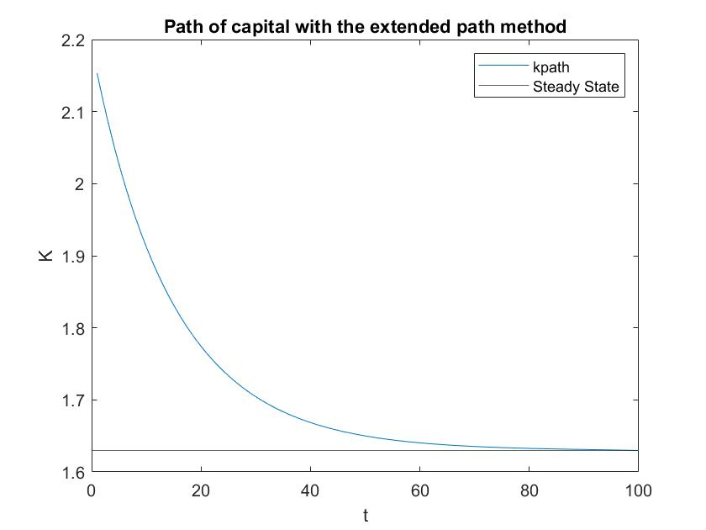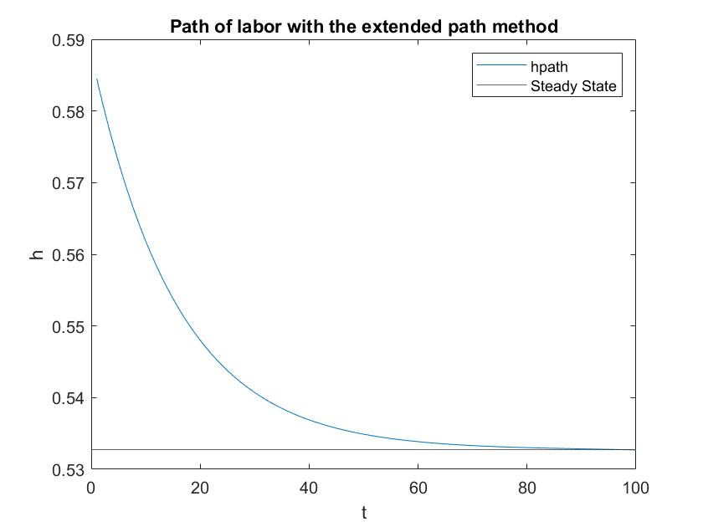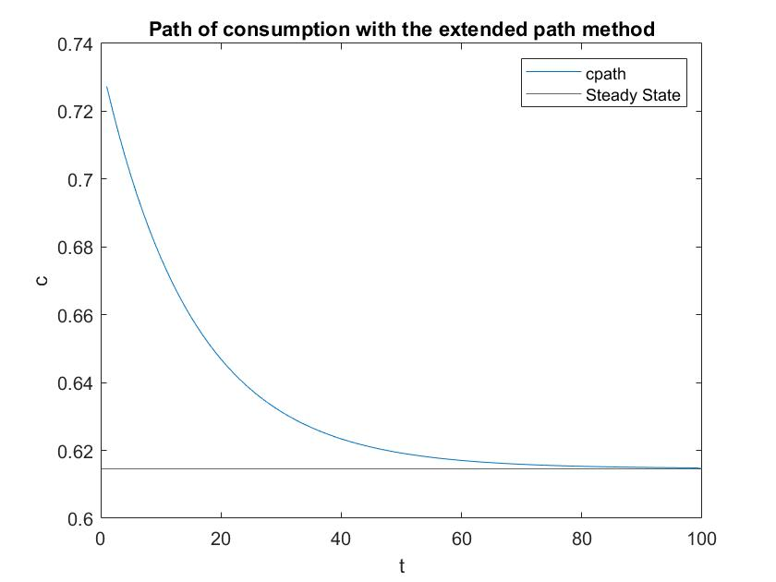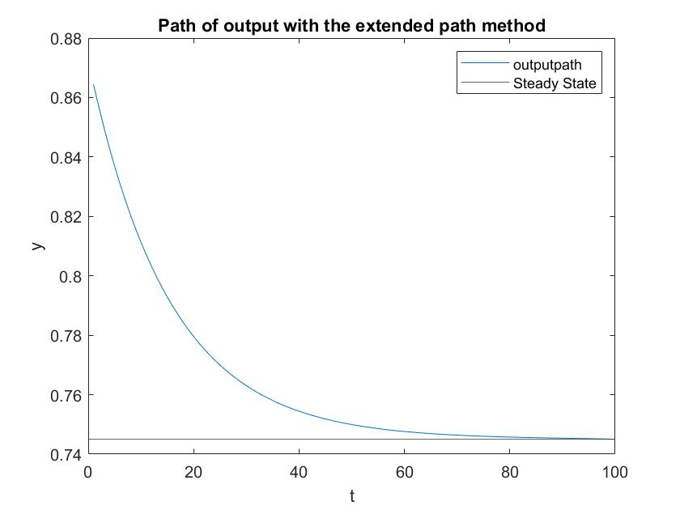

1. *[script main.m]*

Congresswoman T.H.Ink proposal ($t_{k}=0;t_{h}=0.315$)

The new s.s. level are:

Capital: $k^{*}={\left(\frac{1-β+δβ}{βα}\right)}^{\frac{α+θ}{θ*\left(α-1\right)}}*{\left(\left(1-α\right)*\left(1-t_{h}\right)\right)}^{\frac{1}{θ}}=2.0927$

Labor: $h^{*}={\left(\left(1-t_{h}\right)*\left(1-α\right)*k^{*α}\right)}^{\frac{1}{α+θ}}=0.5652$

GDP: $y^{*}={k^{*}}^{α}*{h^{*}}^{1-α}=0.8317$

The percentage increase in fiscal revenues in the s.s. would be $5.59\%$

Fiscal revenues under the first regime: $0.1748$

Fiscal revenues under the congresswoman proposal: $0.1846$

Percentage change: $\frac{0.1846}{0.1748}-1$

Assuming that the starting point of capital is its s.s. level under the first regime ($t_{k}=0.15;t_{h}=0.25$) and the starting point of labor is the value of labor computed with the new tax rates, we can compute the path of the economy to the new steady state. [$k_{1}=2.1534; h_{1}=0.5670$]

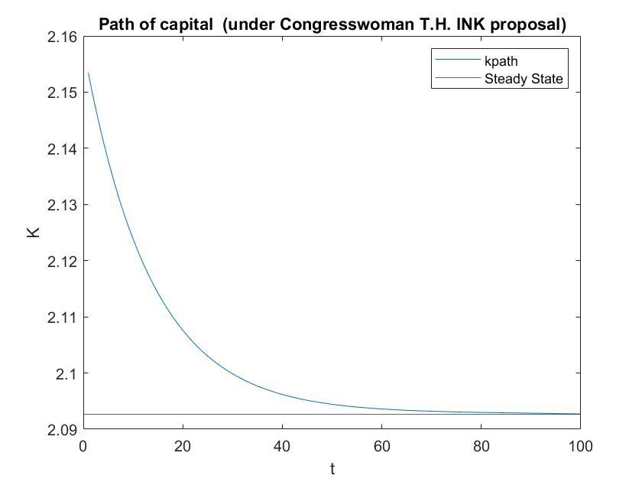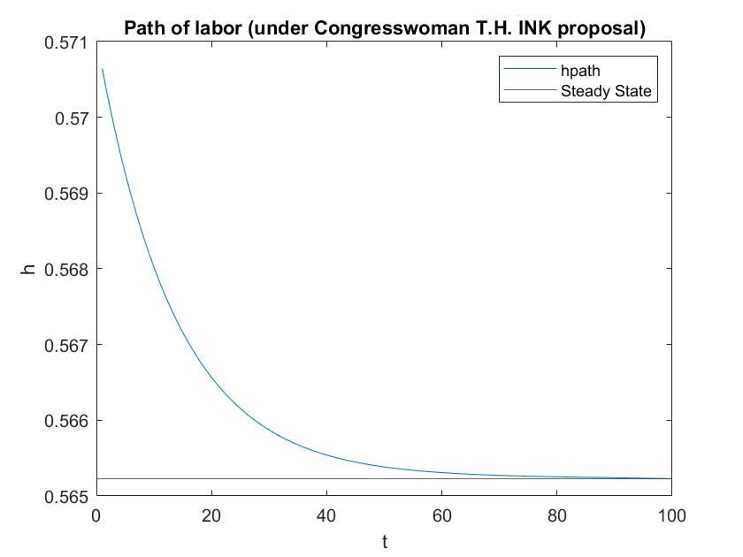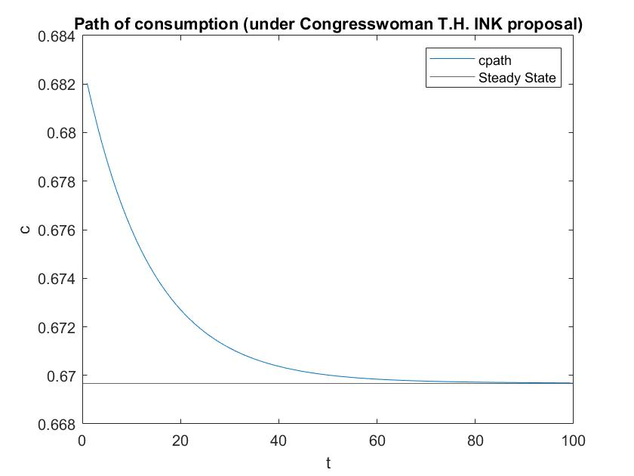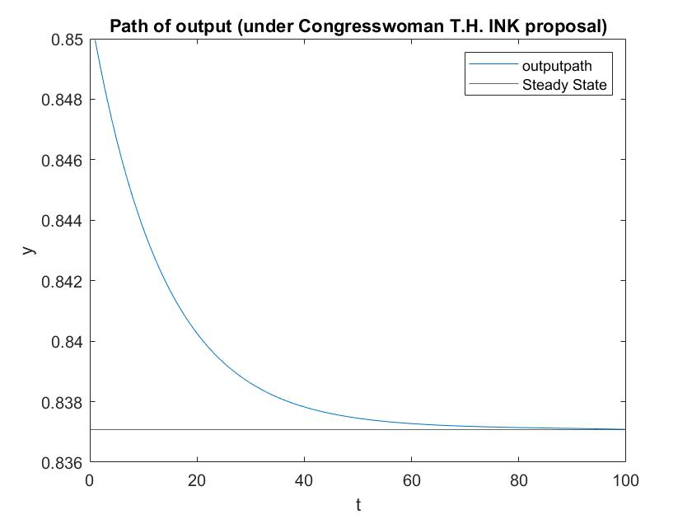

This proposal would increase the GDP in the s.s. w.r.t the one of the President by $0.0921$ units. Moreover, also the welfare in the s.s. is greater: the equivalent variation of consumption in the s.s., under the President’s proposal, to leave the agent’s welfare equal to the one under the congresswoman proposal is $0.0526$.

The congresswoman’s proposal induces also a greater increase in the fiscal revenues. ( $5.59\%$ vs $5.58\%$ increase of fiscal revenues w.r.t. the first regime)

Besides, I computed the lifetime discounted utility of the agent (considering T=100 periods) under the two alternative regimes, in the economy path to the s.s.: the discounted utility under the congresswoman proposal is still greater than the one under the President’s proposal

($-21.9925>-22.3712$). However, the size of the difference has no economic meaning because the utility function is ordinal and not cardinal

Considering the outcomes on the GDP, welfare and fiscal revenues, the Congresswoman is right!

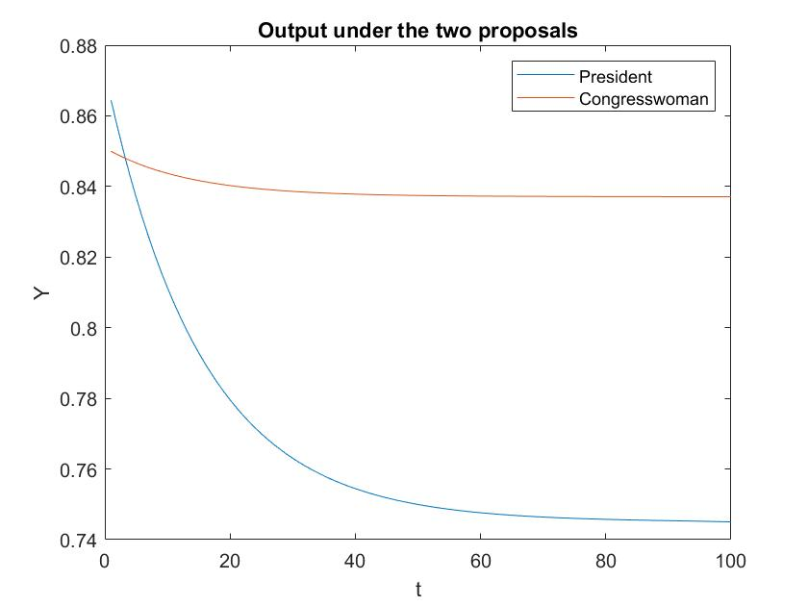

In this graph the output paths to the s.s. under the two different regimes are compared.

As we can see, output under the congresswoman proposal is consistently higher for t>3

1. In the last exercise, I studied this economy under no public intervention ($t_{k}=t_{h}=λ_{t}=0$*).*

*[script noint.m]*

The s.s. level under no intervention are:

Capital: $k^{*}={\left(\frac{1-β+δβ*}{βα}\right)}^{\frac{α+θ}{θ*\left(α-1\right)}}*{\left(\left(1-α\right)\right)}^{\frac{1}{θ}}=3.9315$

Labor: $h^{*}={\left(\left(1-α\right)*k^{*α}\right)}^{\frac{1}{α+θ}}= 1.0619$

GDP: $y^{*}={k^{*}}^{α}*{h^{*}}^{1-α}=1.5726$

Assuming that the starting point of capital is its s.s. level under the first regime ($t_{k}=0.15;t_{h}=0.25$) and the starting point of labor is the value of labor computed with the new tax rates, we can compute the path of the economy to the new steady state. [$k_{1}=2.1534; h_{1}=0.8688$]

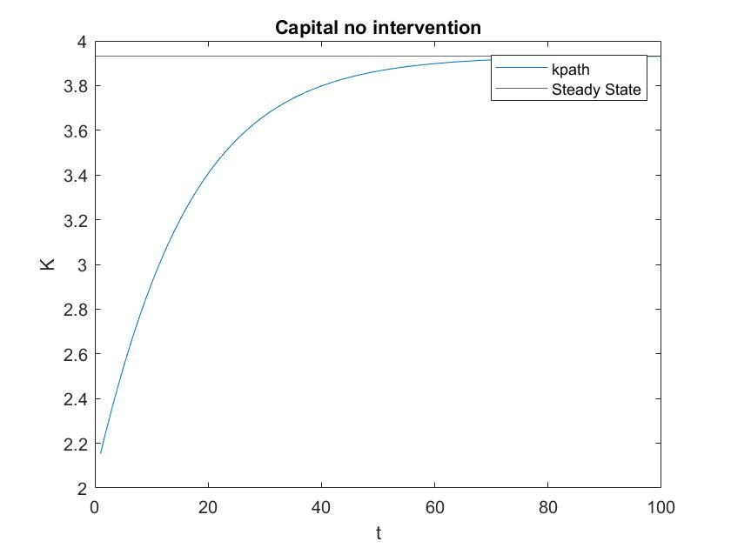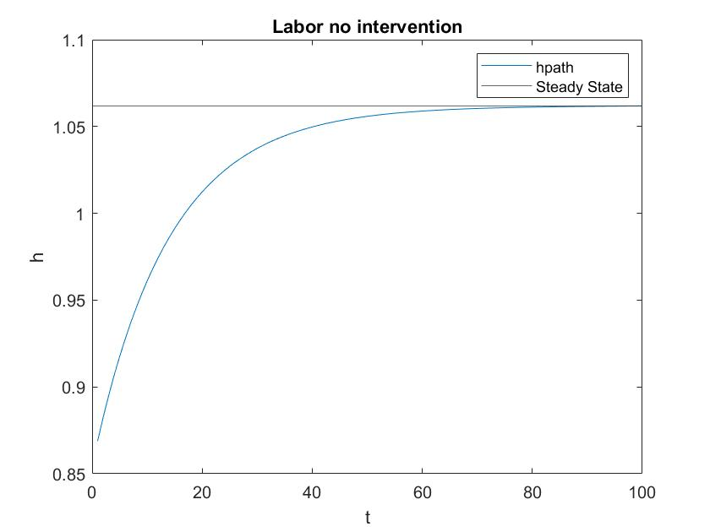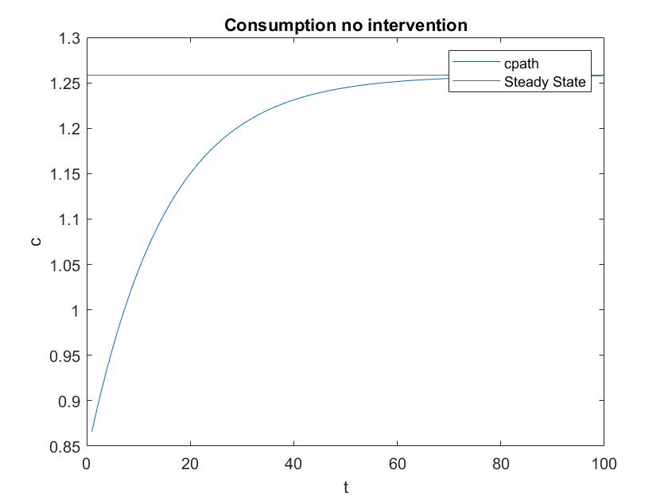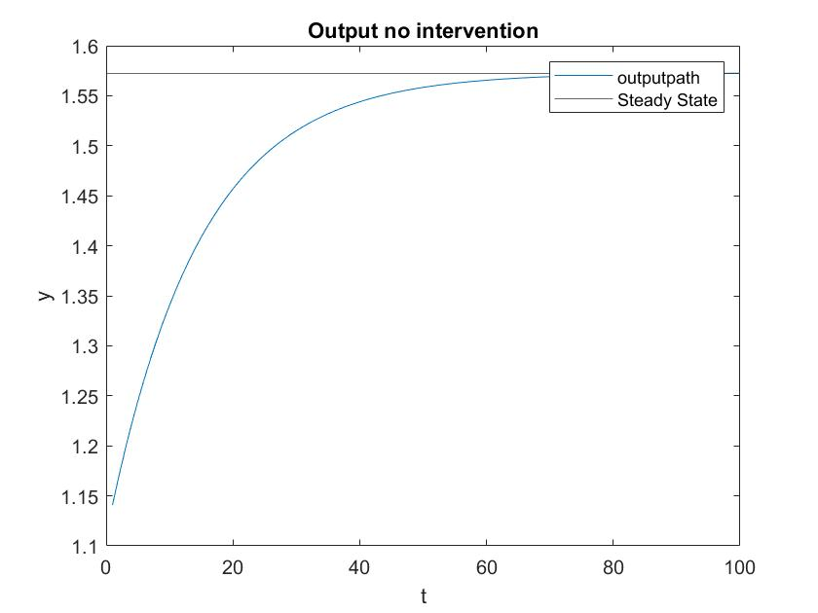

Moreover, I considered different value of the tax rates and computed the fiscal revenues under each combination of fiscal revenues in the steady state. *[script fiscalexperiment.m]*

I plotted the results in a 3D graph and highlighted the combination that maximizes fiscal revenues in the s.s. ($t_{k}=0.02 ;t_{h}= 0.37$)

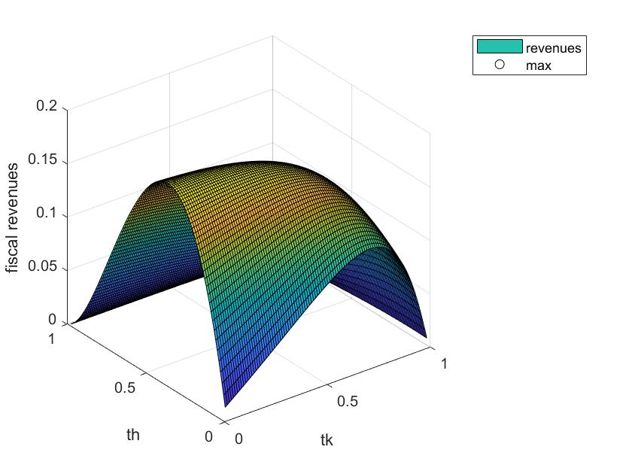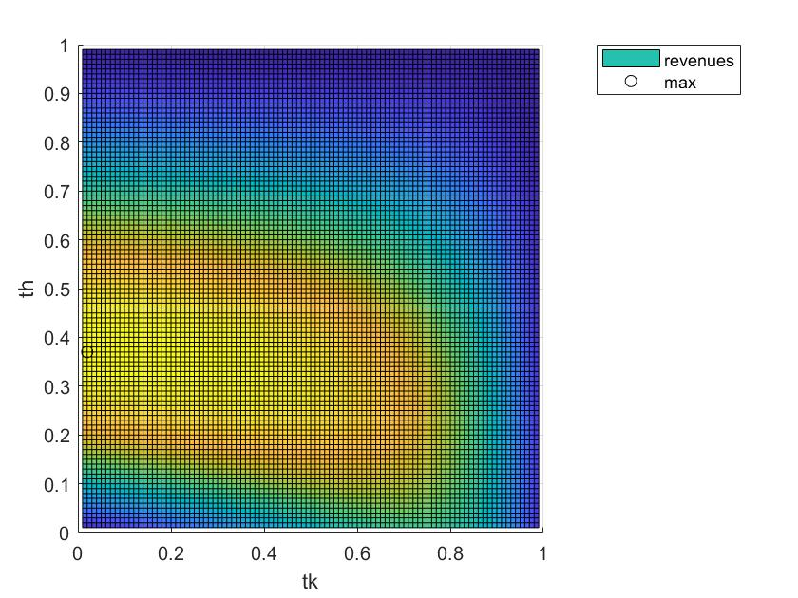

The s.s levels under the regime that maximizes fiscal revenues are:

Capital: $k^{*}={\left(\frac{1-β+δβ*\left(1-t_{k}\right)}{βα*\left(1-t_{k}\right)}\right)}^{\frac{α+θ}{θ*\left(α-1\right)}}*{\left(\left(1-α\right)*\left(1-t_{h}\right)\right)}^{\frac{1}{θ}}=1.7940$

Labor: $h^{*}={\left(\left(1-t_{h}\right)*\left(1-α\right)*k^{*α}\right)}^{\frac{1}{α+θ}}=0.4893$

GDP: $y^{*}={k^{*}}^{α}*{h^{*}}^{1-α}=0.7225$

Fiscal revenues: $t_{h}*w^{*}*h^{*}+t_{k}*\left(r^{*}-δ\right)*k^{*}=0.1886$

Assuming that the starting point of capital is its s.s. level under the first regime ($t_{k}=0.15;t_{h}=0.25$) and the starting point of labor is the value of labor computed with the new tax rates, we can compute the path of the economy to the new steady state. [$k_{1}=2.1534; h_{1}=0.5200$]

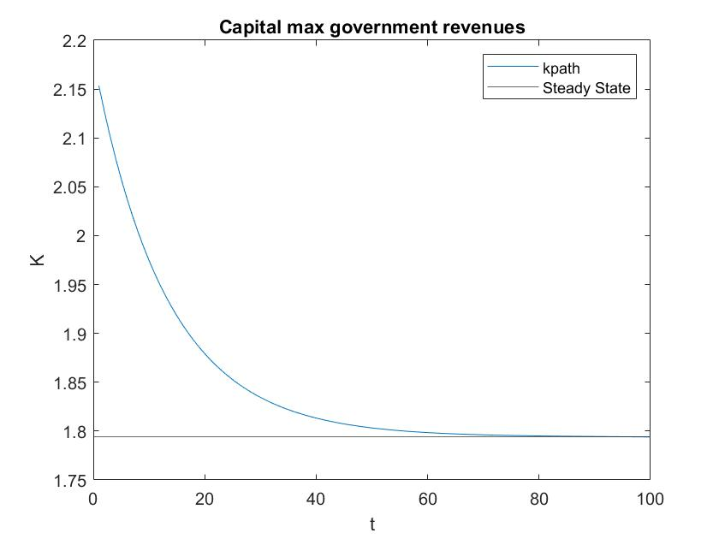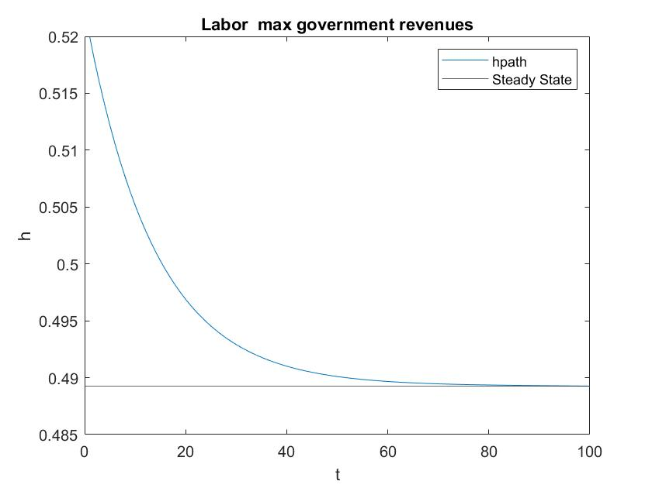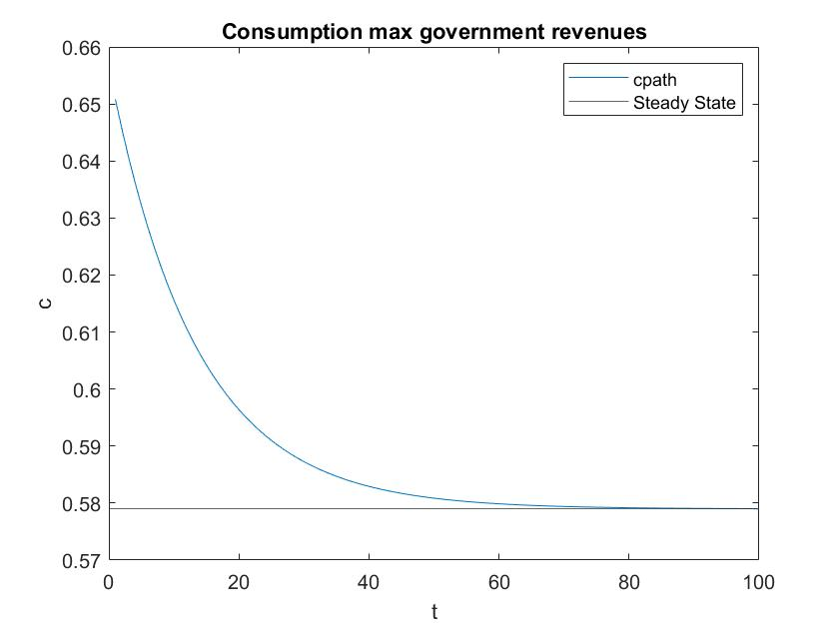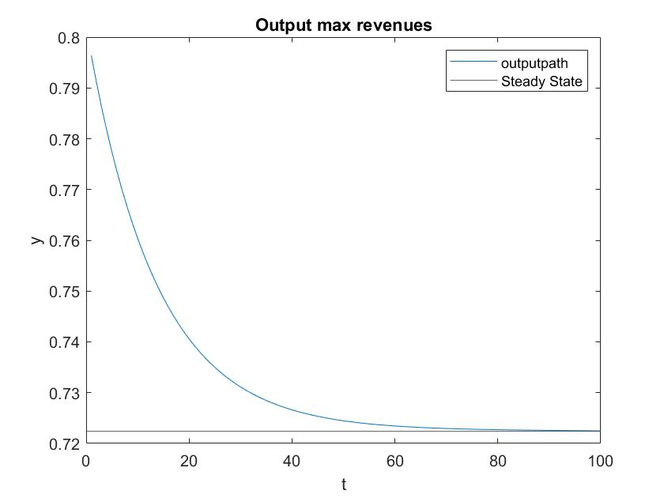

Then, I compare the outcomes under the two regimes (no intervention and max fiscal revenues)

The fiscal regime that maximizes revenues decrease the s.s. GDP by $0.8501$

The compensating variation of consumption in the s.s. under this regime is $0.3286$

Moreover, I plotted the output path under the two regimes: clearly, the regime that maximizes revenues depresses output w.r.t the no intervention regime.

