**Splunk Registration Issue and Workarounds**

**Issue:** During the first activity of SIEMS Week 19, Day 2. If you receive issues when registering for your free Splunk Account, the following document will provide fixes/workarounds.

1) **Issue 1**

**Issue:** US Export Error (Or similar error) appears after trying to register

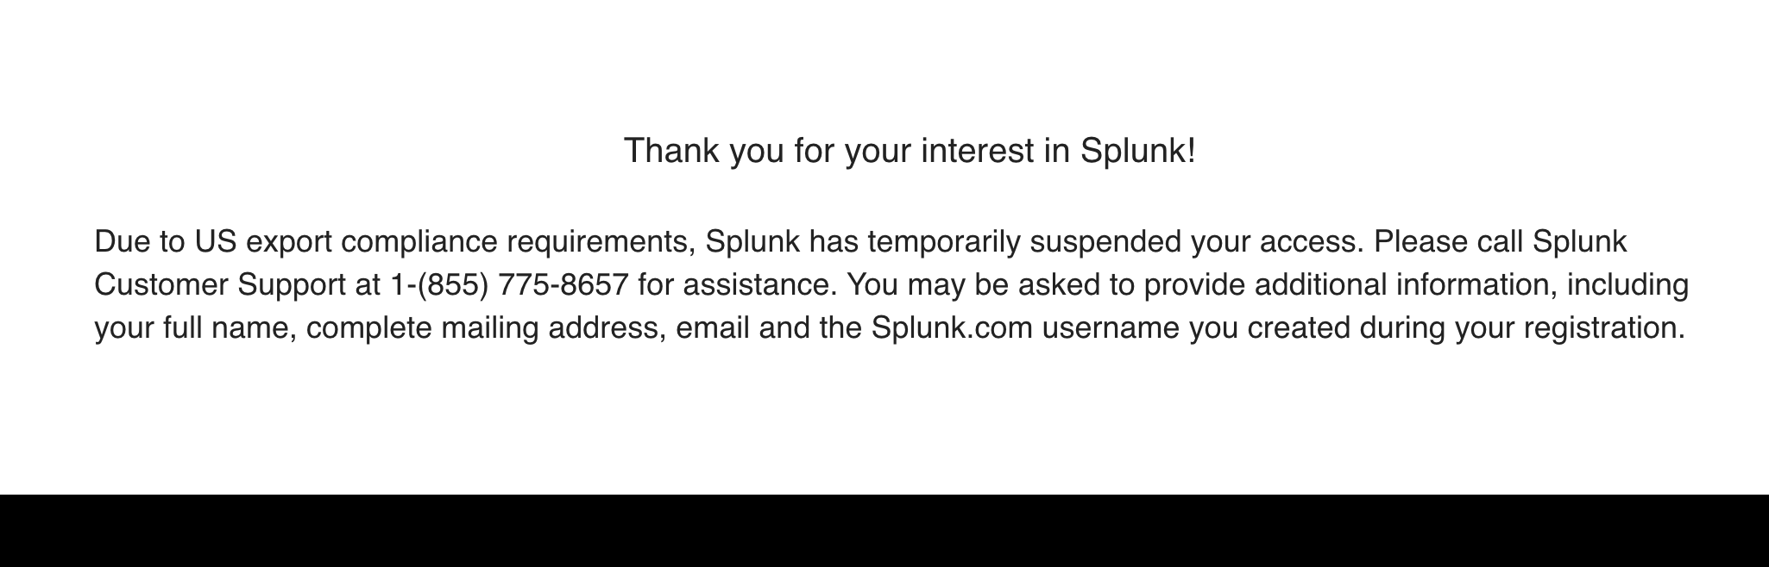

**Workaround/Fix:**

* Login to your Pentesting Azure Lab that was used in the previous lesson.
* Open up a web browser within the main Pentesting Azure Lab and access the same Splunk Registration Webpage: <https://www.splunk.com/page/sign_up/es_sandbox?redirecturl=/getsplunk/es_sandbox>
* Complete the registration on the right side of the page below: **Start Your Free Trial**
* You should receive an email within minutes
* Log out out your Pentesting Lab
* Access your Splunk Account with the Link and Account sent to your email from your regular PC
  + Note: If registration works fine, and you **do not** receive an email within 5 minutes after registering, proceed to Issue 2 Below

=========================================================================

2) **Issue 2**

**Issue:** No email received after successfully registering

If after 5 minutes of registering, you do not receive an email with your Splunk Link/User/Password, follow the below steps:

**Workaround/Fix:**

* Access the following temporary email webpage: <https://10minutemail.com/>
* When pulling up the page, it will provide you a email address for 10 minutes

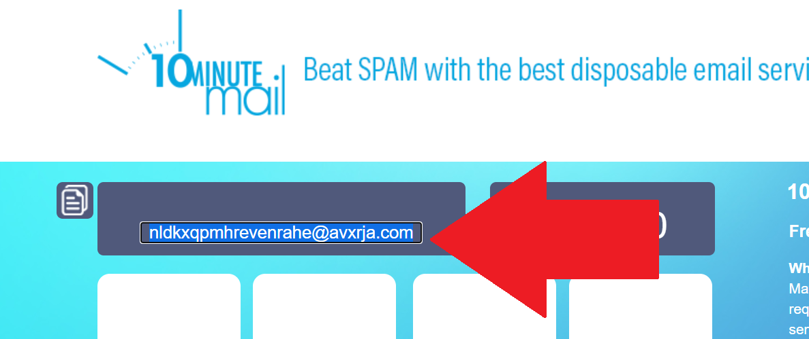

* Use your email provided to register for your Splunk Account at<https://www.splunk.com/page/sign_up/es_sandbox?redirecturl=/getsplunk/es_sandbox>
* Within 5 minutes you should receive your email on the 10minutemail webpage

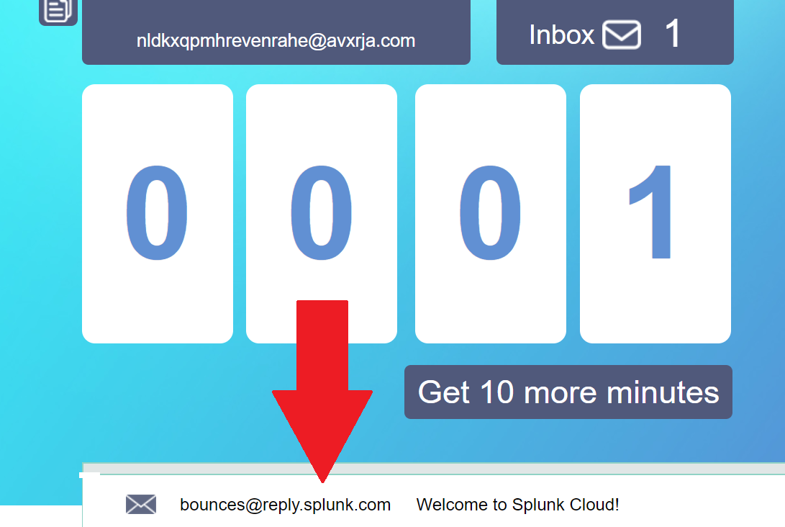

* Follow the steps to login within your email