**Data preparation:**

To structure the data I just created a dictionary containing all the main data that could be of statistical interest (see below):  
  
 **commit = {'revision': details[0].strip(),**

**'author': details[1].strip(),**

**'date': details[2].strip().split(' ')[0],**

**'time': details[2].strip().split(' ')[1],**

**'day': details[2].strip().split(' ')[3][1:4],**

**'number_of_lines': details[3].strip().split(' ')[1]**

**}**

After having created the data structure above, I implemented some line of code to export the parsed data in a .csv file (for simplicity, I exported everything as a string):  
  
 **text_file = open("Output.csv", "w")**

**i=0**

**while i < len(commits):**

**print (i+1)**

**print(commits[i]['author'])**

**print(commits[i]['date'])**

**print(commits[i]['time'])**

**print(commits[i]['day'])**

**text_file.write("%s, %s, %s, %s, %s\n" % (str(i+1), commits[i]['author'],(commits[i]['date']),(commits[i]['time']),(commits[i]['day'])))**

**i = i+1**

**text_file.close()**

I then simply **opened the file in Excel**, **converted** the **format to number/date where needed** (it would be impossible to load the data as all strings on Tableau), and **saved** it **as an Excel .xlsx file**.  
  
Finally, I **imported the file into Tableau for** smooth **data visualization** (see below)

**Tableau Data Visualization**

Analyzing the data through Tableau was simple enough.   
  
The **only small challenge** was **understanding the need of recombining the hour and date** (since **I extracted the date as 3 separated fields: hour, date, day of the week**) in order **to use this attributes smoothly**, on the tool.  
  
Here are my findings:

1. The **2 most productive employee** by far would seem to be **Thomas** and **Jimmy**:  
     
   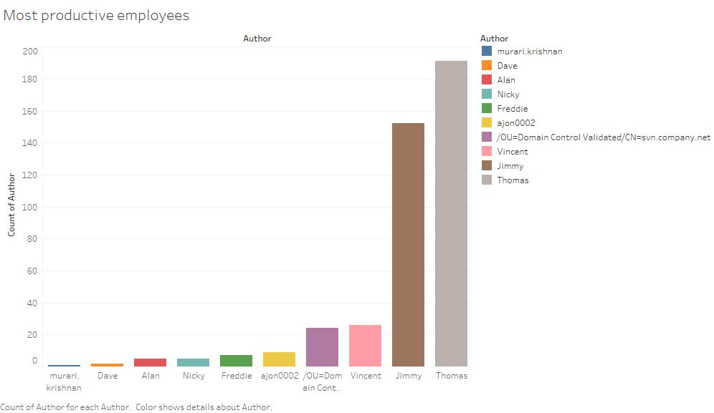
2. The **hours immediately after lunch** seem to work wonders for **productivity**, in terms of numbers of commits:  
     
   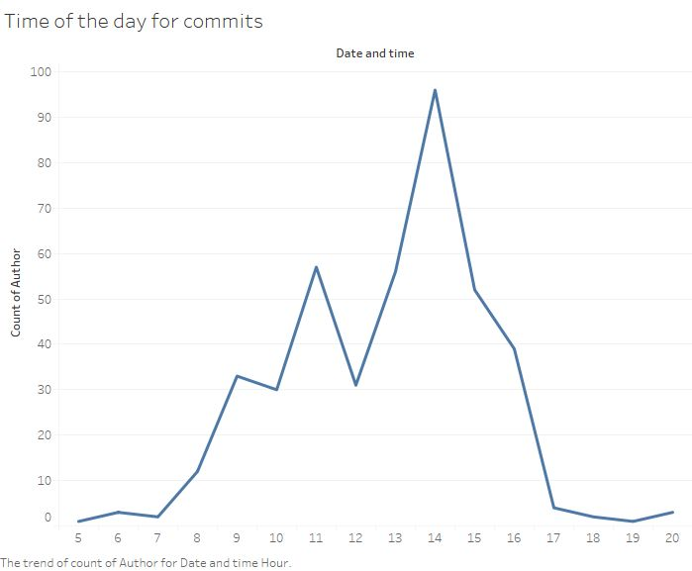
3. The **productivity by day of the week** and **author** is **distributed as follows**:  
     
   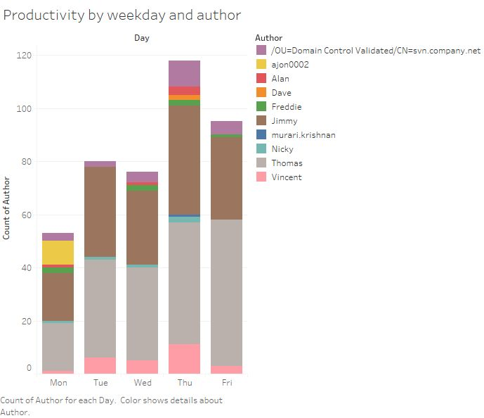

In this histogram we can notice how for example how:  
  
- **Freddie, Dave, Alan and Murari never** seem to **commit** anything on **Tuesday**  
- **Tuesday and Friday** are days in which **only some (5) employees actually commit anything at all**

- **Murari commits only** (and **very little**) on **Thursday**