Project: led_RGB_esp32

PC path = \_WS_ESP32\led_RGB_esp32 (as example)

cd <PC path>

WiFi mode select: AccessPoint(AP) or Station (STA)
Wifi can be set as AP (Access Point), STA(Station) or NO_WiFi (reserved for debug) with following steps:

From IDF terminal issue command idf.py menuconfig, to see command window as shown below.
Select “projbuild Connection Configuration”

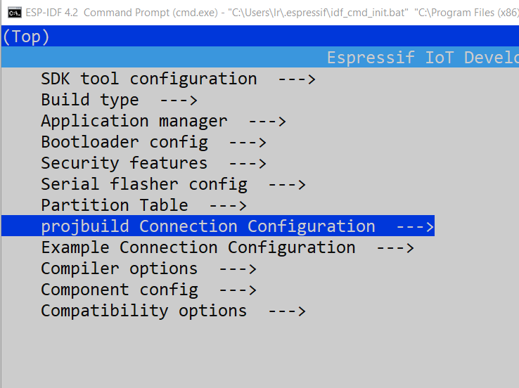
Press ENTER and select WiFi mode
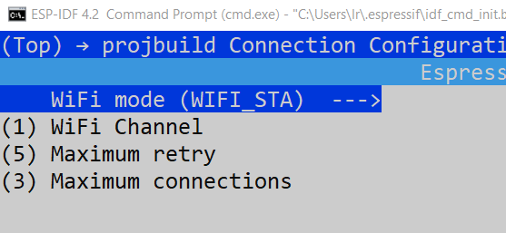

Press ENTER again and choose among WIFI_AP, WIFI_STA, WIFI_NO
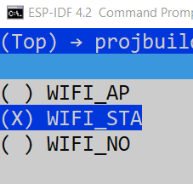

Then press BACK arrow two times to go back to main menuconfig and select item “Example Connection Configuration”
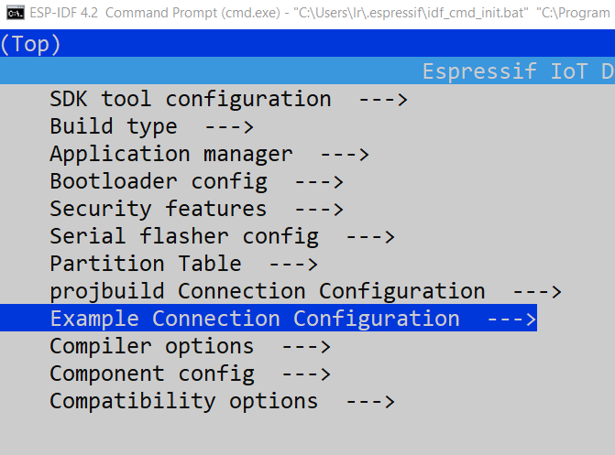
Press ENTER and in new window edit SSID (WiFi network name) and Password by pressing ENTER on each item

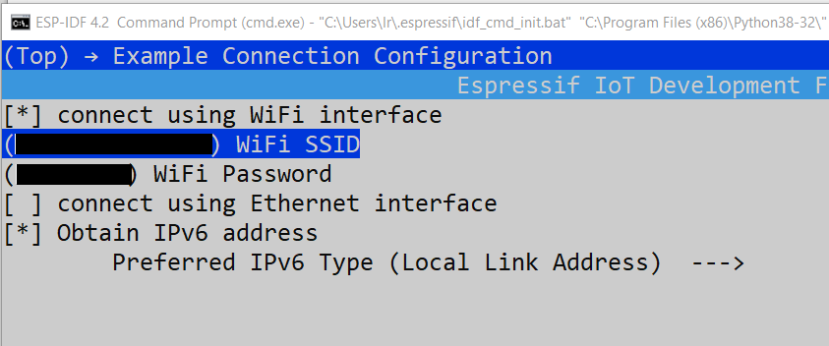

Case of ESP32 configured as AP
If ESP32 is configured as AP (Access Point), there is no need of a router or a network, because the ESP32 itself is the master, and a browser connects with the WiFi SSID and Password which are set with menuconfig as described above, and are:
SSID = ESP32-XXXX (where XXXX is an unique number, coming from MAC address)
Password = 12345678
The Web browser connect to ESP fixed IP address 192.168.4.1
IT IS RECCOMENDED TO CONNECT TO ESP32 (IN AP MODE) USING THE FIXED IP ADDRESS ABOVE, instead of DNS webname.
This because the mDNS server embedded into ESP32 works only with Apple (or iPhones).
If web client is Windows, the Bonjour Print service must be installed to PC.
If web client is Linux, the Avahi service must be installed on PC to resolve mDNS name.

Case of ESP32 configured as STA
If ESP32 is configured as STA (Station), the WiFi SSID and Password are the router access credentials, and must be asked to network administrator. The ESP connect to WiFi network and can be accessed with a Web Browser as http://webesp32

