olfStim Documentation

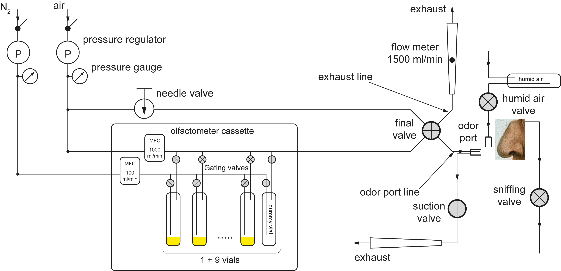

List of hardware

Setting up the hardware

Connecting the valves
LASOM makes assumptions about which valves are connected to which connectors on the LASOM2_V1 board (the board with the connectors for the valves). Therefore always connect the valves, which gate the dummy vial (they’re normally open), to V1 and V2. From V3 to V20 connect the other odor vial gating valves. Connect the gating valves from the N2 stream to the even-numbered connectors, and the gating valves from the air stream to the odd-numbered connectors. The two valves gating one vial have to be connected to two consecutive connectors.
Example: the valve gating the air stream for the first vial has to be connected to V3, and the valve gating the N2 stream for the first vial, has to be connected to V4. For the second vial, the gating valve for the air stream goes into V5, and the N2 equivalent into V6.

The other valves (final valve, suction valve, sniffing valve, or custom valves you want to control) go into valve connectors V21 to V32. You have to define the mapping of valves handled by the olfStim software to the connectors on the LASOM2_V1 board. For the default valves in olfStim the mapping is as follows:

Valve | Connector
Final valve | V31
Sniffing valve | V32
Suction valve | V28
Humidity valve | V27

These definitions are saved in the olfStim/lsq/core.lsq file, section “Configuration Parameters”.

The definition looks something like this:

Param, finalValveIndex, 31;

If you want to change the mapping for the default valves just change the numbers in the parameter definition. 31 in this example means that finalValve is connected to connector 31.
If you want to add new valves and control them through olfStim, read on in the section for developers.

Connecting the Mass Flow Controllers
There are two mass flow controllers, one for regulating the flow of the air stream, the other one for the N2 stream. olfStim currently only supports mass flow controllers (MFC), which can be directly controlled by LASOM control board. These currently include Bronkhorst-type mass flow controllers (MFC), using the digital RS232 interfaces. Tested were the Bronkhorst MFCs IQ-Flow. See parts list for details.
There are two RS232 connectors on the LASOM_C1 board: J21 and J22. The MFC # 1 goes into J21 the MFC#2 goes into J22. OlfStim expects MFC#1 to be the air regulating MFC, and MFC#2 to be the N2 regulating MFC.
MFC # | MFC type | Connector
1 | Air | J21
2 | N2 | J22

Olfactometer - computer connection
Get the latest LASOM package, which includes the driver
Open a command line, go to the RP Metrix foler from the LASOM package and execute the following statement:
regsvr32 lasomx.ocx
You should receive a success pop-up message.

Required testing
Before starting to use the olfactometer with olfStim some initial testing has to be done to make sure, everything works as expected. For this use the LASOM control software “LoadBoard” which can be downloaded from

Understanding the sequencer code

Odor,slaveIndex,odorValveIndex | Command will open the two valves gating the vial defined by odorValveIndex and will automatically close the two valves gating the dummy vial in the slave defined by slaveIndex. ATTENTION: As the two valves gating the vial #2 are connected to V3 and V4, the odorValveIndex of the first vial is 2. The reason is because the dummy valves are connected to connectors V1 and V2. Therefore all valve indices are shifted by 1.
Gate,slaveIndex,valveIndex | Command will open the valve connected to the connector defined by valveIndex on the slave defined by slaveIndex.  Gate,1,3 will open the valve connected to connect V3 on slave 1.

Start pogram in matlab by
>> initOlfStim

In the olfactometerSettings panel the times of valves opening & closing can be entered manually for each trial. Also multiple opening and closing times are allowed. This can be done by entering two values in square brackets (matlab vector notation). For instance entering [3 6] in the open sniffing valve and [5 8] in the close sniffing valve field will result in the sniffing valve opening at 3 s, closing at 5s, opening again at 6 s and closing again at 8 s.
Note however that at the end of the trial the resting state has to be reestablished. Which means you have to close/unpower every valve you open/power.

For users

Setting up olfStim in Matlab
Add the olfStim folder with it’s subfolders to the Matlab path (Matlab – File tab – Set Path – Add with subfolders). If you checked out the olfStim package from a version tracking system (Mercurial, svn, git,…) make sure you delete all the of the subversioning system from the Matlab path. For example if you used Mercurial on Linux and Mac there will be a bunch of folders starting with .hg/ - these folders should not be on the Matlab path.

Protocols

Cleaning
Start by filling all vials with Ethanol.

For Developers

