## Introduction

The Rocket Switch Interface is a USB switch interface device which enables users to operate their computer or smartphone devices using assistive switches. Up to two assistive switches with 3.5 mm connections can be used. When a connected assistive switch is activated, a keystroke or mouse click will be generated depending on the operating mode. The Rocket Switch Interface can operate in three different modes, and has an adjustable reaction time.

## Features

### Switch Inputs

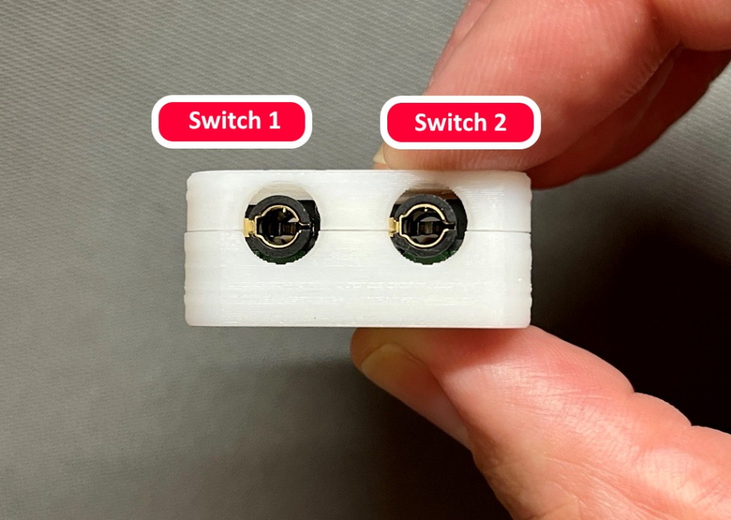

### Type-A USB Connector

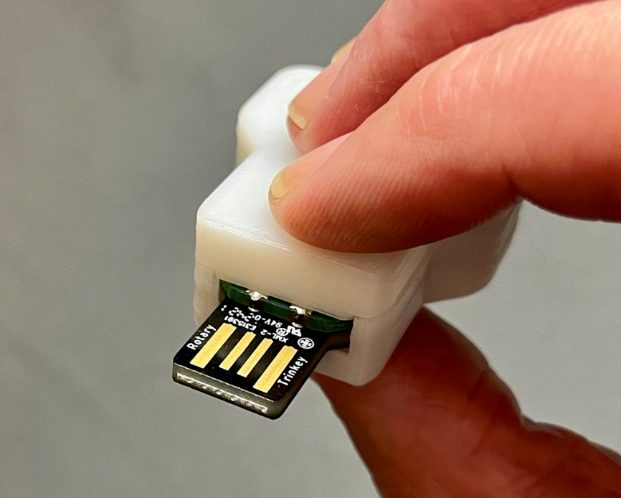

### LED Indicator

## Usage

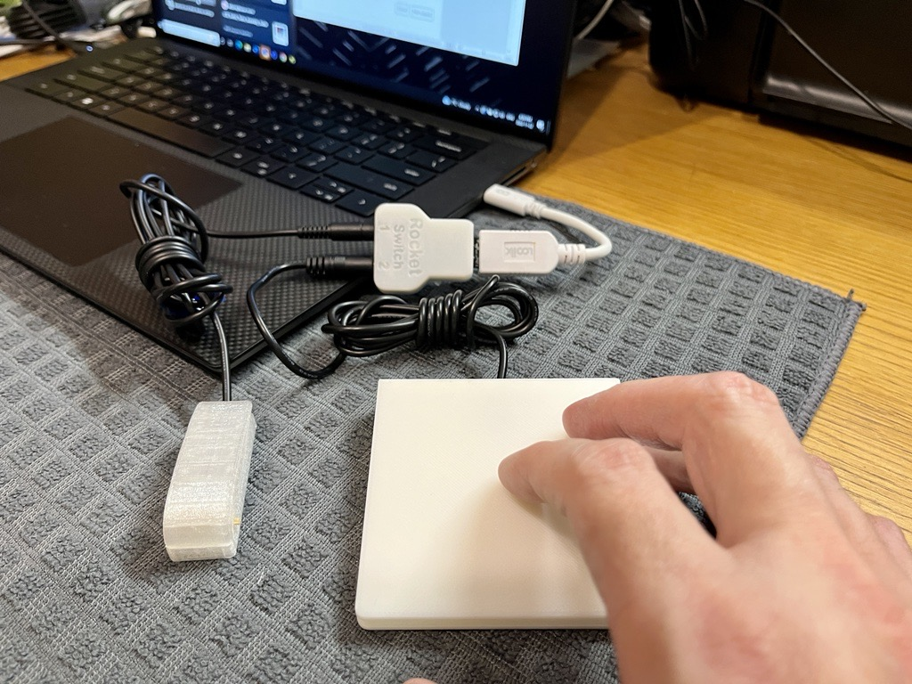

### Setup

1. Connect an assistive switch to the 3.5 mm audio jack labelled ‘Switch 1’.
2. Connect a second assistive switch to the 3.5 mm audio jack labelled ‘Switch 2’.
3. Locate a USB type A ports on the host device. You may need an adapter cable if your device doesn’t support USB type A.
4. Plug the USB connector of Rocket switch interface to the located USB type A port on your computer or smartphone device.
5. The side mounted LED should turn on, and stay in a teal color, to indicate the device is ready to use.

### Selecting Mode

There are three operating modes and a fourth mode for adjusting the reaction time. The operating mode is indicated by the color of the LED. The operating mode can be changed by cycling through the modes, this is done by pressing and holding Switch 1 for 4 seconds.

|  |  |  |  |  |
| --- | --- | --- | --- | --- |
| **Operating Modes** | | | | |
| **Mode** | **Mode** | **Switch 1 Action** | **Switch 2 Action** | **LED Color** |
| 1 | Switch | A Key | B Key | Teal |
| 2 | Switch Mac | F1 Key | F2 Key | Pink |
| 3 | Mouse | Left Click | Right Click | Purple |
| 4 | Settings | Decrease Reaction Time | Increase Reaction Time | Orange |

### Feedback

When a connected assistive switch is pressed, the LED will provide visual feedback.

|  |  |  |  |
| --- | --- | --- | --- |
|  | | **Visual Feedback** | |
| **Input Action** | |
| Short Press | Long Press (> 4 Seconds) |
| **Input** | Switch 1 | Red | Mode Color (Teal, Pink, Purple, Orange) |
| Switch 2 | Blue | n/a |

### Changing Reaction Time

The Reaction Time can be changed to suit the user’s preferences. The default reaction time is 100 ms. There are 10 different options for Reaction Time.

1. Press and hold Switch 1 for 4 seconds to cycle through the operating modes. Repeat until the LED turns Orange.
2. Short press Switch 1 or Switch 2 to decrease or increase the Reaction Time.

|  |  |  |  |
| --- | --- | --- | --- |
| **Adjusting Reaction Time** | | | |
| Input | Action | LED |
| Switch 1 | Decrease Reaction Level | Blinks Red |
| Switch 2 | Increase Reaction Level | Blinks Blue |

1. Press and hold Switch 1 for 4 seconds to return to the desired operating mode.
2. The number of LED blinks indicates the reaction level ( Example: 5 Blinks indicates reaction level 5)

|  |  |
| --- | --- |
| **Reaction Time** | |
| Reaction Level | Reaction Time |
| 1 | 500 ms |
| 2 | 450 ms |
| 3 | 400 ms |
| 4 | 350 ms |
| 5 | 300 ms |
| 6 | 250 ms |
| 7 | 200 ms |
| 8 | 150 ms |
| 9 (Default) | 100 ms |
| 10 | 50 ms |

1. The LED blinks six times in a yellow color when the updated reaction level reaches minimum or maximum reaction level.

## Compatibility

|  |  |
| --- | --- |
| **Compatibility** | |
| Operating System | Compatible |
| Windows | Yes |
| Mac | Yes |
| Android | Yes |
| iOS | Yes |

## Specifications

Dimensions: 51.1 mm x 33.5 mm x 14.5 mm

## Cleaning

The Rocket-Switch-Interface can be wiped down with a damp cloth Do not submerge the device. Do not expose to high heat.