Differential equation solvers + Laplace v. 2.05

for TI-92/TI-92II/ TI-89/TI92+

When installed using TI-Graph Link the files will be placed in a folder named "dif". Before using the functions make the "dif"-folder to the current folder. Do not create any variable in the "dif"-folder.

The package include following programs and functions:
Install | Prepare the programs for archiving and archiving them.
Help | Online help to programs.
SlvD | Differential equation solver.
Chk | verifying the results from SlvD
SimultD | simultaneous differential equations solver
Laplace | Laplace transformation
iLaplace | Inverse Laplace transformation.

Other files in the package are all sub functions or data for above functions.

Archiving on TI-89 and TI-92+

Install

All variables can be archived on the TI-89 and TI-92+. Functions and programs can also be archived, but first after they have been used one time each. If the programs have not been run before archiving, the calculator has to compile them each time they are used, this will slow down the execution time of the programs.

The Install program will perform this preparation and archiving. Just execute following command from the command line: dif\install(). The install program "install()" and it's sub program "archiv()" can be deleted after installation.

Help

Syntax: Help()

This program will give online information about and demonstrate the use of functions in this package. When you do not need this program any longer just delete it and the data file "hlp".

Functions in help | key
Scroll left | left arrow
Scroll right | right arrow
Scroll down | down arrow
Scroll up | up arrow
Page down | 2nd down arrow
Page up | 2nd up arrow
Jump between main help items | F1 – F7
Chose sub menus | 1 – 9

Differential equation solver

SlvD

This solver will find the solution to most common differential equations.

The methods the program is using can basically be split up in two types:

- Reducing the order, recognising the equation type and solving using formulas.
- Separable equations
- Linear first order equations
- Bernoulli's equations
- Exact equations
- Homogeneous equations

- Linear, (non)homogeneous and Euler or Cauchy equations are solved using either Laplace or a general solution method, which has no name. These methods can solve any equation of mentioned types only limited by the calculator’s ability to handle the result.
- Linear, homogeneous 1-9th order equations
- Linear, nonhomogeneous 1-9th order equations
- Euler or Cauchy 1-9th order equations

NOTE: TI-89/TI-92+ can solve single differential equation with an order<3.

Syntax for solver:

SlvD(equation, independent var, dependent var)
SlvD({equation, t0, y(t0), y’’(t0), y’’(t0), y’’’(t0), ......}, independent var, dependent var)

The result when solving without initial conditions will contain constants with the name cc1-cc9, which are arbitrary constants.

Following constant names is reserved for the program and may not be used in equations or initial conditions: cc1-cc9 and all constants with two or more characters starting with a Greek char.

Equation:
A derivative of a function is written: 'prefix'+name+order. The default prefix is the letter 'd', but storing another letter in the variable "dif/prefix" will change it. The order can be a number from 1-9.

Example where the function name is y:
y is written "y"
y’ is written "dy" or "dy1"
y’’ is written "dy2"
y’’’ is written "dy3"
...
...
y''''''''' is written "dy9"

Initial conditions
t0 is the initial time for all conditions
y(t0) is the wanted result if solution is evaluated to time t0
y’(t0) is the wanted result if solution is differentiated and evaluated to time t0
...

Examples of solving equations without initial conditions.

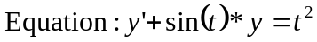Example 1: solving a linear first order equation

On the command line write:

slvd(dy+sin(t)*y=t^2,t,y)

Result on the home screen:
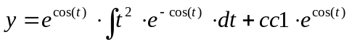
Where cc1 is an arbitrary constant.

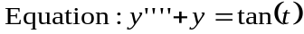Example 2: Linear, nonhomogeneous fourth order equation

On the command line write:

slvd(dy4+y=tan(t),t,y)

Result on the home screen:
Too big to write down

Example 3: general solutions to Linear, nonhomogeneous second order equations.

On the command line write:

slvd(dy2+a*dy+b*y=r(x),x,y)

Result:

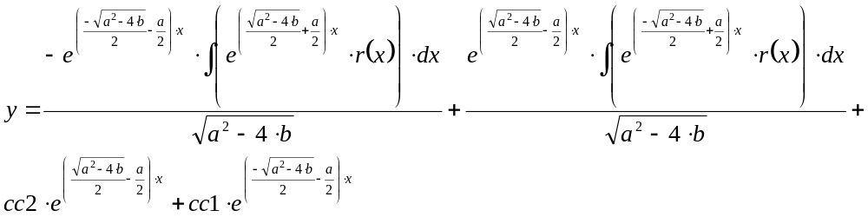

Examples of solving equations with initial condition.

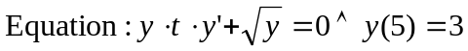Example 1: separable equation

On the command line write:

slvd({y*t*dy+√(y)=0,5,3}, t, y)

Result on the home screen:
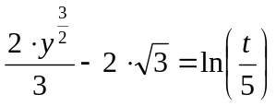

Example 2: third order linear equation

On the command line write:

slvd({dy3+12*dy2+36*dy=0 0, 3, 1, -7}, t, y)

Result:
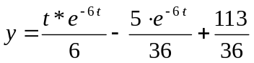

Check solutions from SlvD

Chk

Verifying the solutions from SlvD by inserting them into the original equation. It can only verify a solution, if it can isolate the dependent variable. If there is more than one solution, then it will only verify the first solution it finds.

This function can check many solutions, but not all. The solution may be too complex to that it is possible to isolate the dependent variable or the solutions may be so big that the calculator runs out of memory when trying to insert the solution in the equation. In the complex case the only way to check the result may be to manually try to isolate the dependent variable and insert the found solution in to the equation. In the case where the solution is to big for the calculator to handle it may be necessary to us one of the math programs to PCs to check the result.

Chk(equation, independent var, dependent var, solution from SlvD)
Chk({equation, t0, y(t0), y'(t0), ...}, independent var, dependent var, solution from SlvD)

Return: solution from SlvD inserted in the original equation.

Simultaneous differential equation solver

SimultD

Solving multiple simultaneous differential equations. The Principe in this function is, first it will transform the equations in to the Laplace-domain and second it solves the equations as a system of linear equations, third it transforms the solutions back to the time-domain (see Laplace/iLaplace for further information about Laplace-transformation).

There are very few rules to obey when using SimultD. First, there has to be an equal number of equations and unknown variables. Second, the variable has to be a function of the type f(var).
Equations do not need to be of same order. In Principe SimultD can solve any number of simultaneous differential/integral equations of any order or mixture of different orders, if there are a sufficient number of equations. The only limitation is the size of the calculator's memory (if it is a very complex solution, it can run out of memory).

Following constant names is reserved for the program and may not be used in equations or initial conditions: 's' and all constants with two or more characters starting with a Greek char.

Heaviside/Dirac delta functions may be used in equations (see Laplace/iLaplace for further information).

Syntax: SimultD

SimultD([equation1;equation2;...], [f1(var),f1(0),f1'(0),..;f2(var), f2(0),f2'(0),..;f3(var).. ])

equation1; equation2;..... | Differential/Integral equations separated by ';' . A derivative of a function is written: d(f(x),x,n) where "d()" is the normal differentiation function on the calculator and 'n' is the order. Integrals of a function is written: ∫f(x),x) or d(f(x),x,-n). Where ∫() is the calculators normal integral-function.
f1(var), f1(0), f1’(0),.... | Functions to solve for and belonging initial conditions separated by ';'.

Example 1:

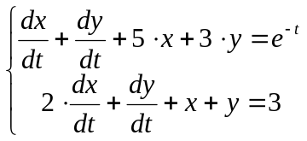Solve for t>=0 the first-order simultaneous differential equation

Initial conditions x=2 and y=1 at t=0

First store the equations in a variable:

[d(x(t),t)+d(y(t),t)+5*x(t)+3*y(t)=e^(-t); 2*d(x(t),t)+d(y(t),t)+x(t)+y(t)=3] ->m1

Result:
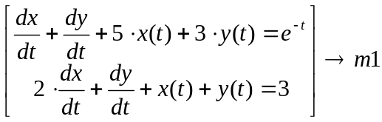
To solve the equations on the command line write:

SimultD(m1, [x(t),2;y(t),1])

Result on the home screen:
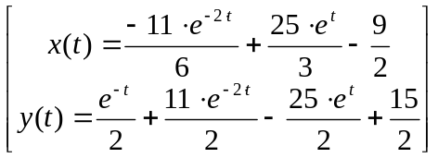

Laplace transform

Laplace

Function, which will perform Laplace transformation.

Following constant names is reserved for the program: all constants with two or more characters starting with a Greek char.

Syntax: Laplace(f(var), var)

f(var) | Can be almost any expression, which have a Laplace transform.
var | Is the name of the variable to transform normally 't', but can be any name.

Special transforms:
Unit step function (Heaviside function):
Laplace(u(t - a),t) = e^(-a*s)/s

Dirac delta function:
Laplace('delta'(t - a),t) = e^(-a*s)

Functions/derivatives of functions: only f(var)
Laplace(d(f(t - a),t,2),t) = s^2*f(s)-s*f0-f1

You can get 'delta' by pressing 'green diamond' + G + D on TI-92.

Example 1: Find the Laplace transform of sin(t)^2

On the command line write:

Laplace(sin(t)^2,t)
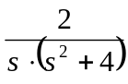
Result on the home screen:

Example 2: Find the Laplace transform of cos(t)*u(t-4)

On the command line write:

Laplace(cos(t)*u(t-4),t)

Result on the home screen
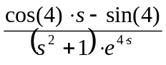

Inverse Laplace transform

iLaplace

Function, which will perform Inverse Laplace transformation.

Following constant names is reserved for the program: all constants with two or more characters starting with a Greek char.

This is a special inverse Laplace function, designed to use in connection with solving of differential equations or equal. It does NOT return Dirac Delta or Heaviside functions. If there is a need for those use the inverse Laplace function from Laplace89/Laplace92.

Syntax: iLaplace(F(var), var):

F(var) | can be any proper fraction.
var | is the name of the variable to transform normally 's', but can be any name.

This function cannot transform integrals.

Special transforms:
It can transform all functions, which does NOT have a point in which it goes against infinity. The result of the transformation will be wrong, if the function does not obey this rule.

Examples of special function, which can be transformed:
sin(f(s))/g(s) (sinus does in no point goes against infinity)
cos(f(s))/g(s)
exp(s^n)/g(s) where n={1,2,3,4....}
...

Examples of special function, which can NOT be transformed:
tan(f(s))/g(s) (limit(tan(f(s)),f(s),pi/2+n*2pi)=infinity)
arctan(f(s))/g(s)
ln(f(s))/g(s)
exp(1/s^n)/g(s)
...

Example 1:
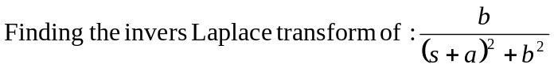
On the command line write:

iLaplace(b/((s+a)^2+b^2),s)

Result on the homescreen:
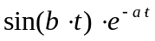

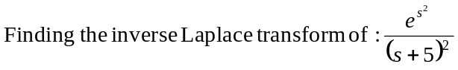Example 2:

Write on the command line:

iLaplace(e^(s^2)/(s+5)^2,s)

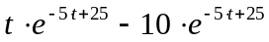Result on the home screen:

About the files in the package

These programs are quit big if you do not need them all, some space can be gained by deleting some of the files. The following list tell which files are used by the individual functions:

Function/  Program | Operation | Files
SlvD | Separable equations, Linear first order equations, Bernoulli's equations, Exact equations, Homogeneous equations. | slvd, nlin1,xfml2, prefix
SlvD | Linear, homogeneous 2-9th order equations, Euler or Cauchy 2-9th order equations. | slvd,prefix,nlin2,xfml,xeul,int1,xfun1,xfun2,xfun3,xnum, xnum1
Laplace | Laplace transformation | laplace, lapsub
iLaplace | inverse Laplace transformation | ilaplace,int1, xfun1,xfun2,xfun3,xnum
SimultD | Simultaneous differential equations | simultd, laplace, lapsub, ilaplace, int1, xfun1,xfun2,xfun3,xnum
Help | Online help | help,hlp
Chk | Checking results from SlvD | chk
Install | Installation program | install, archiv

An example: if you have a TI-92/TI-92II and only want a solver like the DESolve of the TI-89/TI92+ then all files except slvd, nlin1, xfml2 and prefix can be deleted.

About

Author: Lars Frederiksen
Email: ltf@post8.tele.dk

Other programs:
Name | Description | Calculator
Laplace92/Laplace89 | advanced Laplace/inverse Laplace transformation | TI-89/TI-92/TI-92II/TI-92+
Fourier | Fourier/inverse Fourier transformation | TI-89/TI-92/TI-92II/TI-92+
inverseZ92 | inverse Z-transformation | TI-92/TI-92II

PS: Please do not ask for more programs

