Class04.R

lorettacheng

2023-04-13

x <- 1:50  
plot (x, sin(x))

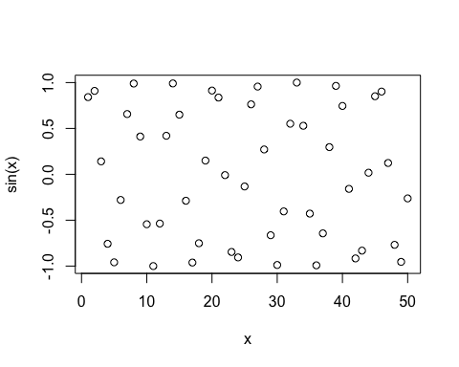

plot (x, sin(x), typ="l", col="blue", lwd=3, xlab="Hello there")

