[Adding and mapping images](http://vconfluence.ads.volusion.com/display/Product/Adding+and+mapping+images)

Add an image to a topic

When it's time to add a new image to a topic, this is how you do it.

1. Save the image file to the**\\corp\fileshares\Public\Documentation_Image_Library**folder you use for images.
2. In Flare, in the topic, select **Insert > Image**.  
   In the **Insert Image** dialog box, under **Select File**, click the browse button and go to**External Resources > Documentation_Image_Library > {folder}**.
3. Select the file and click **Open**.
4. Click **OK**.
5. In the **Copy to Project** box, select **Keep files synchronized (create mapping)**. Verify **Add to Source Control** is selected and click **OK**.
6. Click **Check Out**.
7. Click **Save**. Move the image from **Content > Resources > Images** to**Content > article_files**. *By default, Flare puts images in the Images folder. It's very annoying.*
8. Check in all to source control.

**Important!** When you opened the External Resources, was it empty? If so, you need to create a new mapping to the Image Library:

1. Click View and select External Resources. Depending on your window size, the button may be small or large.

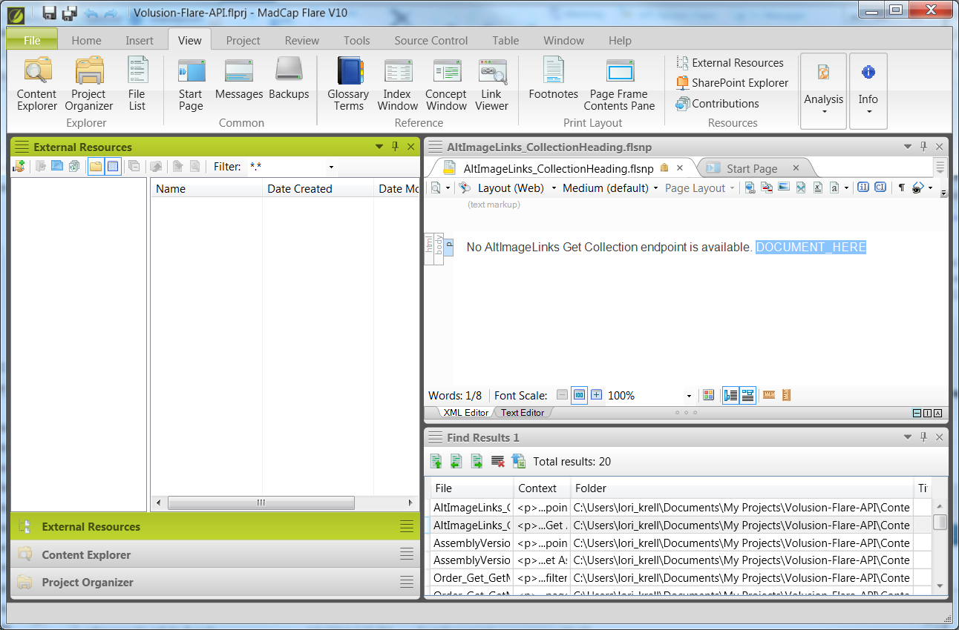

1. In the External Resources toolbar, click the http://webhelp.madcapsoftware.com/flare7/Content/Resources/Images/add_new_external_resources_folder_btn.jpg button.
2. A window opens to locate the folder you want to add. You may have to expand Computer to see it. Browse to the doc folder we want: P:\Documentation_Image_Library folder.

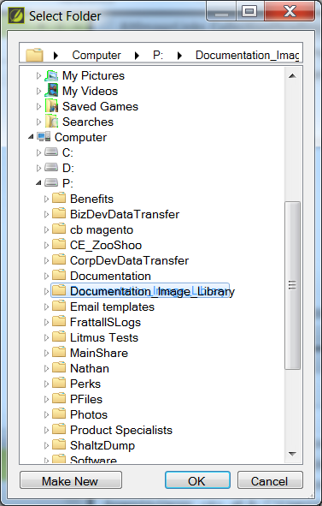

1. Click Ok. This will add the mapping.
2. Now try the instructions above for adding an image file! You should see the location in the External Resources area.

Modify image size for print

To make sure the image will scale for PDFs and other print outputs, this is how you do it.

1. Right-click the image and select **Edit Image**.
2. In the left pane, click **Print Size**.
3. Under **Maximum Size**, select **Length**:
4. Enter **6.5** and select **inches (in)**.
5. Click **OK**.

Modify image file

When it's time to change an image, this is how you do it.

1. Navigate to the image file in**\\corp\fileshares\Public\Documentation_Image_Library.**
2. Open the image file in your image manipulation tool of choice, make your changes, and save them.
3. In Flare, on the **Project** ribbon, click **Synchronize Files**.
4. In the **Synchronize Files** dialog box, your image should appear in the list. Click **Synchronize**.