# Import a Flare Project from TFS

You should follow these steps when importing a current Flare project from TFS. These are not the steps for uploading a project to TFS (see later content).

**ACCESS!** You must have been added to the Flare TFS group: CORP\TFS_CE. This group grants TFS access to $/Volusion/Flare. Heather Sessom and Bob Hardister can help when troubles arise!

Onward!

1. Open Flare.
2. Click **File** > **Source Control** > **Import Project**. A wizard opens.

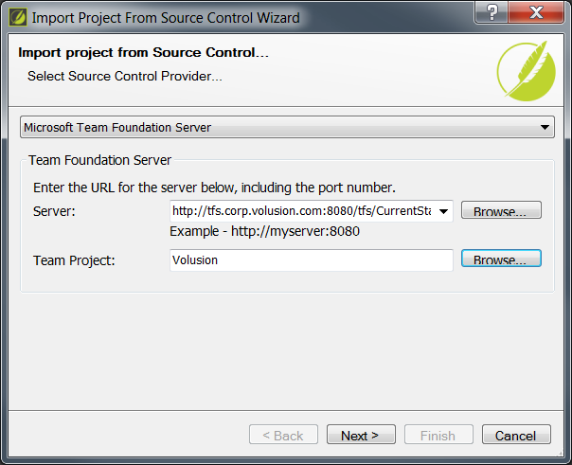

1. For the **Server** type in: http://tfs.corp.volusion.com:8080/tfs/CurrentState Project Collection/
2. For Team Project, click **Browse** and select **Volusion** from the list.
3. Click **Next**.

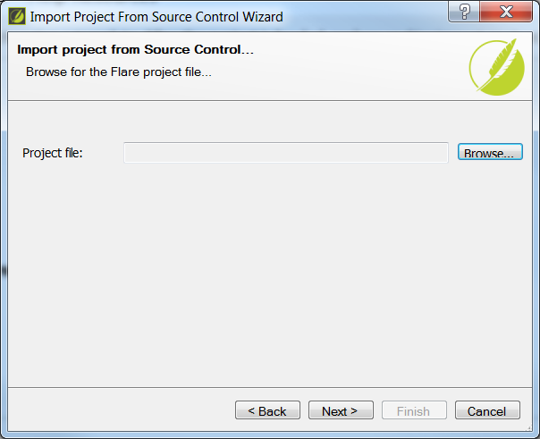

1. For Project file, click **Browse** and drill through the folders until you see and select the following file: **Volusion**>**Flare**>**Trunk**>**Volusion-ClearHelp1**\**Volusion-Flare.flprj**

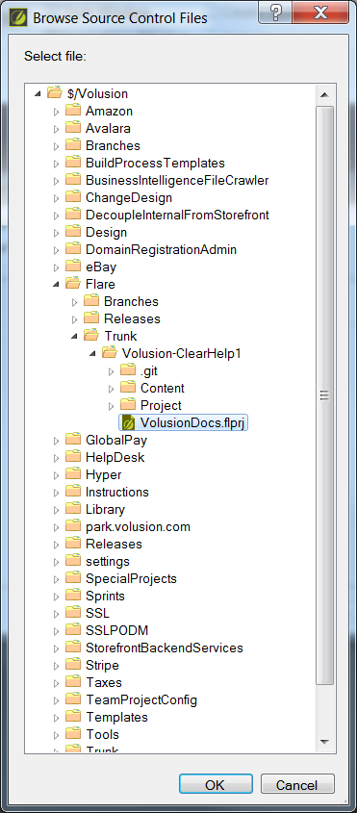

Wait, why is it in Trunk!? I had dev place this in trunk in the case we ever need to start versioning the documentation. This way, TRUNK is always production level. And branches can be cut for one-off content or versioning. Just in case.

1. Click **OK**.
2. For Project Folder, you may see the same location as your Mozu project (or previously imported project). This will be the location to save the project. Change the end of the location to something like Volusion-Flare. For example: **C:\TFS\Volusion\Volusion-Flare**. Your Mozu content may be in C:\TFS\vNext\learn_content\FlareProjects.
3. Click **Finish**.

Flare will import and create a project locally of files, etc. You can check out and in files, update content etc. The binding will always be automatically connected within Flare to the Volusion TFS.

In commit comments, make sure to add the TP number (if available) and clear reasons for commits and updates. The files affected will be listed already as part of the commit content. Other writers and perhaps development/UX may need to read this information on collaboration projects.

**Important:** Within Flare, you will find a helpful folder called ReadMeVolusion! Feel free to add How To docs for other writers, editors, and designers to safeguard content and keep it fresh.

## To Add a Project to TFS from Flare

If you ever find yourself needing to upload a project, here is that info:

1. In an open Flare project, click Project tab, then Properties.
2. Click Bind Project.

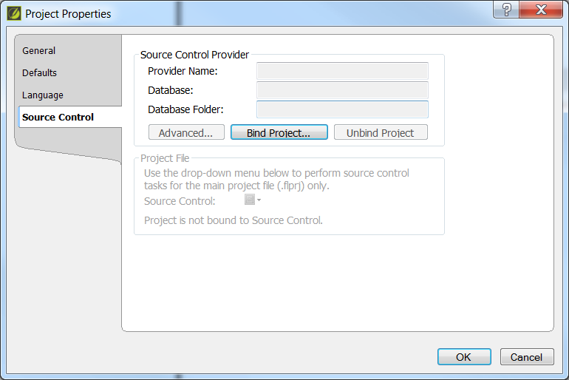

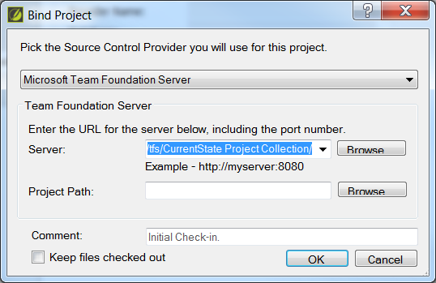

1. For the Server, enter [http://tfs.corp.volusion.com:8080/tfs/CurrentState Project Collection/](http://tfs.corp.volusion.com:8080/tfs/CurrentState%20Project%20Collection/)
2. Click Browse for the Team Project, select Volusion.
3. Click Ok. The updated Source Control info displays.

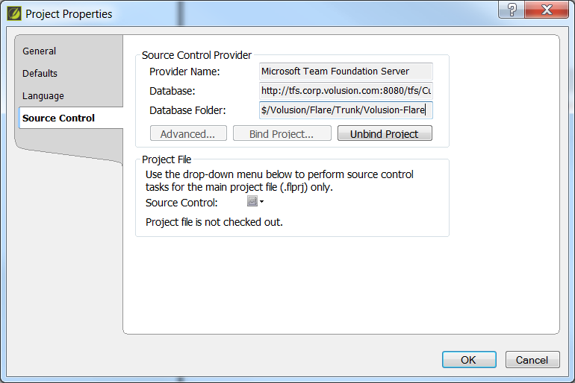

# Checking the TFS Portal

1. Open the webpage <http://tfs:8080/tfs>
2. Click on **Volusion** under **Recent Projects & teams**.

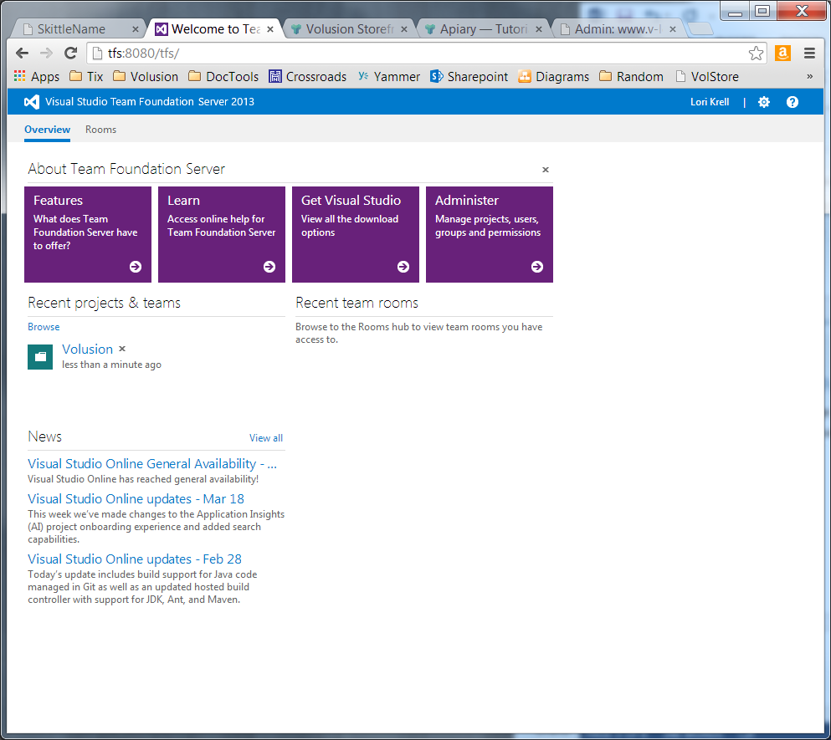

1. Click **Code**.

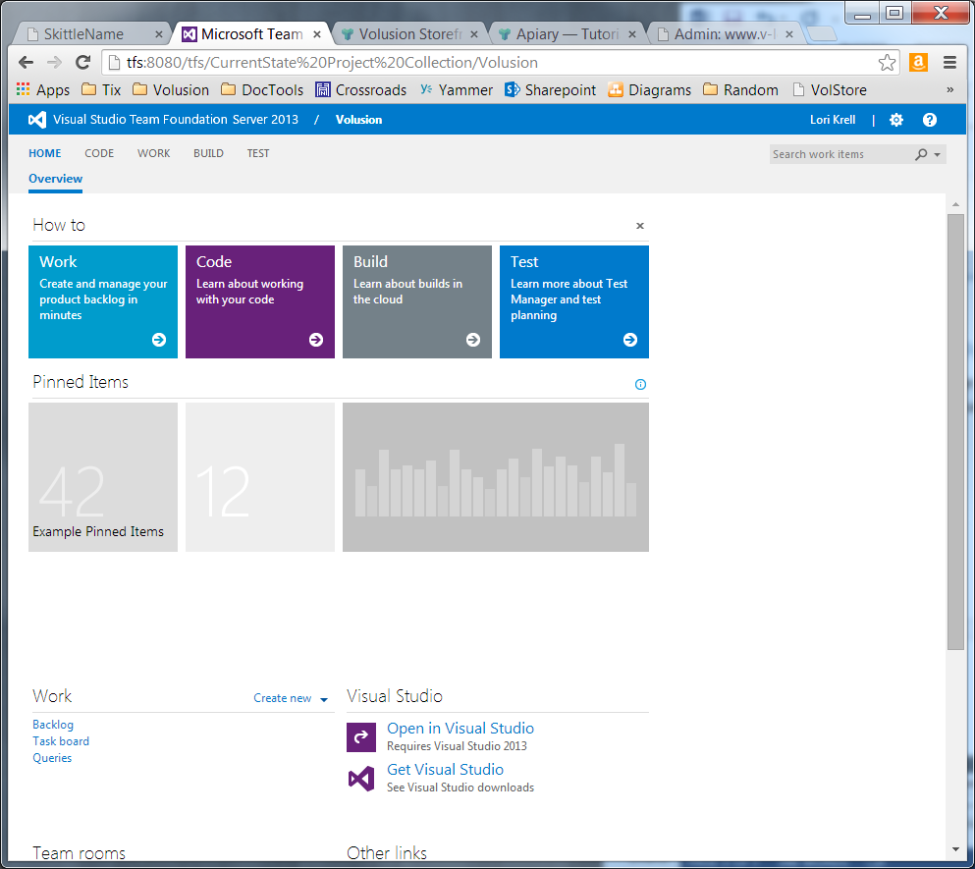

1. Locate the Flare project. The folders are set for version control, just in case. When working with the latest Flare project, select Trunk. The Volusion-ClearHelp1 is the project, though it is called Volusion-Flare in Madcap. (Attempted renaming, deleting and reuploading. Nothing works to rename this, even with Shane’s help.)

You can use Flare to check out specific files to work with, and for updating content to the TFS. This acts as a form of source control with the ability to roll back to previous content.

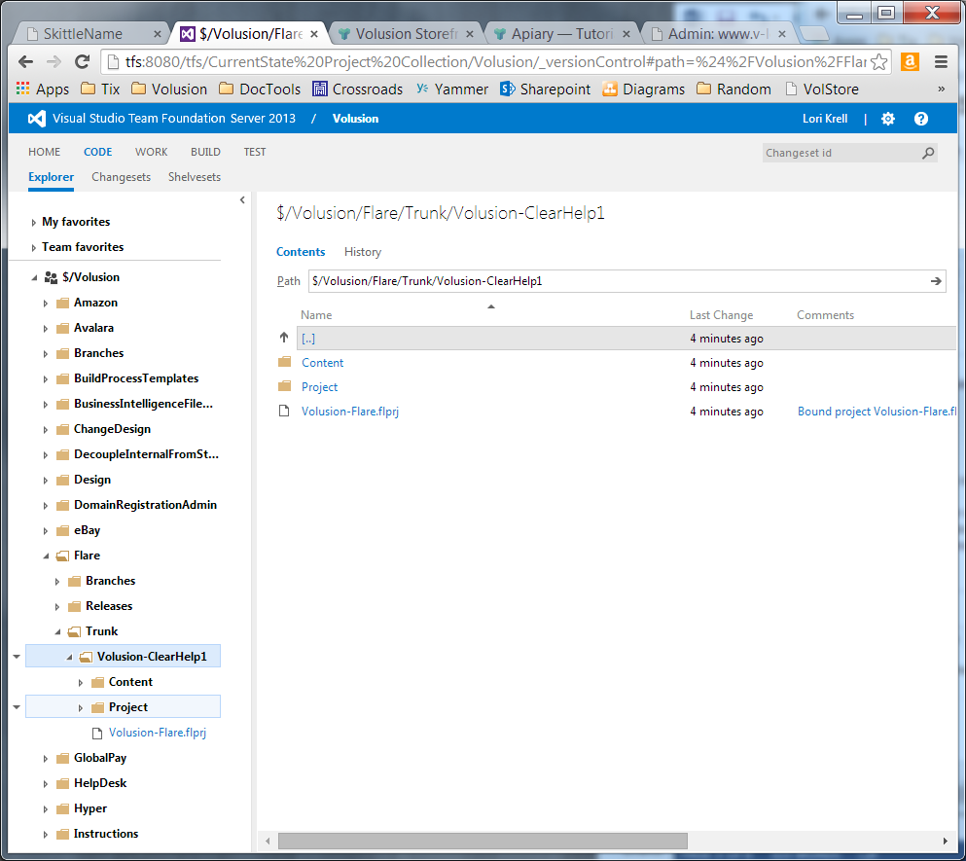

# Flare Skin – Style Colors

|  |  |  |  |  |  |  |
| --- | --- | --- | --- | --- | --- | --- |
| Style | Web Medium | | Tablet Medium | | Mobile Medium | |
| Panel bkgd, button gradient | #ecfbff |  | #ecfbff |  | #ecfbff |  |
| Nav-Active-Bkgd, Button gradient and border | #bdf0fb |  | #bdf0fb |  | #bdf0fb |  |
| Nav Font | #272727 |  | #272727 |  | #272727 |  |
| VolOrange | #fc6003 |  | #fc6003 |  | #fc6003 |  |

Web Navigation Skin

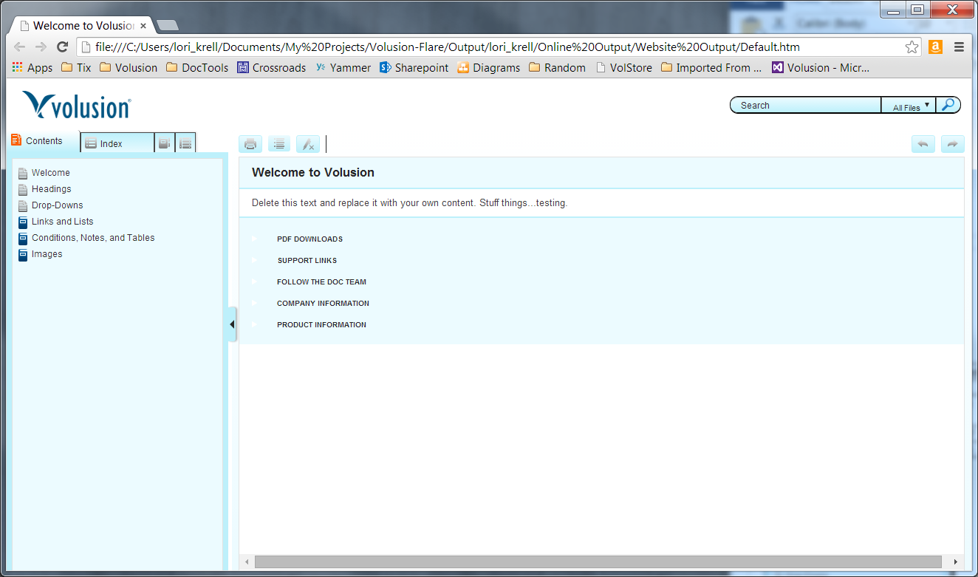

Tablet Navigation Skin

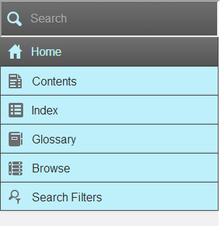 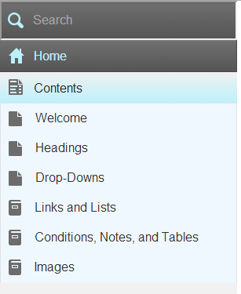

Mobile Navigation Skin

 

Help Skittles – Tooltips

Admin > [Module] > Tooltips folder for all help skittles for that module. Helps to keep all skittles in place. Naming convention could be [PageName]_[Field] such as Products_ProductCode. Created a template, master page, skin, a style type according to the document for Field level help.

Later, the skin will need to be associated during the Alias file linking: alias to topic and skin.

Creating a New ToolTip Topic using a template:

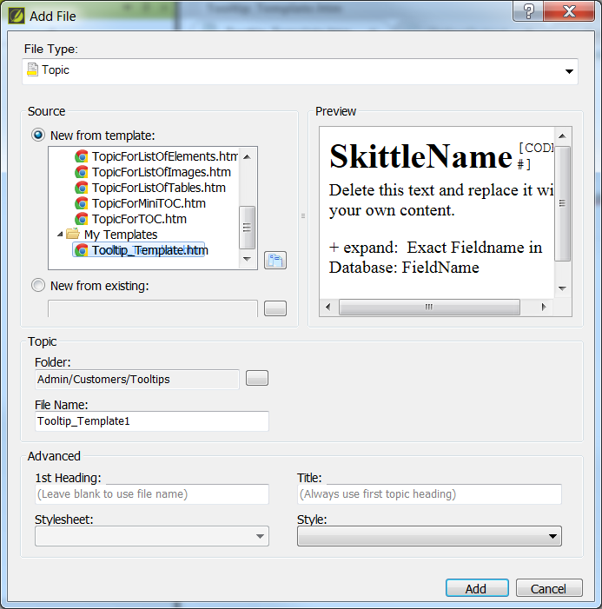

Problem it still keeps adding an H1. Can select style: h1.TooltipHelp. But problematic.

Tooltipname – datatype (make these a variable – TEXT, MEMO, LONG, DOUBLE, CURRENCY, DATETIME)