**Analysis Summary for Project Kickstarter**

*24 February 2019*

*Prepared by Lorie Grant*

Background:

Over two billion dollars have been raised using the massively successful crowdfunding service, Kickstarter, but not every project has found success. Of the over 300,000 projects launched on Kickstarter, only third have made it through the funding process with a positive outcome. Analysis is needed to determine factors which result in a successful project.

# Data Overview:

|  |  |
| --- | --- |
| **Summary of Data Set:**   * 4,114 projects * 21 countries * Period of 11 years (2009 – 2017) * 41 category and subcategory combinations exist | **Limitations of Dataset:**   1. Data is not clean. (Basic formatting commands are not allowing numeric values to be used in the Data Analysis Tool.) 2. Data should be normalized across currency in order to compare total spend across projects. 3. Definitions of data are not understood. For example, Spotlight and the relationship between launched and deadline. |

# Key Conclusions:

1. Theater, music, technology, and film & video are the most attempted projects. Combined, they account for 78% of all projects.

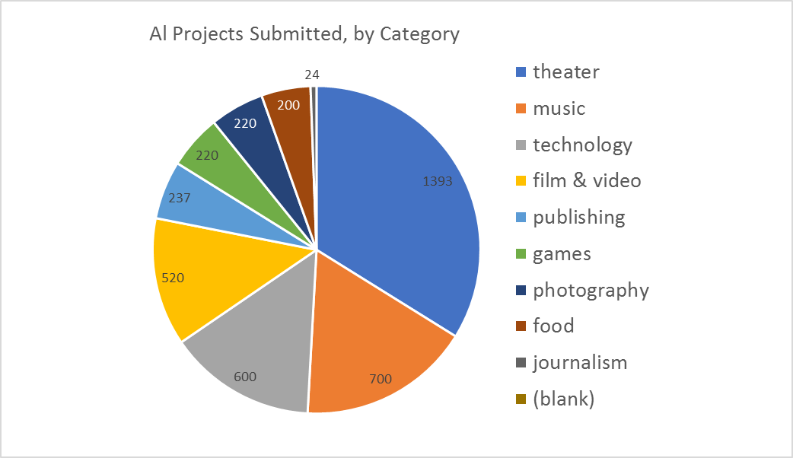

1. Music, theater, and film have the highest percentage of success. Journalism and food are the top two unsuccessful projects, and tied for 3rd are publishing, technology and games.

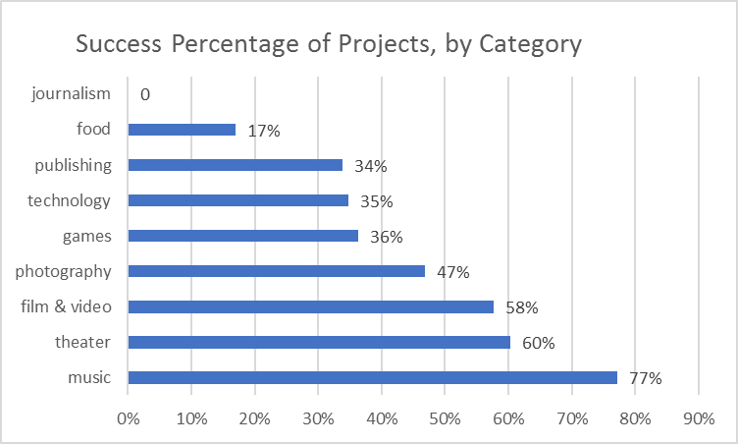 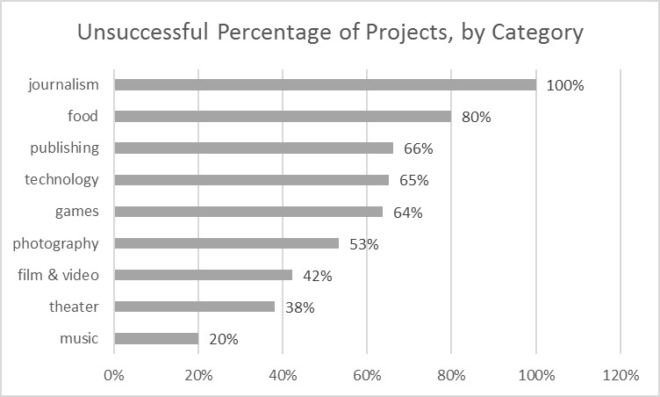

*The Success Percentage measures the total number of all projects submitted against the number of projects which were successful or unsuccessful.*

1. The greater the number of projects, the greater the number of failures and success. Overall, technology is the most troubling as it is the 3rd highest in overall projects yet has more failures than success.

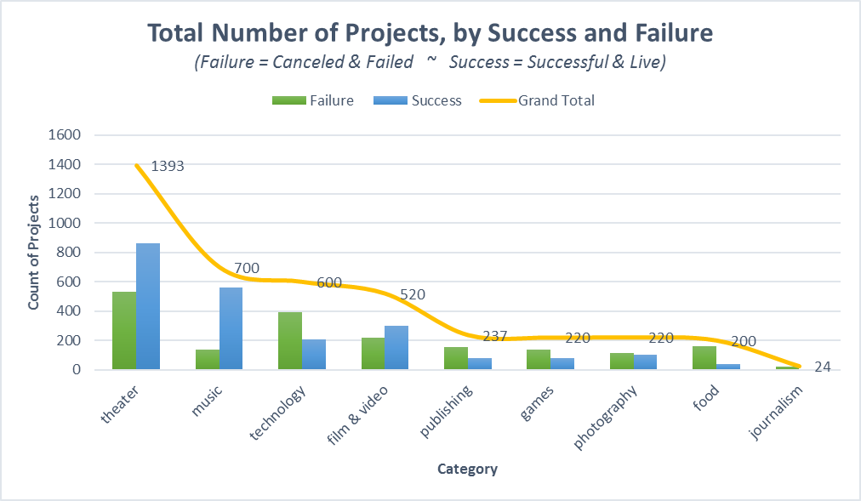

# Other Factors To Consider:

1. Review the success rate to find other relationships in the data. (Opposed to only success and failure numbers.)
2. Define the launch date and deadline, and what they indicate for project success.
3. Determine factors which contribute to success and failure; ie, funding, country, spotlight, and staff picks

# Reference:

## Other Analysis Points

### By Country

Of the successful projects, 96% are from the United States, United Kingdom, Canada, and Germany. These are also the only countries which have a least 1% of the total successful projects.

However, the countries with the highest success rates are:

|  |  |
| --- | --- |
| Luxembourg & Singapore | 100% |
| Great Britain | 61% |
| United States | 54% |
| Ireland | 53% |

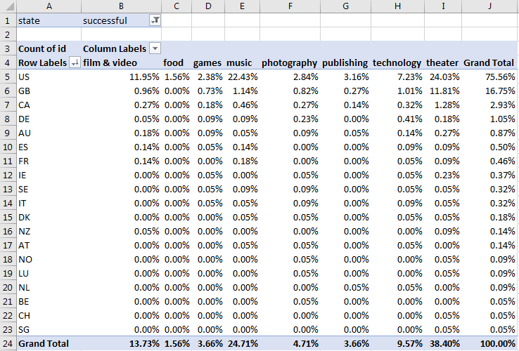

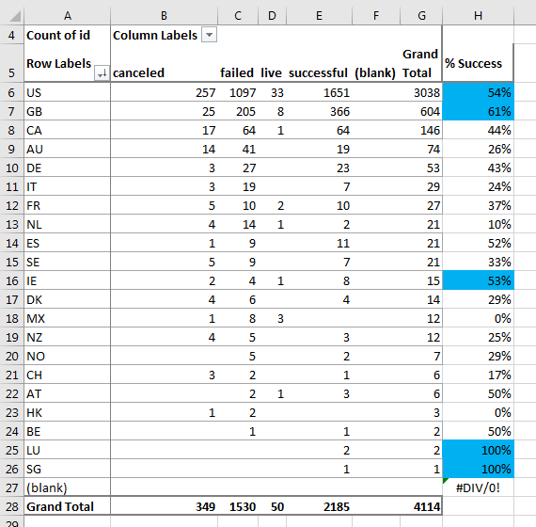

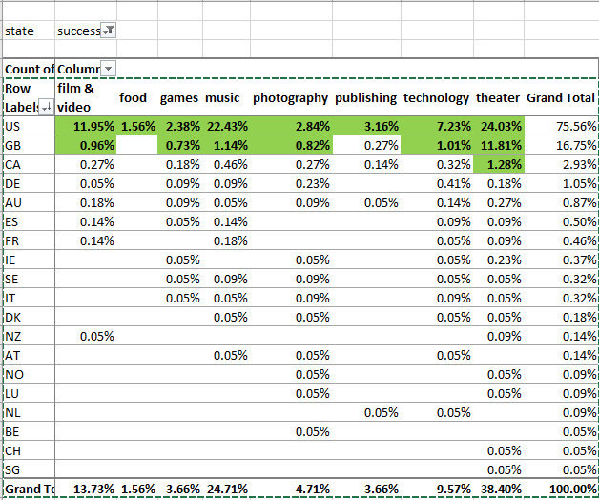

### Factors which contribute to success

1. Is the percent of money spent related to the success?

* Values must be normalized across currency.

1. Is the funding goal related to success?

NOTE: both the above require clean up of the data as the Regression function rejects the data as non-numeric. Took basic steps to format data as a number, but this did not solve the problem. Once data cleanup is complete, then can offer the P-Value.

Given the time needed, foregoing this work in favor of the bonus homework.

### Success & Failure Percentage Across Category

Two of the projects with the highest success also had the highest failures, by number. (Not by percentage.)

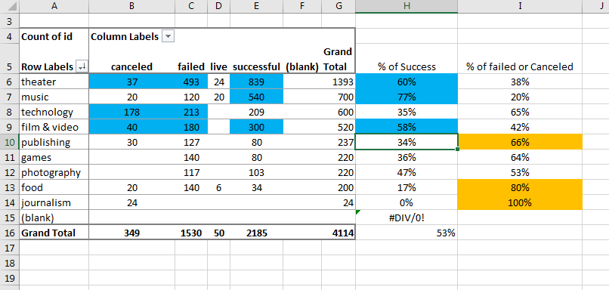

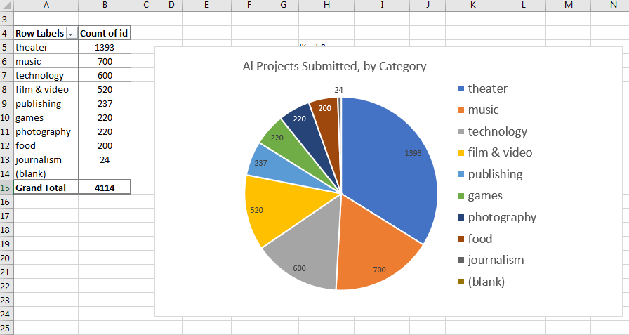

### Launch Dates

More information is needed on the conversion dates. For example, the relationship between launched and deadline. Would need to understand what Live means, and whether it is included in success.

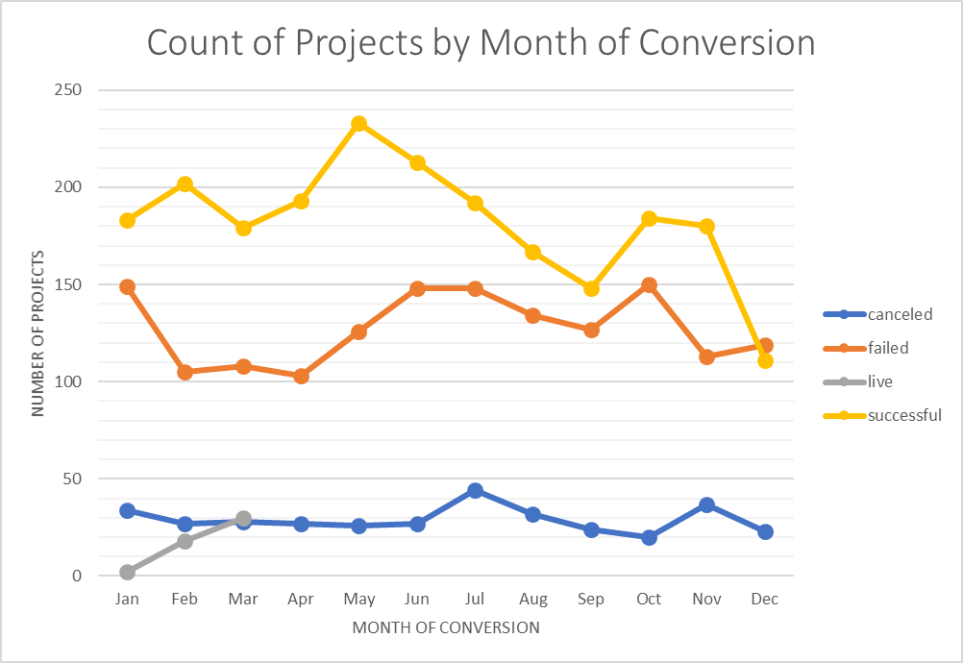

### Staff Picks

Interesting, but need to know what is meant by Staff Picks. Ie, maybe they can only pick a set number? If they can pick as many as they would like, then this tells an interesting story – the staff are not good at picking.

