Cerebellar Sham Dose
Pipeline Manual
A reproducible workflow for estimating cerebellar exposure and circuit-level response from active/sham TMS pulse and active tDCS
Draft manual for code users and collaborators | Last updated: Lorina Sinanaj UNIGE June 2026

1. Purpose
This manual explains how to run and understand the Cerebellar Sham Dose pipeline. The repository contains code for estimating cerebellar electric-field exposure, waveform-filtered effective dose, and virtual-cerebellum Purkinje-cell responses from active and sham non-invasive brain stimulation conditions.

2. Hypothesis and research questions
The hypothesis is that if sham TMS produces a nonzero cerebellar E-field, and that field is large enough to perturb cerebellar circuit output, then sham stimulation may not be a biologically neutral control condition.
To test this hypothesis, the pipeline combines individualized E-field modeling, published coil-specific sham-field measurements, waveform filtering, and a validated virtual model of the cerebellum to estimate whether sham TMS exposure can produce a Purkinje-cell population response comparable to active cerebellar tDCS.
Question | Context
Q1. What is the cerebellar GM E-field exposure during active/sham TMS and active tDCS? | How much E-field stimulation physically reaches the cerebellar gray-matter target?
Q2. What is the acute PC population response to this exposure? | Does the exposure produce a modeled acute Purkinje-cell population response?
Q3. At what intensity does sham TMS reach active-tDCS response? | At what sham intensity does the modeled sham response match or exceed the active-tDCS response in the same subject?
Q4. Does anatomy affect when sham TMS reaches active tDCS? | Do local anatomy measures such as scalp-GM distance or CSF thickness shape sham sensitivity?
Q5. Are these patterns reproduced across clinical cohorts? | Do the same exposure, response, and anatomy patterns appear in HC, SZ, and CUD cohorts?

3. Pipeline overview
The analysis follows the conceptual sequence below.
individualized cerebellar E-field simulations and ROI extraction
→ waveform-filtered effective dose
→ propagation of dose through mossy-fiber drive in the cerebellar virtual model
→ subject-level sham vs active-tDCS analysis
→ anatomy and cohort-level analyses
A sham condition is considered to reach active tDCS when the modeled Purkinje-cell response from sham TMS is greater than or equal to that subject's modeled active-tDCS response.

4. Sham E-field modeling
Sham TMS was not modeled as a zero-field condition. Instead, sham fields were estimated from measured active and sham coil-field maps from Smith and Peterchev.
For each measured coordinate, the vector E-field components were converted into E-field magnitude. A local sham/active correction factor was then calculated:
local sham/active factor = measured sham |E| / measured active |E|

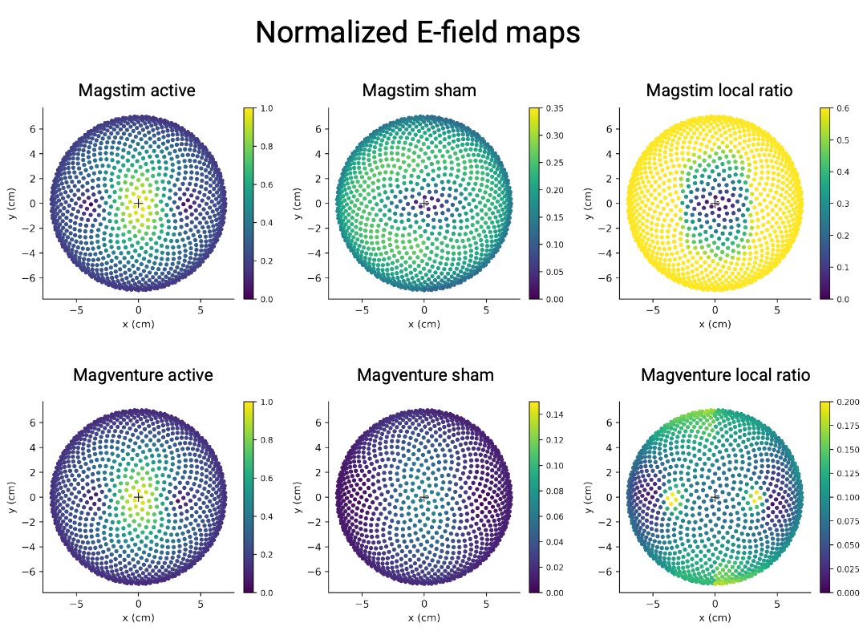

This factor was combined with each subject's active E-field simulation. Each subject's cerebellar GM ROI elements were mapped into coil-centered space, the empirical sham/active factor was interpolated at each element's position, and that factor was multiplied by the subject-specific active E-field magnitude.
subject-specific sham field
=
subject-specific active field × empirical sham/active correction factor

This preserves both coil-specific sham behavior and individual anatomy.
For the MagVenture sham + electrodes condition, there is also an option to model the magnetic sham field and add the electrode-related contribution following the Smith and Peterchev sham+electrode estimate as 10% of the active field.

5. Cerebellar virtual model
Circuit-level responses were estimated using the Lorenzi cerebellar mean-field model. This model represents the main cerebellar cortical populations, including granule cells, Golgi cells, molecular-layer interneurons, and Purkinje cells.
In this pipeline, the E-field-derived dose was mapped onto the model's external mossy-fiber drive variable. The primary endpoint was the acute Purkinje-cell population response.
The model output should be interpreted as a computational circuit-level prediction, not as a direct physiological recording.

6. What the pipeline estimates
This pipeline estimates how much stimulation reaches the cerebellar gray-matter target, how local anatomy such as scalp-to-GM distance and CSF thickness may shape that exposure, how TMS pulse waveforms change the effective neural dose through a first-order membrane filter, how that dose propagates through a virtual cerebellar circuit, and when sham TMS produces a Purkinje-cell response comparable to active cerebellar tDCS.

7. Repository organization
Folder | Purpose
config/ | Templates for local paths and metadata. Private local files are not committed.
resources/waveforms/ | Digitized TMS waveforms used for waveform filtering.
resources/external/smith_peterchev_2018/ | Instructions for placing external active/sham coil-measurement source data.
scripts/ | Numbered scripts that run the pipeline step by step.
src/shamdose/ | Reusable Python functions used by the scripts.
results/ | Generated local outputs. Not committed to Git.

8. Script guide
Script | Main duty
00_check_metadata.py | Checks cohort metadata before running analyses.
01_run_simnibs_extract_efield.py | Extracts cerebellar E-field distributions from subject head models.
01b_extract_target_anatomy.py | Extracts local anatomy under the target, including scalp-GM distance and CSF thickness.
01c_collect_step1_outputs.py | Collects per-subject E-field outputs into cohort-level tables.
02_compute_membrane_filtered_dose.py | Converts E-field exposure into waveform-filtered effective dose.
02b_scan_gamma_inputs.py | Scans the E-field-to-model-drive coupling parameter.
02c_build_empirical_coil_kernels.py | Builds empirical active/sham coil-field correction maps from Smith-Peterchev measurements.
02d_extract_magstim_kernel_efield.py | Applies the empirical Magstim sham correction to subject-specific active fields.
02e_build_step1_empirical_kernel_tables.py | Builds final E-field tables using empirical sham-field corrections.
02f_extract_magventure_kernel_efield.py | Applies the empirical MagVenture sham correction to subject-specific active fields.
02g_freeze_primary_gamma.py | Selects the primary gamma value from the gamma scan and writes it into the local Step 3 configuration.
03_run_meanfield_predictions.py | Propagates the effective dose through the cerebellar virtual model and estimates Purkinje-cell response.
04_build_subject_level_table.py | Builds subject-level sham-vs-active-tDCS comparison tables.
05_run_primary_statistics.py | Summarizes crossover probabilities and anatomy associations.
05b_make_report_ready_tables.py | Creates cleaner tables for reporting and manuscript writing.
06_make_main_figures.py | Creates the main cohort figures.
06b_make_main_figures_no_electrodes.py | Creates an alternate main-figure version without the MagVenture sham + electrodes condition.
07_make_supplementary_figures.py | Creates supplementary figures.
08_run_discrete_time_survival_models.py | Runs adjusted models testing how anatomy and demographics affect sham sensitivity.
99_run_full_pipeline.py | Option 2: Runs the post-E-field downstream pipeline after E-field extraction outputs are available. Test first with --dry-run. Only run if you don’t run scripts step by step.

9. Local configuration and external data
Users should create a private local configuration file config/paths_local.yaml from config/paths_template.yaml. Users should also provide their own subject metadata file based on config/cohort_metadata_template.csv.
The empirical coil-field correction requires the Smith and Peterchev active/sham coil measurement data. The raw spreadsheet should be placed locally under resources/external/smith_peterchev_2018/raw/. The cerebellar mean-field model code must also be available locally and referenced in config/paths_local.yaml.

10. How to run
The pipeline can be run in two ways.

Option 1: Run scripts step by step
This is the recommended mode for debugging, teaching, and checking intermediate outputs. Each script corresponds to one analysis stage, and each stage writes tables or figures that can be inspected before moving forward.

1. Check metadata
python scripts/00_check_metadata.py

2. Extract E-field distributions
python scripts/01_run_simnibs_extract_efield.py --cohort HC
python scripts/01_run_simnibs_extract_efield.py --cohort SZ
python scripts/01_run_simnibs_extract_efield.py --cohort CUD
python scripts/01c_collect_step1_outputs.py --cohort HC
python scripts/01c_collect_step1_outputs.py --cohort SZ
python scripts/01c_collect_step1_outputs.py --cohort CUD

3. Extract target anatomy
python scripts/01b_extract_target_anatomy.py --cohort HC
python scripts/01b_extract_target_anatomy.py --cohort SZ
python scripts/01b_extract_target_anatomy.py --cohort CUD

4. Build empirical coil kernels
python scripts/02c_build_empirical_coil_kernels.py

5. Extract empirical sham E-field rows
python scripts/02d_extract_magstim_kernel_efield.py --cohort HC
python scripts/02d_extract_magstim_kernel_efield.py --cohort SZ
python scripts/02d_extract_magstim_kernel_efield.py --cohort CUD
python scripts/02f_extract_magventure_kernel_efield.py --cohort HC
python scripts/02f_extract_magventure_kernel_efield.py --cohort SZ
python scripts/02f_extract_magventure_kernel_efield.py --cohort CUD

6. Build empirical-kernel E-field tables
python scripts/02e_build_step1_empirical_kernel_tables.py --cohort ALL --promote

7. Compute waveform-filtered dose and gamma calibration
python scripts/02_compute_membrane_filtered_dose.py --cohort ALL
python scripts/02b_scan_gamma_inputs.py --cohort ALL
python scripts/02g_freeze_primary_gamma.py

8. Run cerebellar virtual-model predictions
python scripts/03_run_meanfield_predictions.py --cohort HC --n-workers 2
python scripts/03_run_meanfield_predictions.py --cohort SZ --n-workers 2
python scripts/03_run_meanfield_predictions.py --cohort CUD --n-workers 2

9. Build analysis tables and statistics
python scripts/04_build_subject_level_table.py
python scripts/05_run_primary_statistics.py
python scripts/08_run_discrete_time_survival_models.py
python scripts/05b_make_report_ready_tables.py

10. Make figures
python scripts/06_make_main_figures.py --cohort HC
python scripts/06_make_main_figures.py --cohort SZ
python scripts/06_make_main_figures.py --cohort CUD
python scripts/06b_make_main_figures_no_electrodes.py --cohort ALL
python scripts/07_make_supplementary_figures.py --figure all

Some steps require the SimNIBS Python environment and access to local head-model folders. Downstream statistical and plotting steps run from generated CSV tables.

Option 2: Run the post-E-field pipeline with one command
The script scripts/99_run_full_pipeline.py runs the downstream pipeline after the E-field extraction outputs are available. It does not run the expensive SimNIBS E-field simulations themselves.
Before running it for real, use dry-run mode:
python scripts/99_run_full_pipeline.py --dry-run

To run the full downstream pipeline:
python scripts/99_run_full_pipeline.py –yes

To run only part of the pipeline:
python scripts/99_run_full_pipeline.py --from-stage step4_subject_level --to-stage supplementary_figures –yes

To skip figure generation:
python scripts/99_run_full_pipeline.py --skip-figures –yes

The runner saves a run manifest and log files under logs/full_pipeline_<timestamp>/. The manifest records the planned commands, Git branch, Git commit, and execution status for each stage.
Use the one-command runner only after paths_local.yaml is configured, cohort_metadata.csv is finalized, external Smith-Peterchev source data are available locally, E-field outputs exist, and head-model folders are mounted and accessible.

11. Key references
Smith JE, Peterchev AV. Electric Field Measurement of Two Commercial Active/Sham Coils for Transcranial Magnetic Stimulation. Journal of Neural Engineering.
Lorenzi RM et al. A multi-layer mean-field model of the cerebellum embedding microstructure and population-specific dynamics. PLOS Computational Biology.

12. Results
Stay tuned for results.

13. License
No license has been selected yet.

