Solving the Airbus Ship Detection Challenge with U-Net

Armand Szokoly-Angyal, Lőrinc Toldi, Balázs Kiss

Abstract— Ship detection in satellite imagery is a key problem in maritime monitoring, naval security and global logistics. The Airbus Ship Detection dataset provides high-resolution images with run-length encoded segmentation masks for ships, posing challenges such as class imbalance, varying ship sizes and noisy annotations. In this project, we implemented a complete pipeline for ship localization and segmentation. Our primary solution uses a U-Net [1] architecture that performs semantic segmentation by predicting a binary ship mask for each image. To complement this, we built a lightweight convolutional neural network to classify whether an image contains ships at all, helping to mitigate data imbalance. We also experimented with a Mask Region Based Convolutional Neural Network (Mask R-CNN) [1] instance segmentation model to explore whether an object-level architecture could outperform classical semantic segmentation methods, although this approach ultimately performed poorly. Additionally, we conducted exploratory tests using the Segment Anything Model (SAM) [2] to compare automatic mask generation with ground-truth labels. The U-Net model achieved an F2 score [4] of 0.6 and became the final solution, while Mask R-CNN reached only 0.08, and SAM also produced negligible results. This documentation summarizes our dataset preparation, model architecture, training strategies, evaluation methods and the lessons learned from comparing multiple approaches.

I. INTRODUCTION
A
ccurately identifying ships in satellite images is a longstanding research topic with implications for commercial shipping oversight, illegal maritime activity detection and large-scale environmental observations. The Airbus Ship Detection dataset constitutes an attractive benchmark for such research, consisting of 768×768 RGB satellite images annotated with per-ship masks stored in run-length encoding format. The problem is challenging because the dataset contains many empty images, ships appear at vastly different scales and annotations vary in quality.

II. Related Work
A wide range of approaches have been explored in prior work. Classical semantic segmentation architectures, particularly fully convolutional networks such as U-Net, have repeatedly demonstrated strong performance on dense prediction tasks, including remote sensing applications [3] [5]. At the same time, region-proposal-based architectures, especially Mask R-CNN [1], provide object wise predictions and could theoretically yield more structured outputs, a property that has been noted in maritime detection research as well [6]. Recent developments in foundation models, such as the Segment Anything Model (SAM) [2], further broaden the landscape by offering general-purpose segmentation capabilities without task-specific training.
Our objective was to evaluate several practical pipelines for this dataset. We developed a U-Net model for semantic segmentation, a CNN classifier for detecting the presence of ships, and an experimental Mask R-CNN model for instance segmentation. These components allowed us to compare semantic and instance-aware approaches under the same processing conditions, supported by data validation and preprocessing.

III. The model architecture
Our primary model uses the U-Net architecture. It is a widely used CNN for image segmentation tasks, because it can capture both the overall structure and fine details of objects [3].
We resized all images and masks to 256x256 to reduce memory usage and speed up training and to emphasize more generic, important image features, even though using the full 768x768 resolution could produce more accurate segmentations. Similarly, we limited the dataset to a balanced sample of 10,000 images to save computational resources while maintaining a representative set of images with and without ships. Hyperparameters were chosen after testing multiple configurations to optimize segmentation performance.
The model outputs a single-channel probability map for each image, indicating the likelihood that each pixel belongs to a ship. To train the model, we use a combined loss function that equally weights Binary Crossentropy [7] and Dice loss (which is widely used in for instance medical segmentation tasks [8] to suppress class imbalance). Binary cross entropy encourages correct pixel-wise predictions, while dice loss directly measures the overlap between the predicted and true masks, which is particularly useful for handling the class imbalance between ship and background pixels. We also monitor Intersection over Union (IoU) [9] and F2 score as metrics, which provide a more holistic evaluation of segmentation quality by considering both precision and recall, rather than just pixel-wise accuracy.
The Adam optimizer [10] is used to update model parameters efficiently during training. Overall, this setup provides a balance between computational feasibility and segmentation performance, allowing us to experiment and evaluate the model within reasonable resource constraints.
Most of the images in this dataset are empty or mostly background. If we used simple accuracy as a metric, the model could just predict all zeros and still get a very high score.
Why not accuracy? Accuracy would mostly reflect background pixels and would make the model look better than it is. IoU and F2 give a more realistic picture of how well the model is detecting ships.
As mentioned above, we implemented an instance-segmentation model based on Mask R-CNN with a ResNet-50 backbone and Feature Pyramid Network (FPN), fine-tuned to detect ships as a single foreground category. Mask R-CNN extends the Faster R-CNN architecture by combining region-based object detection with a dedicated per-instance segmentation branch, allowing the model to jointly perform object localization, classification, and pixel-level mask prediction. The ResNet-50 backbone is responsible for extracting high-level semantic features from the input images, while the FPN augments these representations with multi-scale feature maps, enabling the detection of objects across a wide range of spatial sizes.
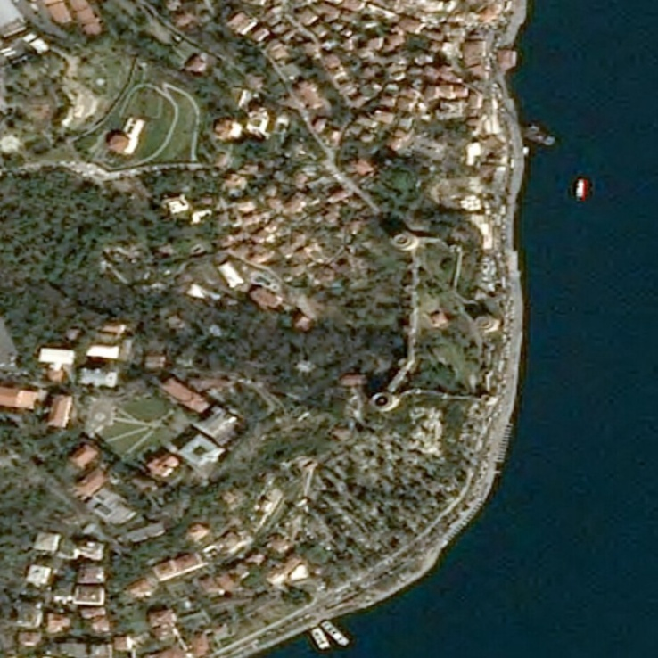
In our implementation, the model was initialized with weights pretrained on the COCO dataset, providing a strong generic visual feature extractor. To adapt the architecture to the Airbus Ship Detection task, the classification and mask prediction heads were replaced to support a binary label space consisting of background and ship classes only. This ensured architectural consistency with the dataset while retaining the benefits of transfer learning in the convolutional backbone and feature pyramid. During training, the model optimized multiple loss components simultaneously, including region proposal losses, ROI classification loss, bounding box regression loss, and instance mask loss, following the standard Mask R-CNN training paradigm.
Figure 1 Example of a discardable image. It is hard to see on this small image, but on the top right-hand side is a mask, very small, and it does not cover the ship correctly. It is also a problem that on the bottom left hand corner, the ships are not annotated
Despite the correctness of the implementation, training loop, and evaluation pipeline, the model’s empirical performance never reached practical levels. The achieved F2 score remained significantly below that of the U-Net–based semantic segmentation approach. This suggests that the increased architectural complexity and reliance on region proposal mechanisms did not translate into improved performance for this dataset. The Airbus images are dominated by background pixels, and ships often occupy very small regions of the image, which can hinder anchor-based proposal generation and cascade into weak instance mask predictions.
For these reasons, we ultimately treated the Mask R-CNN approach as an exploratory experiment rather than a primary solution. While it provides a theoretically appealing instance-level formulation of the problem and serves as a useful comparison point between semantic and instance segmentation paradigms, its limited performance and higher experimental complexity made it less suitable than U-Net for our final submission.

IV. Dataset cleaning
The dataset was downloaded using Google Drive mirrors, as Kaggle’s API proved unreliable for multi-gigabyte transfers and hosting costs on commercial cloud platforms were prohibitive. Access to the dataset also requires joining the Kaggle competition, which further complicates automated setup in reproducible environments. To ensure robustness, multiple mirrored download links were provided and accessed programmatically using the gdown library, with fallback mechanisms in place to handle Google Drive quota limits or intermittent failures.
Once the raw data were obtained, we performed a systematic validation and exploratory analysis of the annotation masks, motivated by the strong assumptions made by both semantic and instance segmentation models. The Airbus Ship Detection dataset encodes ship annotations using Run-Length Encoding (RLE), with each row in the CSV file representing a single ship instance. However, preliminary inspection revealed that not all RLE masks adhered strictly to the implicit assumption that one mask corresponds to exactly one coherent physical object.
To address this, each RLE string was decoded into a two-dimensional binary mask and analyzed in terms of its connected components, pixel area, and spatial consistency. Using connected-component analysis, we computed the number of distinct shapes present in each mask as well as the pixel area of each shape. Masks containing multiple disconnected components were flagged as problematic, as they violate the closed-object assumption required by instance-based models such as Mask R-CNN. Similarly, masks whose connected components all fell below a predefined minimum size threshold were treated as annotation noise and considered unreliable.

In addition to intra-mask consistency checks, we also evaluated inter-mask overlaps within the same image. Since ships cannot physically occupy the same pixels in satellite imagery, overlapping masks indicate annotation errors that can severely degrade training, particularly for region-based detection models. For each image, all associated RLE masks were combined into a single aggregate mask, and overlapping regions were detected by identifying pixels with values greater than one. Images exhibiting such overlaps were flagged for correction or exclusion.
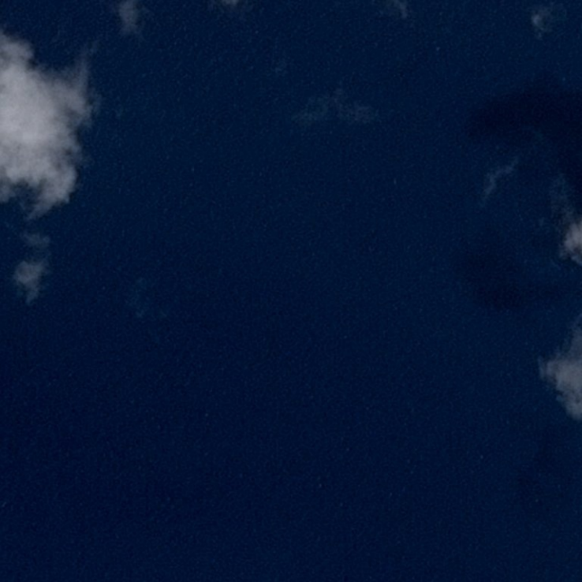
Based on these analyses, a dedicated data cleaning procedure was applied. Masks containing no sufficiently large connected components were discarded entirely. For masks with multiple connected shapes, only the largest component was retained, ensuring that each remaining annotation corresponded to a single ship instance. The cleaned masks were then re-encoded into RLE format and written to a new CSV file, which served as the final annotation source for all subsequent experiments.
This validation and cleaning pipeline significantly reduced annotation noise and improved dataset consistency. While this preprocessing step was beneficial for all models, it was particularly critical for the Mask R-CNN pipeline, which relies on well-defined instance boundaries and non-overlapping objects. By enforcing these constraints at the data level, we ensured that downstream performance limitations could be attributed primarily to model behavior rather than annotation artifacts..

V. Training
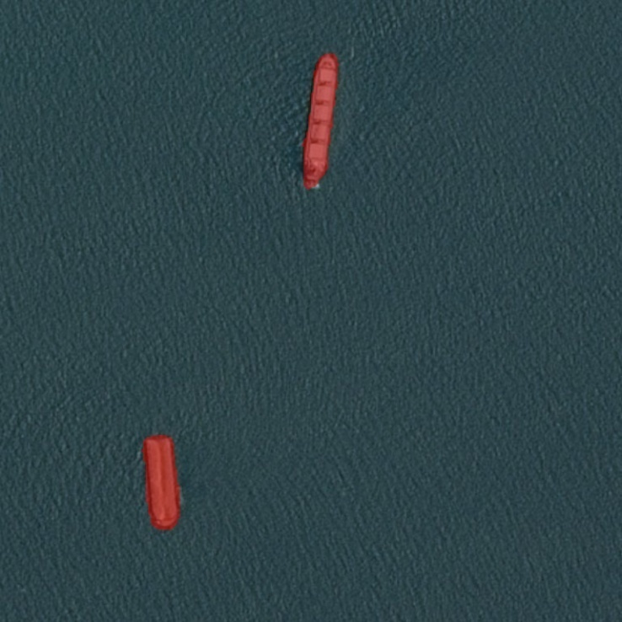
Training the U-Net required careful hyperparameter selection. A learning rate of 10⁻⁴ offered stable convergence without noticeable oscillation, and the Adam optimizer provided reliable gradient updates throughout the process. Because the dataset is severely imbalanced, we constructed a balanced subset of 10,000 images, evenly split between ship-containing and empty images. This reduced the risk that the network would learn a trivial “always empty” solution. During training, we monitored both binary cross-entropy and a dice-based metric to better capture segmentation quality.
Figure 2 Example of an empty image, where there are correctly no annotation placed by U-Nets
The Mask R-CNN experiment required a separate training loop due to architectural differences. We fine-tuned a COCO-pretrained model using stochastic gradient descent with momentum and a scheduled learning-rate decay. Despite correct implementation and several iterations, the model converged to a poor solution, suggesting that much longer training, anchor-size adjustments or larger batch sizes might be needed.

VI. Evaluation and results

Model performance was assessed using the F2 score, the metric used in the original Airbus competition. U-Net achieved a significantly higher F2 score than any of the alternative approaches, reaching 0.6 on the validation set. Visual inspection also confirmed that the model successfully captured the shapes and locations of ships, even when multiple vessels appeared in the same frame.
The CNN classifier provided robust predictions on image-level ship presence, aiding error analysis and serving as a potential first-stage filter for computational efficiency.
Figure 3 Ship segmentations correctly identified by U-Net on sea images
In contrast, Mask R-CNN produced very weak outputs, with a mean F2 score of only 0.08. Predictions often missed ships entirely or segmented irrelevant regions. While this does not invalidate the architecture itself, it suggests that much heavier training and parameter tuning would be required to reach competitive performance on this dataset.
Experiments using SAM produced similarly weak results. Although SAM occasionally generated visually plausible segments, its IoU compared to ground truth varied widely, indicating that foundation models still require adaptation for specialized satellite imagery tasks. We did not continue on this path as it requires significant computational resources [11]

Figure 4 A SAM default segmentation. Fine tuning would have required significant efforts, and we considered other architectures to be better for the task

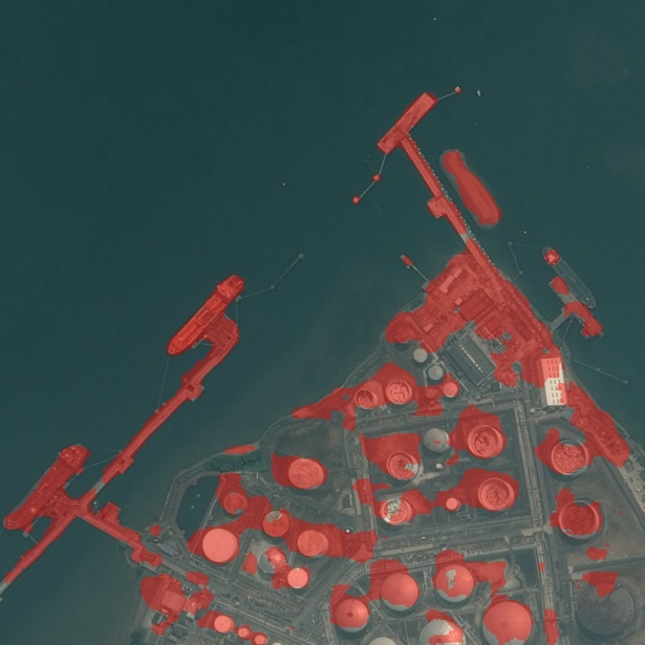
VII. Future plans and conclusion
Figure 5 A U-Net segmentation of a problematic beach. The ships were correctly identified, but there is still significant noise that could be reduced in certain special cases.
Our experiments confirm that U-Net remains a highly effective model for maritime segmentation, especially when paired with careful data cleaning and balanced sampling strategies. The poor performance of Mask R-CNN highlights the difficulty of instance segmentation in this dataset, where object sizes vary dramatically and annotation noise is non-negligible. Additional work—particularly anchor tuning, stronger regularization, more epochs and potential tiling of high-resolution images—would be required before such an approach becomes competitive.
In future work, the U-Net could be enhanced using attention mechanisms, residual blocks or ensemble methods, and using a larger network to extract features from higher resolution images. Training on tiled patches rather than full images may help recover smaller ships. Some postprocessing should also be added to isolate separate ship masks from the unified masks.

VIII. Bibliography
[1] K. He, G. Gkioxari, P. Dollár, és R. Girshick, „Mask R-CNN”, 2018. január 24., arXiv: arXiv:1703.06870. doi: 10.48550/arXiv.1703.06870.
[2] A. Kirillov és mtsai., „Segment Anything”, 2023. április 5., arXiv: arXiv:2304.02643. doi: 10.48550/arXiv.2304.02643.
[3] O. Ronneberger, P. Fischer, és T. Brox, „U-Net: Convolutional Networks for Biomedical Image Segmentation”, in Medical Image Computing and Computer-Assisted Intervention – MICCAI 2015, N. Navab, J. Hornegger, W. M. Wells, és A. F. Frangi, Szerk., Cham: Springer International Publishing, 2015, o. 234–241. doi: 10.1007/978-3-319-24574-4_28.
[4] P. Christen, D. J. Hand, és N. Kirielle, „A Review of the F-Measure: Its History, Properties, Criticism, and Alternatives”, ACM Comput Surv, köt. 56, sz. 3, o. 73:1-73:24, okt. 2023, doi: 10.1145/3606367.
[5] J. Long, E. Shelhamer, és T. Darrell, „Fully Convolutional Networks for Semantic Segmentation”, előadás Proceedings of the IEEE Conference on Computer Vision and Pattern Recognition, 2015, o. 3431–3440. Elérés: 2025. december 7. [Online]. Elérhető: https://openaccess.thecvf.com/content_cvpr_2015/html/Long_Fully_Convolutional_Networks_2015_CVPR_paper.html
[6] X. Nie, M. Duan, H. Ding, B. Hu, és E. K. Wong, „Attention Mask R-CNN for Ship Detection and Segmentation From Remote Sensing Images”, IEEE Access, köt. 8, o. 9325–9334, 2020, doi: 10.1109/ACCESS.2020.2964540.
[7]. Usha Ruby Dr.A, „Binary cross entropy with deep learning technique for Image classification”, Int. J. Adv. Trends Comput. Sci. Eng., köt. 9, sz. 4, o. 5393–5397, aug. 2020, doi: 10.30534/ijatcse/2020/175942020.
[8] R. Zhao és mtsai., „Rethinking Dice Loss for Medical Image Segmentation”, in 2020 IEEE International Conference on Data Mining (ICDM), nov. 2020, o. 851–860. doi: 10.1109/ICDM50108.2020.00094.
[9] H. Rezatofighi, N. Tsoi, J. Gwak, A. Sadeghian, I. Reid, és S. Savarese, „Generalized Intersection Over Union: A Metric and a Loss for Bounding Box Regression”, előadás Proceedings of the IEEE/CVF Conference on Computer Vision and Pattern Recognition, 2019, o. 658–666. Elérés: 2025. december 7. [Online]. Elérhető: https://openaccess.thecvf.com/content_CVPR_2019/html/Rezatofighi_Generalized_Intersection_Over_Union_A_Metric_and_a_Loss_for_CVPR_2019_paper.html
[10] K. Ahn, Z. Zhang, Y. Kook, és Y. Dai, „Understanding Adam Optimizer via Online Learning of Updates: Adam is FTRL in Disguise”, 2024. május 30., arXiv: arXiv:2402.01567. doi: 10.48550/arXiv.2402.01567.
[11] „Generalized SAM: Efficient Fine-Tuning of SAM for Variable Input Image Sizes”. Elérés: 2025. december 7. [Online]. Elérhető: https://arxiv.org/html/2408.12406v1

