# First step

# Define the Project Scope and Objectives

It will be coded in several steps. The first step is going to be the minimum app. The second and third step is going to be the future implementations of the app.

The project scope is to design a blog app coded in java (backend) and angular 11 frontend. It should be a minor project with a minimun scope of a blog. Only containing a login system and a simple register system and several other things.

# Gather Requirements

* **The blog must have login and register. Each logged person is able to create posts about things it want to post.**
* **There is a page where you can see other webBlogPages. But, you can only see it if you are allowed by the owner to see it. Then it need to have a page that receives invite of people to see your content. Also there is the main page where the user can see your posts or request another blogs to enter**
* **The blog must have a main screen to see your posts. This screen has a separator called ‘all posts and archive. All posts have their posts separeted by categories and archive is separeted by the year.**
* **the blog must have a page to the person write it’s posts**
* **The blog must have a page to see the post in details. This page must have the possibility to people with access to write message to its posts**

# Use Cases

**Registering**

* **Title -> registering to the blog**
* **Primary -> User not registered**
* **Goal -> to get registered to the system and be able to login to it**
* **Preconditions -> User must access the page of register**
* **Main success Scenario:**
  + **The user go to the page register;**
  + **The user provides its information and click submit;**
  + **The user is redirected to the page of login**
  + **The user login with the credentials previously presented**
  + **The user gets inside the main page**

**Login**

* **Title-> login to the blog**
* **Primary -> User registered**
* **Goal -> Login to the system**
* **Precondition -> be registered**
* **Main success Scenario:**
  + **User go to the page login**
  + **User provide it credentials**
  + **User submit the form**
  + **User is redirected to the main page where he sees the main page**

# Design Prototypes

**login**

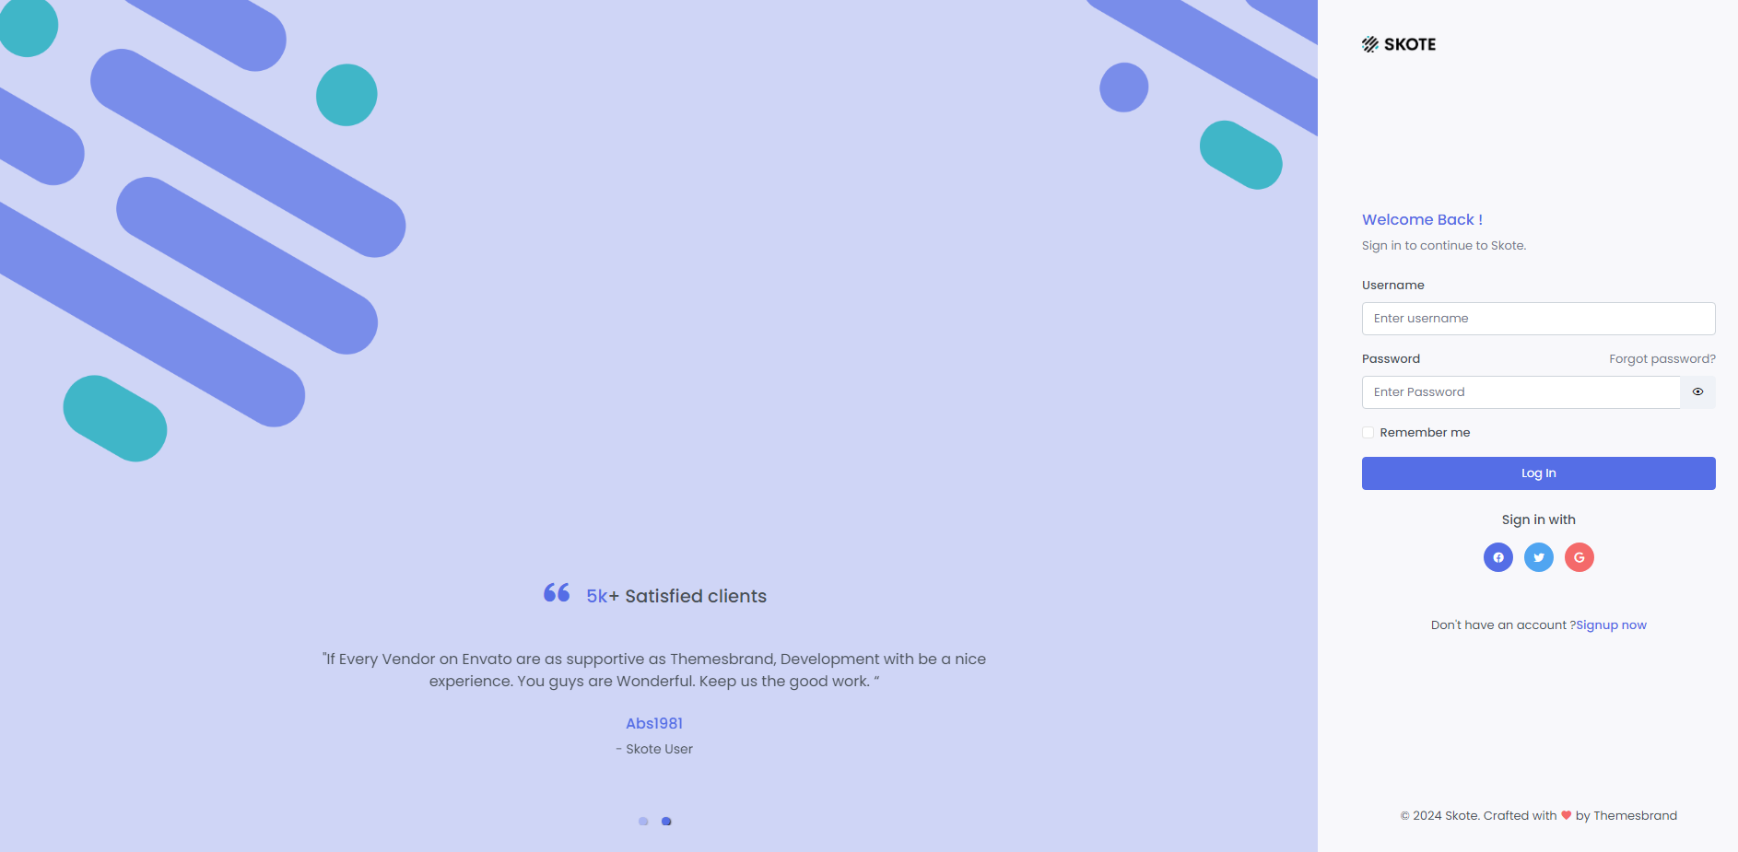

Ou

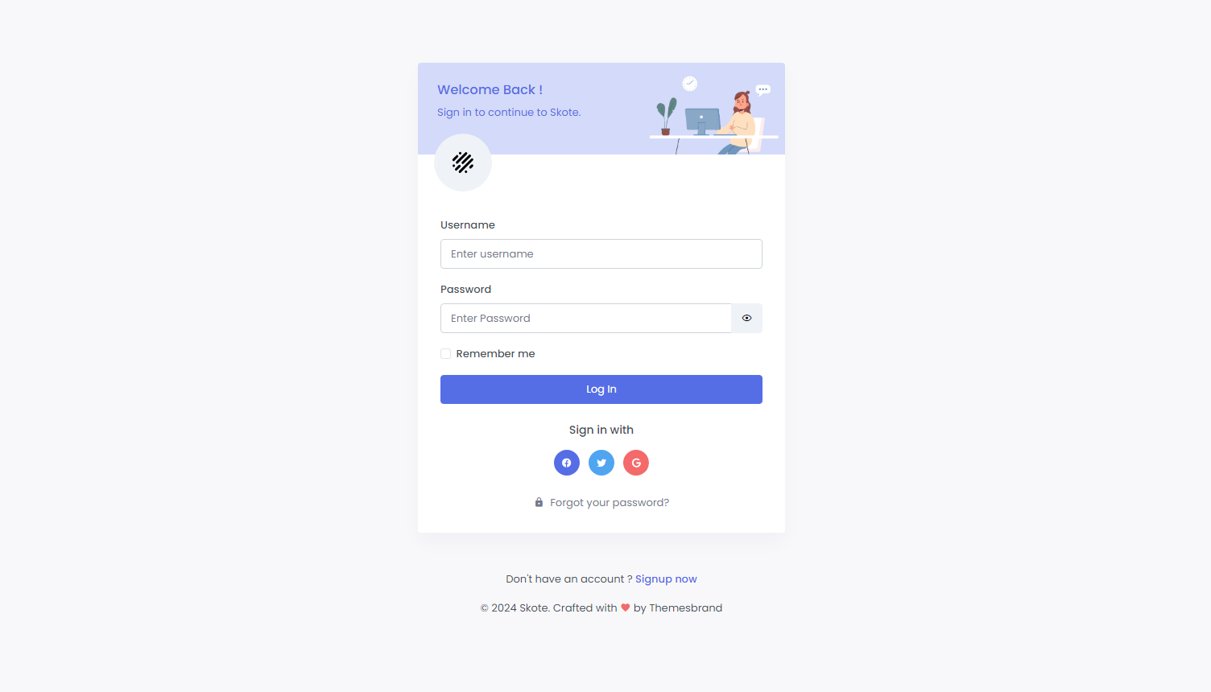

**Register**

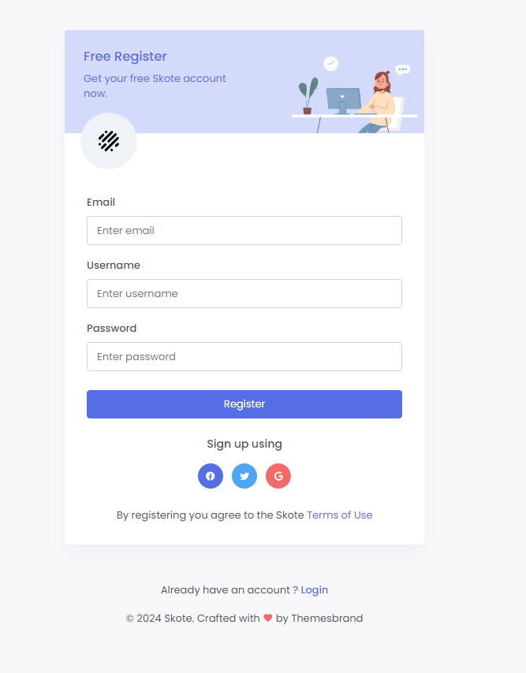

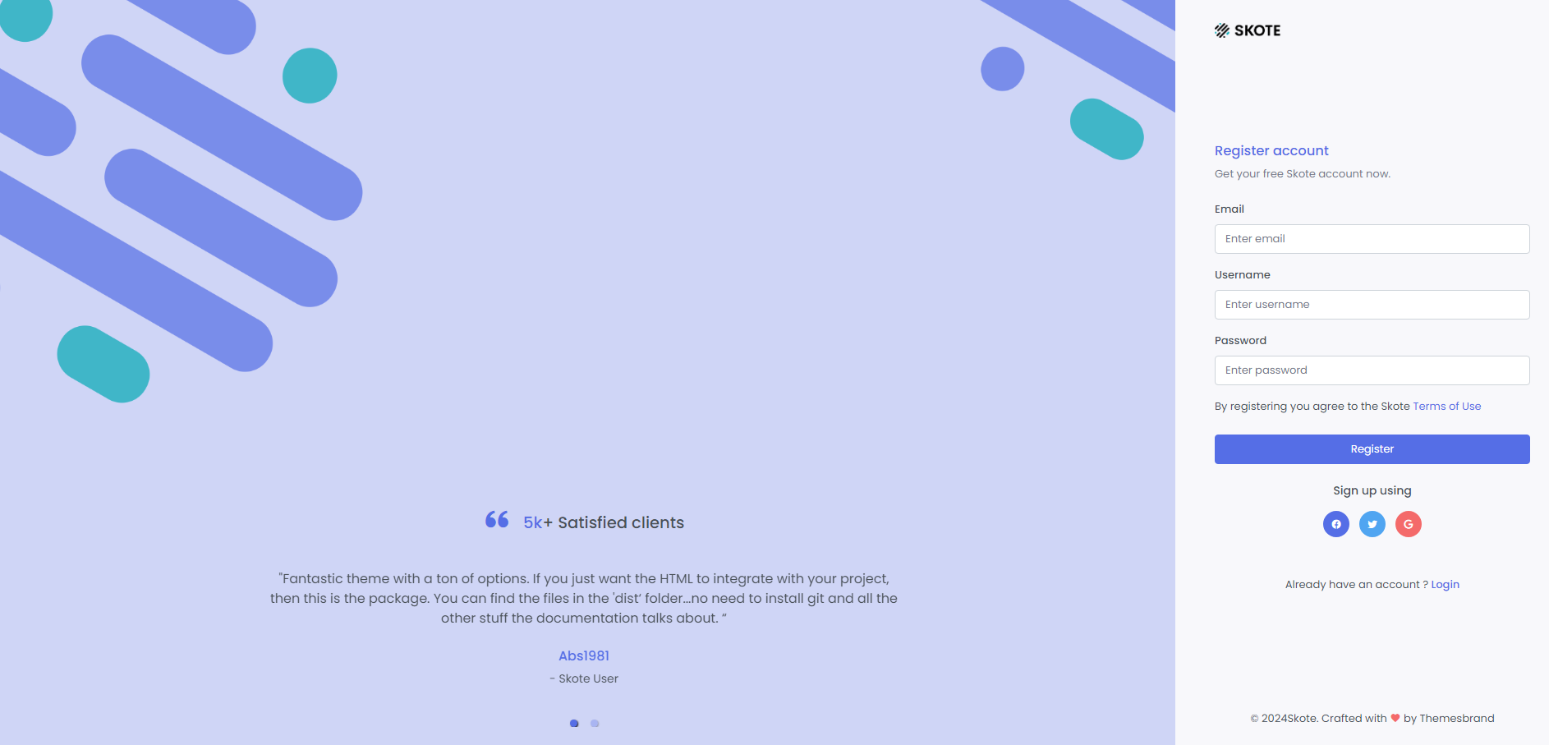

**Main page**

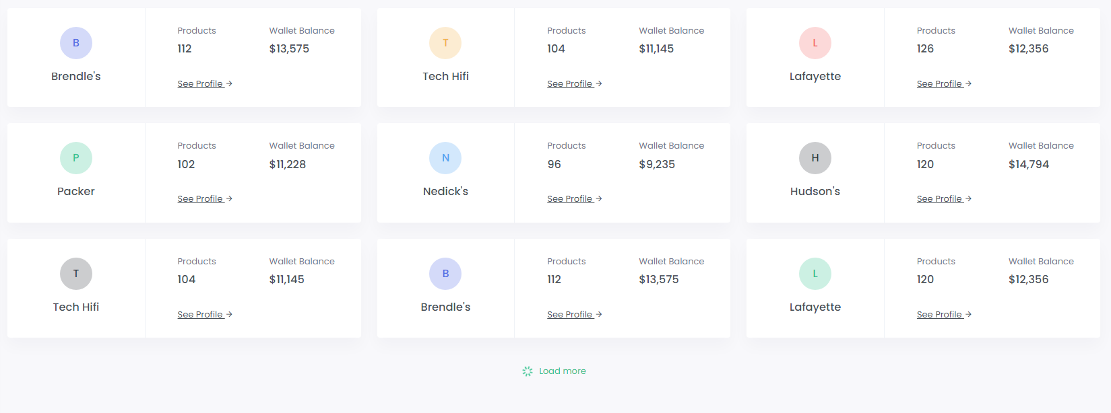

See profile is only going to be visible if the person allows you to see their profile. It must have a button to send invitations.

The person profile is going to be always the first one at top left.

**webPageBlog**

