Purpose:

Document actions taken and knowledge gained while working through Module05 course content.

### Weekly Content:

Dictionaries, and Separation of Concerns, and GitHub – Oh my! This week we jumped into several new concepts and experimented with working on preexisting data/code.

Let’s dive in with Dictionaries. Dictionaries are mapping types that use {key: value} pairs to store information in sequence.[1] The main difference between a dictionary and a list is that dictionaries use keys to access data, rather than the position of the data. This is because lists are an ordered sequence of objects and dictionaries are unordered sets.[2] The dictionary key allows for easy lookups regardless of ordering.

Even with Dictionaries it is still logical to structure data in a 2D manner; dictionaries can be added to a list to form a list of Dictionaries and are easily formatted into tables, same as a 2D list. We’ll see this in Assignment05.

Another new concept was loading preexisting data into a program to be viewed, added to, and deleted from.

Data stored in a .txt file can be loaded to a program by opening and reading the file in an IDE or, in code, objFile = open(‘FileName’, ‘r’). After opening you tell your program how to parse the information available in the file, and append the formatted information to an existing list. This is functionally the same for both 2D Lists and Lists of dictionaries, though the formatting required to read a list of dictionaries has one extra step. Take a look at Figures 1-2, can you spot the difference?

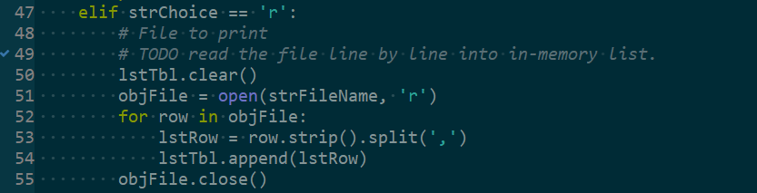

Figure 1 - Read data into program as List of lists

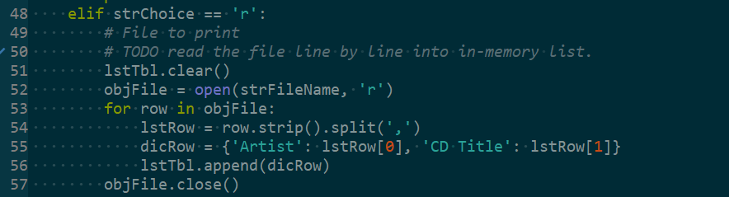

Figure 2 - Read data into program as List of dictionaries

Deleting information from a dataset was particularly challenging for me. I struggled to understand the methods described and introduced in Module04 for deleting information from a list, and finally found my way to good ole google.com in search of deleting rows from a list of dictionaries based on user inputs in Python3.

I was able to find a great resource that explained a method combining a for loop and del to remove a value from a list of dictionaries.

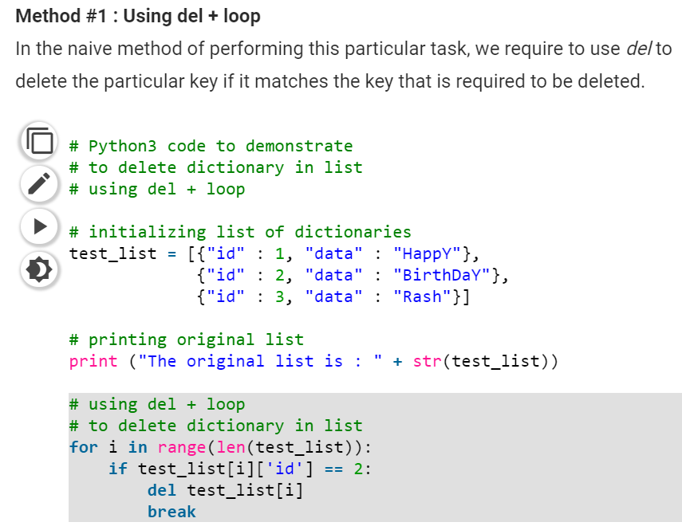

Figure 3 - How to delete from a dictionary[3]

I manipulated this format to include a user input and was able to accomplish the task of deleting information for the assignment.

### Summary

This week was refreshing simple for me to grasp. I am still struggling with other concepts such as how to implement .format on strings effectively. It is a work in progress and this course is providing plenty of practice! I am finding google to be an extremely helpful source of information. Most of my questions I can solve via self-service on google. For instance, I was having some odd extra spaces show up in my code this week that were unintentional and I was able to self-resolve through research and self-review. Looking back to week one and now the progress is amazing, it’s been five weeks and I can now perform code I never would have understood before. Appendix I holds screenshots of my executed code in Anaconda Prompt.

### APPENDIX I

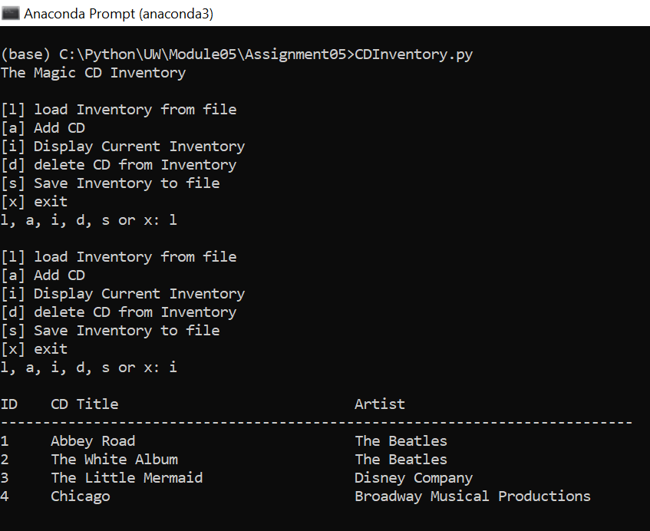

Screenshot 1 - Assignment05 menu task(s) l & i

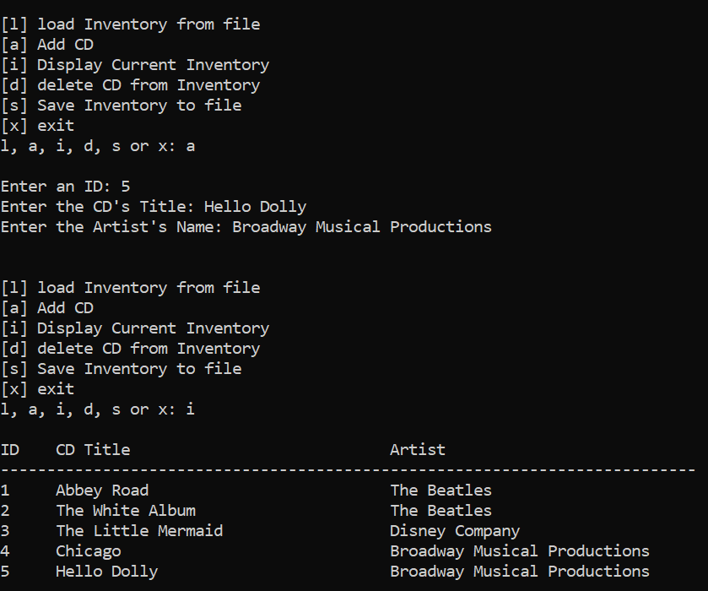

Screenshot 2 - Assignment05 menu task(s) a & i

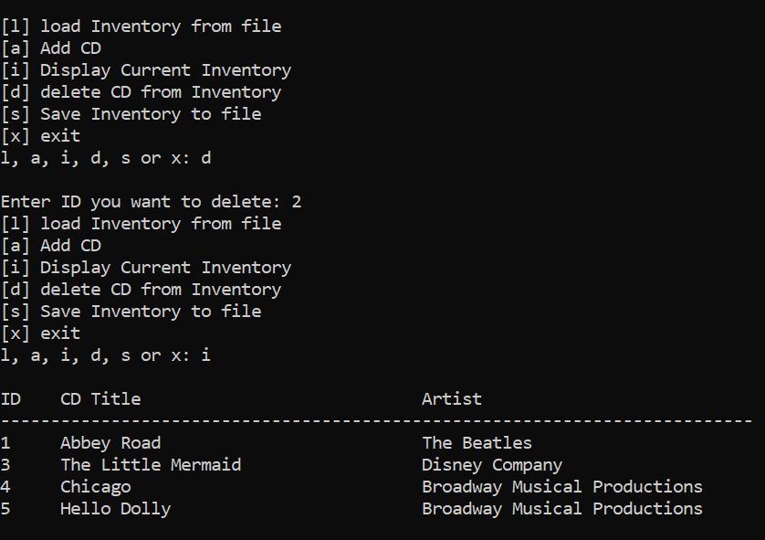

Screenshot 3 - Assignment05 menu task(s) d & i

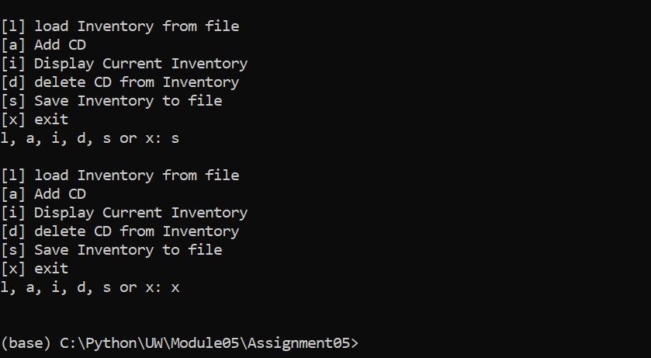

Screenshot 4 - Assignment05 menu task(s) s & x

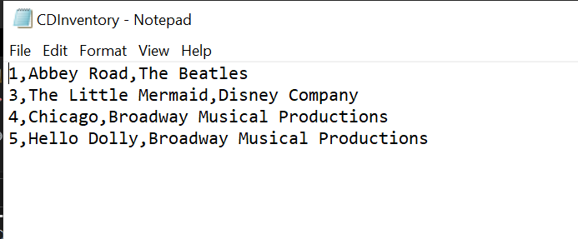

Screenshot 5 - Assignment05 Final saved CDInventory.txt

1. FDN_Py_module05.pdf, page 7
2. [https://www.python-course.eu/python3_dictionaries.php](https://www.python-course.eu/python3_dictionaries.php#:~:text=A%20list%20is%20an%20ordered,and%20not%20via%20their%20position.&text=The%20values%20of%20a%20dictionary%20can%20be%20any%20type%20of%20Python%20data.)
3. <https://www.geeksforgeeks.org/python-removing-dictionary-from-list-of-dictionaries/>