**Exploration device option: *TM1637 display***

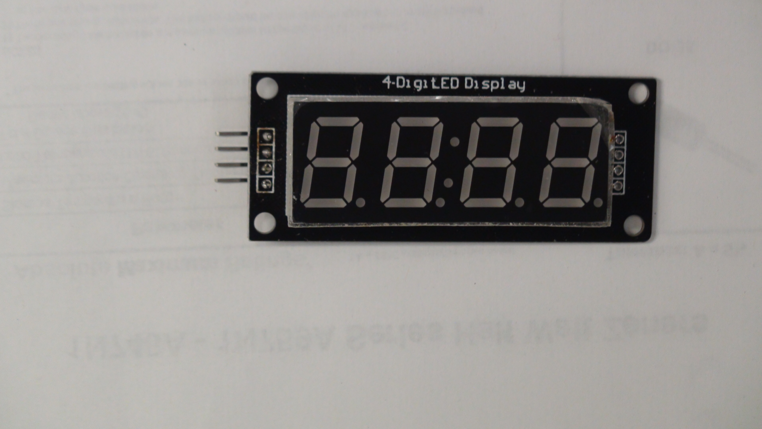

***Device:***

***This set has a 4 digit 7-segment display which includes a centre colon (for a clock).***

**It uses the TM1637 controller.**