Università degli Studi di Milano – Data Science for Economics
Project for Statistical Learning exam
Loris Palmarin – 32349A

IS IT ALL ABOUT CREATIVITY?

ABSTRACT
Developing a data-driven strategy for a marketing campaign involving a supermarket international chain whose aim is to increase engagement of their customers. At first, clustering techniques will be applied to better segment the consumers market and improve targeting. Some ideas about newsletters will be developed. Results will suggest deep preferences for wine products and clusters mainly based on income and number of dependents at home.
Secondly, supervised statistical learning methods will be implemented to discover which customers’ features best predict the likelihood to respond positively to the future marketing campaign. Random forest is the best model and suggests that elements like days since last purchase, income and spending on different product categories are key factors for success.

- Introduction
  - Background and motivation
  - Objectives
- Data preparation and pre-processing
  - Description of the dataset and sources
  - Data cleaning
  - Feature engineering
- Wearing data-driven glasses, a first look
  - Summary statistics and distribution of key variables
  - Relationships between variables
  - How many native speakers?
- Stay out of the spam!
  - Rationale for segmenting customers.
  - Methodology
    - Clustering with numerical variables.
    - Clustering including categorical variables.
  - Results.
  - Implication for marketing targeted offers and newsletter
- Does meat really matter?
  - Objective and importance of predicting customer’s response
  - Model’s selection and implementation
  - Model comparison and evaluation
- Conclusion
  - Summary of key findings and their implications for the business
  - Limitations of the current analysis and potential future work.

INTRODUCTION

  - Background and motivation
This project is developed as final exam of a university course of Statistical Learning, with the purpose of applying both supervised and unsupervised techniques to a dataset that contains data about customers of a company that intends to develop a new marketing plan.

In today's rapidly evolving marketplace, understanding customer behavior and preferences has become fundamental for companies seeking to optimize their marketing strategies and enhance customer engagement. This project aims to leverage these technological advancements to segment customers based on their behavior and predict their responses to future marketing campaigns.

For the purpose, I act as a marketing agency consulting for an international supermarket chain. This aims to enhance its customer engagement strategies and wants to segment customers to tailor newsletters and offer customized promotions.
Additionally, they want to increase their prediction capability of customer response in view of their upcoming marketing campaign.

  - Objectives
Through a systematic approach that includes data preparation, exploratory data analysis (EDA), and the application of both unsupervised and supervised learning techniques, this project endeavors to provide actionable insights that can inform targeted marketing efforts. Specifically, we explore clustering methods to segment customers based on available demographic and transactional data, followed by the implementation of logistic regression, forward stepwise logistic regression, and random forest models to predict customer responses.

By undertaking this analysis, we aim not only to enhance the efficiency of marketing campaigns but also to contribute to a more personalized customer experience. The findings and methodologies outlined in this report are intended to offer a roadmap for leveraging data analytics in marketing strategy development, ultimately driving better business outcomes.

DATA PREPARATION AND PREPROCESSING

  - Description of the dataset and sources.
The dataset used in this project is taken from Maven Analytics, an e-learning platform that teaches new skills to data analysts. This dataset contains marketing campaign data about 2240 customers of Maven Marketing over 28 variables.

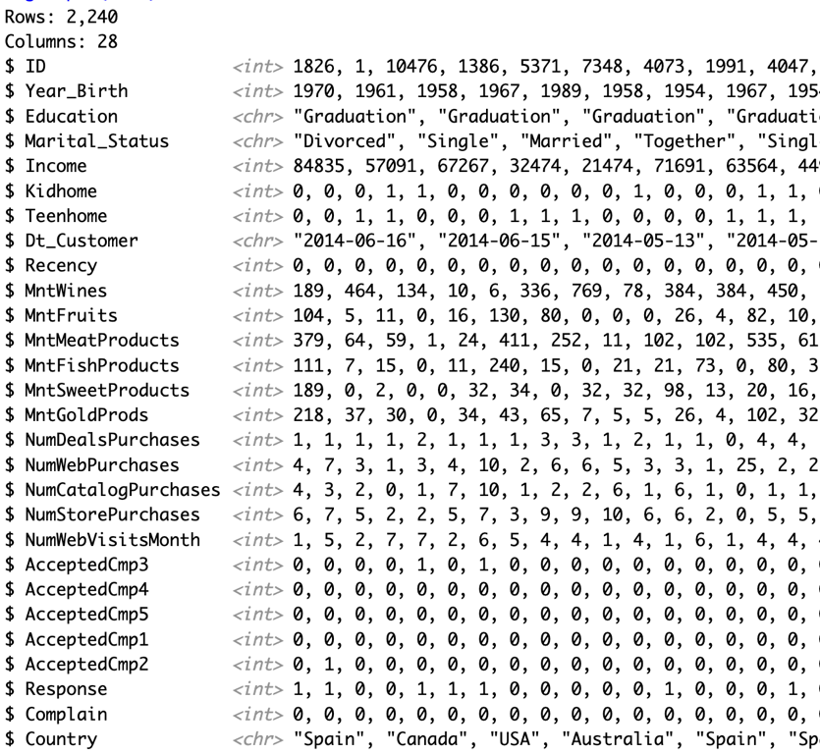

Each customer is assigned to an ID and is described by the following features:
- Year_Birth - Customer's birth year.
- Education - Customer's education level.
- Marital_Status - Customer's marital status.
- Income - Customer's yearly household income.
- Kidhome - Number of children in customer's household.
- Teenhome - Number of teenagers in customer's household.
- Dt_Customer - Date of customer's enrollment with the company.
- Recency - Number of days since customer's last purchase.
- MntWines – MntFruits – MntMeatProducts – MntFishProducts – MntSweetProducts – MntGoldProds - Amount spent on different products in the last 2 years.
- NumDealsPurchases - Number of purchases made with a discount.
- NumWebPurchases – NumCatalogPurchases - NumStorePurchases - Number of purchases made with different methods.
- NumWebVisitsMonth - Number of visits to company's web site in the last month.
- AcceptedCmp1-2-3-4-5 - 1 if customer accepted the offer in the n campaign, 0 otherwise.
- Response - 1 if customer accepted the offer in the last campaign, 0 otherwise.
- Complain - 1 if customer complained in the last 2 years, 0 otherwise.
- Country - Customer's location.

  - Data cleaning
Data cleaning is a fundamental task to accomplish during the first steps of the project, aimed at ensuring data quality and reliability.

At first, I applied na.omit() function to remove all null values. Only 28 records were lost.

Subsequently, a boxplot of numerical variables of interest was generated to identify outliers that might adversely affect the analysis. The variables were scaled to enhance graphical representation.
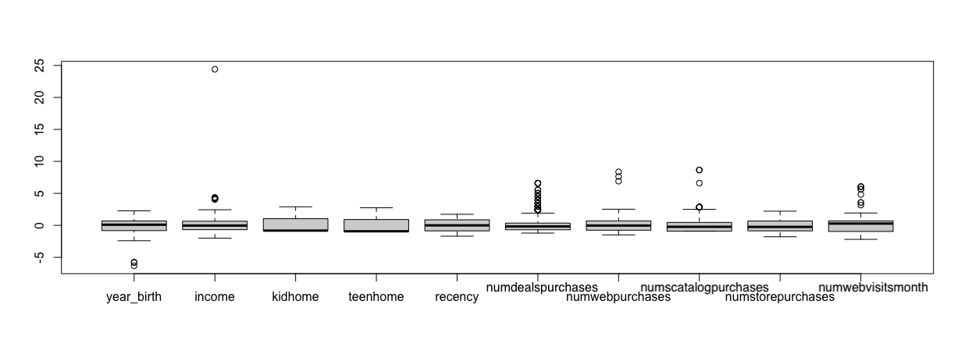
As we can see, there is an outlier in income, that amounts to 666.666, and some outliers in year of birth. I decided to remove both. Data are very sparse also on the number of articles bought with discount, but for my purposes, I decided to keep those records. A revised boxplot, post-outlier removal, is provided below.
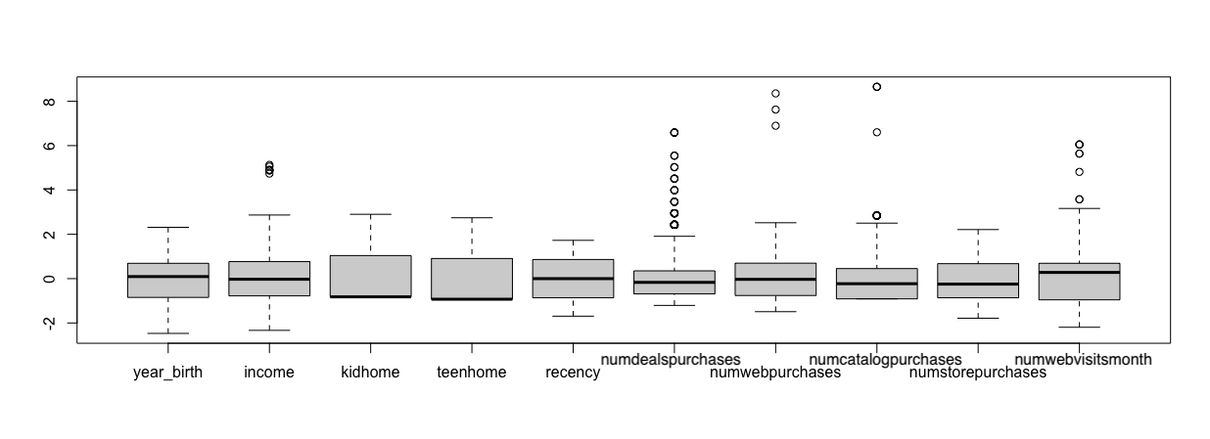
Lastly, I noticed that variable “Marital_Status” assumed meaningless values like “alone”, “yolo”, and “absurd”. These answers suggest that maybe when asked to the customer, he didn’t pay much attention to the quality of answers, and this could influence analysis results. So, I dropped them.

  - Feature engineering
For future analysis purposes, I created some variables:
- age: current age of the customer (year base 2024).
- totalpurchases: sum of number of purchases.
- moneyspent: sum of money spent in different goods categories.
- dt_customer: I converted this variable from a date type to the years of fidelisation of the customer.

WEARING DATA-DRIVEN GLASSES: A FIRST LOOK

  - Summary statistics and distribution of key variables.
At first, I computed summary statistics of all numerical variables to check their distributions and understand their ranges.

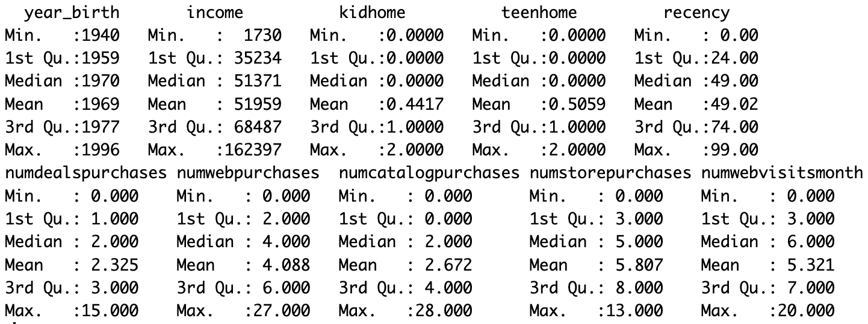

Year_birth has a wide range: customers of the supermarkets belong to different generations, from Baby Boomers to Millenials. Youngest Gen Z is excluded from this dataset.
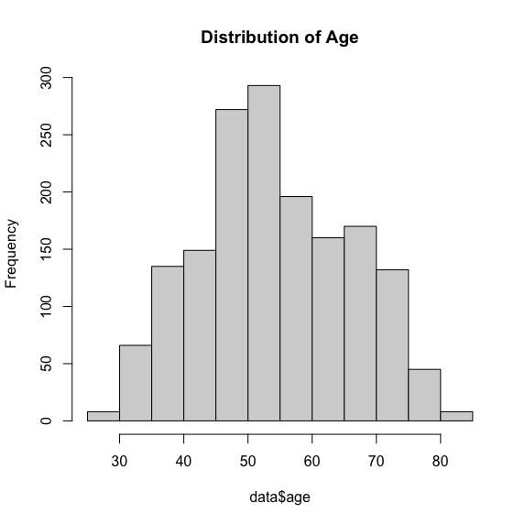

However, checking distribution of Age provides meaningful insights because even though age range is very wide, most of the customers are 45-60 years old.
I produced another boxplot regarding transactional behavior across different product categories and overall spending and purchases. I didn’t scale the variables because at the moment I’m interested in the original numbers.

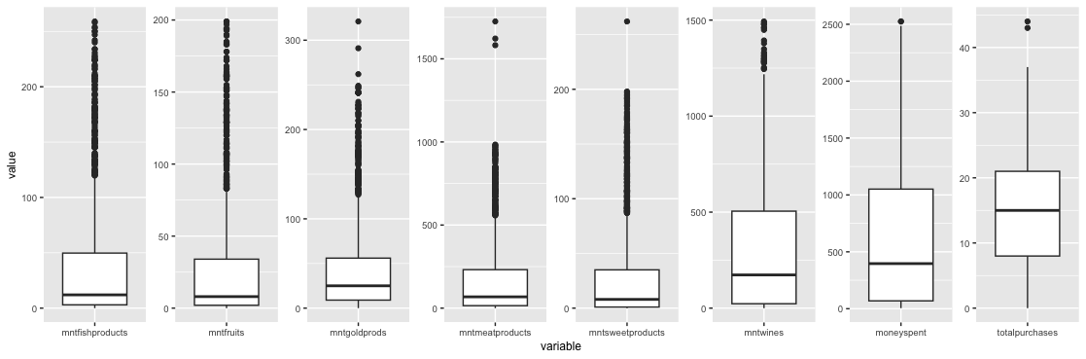

Customers tend to spend more in meat products rather than gold or fish. However, almost all products have long tails of outliers who spend much more.
Total purchases variable has an almost symmetric distribution with a mean of 15. The outliers’ presence indicates that some customers make a substantially higher number of purchases.

In addition to this, all other variables also exhibit significant variability, which will certainly aid the analysis in understanding different consumer categories more comprehensively.

  - Relationships between variables.
I make use of correlation matrix and heatmap to identify relationships between variables. This is a good starting point to undercover unexpected relations and identify predictors for customers response and segments.
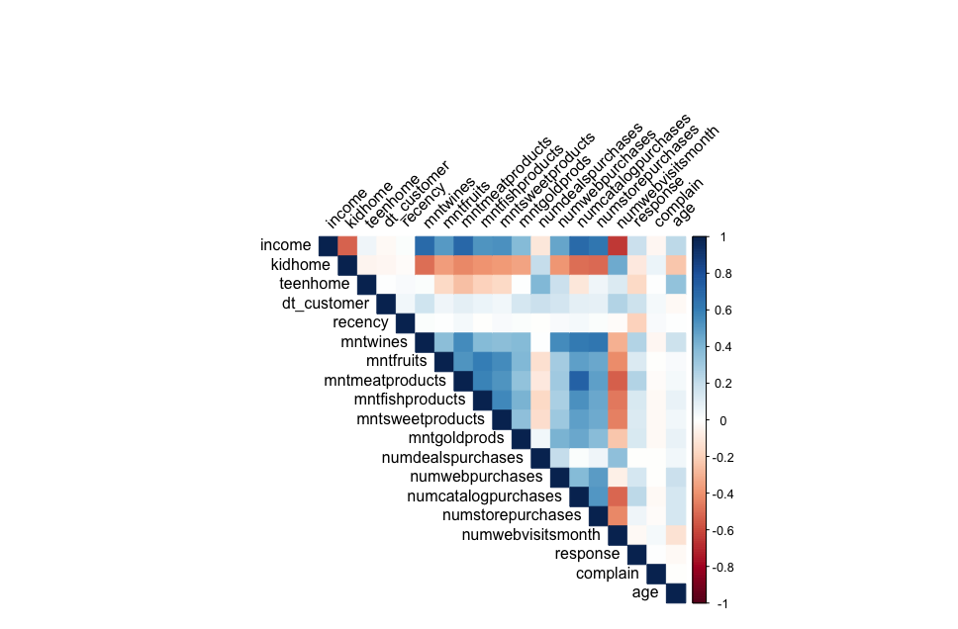
Income and response are strongly negatively correlated. This means that as income increases, response rate decreases, and vice versa. This relation suggests that higher income customers may already have met their needs and are less responsive to marketing offers, that mostly consist of promotional offers. Allocating marketing resources toward lower income customers could be more effective and lead to higher responses rates.

We observe a negative correlation between the variable kidhome and all variables related to the number of purchases and spending on various products. This is likely because families with more children tend to be more budget-oriented, leading to a decrease in both the frequency of purchases and the amount spent on products.

Conversely, all variables related to the number of purchases and spending on various products are positively correlated, as one would intuitively expect. This suggests that individuals who make more purchases in one category are also likely to make more purchases in other categories, and similarly, those who spend more on one type of product tend to spend more on others as well.

  - How many native speakers?
Across this report, reader will notice that categorical variable country is never included in the analysis. This is because the supermarket chain wanted to know at first if only country could influence future marketing response. Their concern was that implementing different national campaigns would have been too expensive and require too much human resources to produce different newsletters.
To address this problem, I applied a logistic regression using as predictor only the variable country. Results clearly state that citizenship doesn’t impact on response to future marketing campaigns.

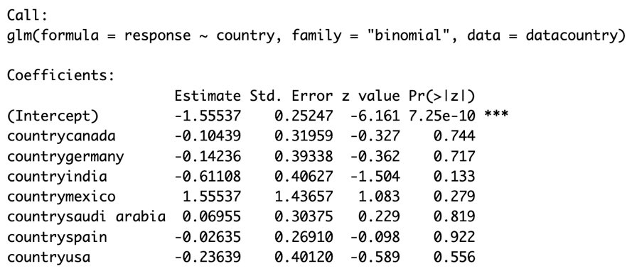

STAY OUT OF THE SPAM!

  - Rationale for segmenting customers
The chain of supermarkets asked marketing agency to provide an efficient way to target their customers that could boost sales and improve customer loyalty.

Clustering is an efficient unsupervised statistical learning technique made for the purpose. The goal of this method is to group a set of observations in clusters, basing on their similarities.
Clustering methods will help splitting customers in different homogenous groups. Once I made the clusters, I will analyze them to uncover differences and unexpected insights and purchase habits.

Customers’ dataset is made of numerical and categorical variables. The latter need to implement more powerful techniques given the “text” nature of these features. At first, I clustered with only numerical variables. Then, I applied a dimensionality reduction technique, t-SNE, and exploited differences.

  - Methodology:

Clustering with only numerical variables.

The first application of clustering with only numerical variables required some dataset transformations to make results more interpretable and meaningful.
At first, I selected only numerical variables. Then, I computed the ratio of every category of product with the total amount of money spent. I did the same with the number of purchases through various sales channels and the total purchases. This transformation is useful because higher spending customers obviously have higher spending in different categories. This issue would make clustering application useless and unnecessary.

K-Means is a good clustering technique when there are mainly numerical features.

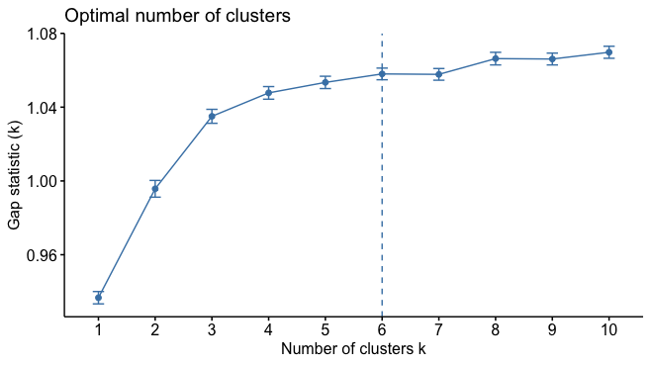
Gap Statistic suggested an optimal number of clusters to 9. By the way, I decided to keep a low number of clusters because of two reasons. The first is supermarket’s budget limitations, marketing agency must stay in a budget and targeting so many groups of customers can be very expensive. The second is that by developing a newsletter for 9 different groups of customers, there is a risk that the brand appears inconsistent or confusing to customers.

Three clusters still keep a good Gap Statistic. So, I performed k-means with three groups. Results:

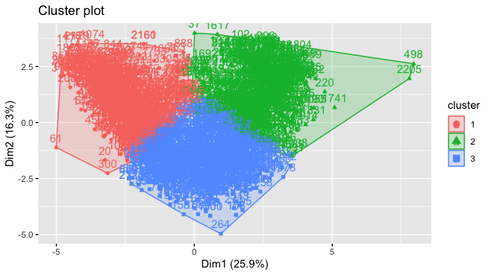

Finally, I assigned clusters to the observations in the original dataset and computed means.

Further analysis will be developed later.

Inclusion of categorical variables through t-SNE visualization and k-means clustering.

Following from only numerical variables clustering, I tried to improve the model including also categorical variables. Dealing with mixed variables datasets isn’t an easy task.

At first, I included categorical variables in the clustering dataset: education, marital status, complain, response and previous marketing campaigns acceptances. The first two variables have different levels, while all the others are binary.

An interesting procedure is to apply t-SNE, a dimensionality reduction technique, and then applying k-Means to the result. For this purpose, I need to compute distance matrix. Euclidean distance isn’t a good measure because it assumes that data is normally distributed and have good linear relations. Gower distance is a better approach as it can handle both types of variables and takes into account differences in the scale and nature of the variables.

Distance matrix computed by Gower’s distance will be the input to t-SNE approach for reducing dimensionality and clustering. To do this, I transformed data types of categorical variables (originally “chr”) in “factors”. Then, I performed k-means to t-SNE results.

Differently from the first clustering, Gap Statistic suggests that optimal number of clusters is 3:

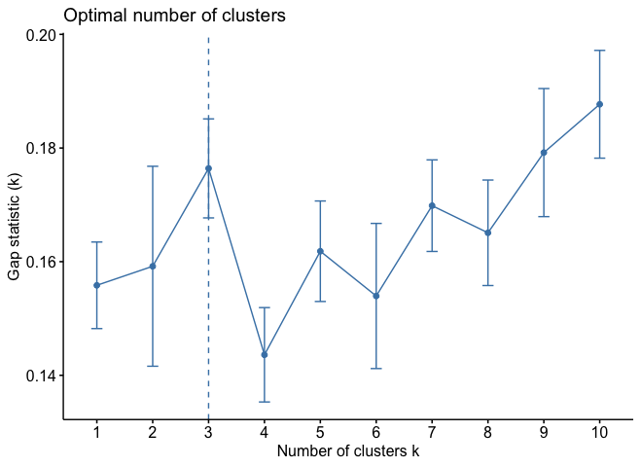
Output of clustering:

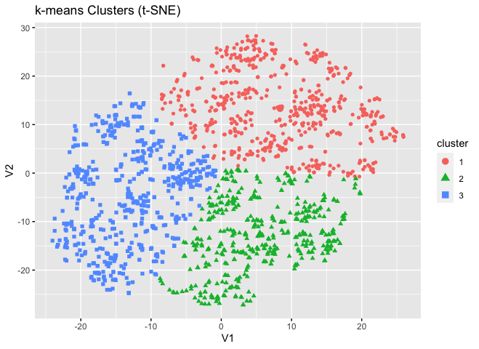
Having also categorical variables included, computation of clusters means is not a general method. As before, I computed means for numerical variables:

When dealing with categorical variables, the average would not make sense. Therefore, I calculated the frequency distribution for each of them to understand their composition and influence with respect to the cluster.

Marital Status graph:
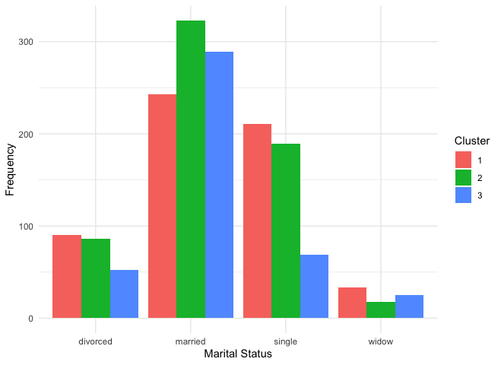

Education level graph:
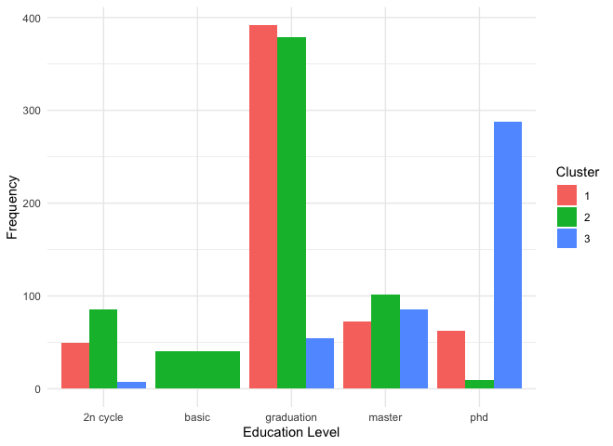

Response to last marketing campaign graph:
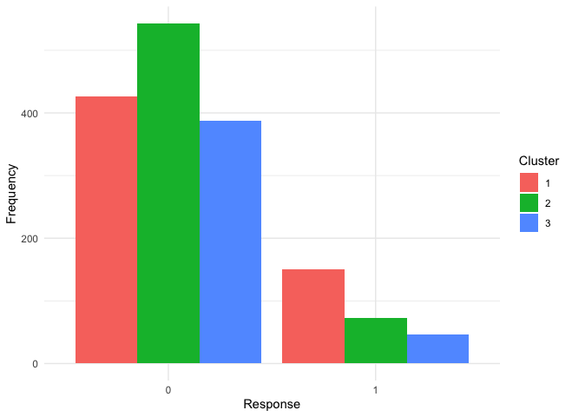

To conclude, I compared the two clusters with the silhouette score. It is a measure of clustering quality that evaluates how well each observation in the dataset is assigned to its own cluster and how distant it is from observations in neighboring clusters. It is a measure of internal validity of clustering, providing an indication of cohesion within clusters and separation between clusters. It ranges from -1 to 1. A higher value means a better clustering.

Silhouette score with only numerical variables: 0.282
Silhouette score with full clustering: 0.405

As we wanted to demonstrate, the clustering technique that also includes categorical variables is the best.
The goodness of this model is also confirmed by the fact that the averages of the clusters in the two techniques are very similar, and the inclusion of the categorical variables does nothing but improve the model, without distorting the information we can gather from it.

Finally, for a final validation of the clusters, I applied logistic regression using response to last marketing campaign as independent variable and clusters as predictors. The result can be used as an indication of the validity of the clustering. If the logistic regression coefficients are significant and the regression overall has a good fit to the data, this suggests that the clusters may be predictive of customer behavior towards the marketing campaign.

Result of regression:
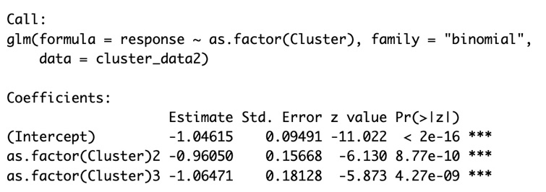
Predictors are statistically significant, so this is the last validation to cluster’s reliability.

  - Results:
Description of identified clusters and interpretations

Based on the overall averages of various variables of the three clusters and general means, we can make an in-depth analysis of the compositions of the clusters and their differences compared to the overall average. Here's a detailed breakdown:

- Cluster 1.
It has an average age of 48 years and a lower average income (30,000). This group has on average 1 child at home, makes a similar number of promotion-related purchases (2) but visits the website more frequently (7 times per month). It has the fewest total purchases (6) and the lowest spending (111). Wine still represents a significant part of spending (25%), but there is also a greater spending on gold (21%) and a predominance of in-store purchases (58%). This cluster is the best responsive to last marketing campaign.

- Cluster 2.
Characterized by an average age of 56 years and a high average income (74,000). This cluster has no children or teenagers at home, makes a low number of promotion-related purchases (1) and visits the website 3 times a month. It shows the highest total number of purchases (20) and highest spend (1,307). Most of the spending is dedicated to wine (43%), followed by meat (32%) and web purchases are a significant portion (27%).

- Cluster 3.
With an average age of 59 and an average income (51,000), this cluster has on average one teenager at home. Has the highest number of promotion-related purchases (3) and visits the website 6 times per month. With 13 total purchases and an expense of 489, it significantly prefers wine (65%) and has a more balanced distribution between purchasing channels, with a slight prevalence of the web (37%) and the store (50%). It has an interesting high number of PhD customers.

Comparison with the general average:

Demographics:
Clusters 2 and 3 have an average age and income above the general average, perhaps indicating greater spending capacity. Cluster 1, younger and with a lower income, represents a different customer segment.

Purchasing behavior:
Cluster 2 stands out for the number of total purchases and total spending, indicating a high-value customer group. Cluster 1, with the fewest purchases and lowest spending, may represent more occasional or budget-conscious customers.

Product preferences:
While wine is popular in all clusters, cluster 2 shows a marked predilection for this product. Cluster 3, with the highest percentage of spending on wine, could represent wine lovers. Cluster 1 shows greater diversification in product preferences, with relatively higher spending on gold.

Purchasing Channels:
The clusters show differences in preferred purchasing channels, with cluster 2 using channels more equally, while cluster 2 prefers in-store purchases.

  - Implications for targeted marketing offers and newsletters.
Based on the analysis of the characteristics and preferences of the three identified clusters, we can develop targeted strategies for a newsletter campaign and assign a name to each cluster.

Cluster 1 – FAMILY EXPLORERS
Characteristics: Younger people, with lower income, presence of children, fewer purchases and spending, tendency towards in-store purchases, varied interest in products including gold ones.

Implications for the newsletter:
- Highlight special coupons and promotions on a variety of products, including baby items.
- Encourage participation in surveys to win discounts or free products, encouraging interaction with the website.

Cluster 2 – GOURMET WINERS
Characteristics: High income, no children or teenagers in the home, high frequency of purchases and spending, strong preference for wine.

Implications for the newsletter:
- Focus on wine products, including reviews and articles on wines, wine tourism and exclusive events related to the world of wine.
- Special offers, proposing offers on premium wine selections, gourmet pairings and winemaking accessories.

Cluster 3 – WINE TEEN BONDING
Characteristics: Advanced age, average income, presence of teenagers, love of wine but with a balance between online and in-store purchases.

Implications for the newsletter:
- Sharing stories of winemakers who talk about their tradition and passion, creating an emotional connection.
- Offer advice on pairing wine with everyday meals, tips for entertaining guests, and ideas for family activities that involve discovering new flavors.

Personalizing newsletters based on clusters will not only increase customer engagement and satisfaction but also optimize the ROI of marketing campaigns. Identifying clusters with names that reflect their characteristics helps to better conceptualize marketing strategies.

DOES MEAT REALLY MATTER?

  - Objective and importance of predicting customer response.
This part aims to explore the application of different predictive modeling techniques to predict the results of marketing campaigns and analyze the practical implications for marketing strategies. Through the use of statistical learning methods, I will examine logistic regression, stepwise selection, and random forest as tools to identify factors that influence customer response to marketing campaigns.

In light of these analyses, I will explore opportunities for target segmentation, personalization of offers, optimization of the marketing budget and continuous monitoring of marketing strategies.

It's important to validate these models properly and ensure they're not overfitting the training data by evaluating their performance on a separate test set. For the purpose, I split data set in an 80% training set and 20% test set. Confusion matrices will be produced over test tests.

  - Model Selection and Implementation:
Logistic Regression: Model overview and rationale for choice.

Logistic regression is a statistical technique used to model the relationship between a binary dependent variable and a series of independent variables. Its main goal is to predict the probability that an observation belongs to one of the two categories of the dependent variable, based on the values of the independent variables.

Once trained, the logistic regression model can be used to make predictions about the probability of membership in a certain category of the dependent variable for new observations based on their independent variable values.

I used as independent variable “response”. This is the output:

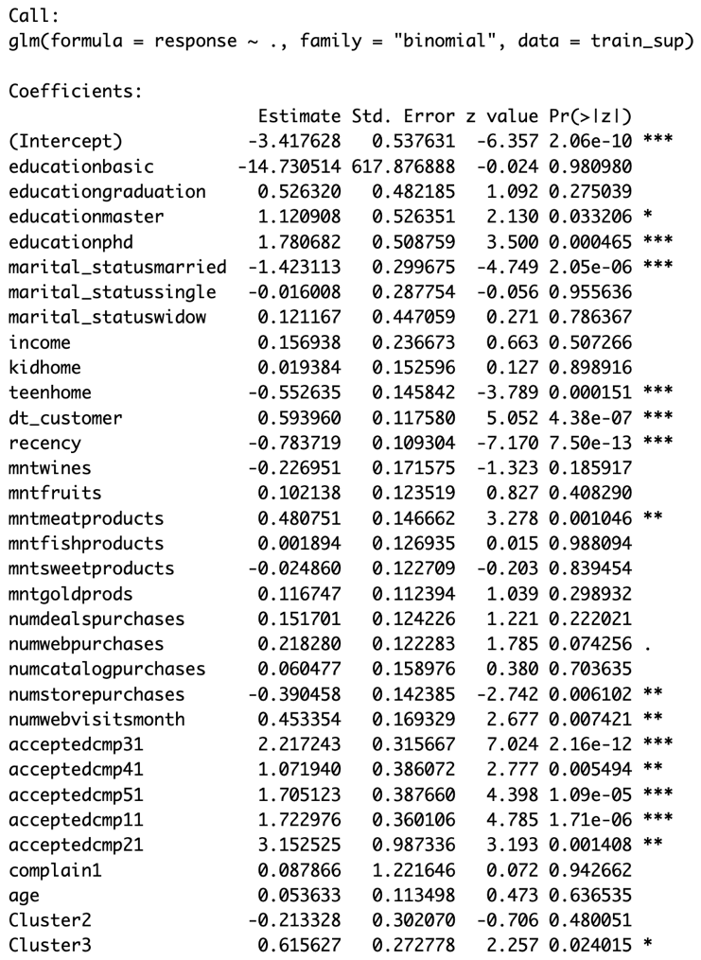

ROC Curve (A) and confusion matrix (B):
A.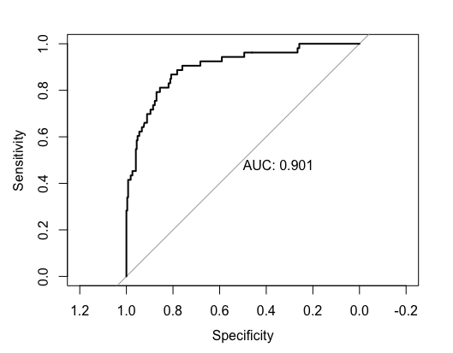 B.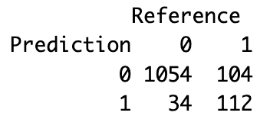

Logistic Regression with Stepwise Selection: approach, variable selection process, and model improvement.

Stepwise variable selection is an iterative process used to identify an optimal subset of predictor variables in a logistic regression model. During each iteration of the process, both adding new variables to the model to improve its performance and eliminating existing variables from the model that may not contribute significantly to overall performance are evaluated.

The goal is to find an optimal balance between model complexity and predictive ability, avoiding overfitting and maximizing performance on the test dataset. “Both directions” variable selection offers flexibility and control over the complexity of the model, allowing to identify the most informative and relevant variables for predicting the dependent variable.

Output of the model:
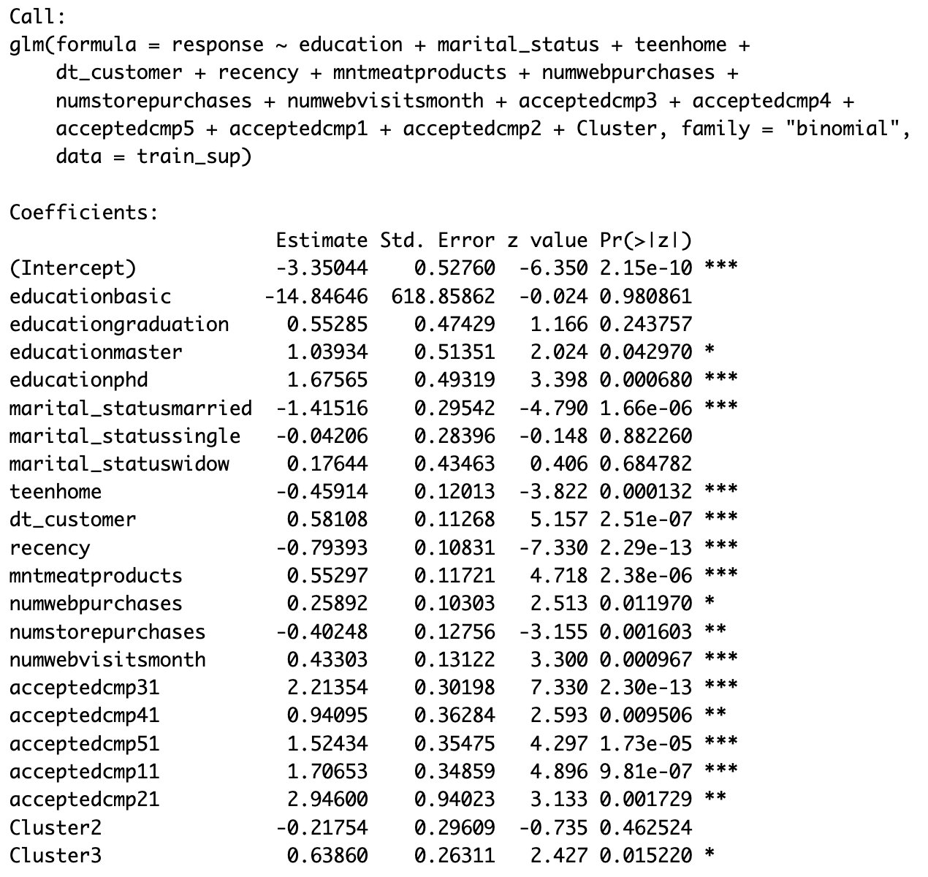

ROC Curve (A) and confusion matrix (B):

A.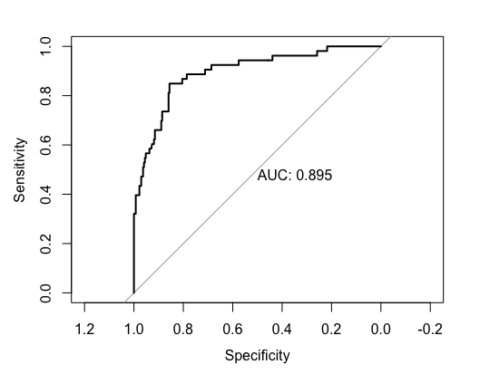 B .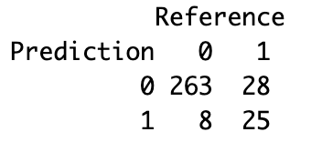

Random Forest: justification for using Random Forest and its expected advantages.

Random Forest is a statistical learning technique widely used to address classification and regression problems. Its popularity stems from several advantages and features that make it suitable for a wide range of problems.

Thanks to the bootstrapping technique and the combination of many decision trees, Random Forest is less prone to overfitting than other more complex models. This means it can generalize better to new data, reducing the risk of prediction errors due to overstoring training data.

Random Forest provides an evaluation of the variable of importance, which helps to identify which variables have the greatest influence on predicting the outcome. This can provide valuable insights into the relationships between the predictor variables and the desired outcome.

The output in this case isn’t similar to previous ones, but with a specific function, Random Forest produces a table with each variable importance associated to the Gini index. The importance of the variables assessed using the Gini index provides an indication of the ability of each variable to effectively predict the output classes in the model. Variables with a higher Gini index are considered more informative and have a greater impact on outcome prediction.

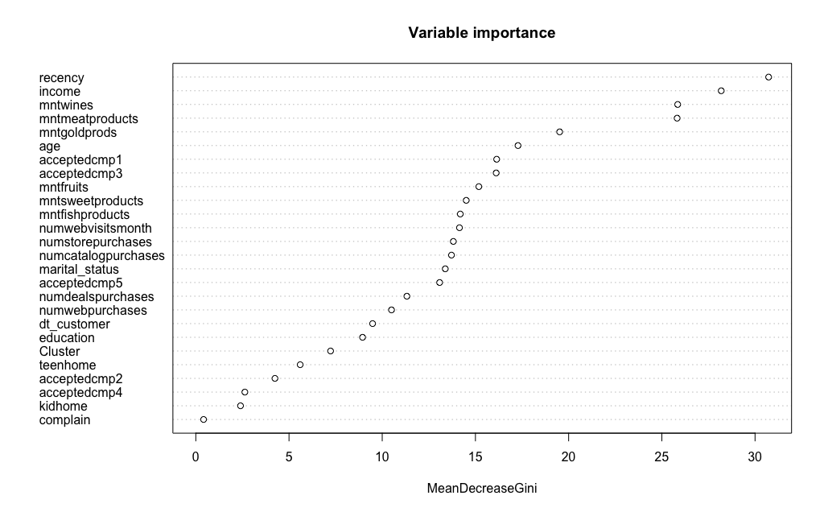

ROC Curve (A) and confusion matrix (B):
A.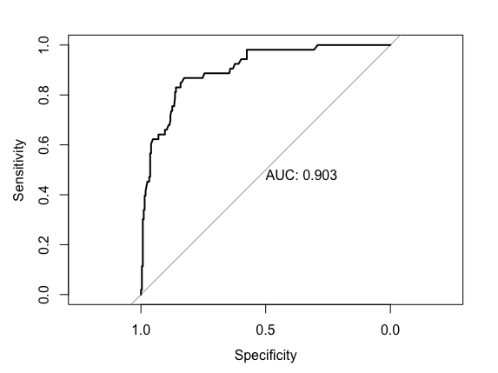 B .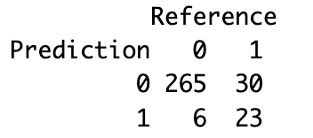

  - Model Comparison and Evaluation:
Deeper analysis of supervised methods

Standard logistic regression:

This analysis includes all available predictors. Variables such as educationphd, marital_statusmarried, teenhome, recency, mntmeatproducts and variables related to previously accepted campaigns (acceptedcmp1, acceptedcmp2, etc.) show a significant influence on the probability of responding positively to the campaign. These factors suggest that customers with a higher level of education and those who have responded to previous marketing campaigns are more likely to respond again. In contrast, being married or having teenagers in the home appears to reduce this likelihood.

Logistic regression with stepwise selection:

The stepwise model selected a subset of predictors. It retains several of the same significant variables as the full model, such as educationphd and recency, but excludes other variables that may be less relevant or redundant to predictive power. We still see the negative effect of marital_statusmarried and teenhome, but with fewer variables in the model, we can be more confident that these actually influence the response.

Random forest:

The importance of variables in the random forest model shows which characteristics contribute most to the predictive ability of the model. recency, income, mntwines, and mntmeatproducts are among the most important, confirming that recent purchasing behavior and income level are particularly relevant in predicting response to campaigns.

Metrics used for comparison (Recall, F1 Score, AUC, etc.).

For comparing different methods of predicting marketing response, I created a table to compare the following indicators:
- AUC (Area Under the ROC Curve): measures a model's ability to distinguish between classes.
- RECALL (Sensitivity): percentage of real positives correctly identified by the model. High values indicate a good ability to detect positives.
- SPECIFICITY: percentage of real negatives correctly identified by the model. Higher values indicate better ability to detect negatives.
- PRECISION: percentage of correct positive predictions compared to the total positive predictions. Indicates the accuracy of the model's positive predictions.
- F1 Score: harmonic mean of precision and recall, provides a single score that balances the two.
- ACCURACY: percentage of correct predictions compared to the total. Measures the overall accuracy of the model.

Comparison table:
 | AUC | RECALL | SPECIFICITY | PRECISION | F1-SCORE | ACCURACY
LR | 90% | 96% | 51% | 91% | 94% | 89%
LR_FWD | 90% | 47% | 95% | 75% | 58% | 89%
RF | 90% | 97% | 47% | 90% | 93% | 88%

Comparative analysis of model performances.

Logistic Regression shows an overall balance across all metrics, with particularly high values for Recall (96%) and Precision (91%), suggesting a strong ability to detect true positives and ensure that positive predictions are correct. Accuracy is high (89%), indicating a high percentage of correct predictions.

Logistic Regression with stepwise variable selection has a high Specificity value (95%) but a low Recall value (47%), indicating an ability to effectively detect negatives but at the expense of the ability to identify positives. Precision (75%) and F1 Score (58%) are lower, suggesting that the model struggles to balance the correctness of positive predictions with the ability to identify them all. Accuracy remains high (89%).

Random Forest has the highest Recall value (97%), excellent at detecting true positives, but suffers in Specificity (47%), indicating difficulty in correctly identifying negatives. Precision is high (90%), but Accuracy is slightly lower (88%) compared to the other two models.

Best performing model and reasons for its superiority.

To evaluate the best model, we must keep in mind that we’re working for a marketing strategy, and we prefer not to lose potential respondents. For this reason, the best model that maximizes the number of correctly identified positive responses is Random Forest. It emerges as the most effective model despite its low Specificity, given its exceptional Recall and still high precision.

If we had different purposes, Logistic Regression would offer a better compromise because it performs better also at avoiding false positives.

Insights derived from the model regarding customer behavior.

Looking at importance of variables, Random Forest model suggests that deeper analysis of purchasing behaviors could further improve campaign personalization and effectiveness.

By choosing this model as the primary tool for marketing model, there are several implications to consider, for example:

- Targeting. Using the variable importance, I can identify which factors most influence response to campaigns and target customers who have the characteristics most likely to respond positively. In this case, we see that different amounts spent on categories of products, responses to previous marketing campaigns and demographical features like age and income influence responses to future marketing campaigns.
- Campaign optimization. Recency is the most interesting variable, meaning that days since last purchase strongly influence probability of accepting marketing campaigns. For example, we might want to target those who have recently purchased first.
- Risk control: it’s important to keep in mind that Random forest model is likely to make mistakes and classify positives when, actually, they are negatives.

I concluded that random forest is ideal for campaigns where the objective is to maximize engagement, accepting the risk of some irrelevant communications.

CONCLUSION
  - Summary of key findings and their implications for the business.

The results of the cluster analysis highlighted significant differences in customers' purchasing behavior and preferences. This allows to further personalize marketing campaigns to maximize engagement. For example, cluster 2 ("GOURMET WINERS") stands out for its high spending on fine wines, suggesting the effectiveness of special offers and exclusive content related to the wine world. Cluster 1 (“FAMILY EXPLORERS”) requires a different approach, emphasizing promotions on a variety of products and engaging families in interactive activities. Finally, cluster 3 ("WINE TEEN BONDING") could be more involved through advice on wine pairings and activities that explore new flavors as a family.

The adoption of the Random Forest model made it possible to precisely outline the profiles of the customers most likely to interact with our marketing initiatives. In particular, the analysis highlighted the importance of recent interaction with the brand (recency), income level, and propensity to previous purchases (acceptedcmp1, acceptedcmp2, etc.) as key factors for a positive response. Therefore, marketing strategies can be adapted to capitalize on these insights: personalized communications for users with recent interactions, targeted offers for customers with a high income level, and revamping past campaigns that have been successful.

  - Limitations of the current analysis and potential future work.
Despite the promising results, some limitations must be recognized. The breadth and variety of the dataset, although sufficient for a first analysis, may not reflect the entirety of our reference market. Future research efforts should aim to extend the dataset, potentially incorporating additional data on online behaviors and social media interactions. Additionally, exploring the application of more advanced machine learning techniques could reveal additional behavioral patterns and hidden customer segments.

A continuous process of validating and updating models is essential, particularly in a dynamic market environment. Monitoring the effectiveness of campaigns in real time and adapting strategies accordingly will be crucial to maintaining the efficiency of our marketing efforts. Future projects should include testing the predictions of the implementation of the model in different market segments and integrating customers’ feedbacks to improve accuracy of the model.

APPENDICES
- Dataset
- R Code

