Example
This description assumes that all required components for the Jasper-Integration are installed on your system. If that is not the case, please follow the instructions in the file “$JASP_DIR/README”.

iReport
This is the designer for Jasper-Reports which can be launched by “$JASP_DIR/iReport-3.0.0/bin/startup.sh”. A working report template is located in “$JASP_DIR/sample/ExampleReport.jrxml”. Because of that we do not create a new one but feel free to view it in the iReport designer.

Jaspit
You can run Jaspit by calling the script “$JASP_DIR/jaspit/jaspit.sh”. This is the tool where you collect all reports and where you store the configuration of the system. The major task of Jaspit is to generate PHP-Classes for every report.
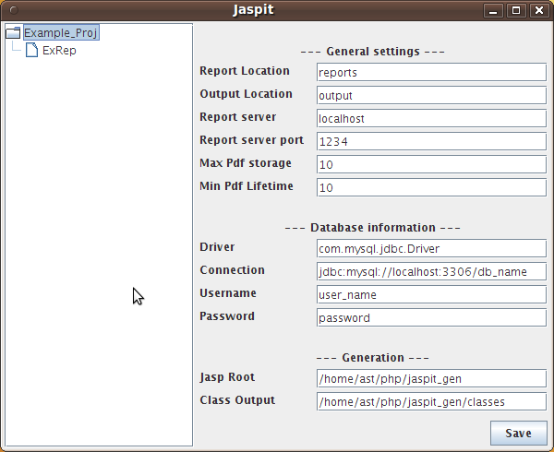

Report Location: |  | This is the folder in which the report-templates will be stored after generation and on the webserver (relative to “Jasp root”).
Output Location: |  | If you decide to store a generated on the webservert, it will be copied to this folder (relative to “Jasp root”).
Report server: |  | Hostname of the backend server.
Report server port: |  | Port on which the backend server islistening.
Max pdf storage: |  | This number defines how many reports can be stored on the webserver. As soon as this number exceeds, a old report will be deleted.
Min pdf lifetime: |  | Time in minutes, how long a generated report can not be deleted. If the maximum of storable reports is exceed and no report can be deleted, storage is not possible.
Driver: |  | Jdbs driver class for the backend server.
Connection: |  | Connection strong for for backend server.
Username: |  | Username to connect to the database.
Password: |  | Password for the database.
Jasp root: |  | Folder in the filesystem where Jaspit generates informations required by the webserver.
Class output: |  | Folder in the filesystem where Jaspit generates the PHP classes.

To create a new project, select “New Project” in the conext menu. Add a new report by choosing “New Report”. Select the report template and a name. For this example name it “ExRep”. Then select “Generate” from the context menu.

Web-Server
Jaspit just generated all required files to the selected folders. If Jaspit is on the same Host as the webserver, you could generate these files directly to the webserver's directory. I recommend to use two steps. Generate to any folder in the filesystem and call a deploy script to duplicate the files. Such a script could look like this:
#!/bin/bash
WWW_ROOT=/var/www
JASPIT_GEN=/home/ast/jaspit_gen
rm -rf “$WWW_ROOT/classes”
rm -rf “$WWW_ROOT/output”
rm -rf “$WWW_ROOT/reports”
rm -f “$WWW_ROOT/jasper.conf”
cp -R “$JASPIT_GEN/”* “$WWW_ROOT”
chmod 0777 “$WWW_ROOT/output”
It's important that the webserver is able to write to “$WWW_ROOT/output”.
Copy also the example scripts in “$JASP_DIR/sample” to the webserver:
cp “$JASP_DIR/sample/example_”* “$WWW_ROOT”

Report starten
To generate the example report, just type the following URL:
http://localhost/example_return.php
You should see the following output.

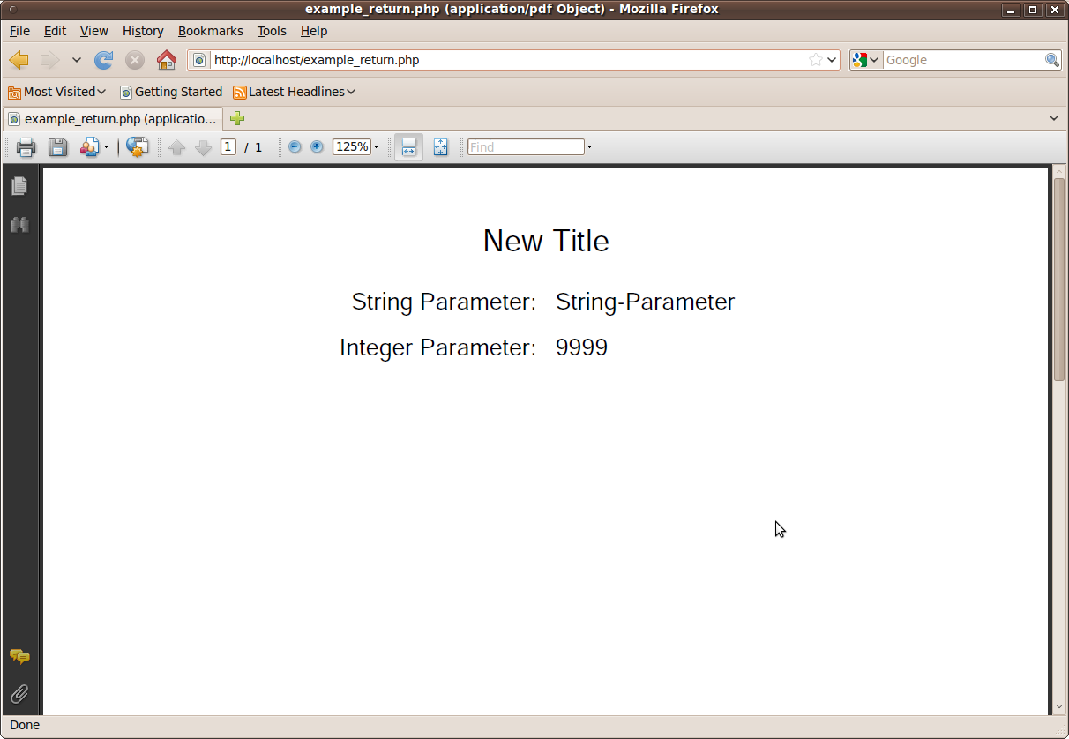

Bayo

