1. preprocess (script)

2. filter (x_reref.set files) (.1, 100, FIR filter automatic)

3.

a) event export BV -> EEGLAB (script)

b) event import (BV + PP) -> EEGLAB (script)

4. epochs (Tools > Extract Epochs)

5. make study (Condition & Group type)

a) make sure study is saved

6. precompute

a) Study > Edit Study Design

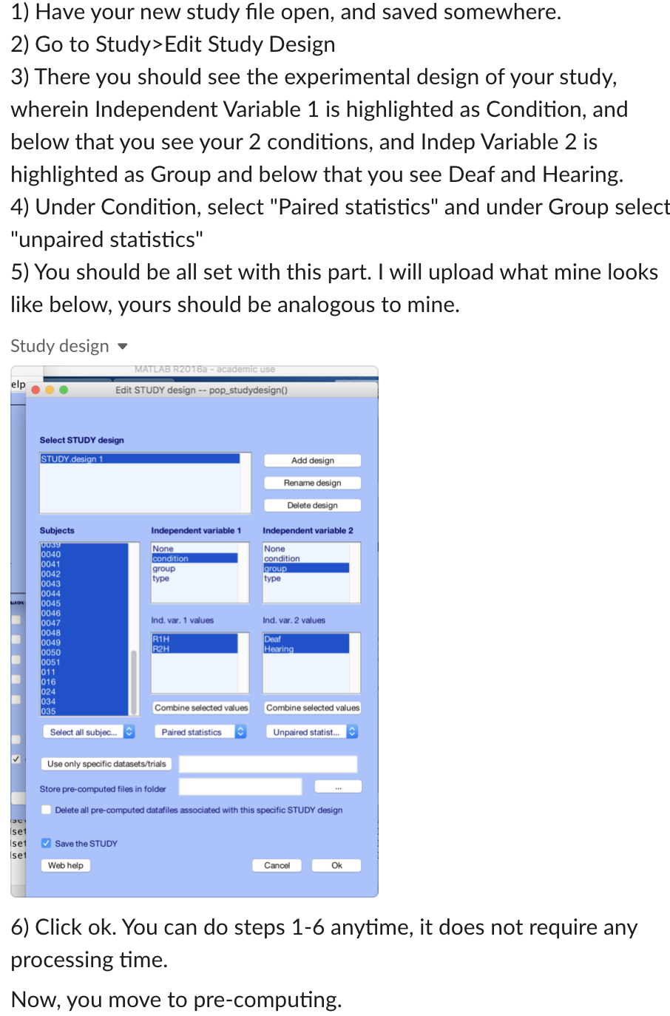b) Should see experimental design of the study, wherein independent variable 1 is highlights as Condition, and below that you see your 2 conditions, and independent variable 2 is highlighted as Group and below that you see Deaf and Hearing

c) Under condition, select “Paired statistics” and under Group select “unpaired statistics”

d) Click ok. Can do steps a – d anytime, it does not require any processing time

e) Click Study > Precompute Channel Measures

f) Click the box next to ERSPs and then in that text box put the following: 'cycles', [4 0.8], 'nfreqs', 80, 'freqs', [5 30], 'ntimesout', 230

g) click test right next to the text box and see results for one subject at one channel, if anything looks wrong stop here

h) If it looks okay, click okay and wait until it is done

i) When it is finished we can look at results!

7. Look at TF results

a) Load study

b) Study > Plot Channel Measures

c) Set statistical threshold. Hit stats button.

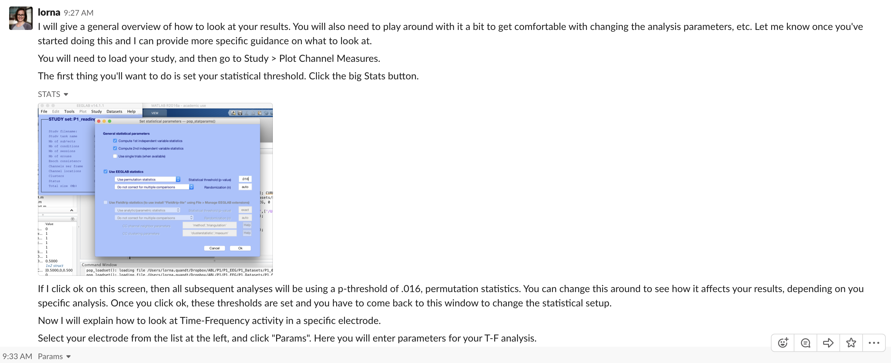d) If we were to click okay on the screen to the left, all subsequent analyses would use a p-threshold of .016, permutation statistics. Once you click okay, these statistical thresholds are set and you have to come back to this window to change your statistical setup.

e) Look at T-F at specific electrode. Select electrode form the list on the left and click “Params” – Here you will enter the params for your T-F analysis.

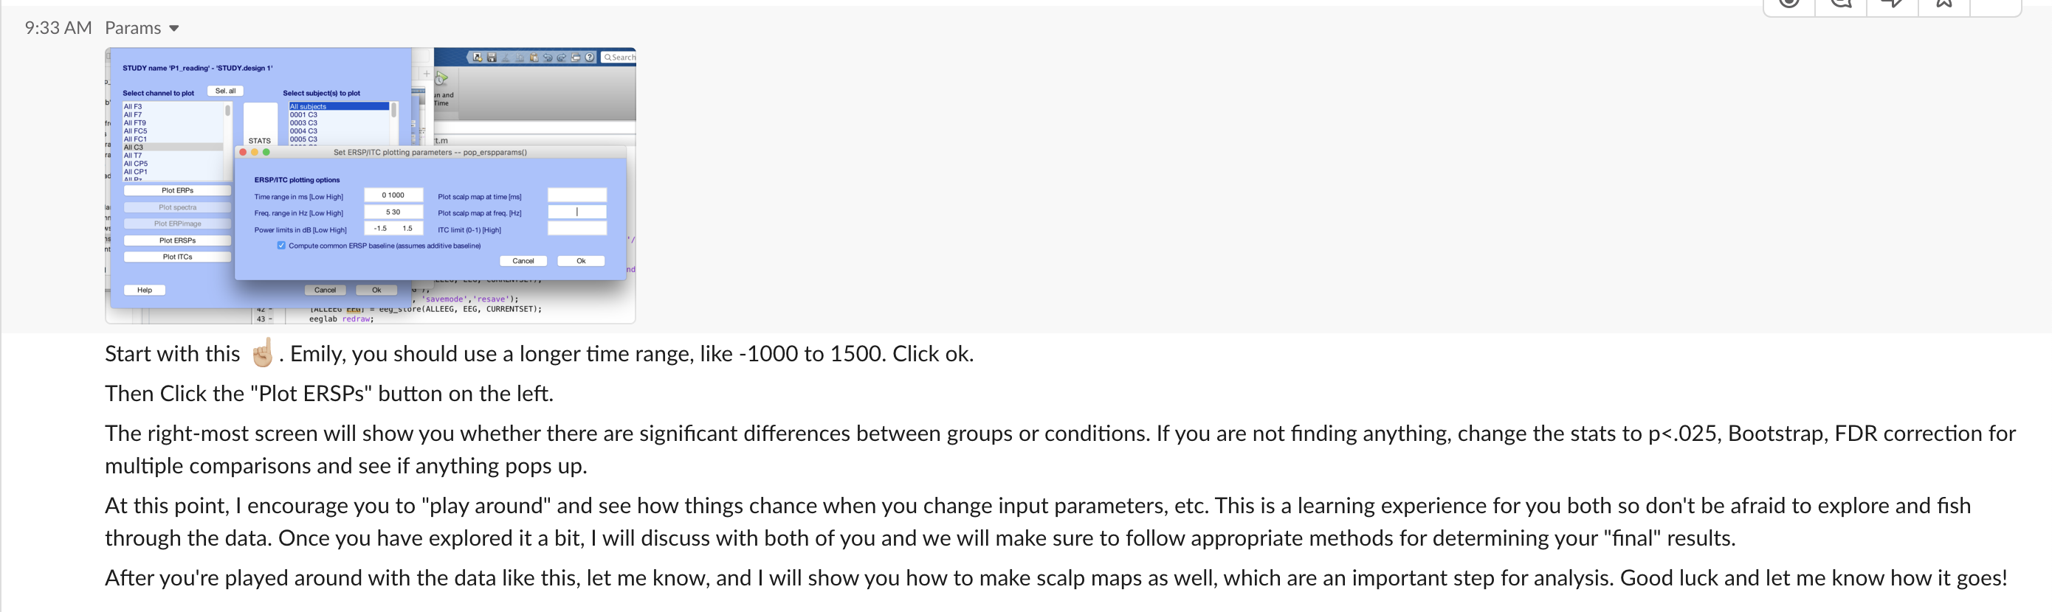f) Start with the example below. Use a longer time range like -1000 to 1500. Click ok.

g) Click “Plot ERSPs” button on the left

h) The right most screen will show you whether there are sig differences between groups or conditions. If you are not finding anything, change the stats to p<.025, Bootstrap, FDR correction for multiple comparisons and see if anything pops up

8. Look at scalp maps

a) click “Sel All” for the channels

b) go to params. Example: power limits = -2, 2, lower alpha = 8-10, time = 0-250ms (Suggested stats p<.016, uncorrected unless discussed something else previously)

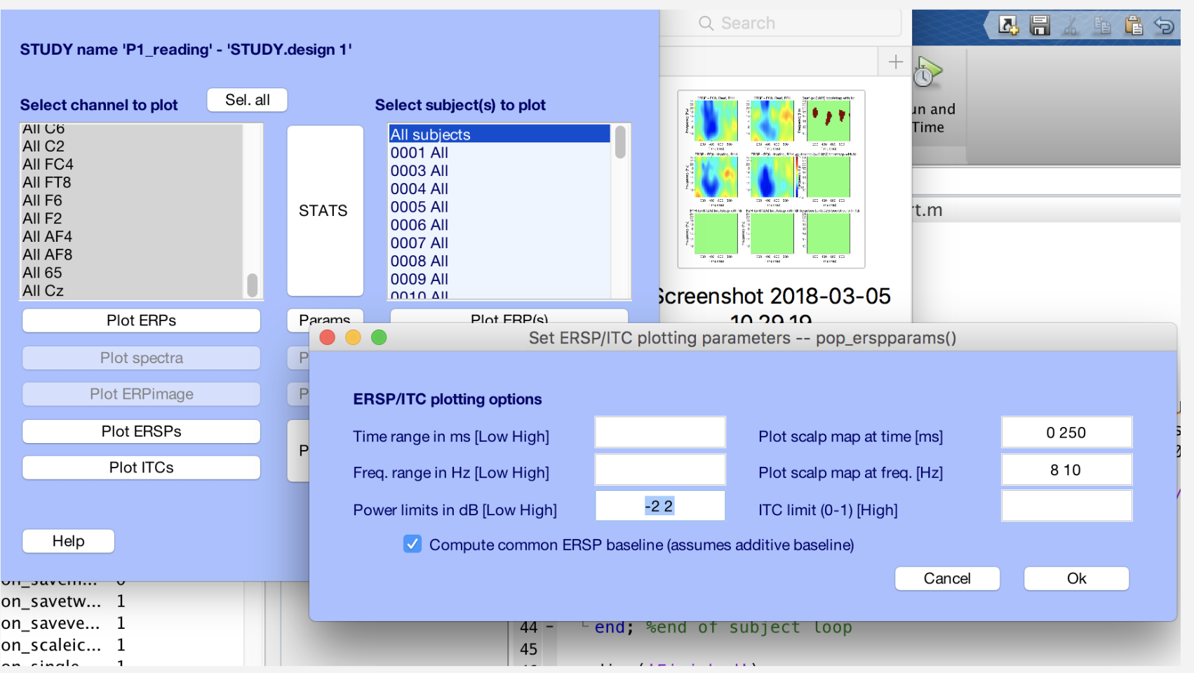

PLDR specific stats:

Filter = .1 to 80

ASLMR specific stats

Filter = .1 100

Attempt A (August 2,3, 2019)

Baseline = -800ms 0

Epoch = -800ms 5000ms

Couldn’t change plot time range = 'cycles', [4 0.8], 'nfreqs', 80, 'freqs', [5 30], 'ntimesout', 500

“” = 'cycles', [4 0.8], 'nfreqs', 80, 'freqs', [5 30], 'ntimesout', 230

Attempt B (August 4, 2019)

Rm baseline = -1500 0

Epoch = -1500 4000

Attempt = 'cycles', [4 0.8], 'nfreqs', 80, 'freqs', [5 30], 'ntimesout', 230

Attempt C August 5, 2019

Rm baseline = -1000 0

Epoch = -1000 2000

Attempt = 'cycles', [4 0.8], 'nfreqs', 80, 'freqs', [5 30], 'ntimesout', 230

F v. NF August 5, 2019

Rm baseline = -1000 0

Epoch = -1000 2000

Attempt = 'cycles', [4 0.8], 'nfreqs', 80, 'freqs', [5 30], 'ntimesout', 500

F v. NF August 8, 2019

Rm baseline = -1000 0

Epoch = -1000 2000

Attempt = 'cycles', [3 0.8], 'nfreqs', 100, 'freqs', [5 30], 'ntimesout', 200

DF hF Attempt D

Rm baseline - -1000 0

Epoch = -1000 2000

Attempt = 'cycles', [4 0.8], 'nfreqs', 80, 'freqs', [5 30], 'ntimesout', 230

DF HF HNF HNS Attempt A

Rm baseline - -1000 0

Epoch = -1000 2000

Attempt = 'cycles', [4 0.8], 'nfreqs', 80, 'freqs', [5 30], 'ntimesout', 230

DF HF HNF HNS Attempt B (Success! With old version of EEGLAB)

Rm baseline - -1000 0

Epoch = -1000 2000

Attempt = 'cycles', [4 0.8], 'nfreqs', 80, 'freqs', [5 30], 'ntimesout', 230

Data to-do

(in progress) F (HF, DF) v. NF (HNF, HNS) precomputations

F v. NF (Hard v. Easy) precomputations

✔ DF v. HF precomputations

DF v. HF (Hard v. Easy) precomputations

F v. NF TF plots (central electrodes)

F v. NF scalp maps (central electrodes)

F v. NF Hard v. Easy TF plots (central electrodes)

F v. NF Hard v. Easy scalp maps

DF v. HF TF plots (central electrodes)

DF v. HF scalp maps

DF v. HF Hard v. Easy TF plots (central electrodes)

DF v. HF Hard v. Easy scalp maps

Writing to-do

✔Get rid of novie and intermediate signer

✔-Address “coda” group – why would hearing native and deaf native be different?

✔No ASL-Ct for non-signers (no ower limit?)

✔Add easy/hard condition within hypotheses

✔Expand upon whybetter signers will have more desynchronization

✔ Gender, writing - flip order of arguments - use gender as an example of malleable - we know that this can be trained, then back to research on gender

✔-Address that we want to keep measures as close to original measures (VKMRT, MRT) so that we can better compare to previous studies

✔ Define language fluenct, define interested in effects of fluenct by which I mean___.

✔ -Exploring if this is on a trajectory or if it is discrete – is it fluenct dependent?

Rotation in sign language may not be processed as a spatial thing - what if it’s only a language thing(alternate explanations) - if ASL is really good, it is possible that its just language language, and THUS we do not see transfer - bc this is possible - why do you even predict they will be so good