CYPHER ANXIETY

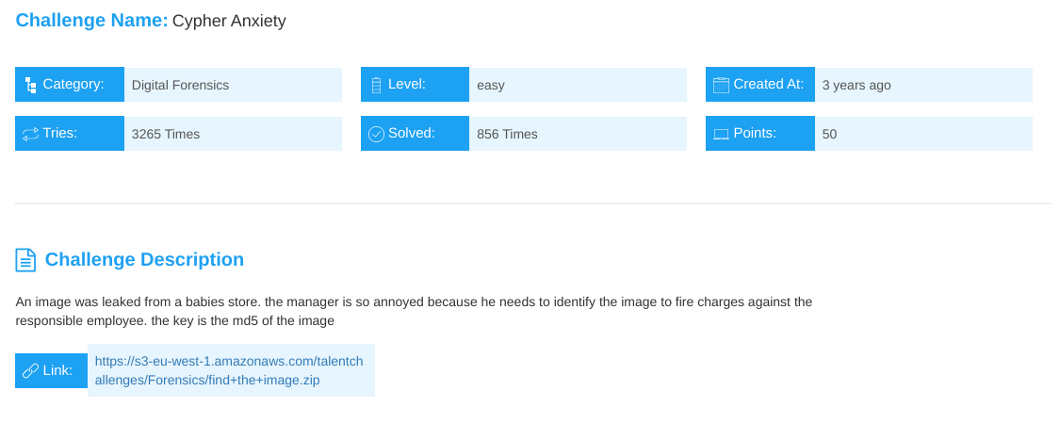
The challenge looks like this.. And from the description you can see there is an image that was leaked. So download the zip file and lets start analyzing it.

So after extracting I got a pcap file that I used strings <filename> to know just help me know what am dealing with.

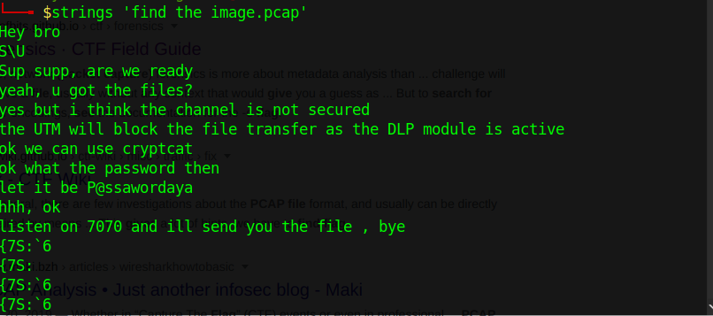
That was the output.. A conversation Giving us a password P@ssawordaya and the port 7070 they will be using making it easy when filtering the data when analyzing the pcap file on wireshark.

I filtered my data by using protocol hierarchy but you can use the port directly which would have been an easier move.

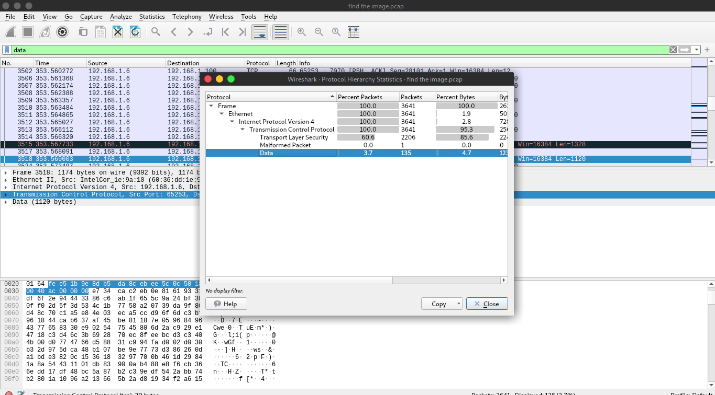
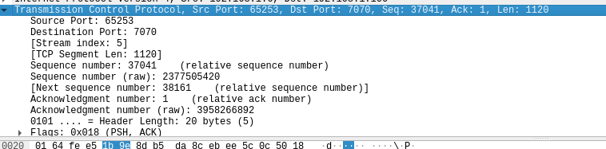
Tpc port == 7070

after that I used netcat and cryptocat to connect so as to be able to communicate at port 7070

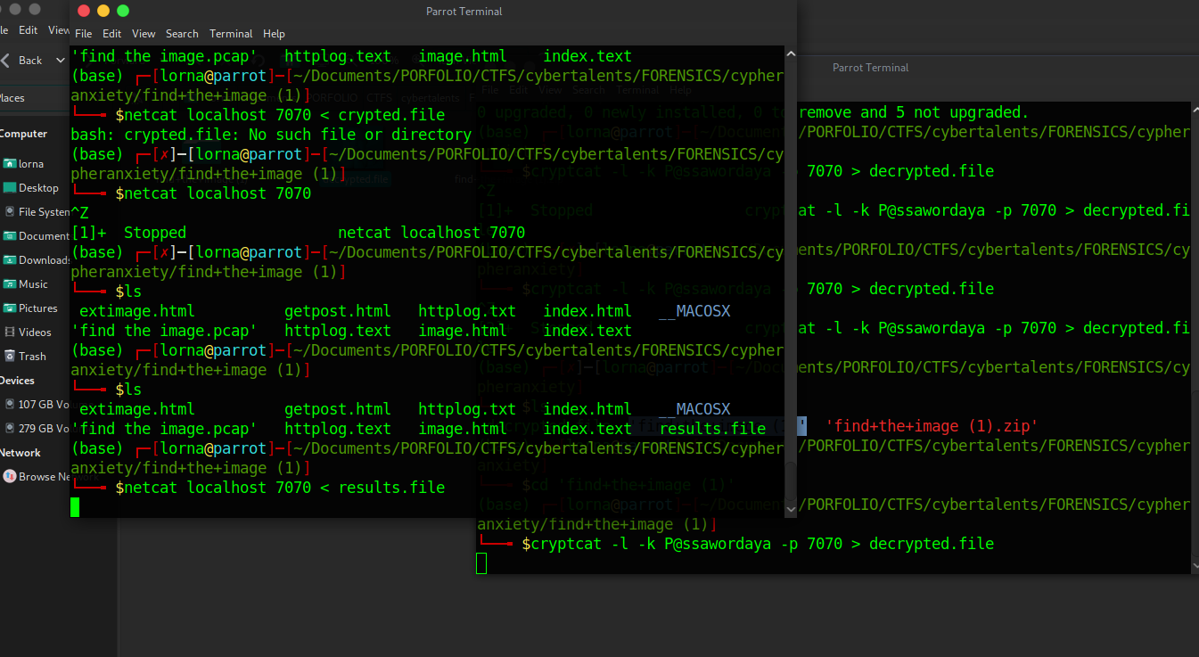

Then I got a my flag : 3beef06be834f3151309037dde4714ec

