Exercise 2

|  |  |  |  |
| --- | --- | --- | --- |
| Domain | Reachable Ping | Reachable Web | Why Not? |
| www.google.co.uk | Yes | Yes | N/A |
| www.columbia.edu | Yes | Yes | N/A |
| www.wikipedia.org | Yes | Yes | N/A |
| ec.ho | No | No | possibly due to nonexistence, being blocked, or DNS resolution issues. |
| hhh.gs | Yes | Yes | N/A |
| defence.gov.au | No | Yes | possibly due to firewall configurations or network policy issues. |
| yes.no | Yes | Yes | N/A |
| one.one.one.one | Yes | Yes | N/A |
| theguardian.com | Yes | Yes | N/A |
| xn—i-7iq.ws | Yes | Yes | N/A |

Exercise 3

1. 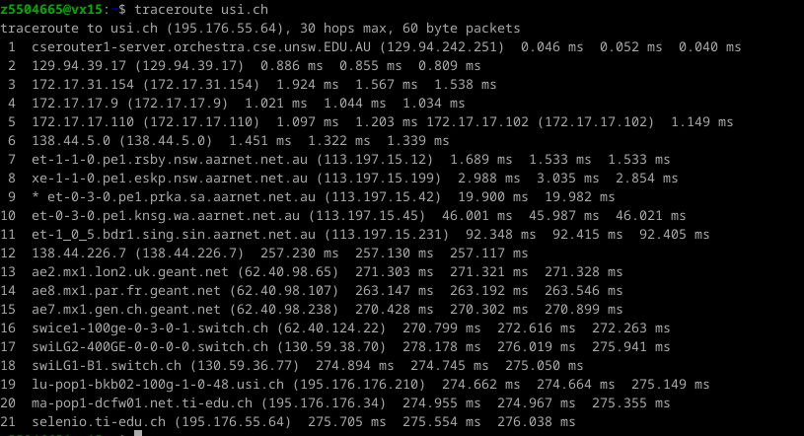

1)There are 20 routers between my workstation and usi.ch, cause the first one is local router.

And first 6 routers belong to UNSW network, cause these 6 routers are passed through to all destinations.

2)The no.11 the domain name include sing, and the delay is much higher than before.

3) The no.13 cause the domain name include UK, and the delay is much higher than before

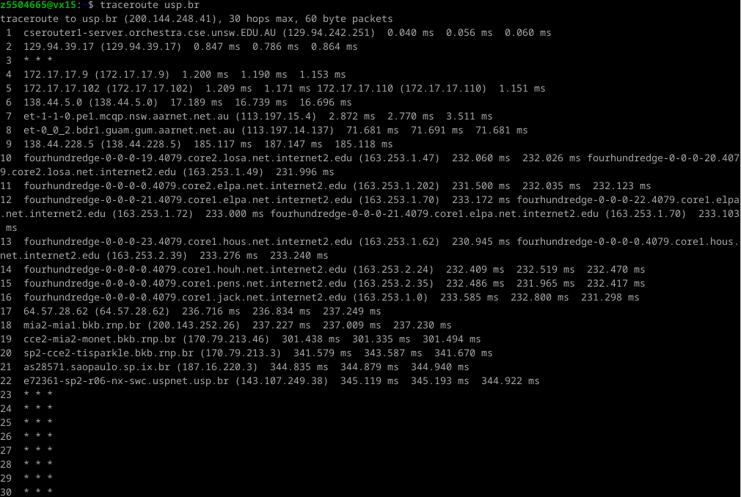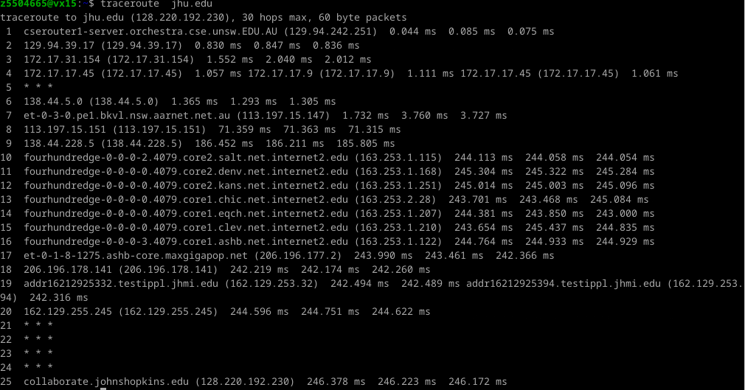2.

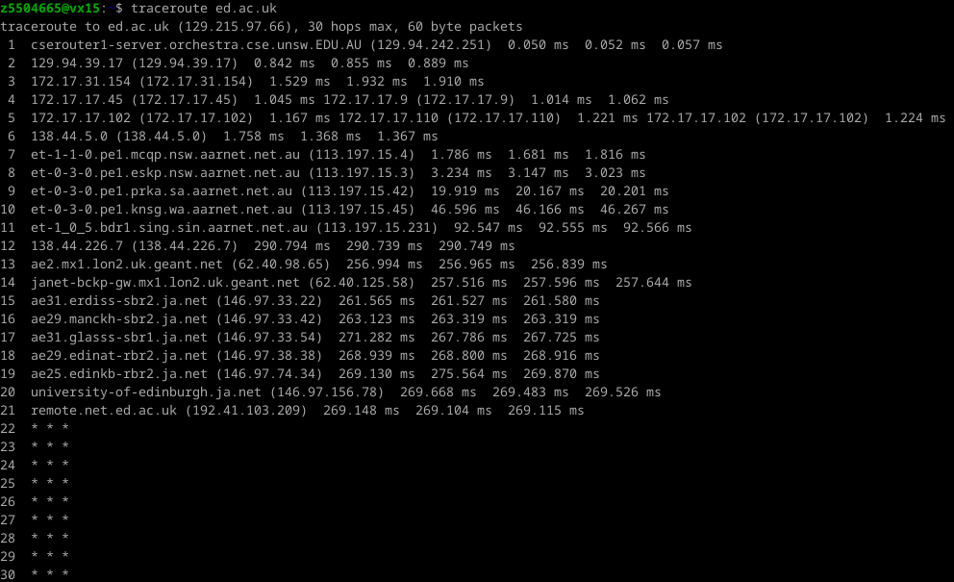

1)The no.6, and here are the further detail below: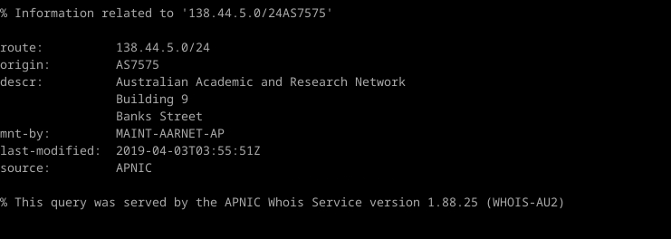

2)No, it is not.

Traceroute to ed.ac.uk, the ip geo location of destination is

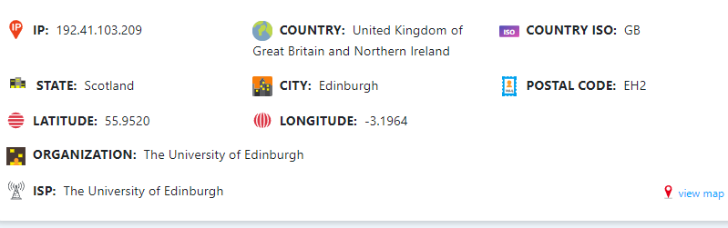

distance:16857km

hops:21

Traceroute to jnu.edu, the ip geo location of destination is

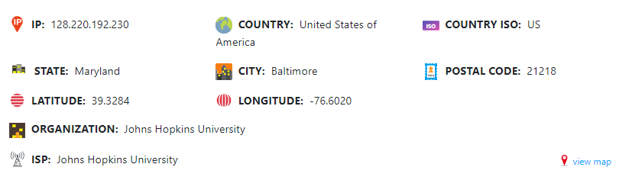

distance:15767km

hops:25

Traceroute to usp.br, the ip geo location of destination is



distance:13346km

hops:22

We can see the number of hops on each path is not proportional to the physical distance.

3.

1)

domain:www.as13030.net domain:www.net.princeton.edu

address:213.144.137.198 address:128.112.128.55

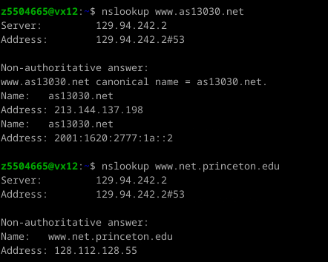

2)

domain: www.as13030.net

hops of reverse path:

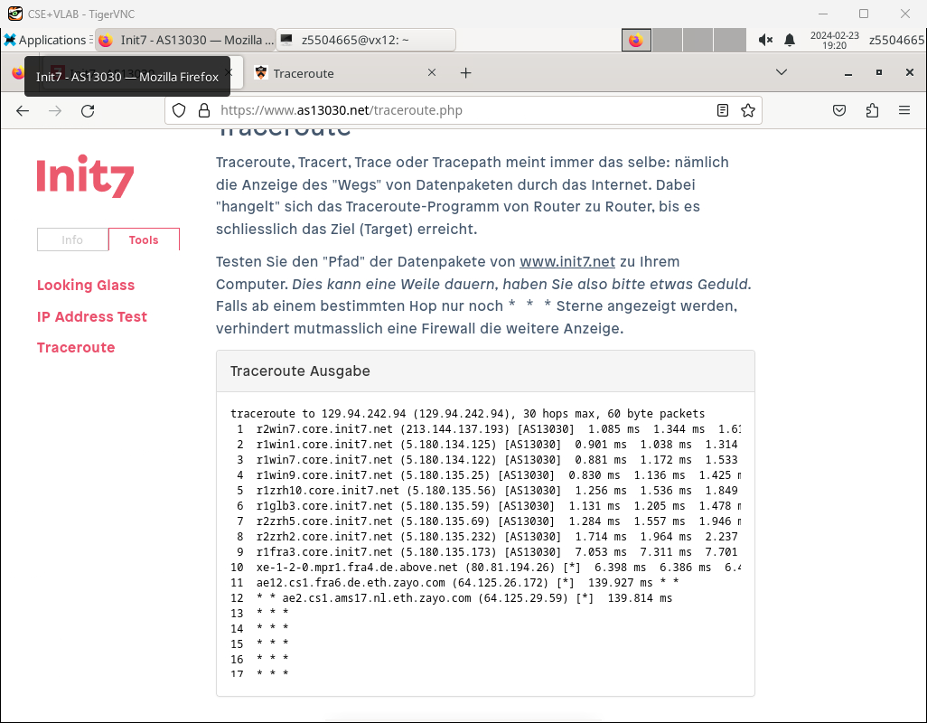

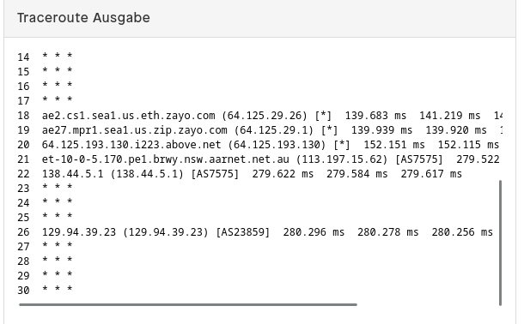

hops of forward path:

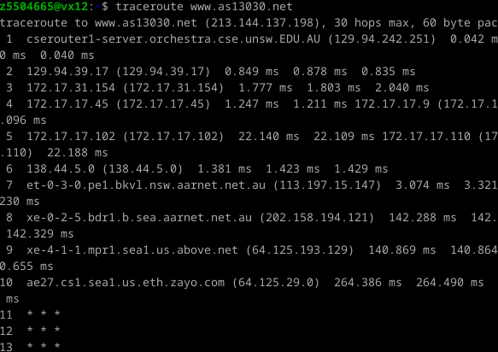

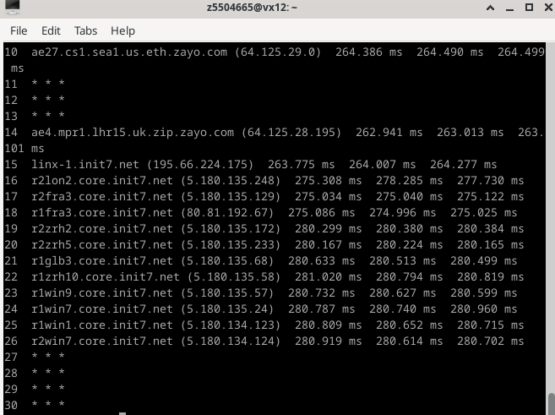

domain: www.net,princeton.edu

hops of reverse path:

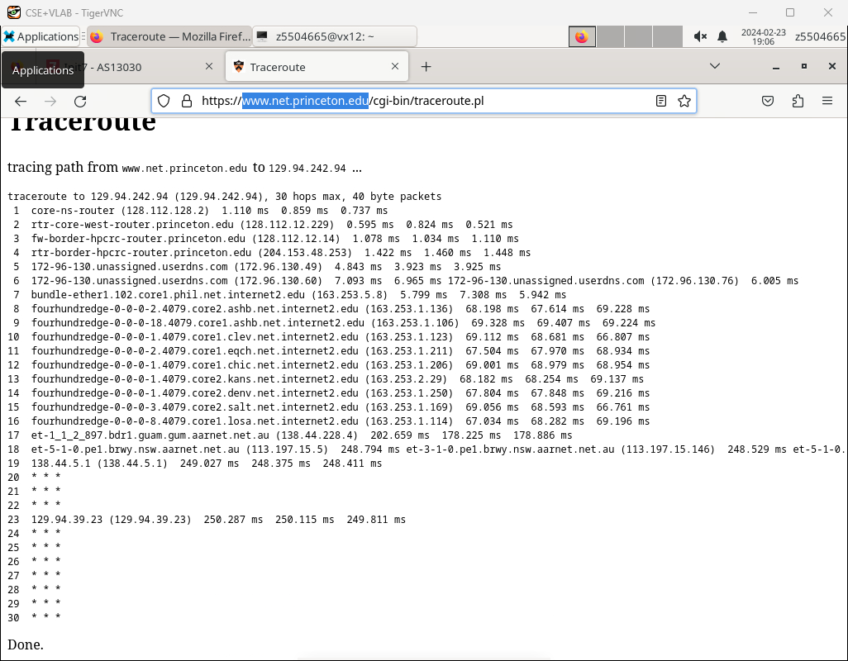

hops of forward path:

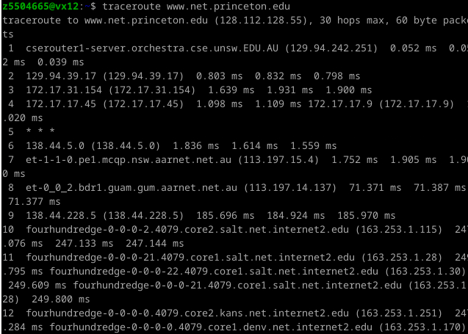

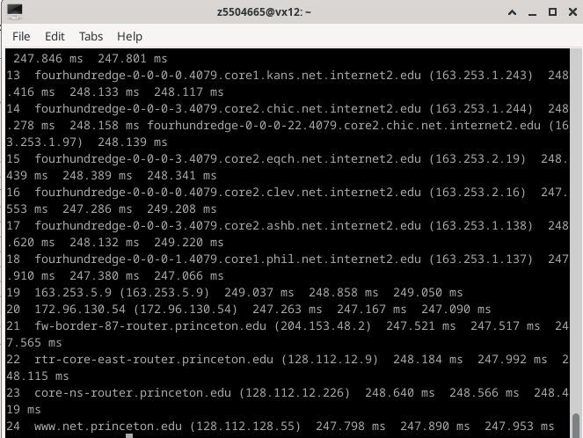

Answer:

I notice that some routers between forward path and reverse path are the same.

3)

Answer:

For paths of [www.net,princeton.edu](http://www.net,princeton.edu), we can find rtr-core-east-router.princeton.edu in both paths, but it has different ip address in these two paths.

This can occur due to Network Address Translation (NAT) or dynamic address allocation.

Exercise 4

1.

|  |  |  |  |
| --- | --- | --- | --- |
| Domain | Location | Distance from UNSW | Shortest possible time |
| cdu.edu.au | Charles Darwin University, Darwin, Australia | 3148.98 km | 10.4ms |
| usp.br | Universidade de São Paulo (USP),Sao Paulo,Brazil | 13490.89 km | 44.9ms |
| ed.ac.uk | The University of Edinburgh - Edinburgh, Scotland, UK | 16880.66 km | 56.2ms |

2.

cdu.edu.au RTT:54ms

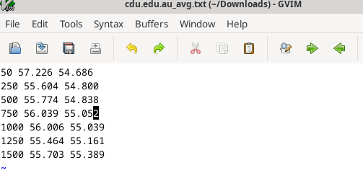

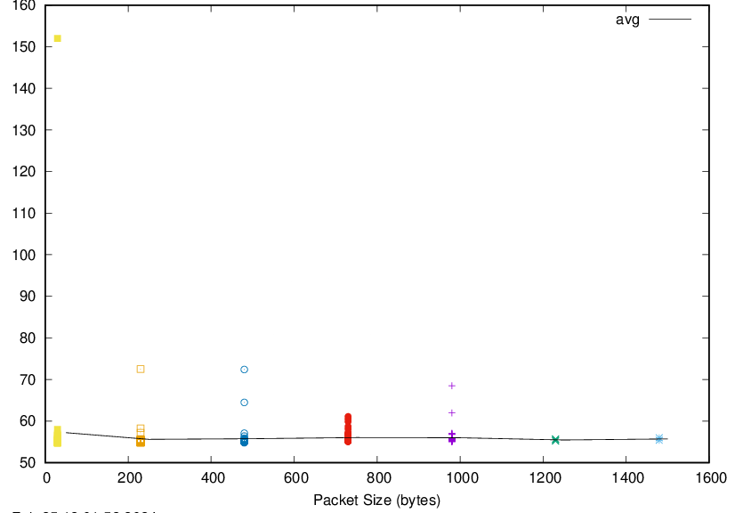

usp.br RTT:344ms

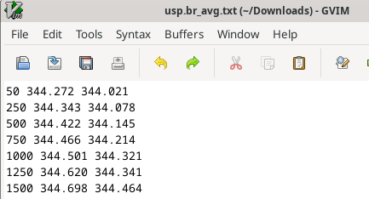

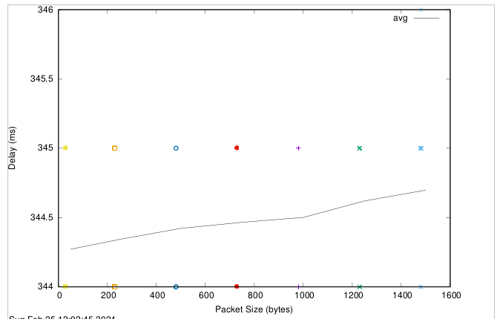

ed.ac.uk RTT:269ms

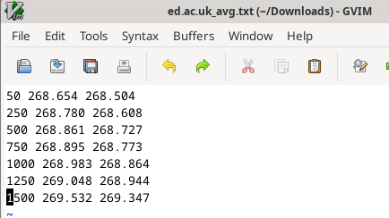

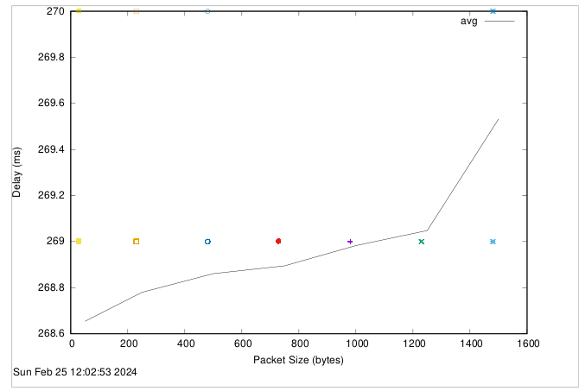

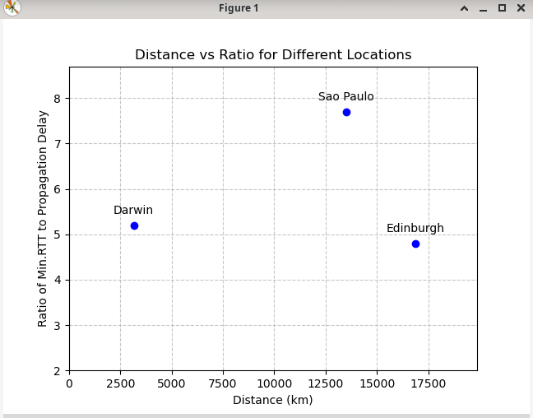

3.

Answer:

There has two possible reasons for why the y-axis values you plot are greater than 2

Network congestion: The actual RTT can be influenced by network congestion, routing inefficiencies, or other factors, causing it to be higher than the theoretical minimum.

Packet processing time: In addition to the time it takes for the packet to travel the distance, there's also packet processing time at routers and other network devices, which adds to the overall delay.

4.

cdu.edu.au_delay:

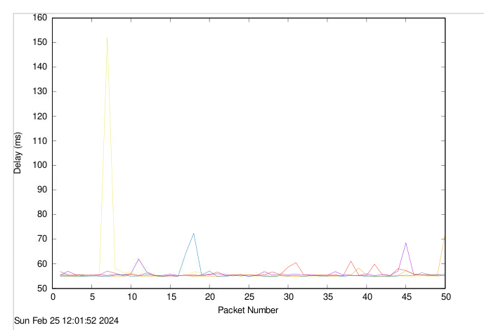

usp.br_delay:

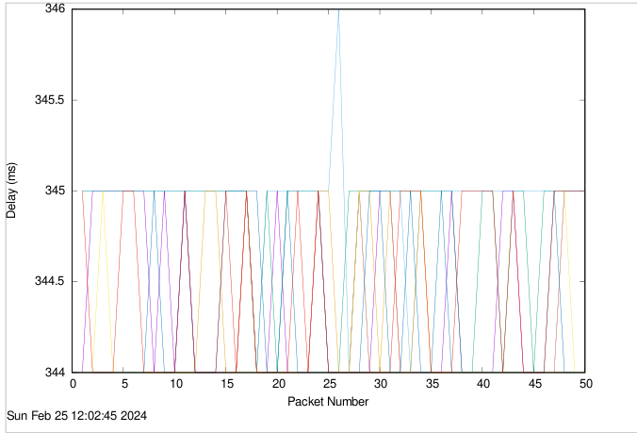

ed.ac.uk_delay:

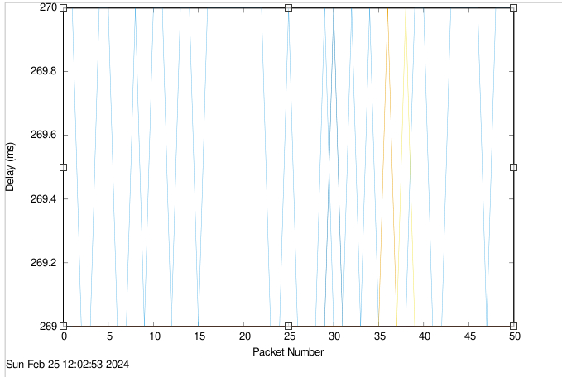

Answer:

From the pictures, We can see that the delay varies over time.

Because the delay in network communication is influenced by a complex interplay of factors, and variations over time are common due to the dynamic nature of network environments.

For example, When there is a high volume of traffic on the network, routers and switches may become congested, causing delays as packets are queued up for transmission. This congestion can fluctuate throughout the day based on usage patterns and network conditions.

5.

Answer:

Propagation delay is independent of packet size, while transmission delay may vary with packet size due to the relationship between packet size and available bandwidth. Processing delay is generally not influenced by packet size, as it is more related to the internal operations of network devices. Queuing delay can be affected by packet size indirectly, as larger packets may contribute to congestion and longer wait times in network queues.