**Lab4**

Exercise 1

**Q1**

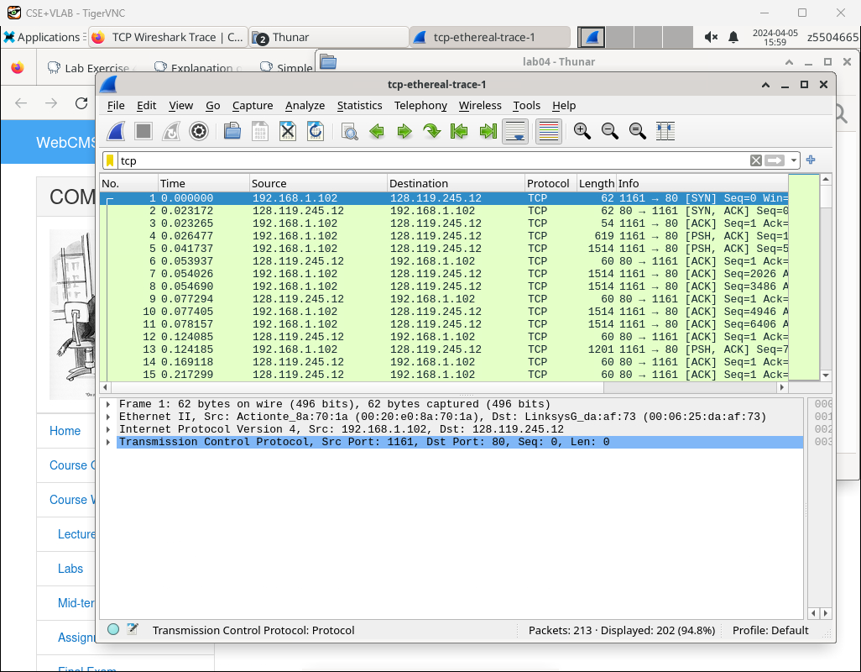

The IP address of gaia.cs.umass.edu:128.1119.245.12

Sending port: 1161 Receiving port: 80

IP and port: 192.168.1.102:1161

Q2

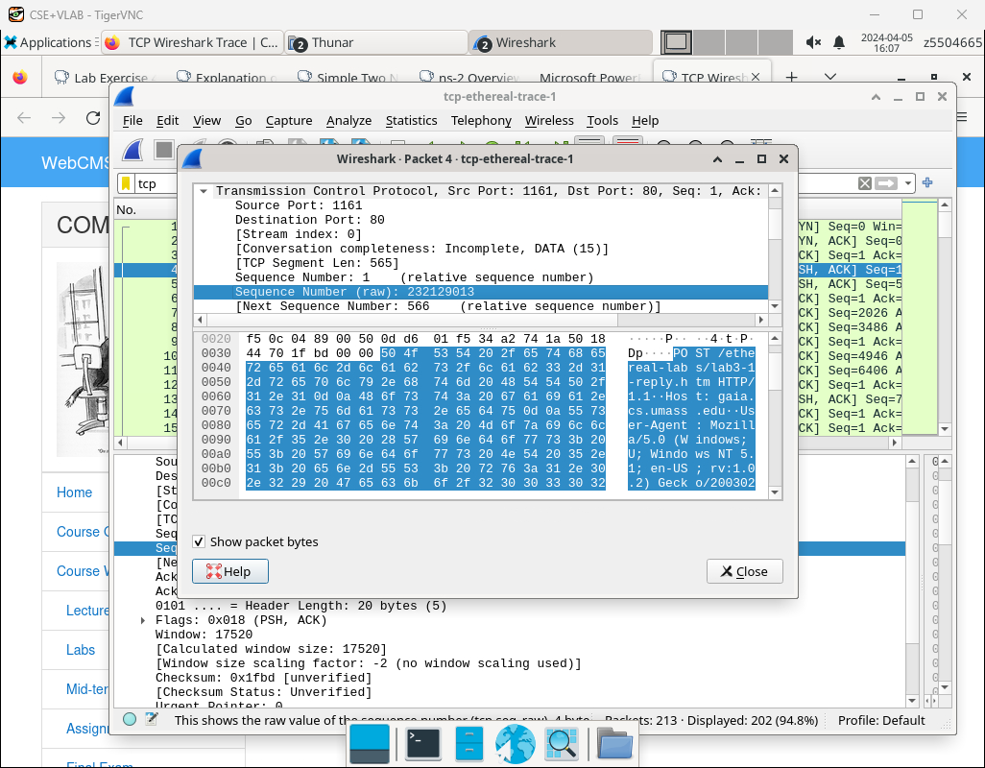

Sequence Number: 232129013

Q3

a)

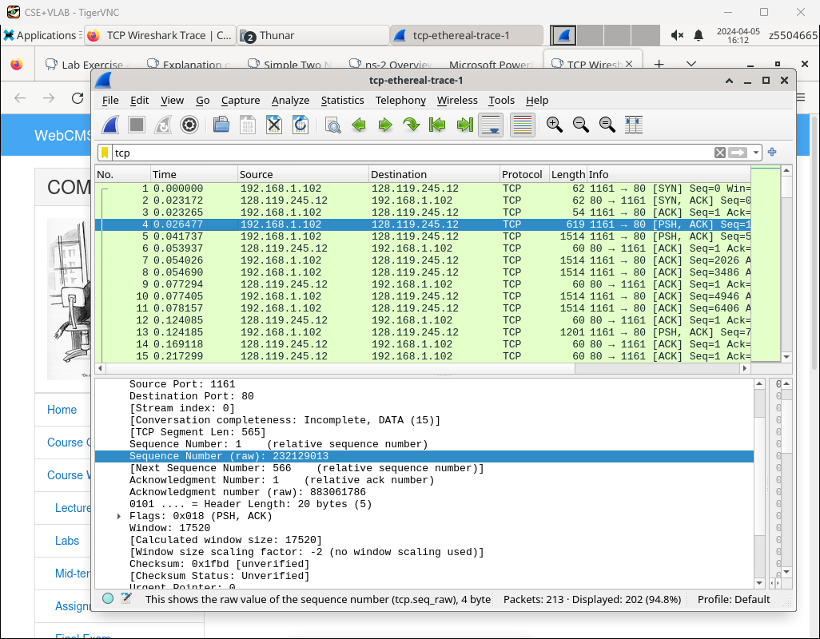

The sequence numbers of the first six segments in the TCP connection (including the segment containing the HTTP POST) sent from the client to the webserver are1,566,2026,3486,4946,6406.

Because the source IP and destination IP are the same which are 192.168.1.102 and 128.119.245.12

b)

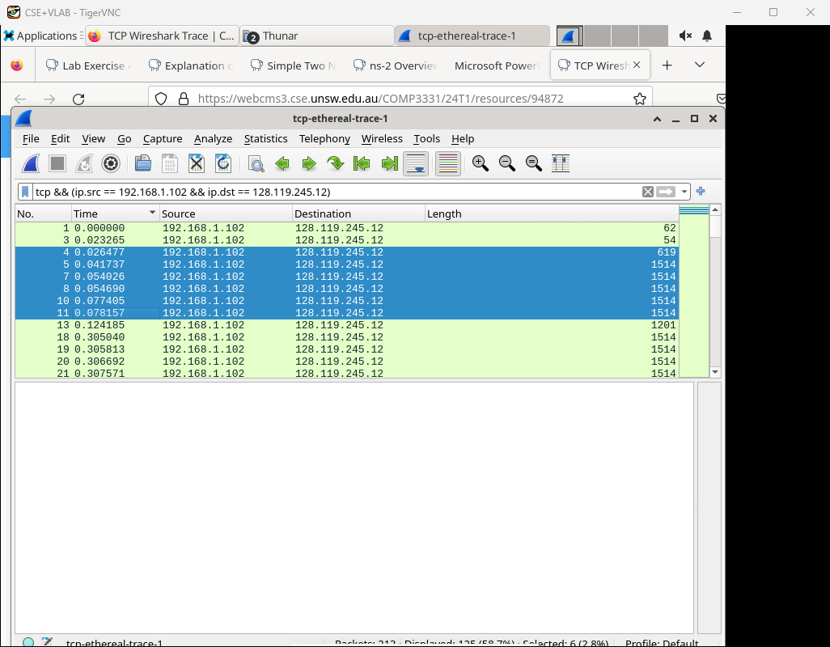Sending time: 0.026477, 0.041737, 0.054026, 0.054690, 0.077405, 0.078157

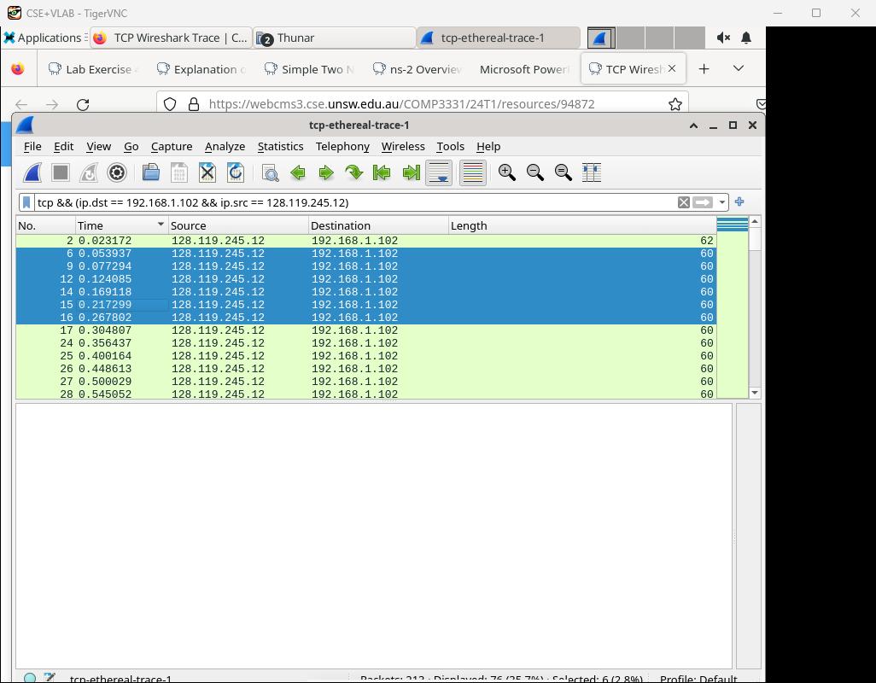

Receiving time: 0.053937, 0.077294, 0.124085, 0.169118, 0.217299, 0.267002

RTT:0.02746, 0.035557, 0.70059, 0.114428, 0.139894, 0.189645

c)

**EstimatedRTT=(1−a)×EstimatedRTT+a×SampleRTT,a=0.125**

EstimatedRTT: 0.02746, 0.028472, 0.033670, 0.043765, 0.055781, 0.072514

**Q4**

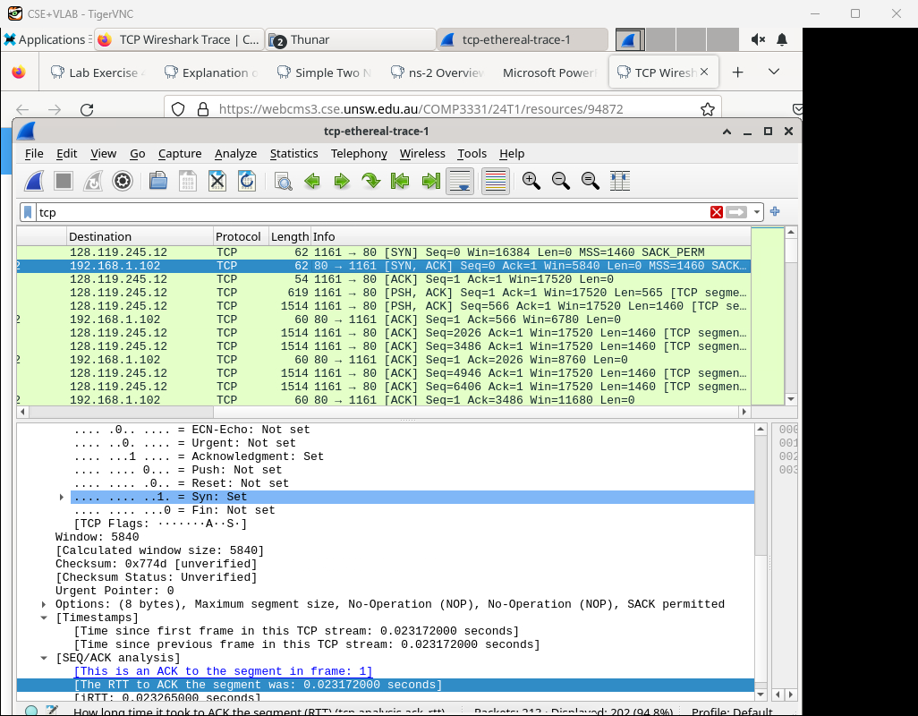

1)The minimum amount of available buffer space advertised at the receiver for the entire trace is 5840

2)No, it doesn’t. Because 5840 > 4MSS=1460*4

**Q5**

No, there are not. Because there are no packets have the same seq number.

**Q6**

1)

Most of it are 1460bytes

2)

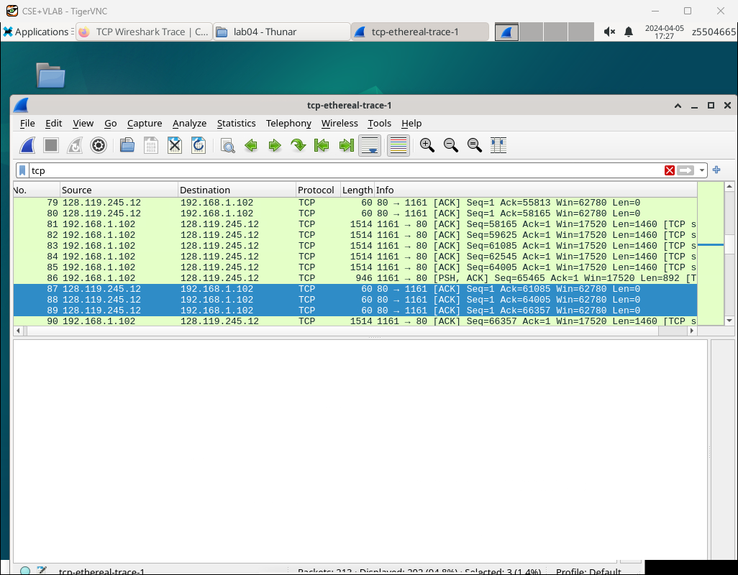

We can observe that the 89th packet is an acknowledgment of the cumulative acknowledgments before the 86th packet

**Q7**

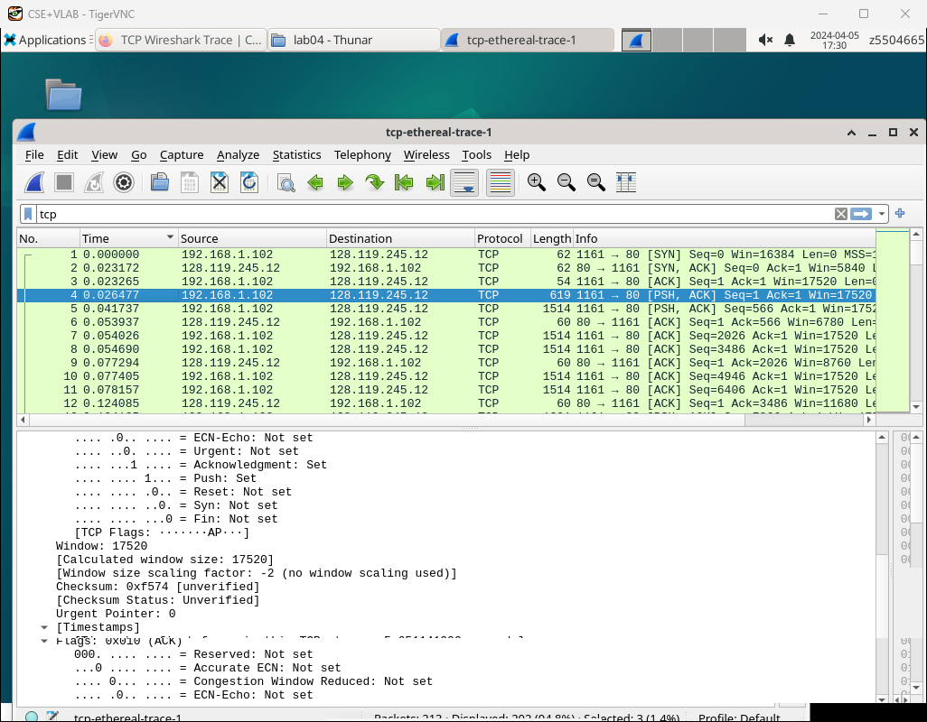

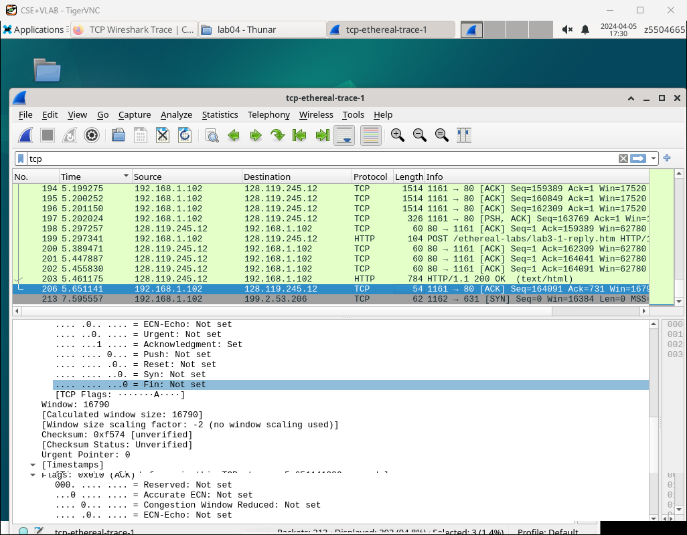

The total elapsed time is calculated by subtracting the time of the first packet transmission from the time of the last packet transmission.

The throughput is approximate

164091×8/(5.651141-0.026477)≈233288.86bps.

Exercise 2

**Q1**

2818463618

**Q2**

1)

The sequence number: 1247095790

2)’

The value of the Acknowledgement field in the SYNACK segment is 281843619

3)

ack value = sequence number of syn segment + 1

**Q3**

1)

The sequence number: 2818463619

2)’

The value of the Acknowledgement field: 1247095791

3)

No, it doesn’t. Because it need building the connect first.

**Q4**

Both client and server do.The type of closure is Simultaneous close.

**Q5**

From the client to the server: 2818463653 – 2818463618 - 2 (syn,fin) = 33 bytes

From the server to the client: 1247095832 – 1247095790 - 2 (syn,fin) = 40 bytes