Revision of TCP Congestion Control (NO SUBMISSION REQUIRED)
The following question is included so that you can revise the TCP congestion control algorithm. It is recommended that students have a short discussion with their tutors at the start of the lab to go over this question and TCP congestion control in general. Students are strongly encouraged to participate and ask questions. You are not required to submit the answer to this question in your lab report. I suggest you use the lab's first 15-20 minutes to review this.
The graph in the figure below shows how the congestion window of a TCP Reno connection changes over time. It is drawn roughly to scale. Certain parts of the graph of extra interest have been marked with numbers. With the help of the graph, answer the following questions:
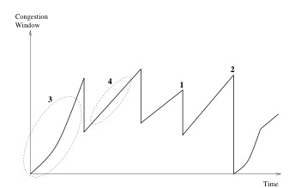
Question 1. Name the loss events that occur at 1 and 2. Explain why the congestion window is changed differently in those two cases.
Question 2. What phase of the TCP congestion control algorithm coincides with the circled segment marked by 3?
Question 3. What phase of the TCP congestion control algorithm coincides with the circled segment marked by 4?
Question 4: Why is the congestion window increased more rapidly at 3 than at 4?
Question 5: Can you precisely explain what happens to the window after 2?
Exercise 1: Understanding TCP Congestion Control using ns-2 (4 Marks)
The lecture (and Section 3.6 of the text) explains the TCP congestion control algorithm in detail. You may wish to review this before continuing with this exercise. Each TCP sender limits the rate at which it sends traffic as a function of perceived network congestion. We studied two variants of the congestion control algorithm: TCP Tahoe and TCP Reno.
We will first consider TCP Tahoe (the default version of TCP in ns-2). Recall that TCP Tahoe uses two mechanisms:
- A varying congestion window determines how many packets can be sent before the acknowledgement for the first packet arrives.
- A slow-start mechanism increases the congestion window exponentially in the initial phase before stabilising when it reaches a threshold value. A TCP sender re-enters the slow-start state whenever it detects congestion in the network.
The provided script, tpWindow.tcl implements a simple network, which is illustrated in the figure below.
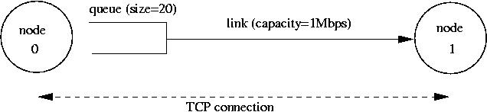
proc finish {} {
global ns file1 file2
$ns flush-trace
close $file1
close $file2
#exec nam out.nam &
exit 0
}
We strongly recommend reading through the script file to understand the simulation setting. The simulation is run for 60 seconds. The MSS for TCP segments is 500 bytes. Node 0 is configured as an FTP sender, transmitting packets every 0.01 seconds. Node 1 is a receiver (TCP sink). It does not transmit data and only acknowledges the TCP segments received from Node 0.
The script will run the simulation and generate two trace files:
(i) Window.tr, which keeps track of the size of the congestion window and
(ii) WindowMon.tr , which shows several parameters of the TCP flow.
The Window.tr file has two columns:
time congestion_window_size
A new entry is created in this file every 0.02 seconds of simulation time and records the congestion window size at that time.
The WindowMon.tr file has six columns:
time number_of_packets_dropped drop_rate throughput queue_size avg_tput
A new entry is created in this file every second of simulation time. The number_of_packets_dropped , drop_rate and throughput represent the corresponding measured values over each second. The queue_size indicates the queue size at each second, whereas avg_tput is the average throughput measured since the start of the simulation.
Question 1: Run the script with the max initial window size set to 150 packets and the delay set to 100ms (be sure to type "ms" after 100). In other words, type the following:
$ns tpWindow.tcl 150 100ms
To plot the size of the TCP window and the number of queued packets vs time, we use the provided gnuplot script Window.plot as follows:
$gnuplot Window.plot
(a) In this case, what is the maximum size of the congestion window that the TCP flow reaches?
(b) What does the TCP flow do when the congestion window reaches this value? Why?
(c) What happens next?
Include the graph in your submission report.
Question 2: From the simulation script we used, we know that the packet's payload is 500 Bytes. Keep in mind that the size of the IP and TCP headers is 20 Bytes each. Neglect any other headers. What is the average throughput of TCP in this case? (both in number of packets per second and bps)
You can plot the throughput using the provided gnuplot script WindowTPut.plot as follows:
$gnuplot WindowTPut.plot
This will create a graph that plots the instantaneous and average throughput in packets/sec. Include the graph in your submission report.
TCP Tahoe vs TCP Reno
Recall that, so far; we have observed the behaviour of TCP Tahoe. Let us now observe the difference between TCP Tahoe and TCP Reno. As you may recall, in TCP Reno, the sender will cut the window size to 1/2 its current size if it receives three duplicate ACKs. The default version of TCP in ns-2 is TCP Tahoe. To change to TCP Reno, modify the Window.tcl OTcl script. Look for the following line:
set tcp0 [new Agent/TCP]
and replace it with:
set tcp0 [new Agent/TCP/Reno]
Question 3: Repeat the steps outlined in Questions 1 and 2 but for TCP Reno. Compare the graphs for the two implementations and explain the differences. (Hint: compare the number of times the congestion window returns to zero in each case). How does the average throughput differ in both implementations?
Note: Remember to include all graphs in your report.
Exercise 2: Setting up NS2 simulation for measuring TCP throughput (3.5 marks)
(submit the completed file exercise2.tcl and throughput. plot separately and answer the questions on throughput behaviour in the report)
Consider the topology in the following figure, where bandwidth and delay for each link are shown.
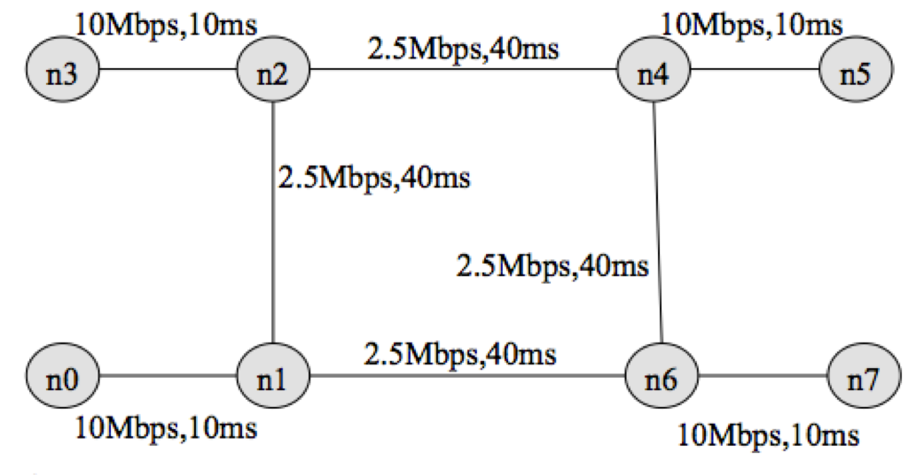
You have been provided with a stub tcl file exercise2.tcl . Your task is to complete the stub file so that it runs with ns and produces two trace files, tcp1.tr and tcp2.tr, and out.nam. Check the animation for the simulation using nam.out file. Next, write a script named "throughput. plot" (referenced from within exercise2.tcl in procedure finish( ) ) to plot the throughput received by host n5 for two flows terminating at n5. Uncomment the line (#exec gnuplot throughput.plot &) to execute gnuplot. You have been provided with the throughput plot TCPThroughput.png produced by gnuplot for comparing your final output.
">>" in the stub file indicates that one (or more) lines need to be added. Remove the ">>" and insert the required code.
Consider the following traffic pattern for your simulation.
FTP/TCP Source n0 -> TCP Sink n5 : start time: 0.5 sec End time: 8.5 sec
FTP/TCP Source n3 -> TCP Sink n5 : start time: 2.0 sec End time: 9.5 sec
FTP/TCP Source n7 -> TCP Sink n0 : start time: 3.0 sec End time: 9.5 sec
FTP/TCP Source n7 -> TCP Sink n3 : start time: 4.0 sec End time: 7.0 sec
You have to submit your completed tcl file (exercise2.tcl) and the script (throughput.plot) to produce the throughput plot. Comment on the throughput behaviour observed in the simulation by answering the following questions.
Question 1: Why is the throughput achieved by flow tcp2 higher than tcp1 between 6 sec to 8 sec?
Question 2: Why does the throughput for flow tcp1 fluctuate between a time span of 0.5 sec to 2 sec?
Exercise 3: Understanding the Impact of Network Dynamics on Routing (2.5 marks)
(include in your report)
This exercise will observe how routing protocols react when network conditions change (e.g., a network link fails) using a ns-2 simulation.
The provided script, tp_routing.tcl takes no arguments and generates the network topology shown in the figure below.
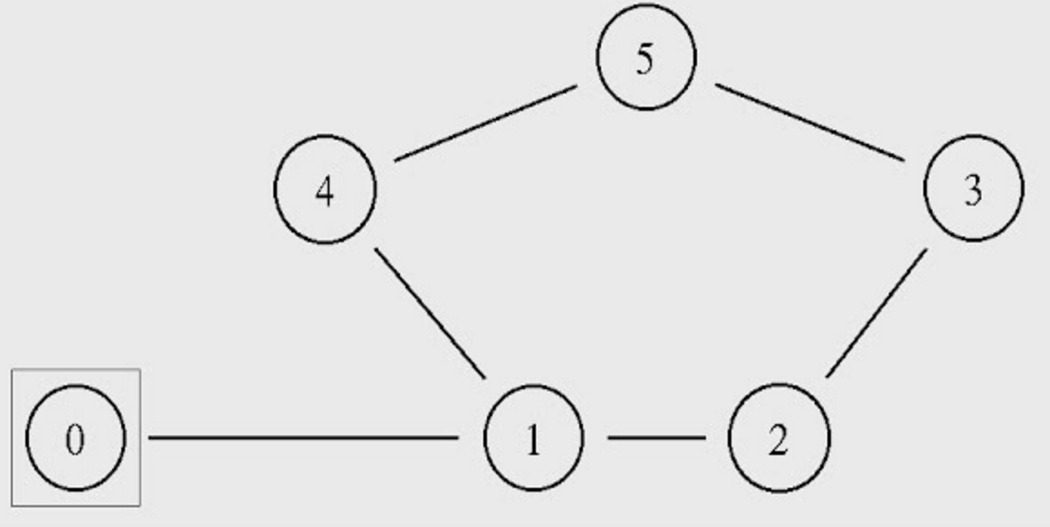
You can run the simulation with the following command:
$ns tp_routing.tcl
Step 1: Run the script and observe the NAM window output.
Question 1: Which nodes communicate with which other nodes? Which route do the packets follow? Does it change over time?
Note: You can also answer the above question by examining the simulation settings in the script file.
Step 2: Modify the script by uncommenting the following two lines (lines No 84 and 85):
$ns rtmodel-at 1.0 down $n1 $n4 $ns rtmodel-at 1.2 up $n1 $n4
Step 3: Rerun the simulation and observe the NAM window output.
NOTE: Ignore the NAM syntax warnings on the terminal. These will not affect the simulation.
Question 2: What happens at time 1.0 and time 1.2? Does the route between the communicating nodes change as a result?
Step 4: The nodes in the simulation above use a static routing protocol (i.e., preferred routes do not change over time). We will change that so that they use a Distance-Vector routing protocol. Modify the script and uncomment the following line (Line No 16) before defining the finish procedure.
$ns rtproto DV
Step 5: Rerun the simulation and observe the NAM window output.
Question 3: Did you observe additional traffic compared to Step 3 above? How does the network react to the changes that take place at time 1.0 and time 1.2 now?
Step 6: Comment the two lines (Lines 84 and 85) that you had added to the script in Step 2 and uncomment the following line ( Line 87) instead:
$ns cost $n1 $n4 3
Step 7: Rerun the simulation and observe the NAM window output.
Question 4: How does this change affect the routing? Explain why.
Step 8: Comment line 87 and Uncomment the following lines (Lines 89 and 90):
$ns cost $n1 $n4 2 $ns cost $n3 $n5 3
and uncomment the following (Line 29), which is located right after the finish procedure definition:
Node set multiPath_ 1
Step 9: Rerun the simulation and observe the NAM window output.
Question 5: Describe what happens and deduce the effect of the line you just uncommented.

