**Lab5**

Exercise 1

**Q1**

**a)**

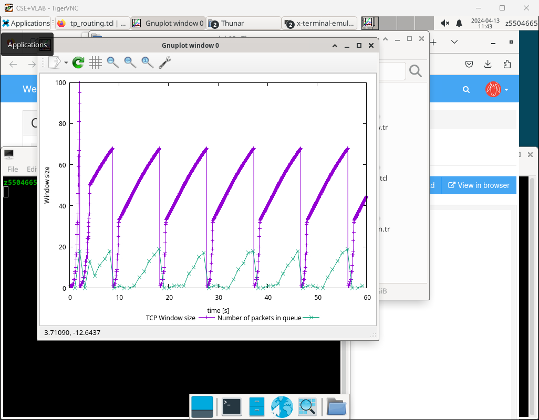

 The maximum size of the congestion window is 100

b)

1. At this point, network congestion occurred, to avoid it, the window size was adjusted to 1, and the program re-entered the slow-start state.
2. Adjusting the window size to 1 and re-entering the slow-start state is done in response to network congestion. When congestion occurs, reducing the window size helps decrease the sending rate, thereby reducing network load and the likelihood of further congestion. Re-entering the slow-start state allows the sender to gradually increase its sending window at a slower rate, testing the available bandwidth cautiously to avoid further congestion. This reactive mechanism helps maintain network stability and ensure reliable data transmission.

c)

The program re-entered the slow-start state

Q2

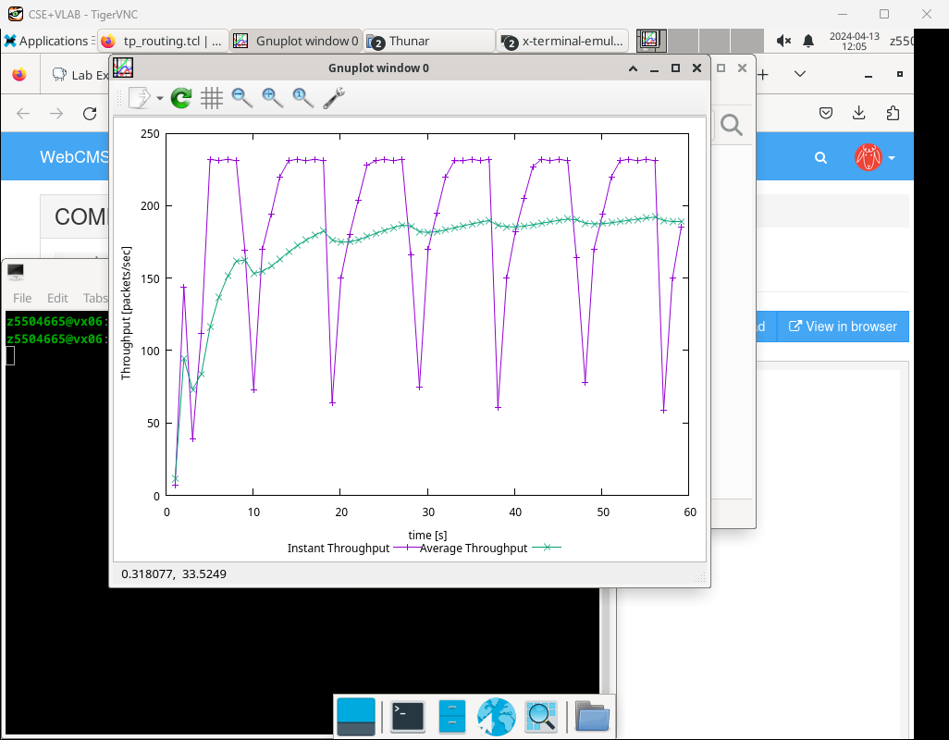

By the picture, the average throughput of TCP in this case like 190 packets per second which is 190 x 500 x 8 = 760 kbps

Q3

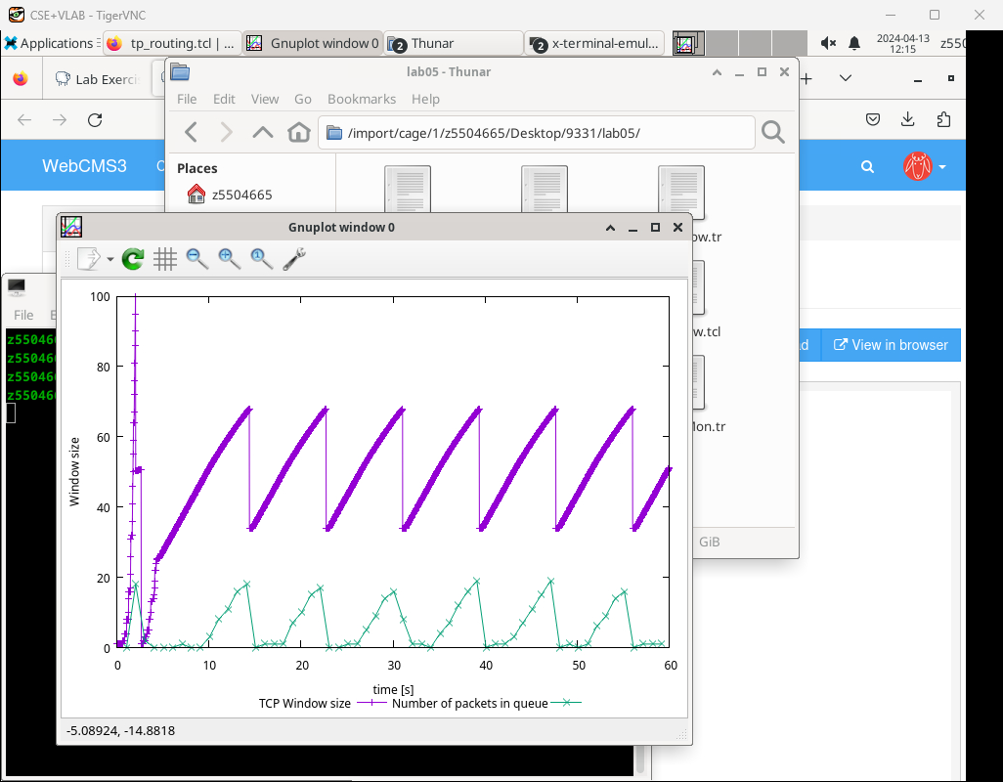

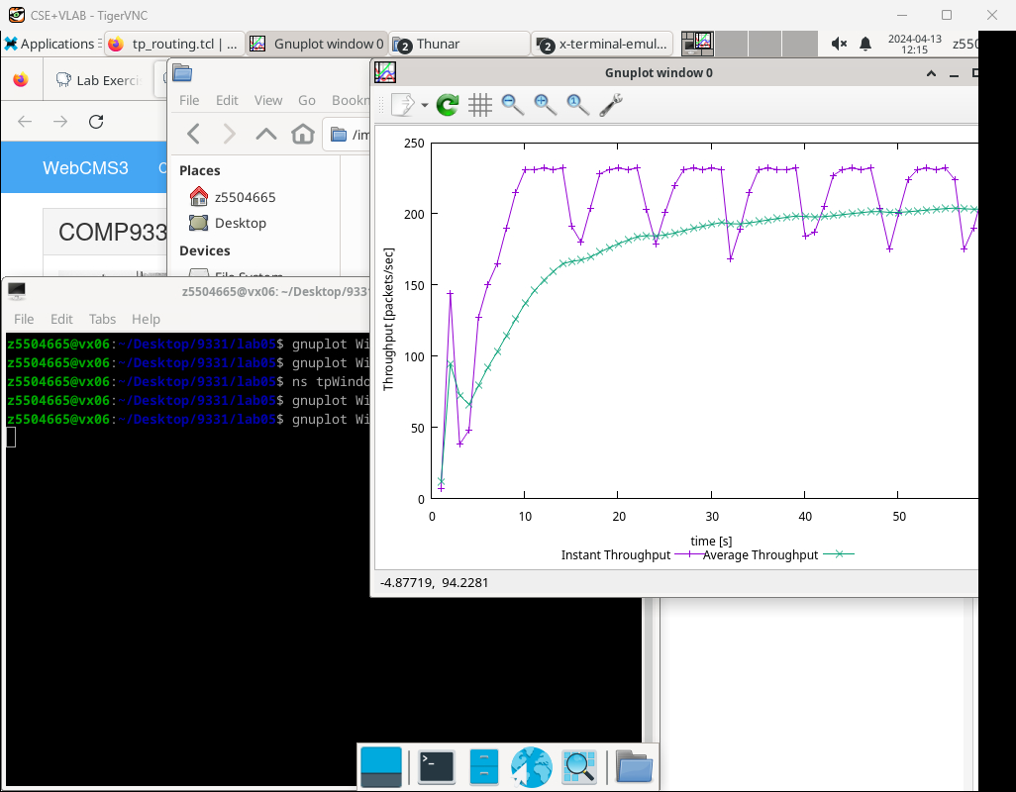

Reno: Implements Fast Retransmit and Fast Recovery mechanisms. When multiple duplicate acknowledgments (dupacks) are received, Reno will fast retransmit the missing segment and enter fast recovery, reducing the congestion window by half and slowly increasing it after a new acknowledgment is received.

Tahoe: Does not implement Fast Retransmit and Fast Recovery. Instead, it relies solely on the slow-start and congestion avoidance mechanisms.

In summary, Reno leads to potentially higher average throughput compared to Tahoe.

Exercise 2

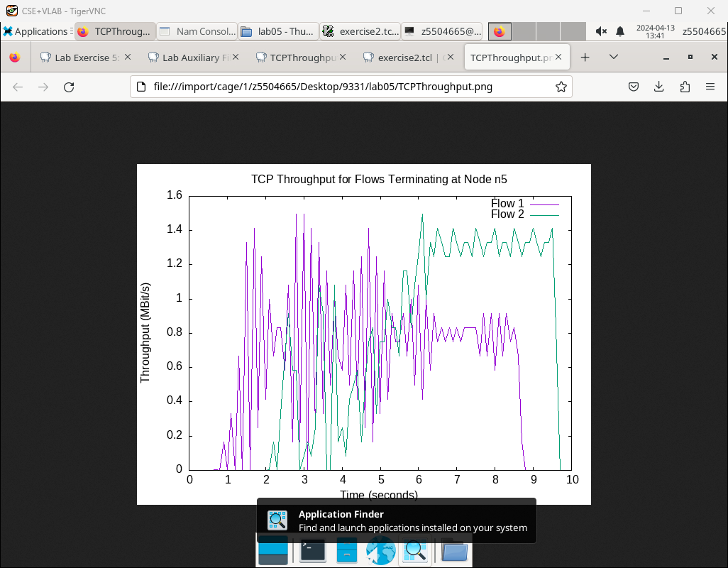

**Q1**

Because tcp1 experienced congestion first and consequently reduced its window size, this allowed tcp2 to achieve a larger window. As a result, tcp2 attained a higher throughput than tcp1 during this time, forming a relative steady state.

**Q2**  
Because initially the correct congestion control window couldn't be accurately determined, the connection experienced multiple timeouts or triple duplicate ACK events. This led to the sending window suddenly reducing to either 1 or half of its size, causing an instantaneous change in throughput and resulting in fluctuations between 0.5s to 2s.

Exercise 3

**Q1**

n0 with n5

route: n0-n1-n4-n5

n2 with n5

route: n2-n3-n5

No, the route does not change overtime.

**Q2**

The link n1-n4 is down.

No, it does not.

**Q3**

Yes, there is an additional traffic n1-n2

The n1 reroute the traffic to n2 when the link n1-n4 was down

**Q4**

The route from n1 to n4 was affected when the cost increased. And n0 choses another route n0-n1-n2-n3-n5 to communicate with n5.

**Q5**

Node set multiPath_ 1 allows n2 to use multiple paths to communicate with n5. By setting the costs using $ns cost $n1 $n4 2 and $ns cost $n3 $n5 3, you're modifying the costs between n1→n4 and n3→n5. This means n2 will utilize both paths.