**COMP9444 Neural Networks and Deep Learning**

**Term 2, 2024**

**Assignment - Characters and Hidden Unit Dynamics**

Due: Tuesday 2 July, 23:59 pm  
Marks: 20% of final assessment

In this assignment, you will be implementing and training neural network models for three different tasks, and analysing the results. You are to submit two Python files kuzu.py and check.py, as well as a written report hw1.pdf (in pdf format).

**Provided Files**

Copy the archive [hw1.zip](https://cgi.cse.unsw.edu.au/~cs9444/24T2/hw1/hw1.zip) into your own filespace and unzip it. This should create a directory hw1, subdirectories net and plot, and eight Python files kuzu.py, check.py, kuzu_main.py, check_main.py, seq_train.py, seq_models.py, seq_plot.py and anb2n.py.

Your task is to complete the skeleton files kuzu.py and check.py and submit them, along with your report.

**Part 1: Japanese Character Recognition**

For Part 1 of the assignment you will be implementing networks to recognize handwritten Hiragana symbols. The dataset to be used is Kuzushiji-MNIST or KMNIST for short. The paper describing the dataset is available [here](https://arxiv.org/pdf/1812.01718.pdf). It is worth reading, but in short: significant changes occurred to the language when Japan reformed their education system in 1868, and the majority of Japanese today cannot read texts published over 150 years ago. This paper presents a dataset of handwritten, labeled examples of this old-style script (Kuzushiji). Along with this dataset, however, they also provide a much simpler one, containing 10 Hiragana characters with 7000 samples per class. This is the dataset we will be using.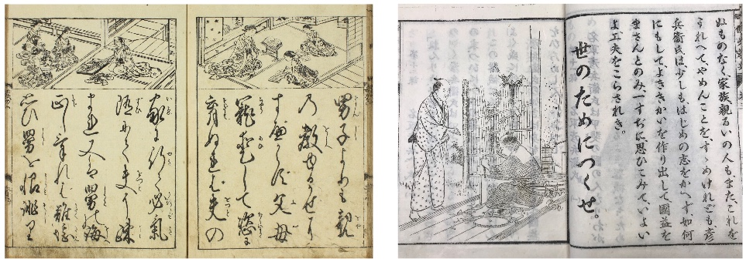Text from 1772 (left) compared to 1900 showing the standardization of written Japanese.

1. [1 mark] Implement a model NetLin which computes a linear function of the pixels in the image, followed by log softmax. Run the code by typing:
2. python3 kuzu_main.py --net lin

Copy the final accuracy and confusion matrix into your report. The final accuracy should be around 70%. Note that the **rows** of the confusion matrix indicate the target character, while the **columns** indicate the one chosen by the network. (0="o", 1="ki", 2="su", 3="tsu", 4="na", 5="ha", 6="ma", 7="ya", 8="re", 9="wo"). More examples of each character can be found [here](http://codh.rois.ac.jp/kmnist/index.html.en).

1. [1 mark] Implement a fully connected 2-layer network NetFull (i.e. one hidden layer, plus the output layer), using tanh at the hidden nodes and log softmax at the output node. Run the code by typing:
2. python3 kuzu_main.py --net full

Try different values (multiples of 10) for the number of hidden nodes and try to determine a value that achieves high accuracy (at least 84%) on the test set. Copy the final accuracy and confusion matrix into your report, and include a calculation of the total number of independent parameters in the network.

1. [2 marks] Implement a convolutional network called NetConv, with two convolutional layers plus one fully connected layer, all using relu activation function, followed by the output layer, using log softmax. You are free to choose for yourself the number and size of the filters, metaparameter values (learning rate and momentum), and whether to use max pooling or a fully convolutional architecture. Run the code by typing:
2. python3 kuzu_main.py --net conv

Your network should consistently achieve at least 93% accuracy on the test set after 10 training epochs. Copy the final accuracy and confusion matrix into your report, and include a calculation of the total number of independent parameters in the network.

1. [4 marks] Briefly discuss the following points:
   1. the relative accuracy of the three models,
   2. the number of independent parameters in each of the three models,
   3. the confusion matrix for each model: which characters are most likely to be mistaken for which other characters, and why?

**Part 2: Multi-Layer Perceptron**

In Part 2 you will be exploring 2-layer neural networks (either trained, or designed by hand) to classify the following data: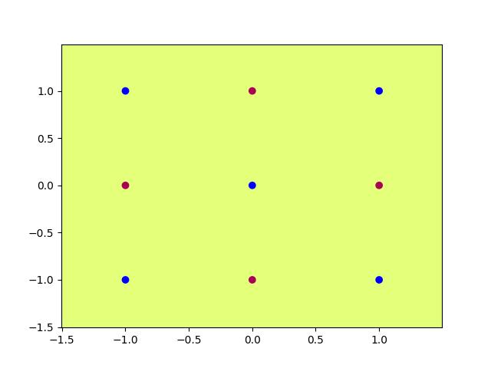

1. [1 mark] Train a 2-layer neural network with either 5 or 6 hidden nodes, using sigmoid activation at both the hidden and output layer, on the above data, by typing:
2. python3 check_main.py --act sig --hid 6

You may need to run the code a few times, until it achieves accuracy of 100%. If the network appears to be stuck in a local minimum, you can terminate the process with ⟨ctrl⟩-C and start again. You are free to adjust the learning rate and the number of hidden nodes, if you wish (see code for details). The code should produce images in the plot subdirectory graphing the function computed by each hidden node (hid_6_?.jpg) and the network as a whole (out_6.jpg). Copy these images into your report.

1. [2 marks] Design by hand a 2-layer neural network with 4 hidden nodes, using the Heaviside (step) activation function at both the hidden and output layer, which correctly classifies the above data. Include a diagram of the network in your report, clearly showing the value of all the weights and biases. Write the equations for the dividing line determined by each hidden node. Create a table showing the activations of all the hidden nodes and the output node, for each of the 9 training items, and include it in your report. You can check that your weights are correct by entering them in the part of check.py where it says "Enter Weights Here", and typing:
2. python3 check_main.py --act step --hid 4 --set_weights
3. [1 mark] Now rescale your hand-crafted weights and biases from Part 2 by multiplying all of them by a large (fixed) number (for example, 10) so that the combination of rescaling followed by sigmoid will mimic the effect of the step function. With these re-scaled weights and biases, the data should be correctly classified by the sigmoid network as well as the step function network. Verify that this is true by typing:
4. python3 check_main.py --act sig --hid 4 --set_weights

Once again, the code should produce images in the plot subdirectory showing the function computed by each hidden node (hid_4_?.jpg) and the network as a whole (out_4.jpg). Copy these images into your report, and be ready to submit check.py with the (rescaled) weights as part of your assignment submission.

**Part 3: Hidden Unit Dynamics for Recurrent Networks**

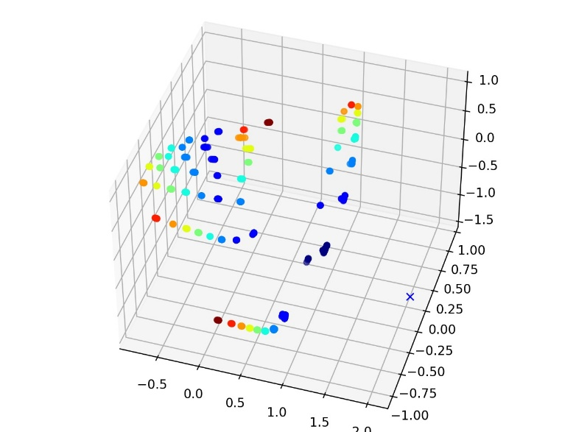In Part 3 you will be investigating the hidden unit dynamics of recurrent networks trained on language prediction tasks, using the supplied code seq_train.py and seq_plot.py.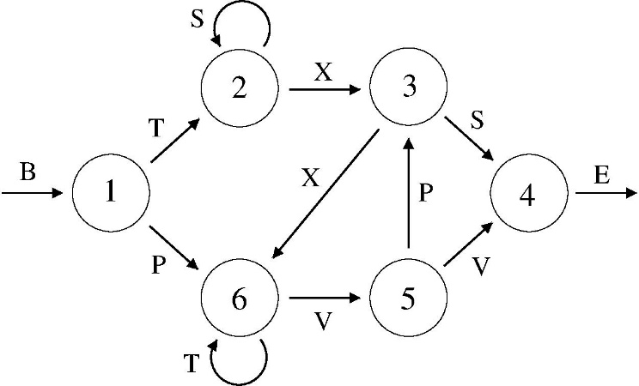

1. [2 marks] Train a Simple Recurrent Network (SRN) on the Reber Grammar prediction task by typing
2. python3 seq_train.py --lang reber

This SRN has 7 inputs, 2 hidden units and 7 outputs. The trained networks are stored every 10000 epochs, in the net subdirectory. After the training finishes, plot the hidden unit activations at epoch 50000 by typing

python3 seq_plot.py --lang reber --epoch 50

The dots should be arranged in discernable clusters by color. If they are not, run the code again until the training is successful. The hidden unit activations are printed according to their "state", using the colormap "jet":Based on this colormap, annotate your figure (either electronically, or with a pen on a printout) by drawing a circle around the cluster of points corresponding to each state in the state machine, and drawing arrows between the states, with each arrow labeled with its corresponding symbol. Include the annotated figure in your report.

1. [1 mark] Train an SRN on the *anbn* language prediction task by typing
2. python3 seq_train.py --lang anbn

The *anbn* language is a concatenation of a random number of A's followed by an equal number of B's. The SRN has 2 inputs, 2 hidden units and 2 outputs.

Look at the predicted probabilities of A and B as the training progresses. The first B in each sequence and all A's after the first A are not deterministic and can only be predicted in a probabilistic sense. But, if the training is successful, all other symbols should be correctly predicted. In particular, the network should predict the last B in each sequence as well as the subsequent A. The error should be consistently in the range of 0.01 to 0.03. If the network appears to have learned the task successfully, you can stop it at any time using ⟨cntrl⟩-c. If it appears to be stuck in a local minimum, you can stop it and run the code again until it is successful.

After the training finishes, plot the hidden unit activations by typing

python3 seq_plot.py --lang anbn --epoch 100

Include the resulting figure in your report. The states are again printed according to the colormap "jet". Note, however, that these "states" are not unique but are instead used to count either the number of A's we have seen or the number of B's we are still expecting to see.

Briefly explain how the *anbn* prediction task is achieved by the network, based on the generated figure. Specifically, you should describe how the hidden unit activations change as the string is processed, and how it is able to correctly predict the last B in each sequence as well as the following A.

1. [2 marks] Train an SRN on the *anbncn* language prediction task by typing
2. python3 seq_train.py --lang anbncn

The SRN now has 3 inputs, 3 hidden units and 3 outputs. Again, the "state" is used to count up the A's and count down the B's and C's. Continue training (and re-start, if necessary) for 200k epochs, or until the network is able to reliably predict all the C's as well as the subsequent A, and the error is consistently in the range of 0.01 to 0.03.

After the training finishes, plot the hidden unit activations at epoch 200000 by typing

python3 seq_plot.py --lang anbncn --epoch 200

(you can choose a different epoch number, if you wish). This should produce three images labeled anbncn_srn3_??.jpg, and also display an interactive 3D figure. Try to rotate the figure in 3 dimensions to get one or more good view(s) of the points in hidden unit space, save them, and include them in your report. (If you can't get the 3D figure to work on your machine, you can use the images anbncn_srn3_??.jpg)

Briefly explain how the *anbncn* prediction task is achieved by the network, based on the generated figure. Specifically, you should describe how the hidden unit activations change as the string is processed, and how it is able to correctly predict the last B in each sequence as well as all of the C's and the following A.

1. [3 marks] This question is intended to be more challenging. Train an LSTM network to predict the Embedded Reber Grammar, by typing
2. python3 seq_train.py --lang reber --embed True --model lstm --hid 4

You can adjust the number of hidden nodes if you wish. Once the training is successful, try to analyse the behavior of the LSTM and explain how the task is accomplished (this might involve modifying the code so that it returns and prints out the context units as well as the hidden units).