# 1 Project Charter

## 1.1 Purpose Statement

To develop a digital education outreach platform at UNSW aimed at supporting students from disadvantaged backgrounds. The platform will enhance students' academic and personal development, foster mentorship and peer support, and provide career exploration opportunities, in line with UNSW's 2025 Strategy for social impact.

## 1.2 Objectives and Success Criteria

**Academic Excellence:**

1. Support high-quality research and maintain UNSW's status among the top 50 research-intensive universities.  
2. Provide practical coursework resources, enhancing educational excellence.  
3. Offer hands-on experience to over 500 students and researchers annually.  
4. Facilitate the publication of at least five Q1 journal articles each year.

**Innovation and Engagement:**

1. Foster collaboration within UNSW and with external universities and industries.  
2. Attract new international research collaborations.  
3. Promote entrepreneurship, increasing UNSW Founders Program start-ups to 1100 by 2025.  
4. Secure $5 million in research funding within five years post-project completion.  
5. Enhance UNSW’s campus and gain media recognition.  
6. Support local manufacturing with sustainable techniques.

## 1.3 Requirements

**Functional Requirements:**

1. Resource Repository:  
- Articles, videos, tutorials, and webinars for academic and personal development.  
2. Mentorship and Support:  
- Connect students with UNSW and industry mentors for academic and personal growth.  
3. Community Engagement and Peer Support:  
- Online communities for student interaction.  
4. Career Exploration and Networking:  
- Virtual and in-person events for career path exposure.  
5. Progress Tracking and Goal Setting:  
- Tools for tracking progress and setting goals with mentor feedback.

**Non-Functional Requirements:**

1. User-Friendly Interface:  
- Intuitive and easy-to-navigate.  
2. Scalability:  
- Support a growing number of users and resources.  
3. Security and Privacy:  
- Protect user data and communications.  
4. Reliability and Availability:  
- Ensure uninterrupted access with backup plans.  
5. Performance:  
- Fast loading times and minimal latency.  
6. Accessibility:  
- Comply with WCAG standards.  
7. Compliance:  
- Adhere to educational, legal, and data protection regulations.

**Other Requirements:**

- Screen mentors for student safety.  
- Collect user feedback to improve functionality.  
- Partner with NSW schools for platform access.  
- Engage stakeholders effectively.  
- Follow standard software development practices.

## 1.4 Project Boundaries

**Scope:**

Development and deployment of the digital education outreach platform with specified features.

**Time:**

Project duration is accepted to be 12 months.

**Cost:**

The budget is constrained to $450,000.

**Project Priority Matrix**

|  |  |  |  |
| --- | --- | --- | --- |
|  | Constrain | Optimise | Accept |
| Scope |  | ✔ |  |
| Time |  |  | ✔ 12 months |
| Cost | ✔$450,000 |  |  |

## 1.5 Stakeholder List

## 1.6 High Level Risks

## The main high-level risks for the Digital Education Outreach Platform project include delays in documentation and technical development, data breaches, regulatory non-compliance, low stakeholder engagement, and poor user adoption. To mitigate these risks, the project will implement effective documentation control, robust security measures, regular compliance audits, enhanced communication strategies, and thorough user experience research and testing.

## 1.7 Summary of Schedule and Milestones

The project schedule for the Digital Education Outreach Platform is structured to ensure timely development and deployment:

* August 2024: Project initiation and planning.
* September 2024 - November 2024: Initial development phase, covering specification documentation and early technical development.
* December 2024 - February 2025: Mid-development phase, focusing on user interface design and security implementation.
* March 2025 - April 2025: Integration and testing phase to ensure platform functionality and performance.
* May 2025 - July 2025: Final development phase, involving scalability enhancements and incorporating user feedback.
* August 2025: Final testing and preparation for launch.
* September 2025: Official platform launch and commencement of post-launch support.

## 1.8 Summary of Preliminary Budget

**Total Budget:** $450,000

**Monthly Spending Breakdown:**

**August 2024:** $7,949 - project setup and early development.

**September 2024:** $7,519 - Continued initial development.

**October 2024:** $9,069 - Early technical development.

**November 2024:** $36,045 - Main development.

**December 2024:** $26,158.5 - Midterm development costs and interface design.

**January 2025:** $17,247.5 - Continued design and security implementation.

**February 2025:** $87,289 - Integration and performance testing.

**March 2025:** $59,863 - Continued integration and testing.

**April 2025:** $65,551 - Scalability enhancements.

**May 2025:** $16,364.5 - User feedback incorporation.

**June 2025:** $76,001.5 - Final development adjustments, Final testing and preparations, Launch preparation and post-launch support.

This budget ensures that all critical aspects of the project, from initial development to final deployment, are adequately funded. Regular budget reviews and adjustments will be conducted to ensure financial control and project success.

# 2. Scope Management

## 2.1 Collect Requirements

**How to collect requirements from clients:**

* According to communicate with students and stakeholders, get their requirements and expectations.
* Organize meeting with groups in order to collect detailed feedback on specific aspects of the platform.
* Review existed literature and researches that on similar educational platforms, in order to find identify best practices.
* Analyze data from existing systems at UNSW which can identify gaps and opportunities for improvement.

**Requirements:**

* This platform, which should be designed user-friendly, safe, and reliable.
* Something important must be provided, such as educational resources, mentoring programs, peer support, career exploration opportunities, and progress tracking and goal setting tools.
* The features of the platform should be usable, extensible, secure, reliable, and accessible.
* Compliance with educational and legal regulations.
* Registration must be made on UNSW's platform.

## 2.2 Define Scope

### 2.2.1 Deliverables

* **Resource Repository:** A comprehensive collection of educational resources which including articles, videos, tutorials, and webinars.
* **Mentorship and Support:** A network which used to connecting students with UNSW mentors and industry professionals, offering both online and face-to-face options.
* **Community Engagement and Peer Support:** Creating interest groups and discussion activities in virtual world.
* **Career Exploration and Industry Networking Events:** Tools which can use for career planning and lectures.
* **Progress Tracking and Goal Setting:** Tools that used for students to achieve and check their learning and development goals.

### 2.2.2 Constraints

* The budget, which this project completed, must be within $350,000, including all contingencies.
* The time that project completed must be less than 14 months
* The project is sponsored and funded by UNSW.

### 2.2.3 Exclusions

* Projects do not include development, maintenance or installation of potential future extensions.

## 2.3 Scope Statement

The aim of this project is developing a digital platform which can support disadvantaged students in transitioning to university. According to this, the platform need to provide some functions, including search for educational resources, get guidance , peer support, career exploration opportunities, and progress tracking tools. The project will be completed less than 14 months and under the budget of $350,000, at same time it need to ensure usability, scalability, security, reliability, and accessibility, while complying with educational and legal regulations. Registration will be through UNSW’s platform only.

## 2.4 Work Breakdown Structure (WBS)

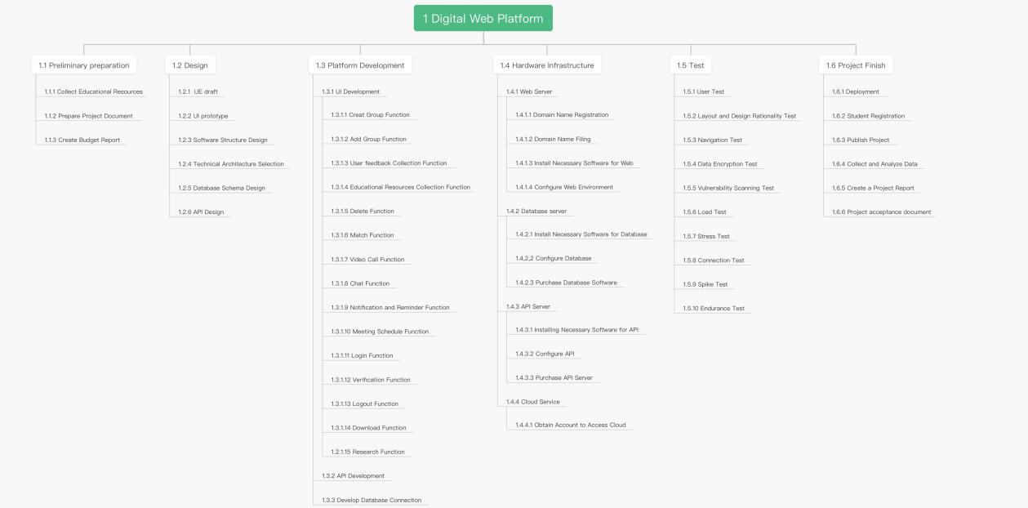

WBS chart

## 2.5 PMBOK Referenced PM Methods Used in Scope – Discussion

•**Requirements Management:** Techniques such as interviews, focus groups, and surveys

are used to gather requirements, ensuring stakeholder needs are met.

• **Scope Definition:** Clear definition of project deliverables and boundaries to prevent

scope creep.

•**WBS Development:** Breaking down the project into manageable components for better

planning and control.

• **Scope Verification:** Ensuring that all deliverables meet the predefined criteria and are

accepted by the stakeholders.

• **Scope Control:** Monitoring project scope and managing changes to the scope baseline.

# 3. Stakeholder Management Plan

# 3.1 Stakeholder Identification

To brainstorm stakeholders:

* Brainstorming Sessions: Conduct brainstorming sessions with the project team to identify potential stakeholders based on their benefits from the project and contributions to it.
* Stakeholder Analysis Workshops: Organize workshops with key project members to discuss and list individuals and groups who might be impacted by the project or have influence over it.
* Review of Project Documentation: Project charters, business cases, and similar projects should be studied in order to identify stakeholders.
* Stakeholder Mapping: Prepare stakeholder mapping that will comprise internal and external stakeholders such as the students, faculty, the college administration, future employers, and the government.
* Interviews and Surveys: Go to the list of existing stakeholders and ask them who else should be included in the list.

## 3.2 Stakeholder Assessment

### 3.2.1 Power Influence Grid

Power Influence Grid: The power/Influence Grid that needs to be utilized for staking the project is demonstrated below. This aids in identifying the management action to be taken with regard to the stakeholders.

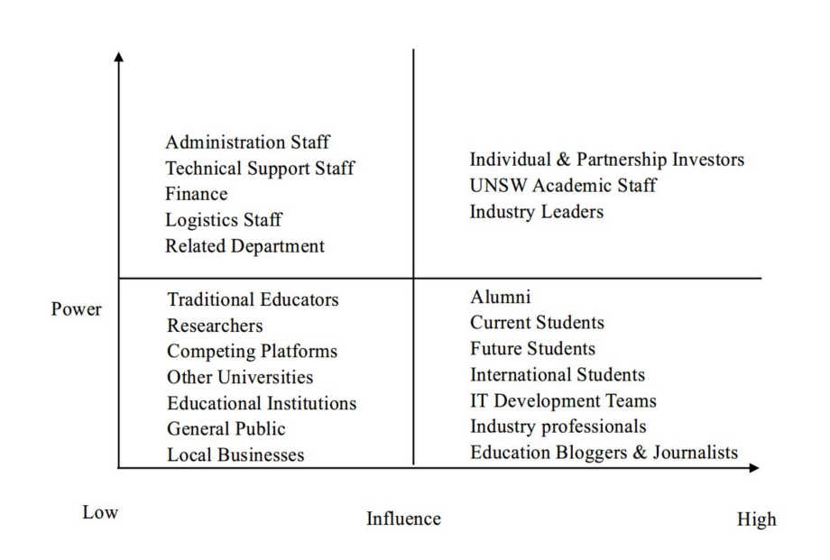

### 3.2.2 Power Interest Grid

Power Interest Grid: Use the Power/Interest Grid to categorize stakeholders based on their level of power and interest in the project. This helps in prioritizing engagement efforts.

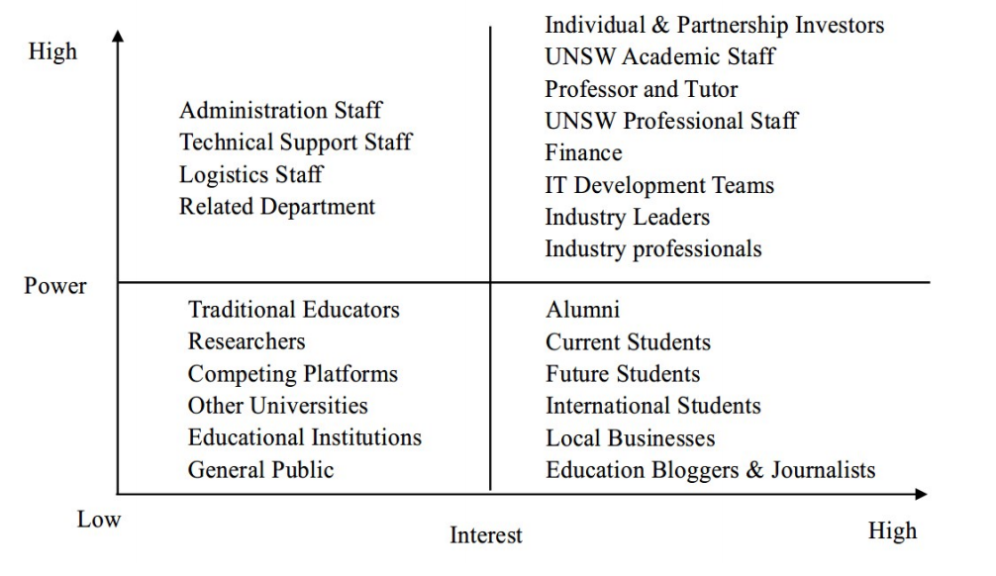

## 3.3 Stakeholder Engagement

### 3.3.1 Engagement Matrix

Engagement Matrix: Develop an engagement matrix that details the level of engagement required for each stakeholder category (e.g., inform, consult, involve, collaborate, empower).

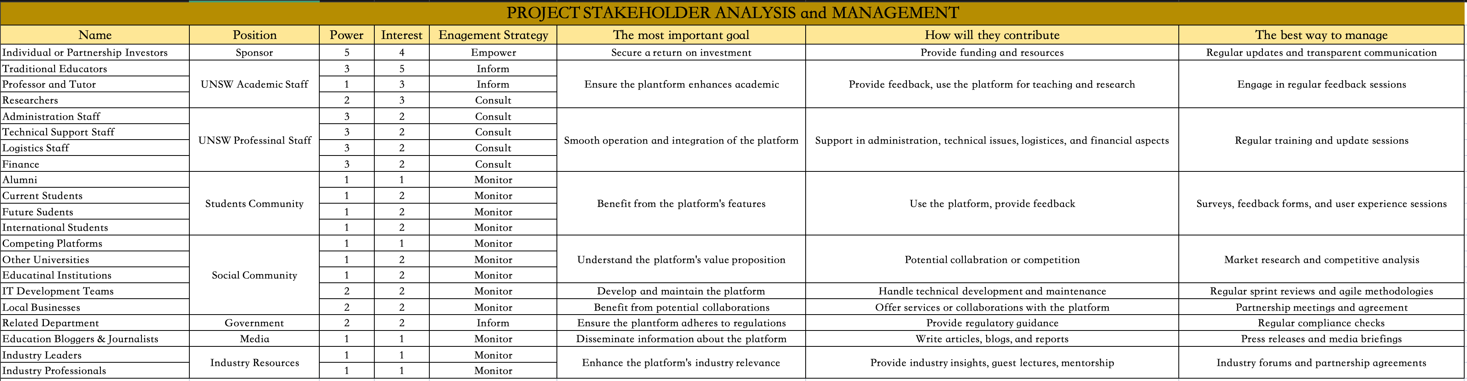

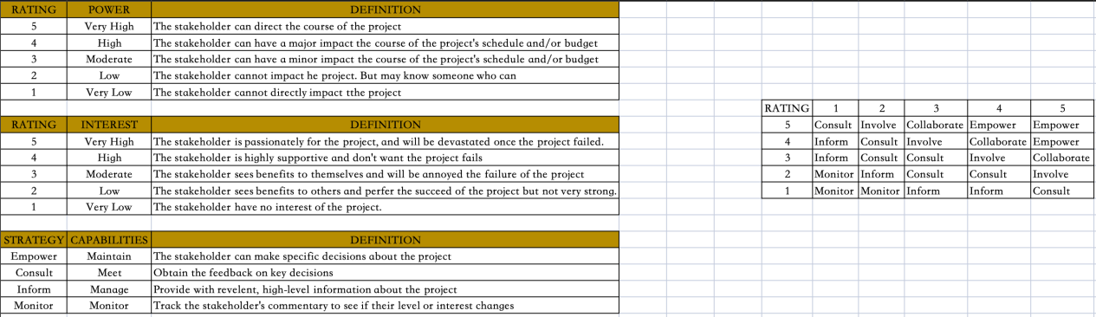

### 3.3.2 Detailed Plan

* Regular Communications: Schedule regular updates, meetings, and feedback sessions tailored to the needs of different stakeholder groups.
* Feedback Mechanisms: Implement channels, such as suggestion boxes, online forums and regular surveys, can provide continuous feedback.
* Transparent Reporting: Cultivate the trust and support that is needed for a report, such as the status of the project, issues, and/or alterations that may have arisen during the course of the project implementation.
* Training and Support: Share with the stakeholders of the project, including but not limited to training and assistance to enable them to participate in the project.

## 3.4 PMBOK Referenced PM Methods Used in Stakeholder Management – Discussion

1. Stakeholder Identification

Stakeholder Analysis (PMBOK 6th Edition, Section 13.1.2.3): This entails the process of identifying all the stakeholders of the project and recording information concerning their interests, roles required, interdependency, power, and the effect they can have on the project's success.

2. Planning Stakeholder Engagement

Stakeholder Engagement Assessment Matrix (PMBOK 6th Edition, Section 13.2.2.5): This tool is used to determine the extent of engagement of the stakeholders at the current point in time against the level of engagement that is deemed necessary to support the project. It will be useful for the purpose of building long and short-term plans on how to influence the stakeholders effectively.

3. Managing Stakeholder Engagement

Communication Management Plan (PMBOK 6th Edition, Section 10.1.3.1): This tool assists in determining the level of engagement of the current stakeholders in relation to the level of engagement that is expected to be achieved by the stakeholders for the success of the project, is very useful. It also assists in the measurement of specific strategies that are called for to enhance the relational strategies with the stakeholders.

4. Monitoring Stakeholder Engagement

Stakeholder Register (PMBOK 6th Edition, Section 13.1.3.1): The power/interest grid, which presents the assessment and the classification of the aforesaid stakeholders, is also crucial, as is this document. By it, the communications of the project stakeholders are managed, and their needs and expectations, which can be termed as major decision-making success factors of a project, are fulfilled during the course of the projects.

5. Power/Interest Grid and Power/Influence Grid

Power/Interest Grid (PMBOK 6th Edition, Section 13.1.2.4): This tool, which is known as the power-interest matrix, splits the stakeholders in terms of the amount of power they possess in relation to the project and the extent of their interest in the project is useful. It assists in identifying who shall be a stakeholder and the kind of relationship that is required between him and the organization.

Power/Influence Grid (PMBOK 6th Edition, Section 13.1.2.4): This tool is also similar to the Power/Interest Grid and entails categorizing stakeholders in according to their power and interest and is applied when planning for the extent of engagement.

6. Stakeholder Engagement Plan

Stakeholder Engagement Plan (PMBOK 6th Edition, Section 13.2.3.1): The plan that contains the strategies and activities directed at improving the efficiency of the stakeholders’ actions regarding the consideration and implementation of the project decisions is viewed as strategic. This section predicates when and in what manner the team of people that are going to be implementing the project will communicate to the stakeholders regarding their needs.

7. Feedback Mechanisms

Feedback Collection (PMBOK 6th Edition, Section 4.7.2): It is necessary to apply tools like surveys, focus groups, and feedback forms that are aimed at collecting stakeholders' opinions. That way, it is easier to determine how stakeholders view the project and what changes can be made where necessary.

# 4 Budget

4.1 Cost & Time Estimation Table

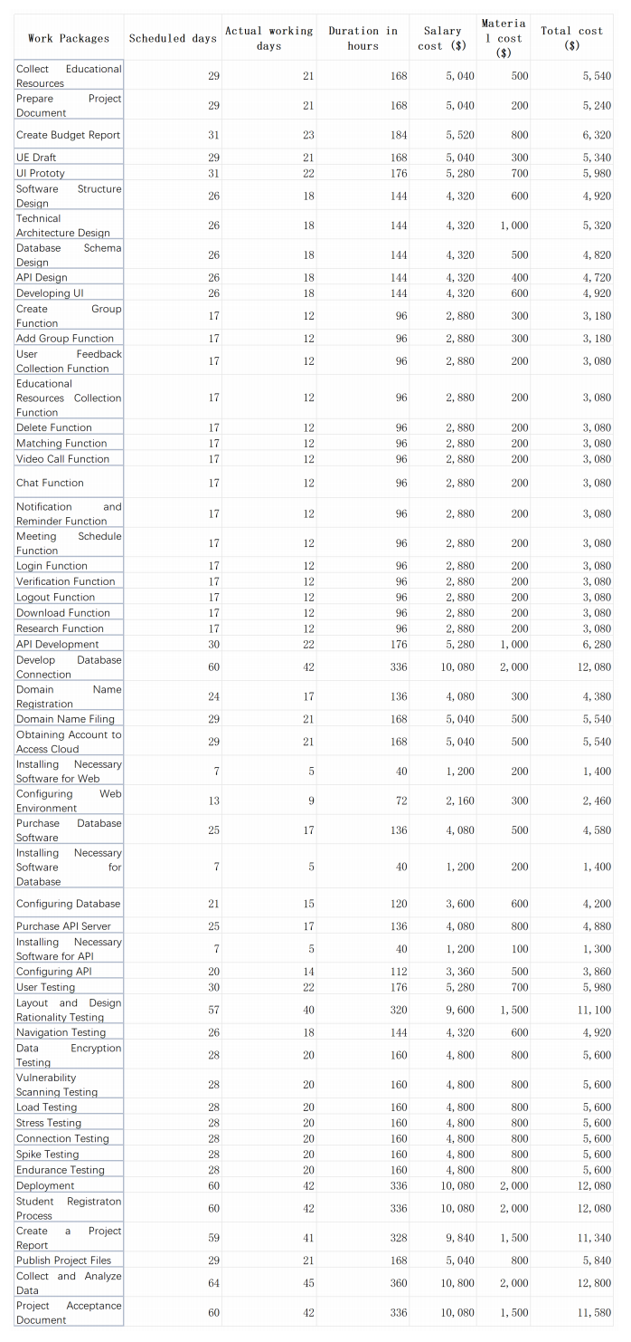

## 4.2 Project Budget

* Contingency Plan:

To ensure we stay within budget, we will include a contingency fund. A typical contingency fund is around 10-15% of the total project cost. For this project, let's use 11.5%.

* Contingency Fund:

Contingency Percentage=12.5%

Contingency Amount=12.5%×284,340=35,542.5

* Total Budget Including Contingency:

Total Budget=Total Cost+Contingency Amount

Total Budget=284,340+35,542.5=319,882.5

Therefore, the total project budget, including a contingency plan, is $319,882.5.

This budget includes a buffer for unexpected expenses, ensuring that we will not exceed the budget limit even if some unplanned costs arise.

## 4.3 Time Phased Budget

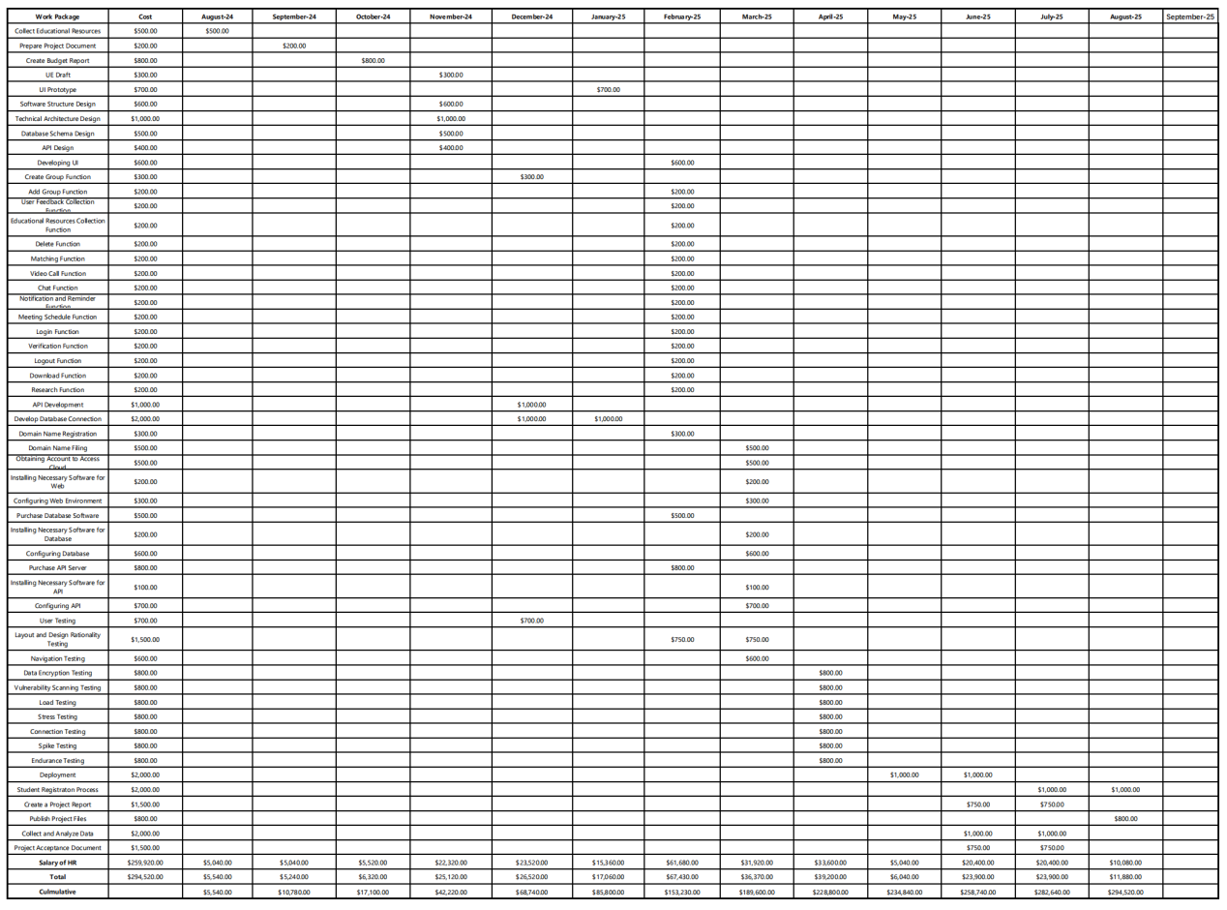

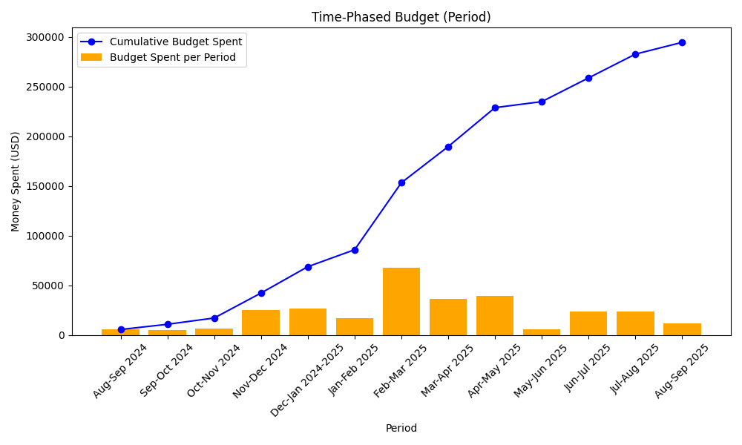

## 4.4 PMBOK Referenced PM Methods Used in Cost – Discussion

In order to manage the projects of the PMBOK Digital Education Platform, the PMBOK name covers many aspects:

Using a bottom-up approach, accurate cost projections are prepared by aggregating the costs of individual activities and preparing comprehensive budgets.

The estimated cost is integrated into the project cost by adding costs together, thus ensuring that there is a proper allocation of funds at all stages of the project.

Therefore, use results management (EVM) to monitor projects, that is, compare cost and schedule levels to identify and address cost differences.

Establish contingency reserves to cover identified risks and provide a buffer against unforeseen costs.

Regular and routine surveys of future project costs should be conducted against current performance indicators to support predictability and control of overruns.

Revision Control Board (CZB) to review and approve changes to the budget to maintain the integrity of the cost baseline.

Assess financial viability and ensure that project objectives match value by comparing expected benefits and associated costs.

# 5 Schedule

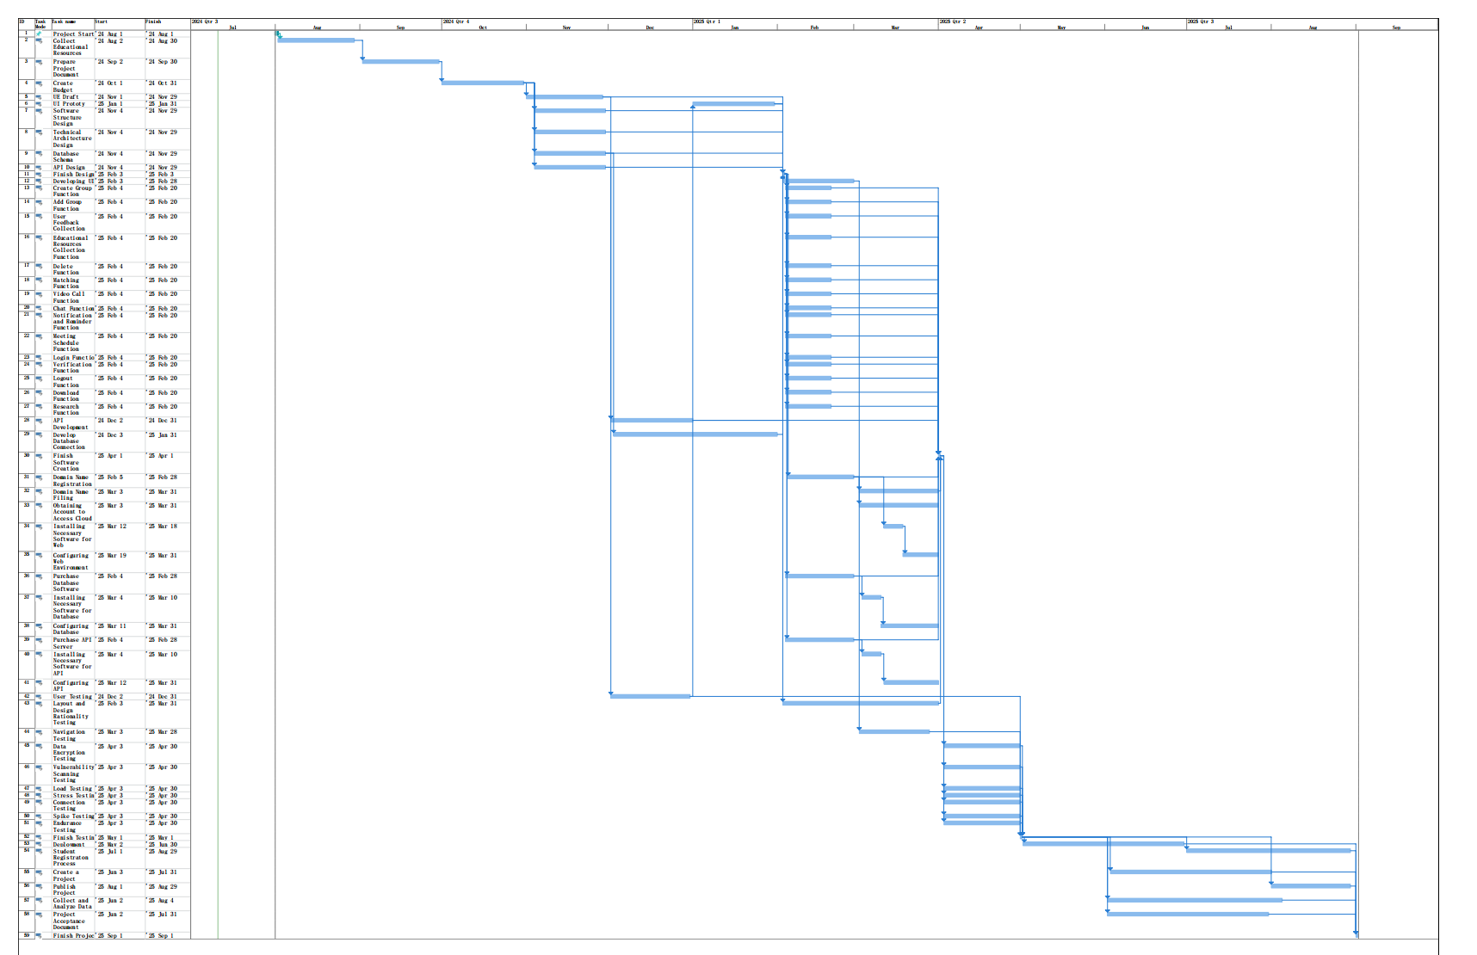

# Risk Management Plan (Week 5 lecture)

Effective risk management is crucial for successfully delivering the digital web platform designed to support students from low-socioeconomic status backgrounds. The following sections outline the approach to identifying, assessing, and managing the risks associated with this project.

## 6.1 Risk Identification

|  |  |  |  |  |
| --- | --- | --- | --- | --- |
| **Item** | Failure Mode | Cause of Failure | Effect | Remedy: Recommended Action |
| 1. Specification Documentation | Delay in documentation | Failure in program monitoring | Project delivery delay | Effective control in documentation |
| 2. Technical Development | Delayed implementation | Insufficient developers | Project delivery delay | Effective control in labor budgeting |
| 3. Security & Privacy | Data breach | Inadequate security measures | Loss of user trust and legal issues | Implement robust security protocols |
| 4. Compliance | Regulatory non-compliance | Lack of awareness of regulations | Legal penalties and project delays | Regular compliance audits and training |
| 5. Stakeholder Engagement | Low engagement levels | Ineffective communication strategies | Reduced support and adoption | Enhance stakeholder communication plans |
| 6. User Adoption | Low platform adoption | Poor user interface design | Limited impact of the platform | Conduct user experience research and testing |
| 7. Equipment & Machines | Technical failures | Poor maintenance | Project delivery delay | Regular maintenance and having backup equipment |
| 8. Training and Support | Inadequate training materials | Insufficient resources allocated | User dissatisfaction and reduced platform usage | Develop comprehensive training materials |
| 9. Data Management | Data loss | Poor data management practices | Loss of critical user data | Implement data backup and recovery solutions |
| 10. Performance | Slow platform performance | Inadequate infrastructure | User frustration and reduced platform usage | Invest in scalable infrastructure |
| 11. Feedback Mechanism | Ineffective feedback collection | Lack of structured feedback processes | Missed opportunities for improvement | Implement structured feedback collection processes |
| 12. Mentorship Program | Mismatch of mentors and mentees | Ineffective matching algorithms | Poor mentorship experiences | Develop robust matching algorithms |
| 13. Resource Repository | Outdated resources | Lack of regular updates | Reduced usefulness of resources | Schedule regular updates and reviews |
| 14. Community Engagement | Low community participation | Ineffective community management | Reduced peer support | Enhance community management strategies |
| 15. Event Coordination | Poorly organized events | Lack of coordination among stakeholders | Low attendance and engagement | Improve event planning and coordination |
| 16. Accessibility | Non-compliance with accessibility standards | Lack of awareness and training | Exclusion of some user groups | Ensure compliance with accessibility standards |
| 17. Scalability | Inability to handle increased load | Insufficient planning for growth | Platform crashes and user dissatisfaction | Plan for scalability from the outset |
| 18. Reliability & Availability | Platform downtime | Poor system architecture and maintenance | Interrupted access for users | Implement robust system architecture and regular maintenance |
| 19. User Feedback and Improvement | Ignored user feedback | Ineffective feedback loops | Reduced platform effectiveness | Establish effective feedback loops |
| 20. Communication | Poor communication between team members | Lack of communication protocols | Project delays and misunderstandings | Implement clear communication protocols |

Risk identification involves recognizing potential risks that could affect the project's objectives. The following are some identified risks for this project in Table 1:

Table 1. Failure Mode and Effect Analysis

## 6.2 Risk Assessment

Risk assessment evaluates the likelihood and potential impact of each identified risk. This process helps prioritize risks and focus on those that could significantly affect the project. Based on the assessment, risks are categorized into high, medium, and low priority levels. High-priority risks require immediate attention and robust mitigation strategies. Risks are then categorized as Low, Moderate or High depending on their Likelihood and Consequence scores as shown in Table 2.

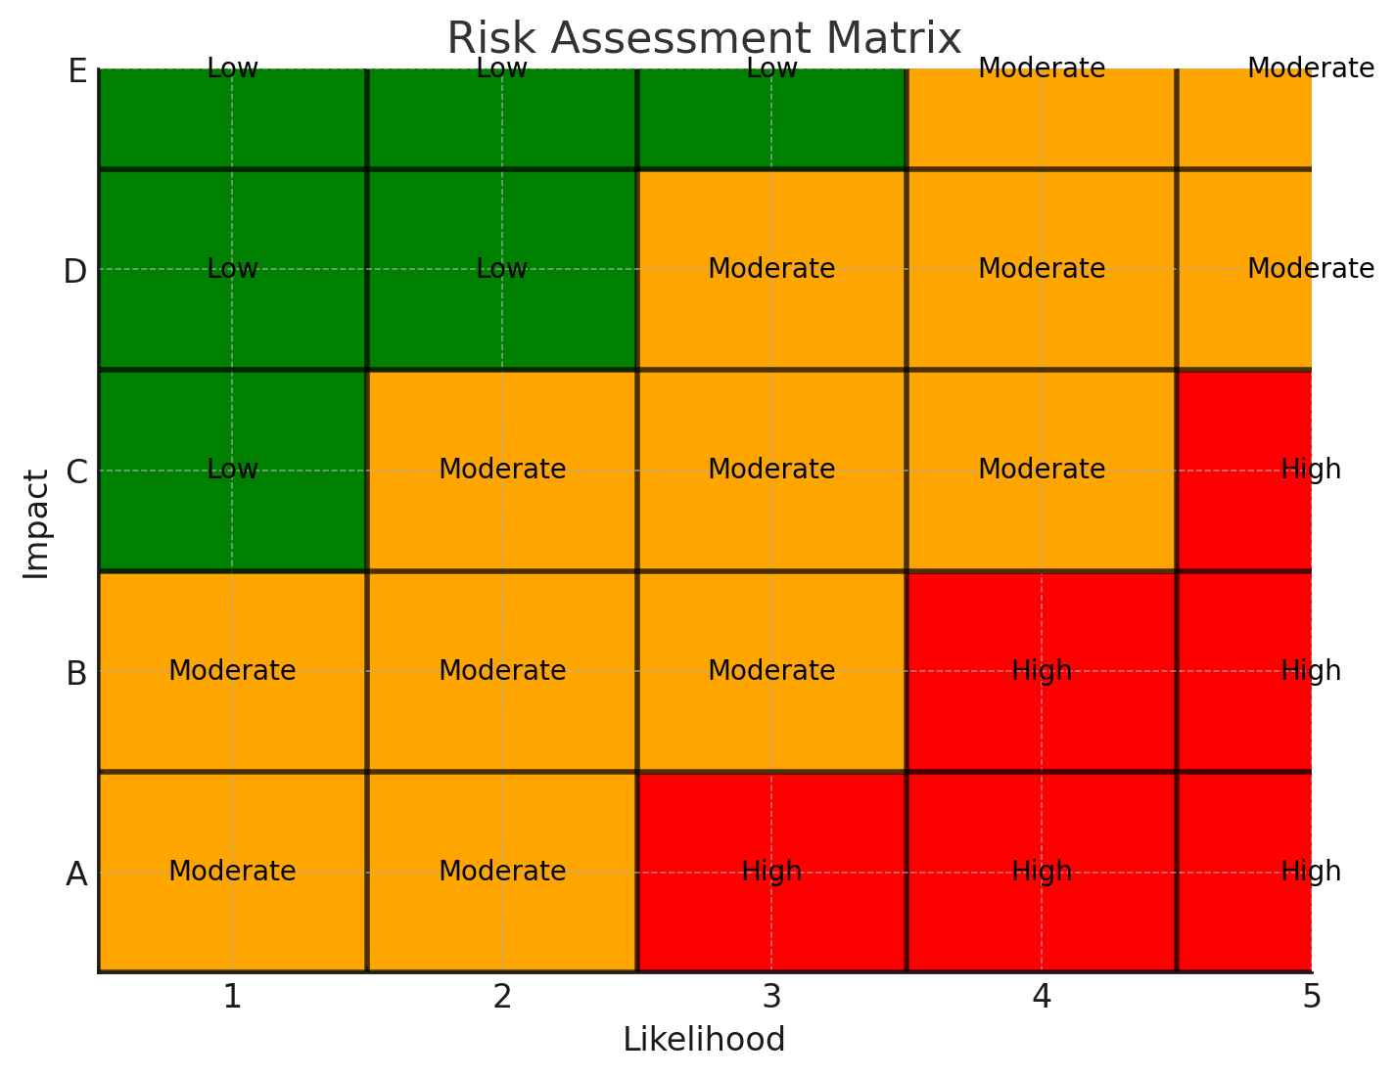

## 6.3 Risk Response and Contingency Plan

The Project Manager has evaluated and prioritized all identified risks. The most probable and impactful risks are integrated into the project schedule for timely mitigation. Upon project completion, the PM will review each risk and assess the risk management process. This analysis will identify areas for improvement to be included in the lessons learned for future projects.

## 6.4 Risk Register Table

Table 3. Project Risk Register

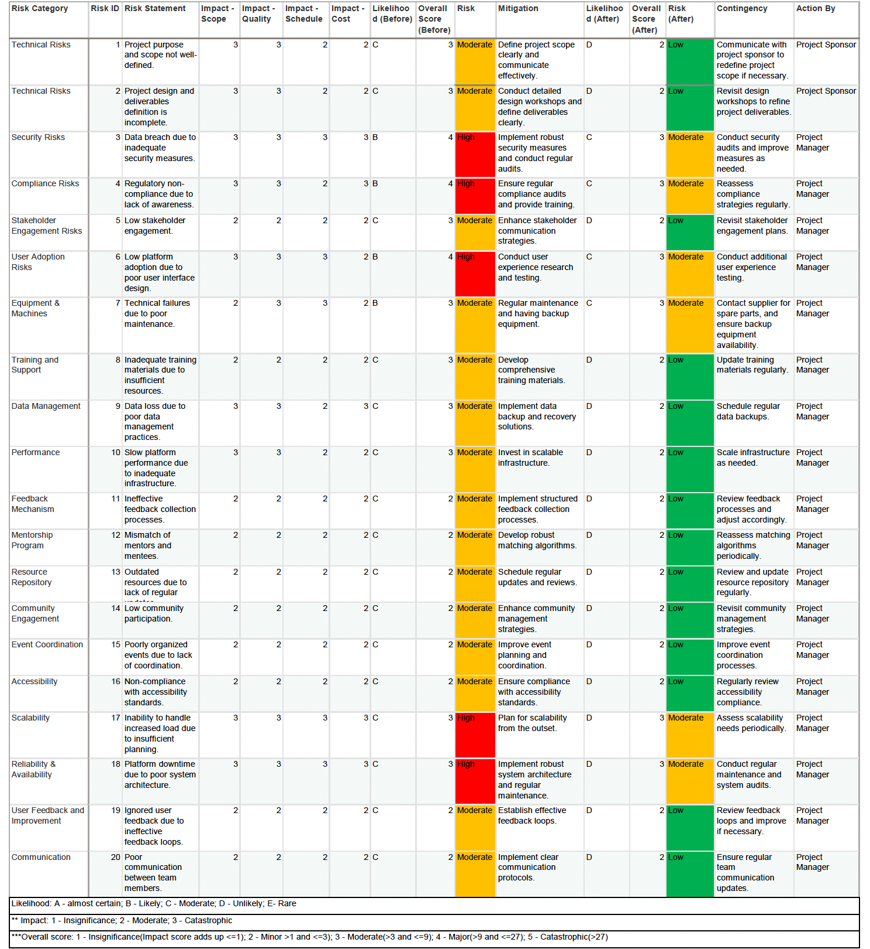

## 6.5 Monitoring and Controlling Risks

The Project Manager will monitor and review risks fortnightly at steering committee meetings with project sponsors to assess their status and the effectiveness of mitigation strategies. During fortnightly project team meetings, the PM will discuss current risks, provide updates to stakeholders, and ensure documentation of risk responses as risks approach. Mitigation strategies will be adjusted based on the evolving risk landscape and project progress. Effective risk management ensures the successful delivery of the digital web platform, aligning with UNSW's commitment to supporting students from low-socioeconomic backgrounds and advancing social impact. Once the project is completed, risks will be analyzed and included in the lessons learned knowledge base as appropriate. This ongoing process of monitoring risks throughout the project life will improve risk management for future projects.

## 6.6 Feedback of Response Cost and Time back into Budget / Schedule (integration)

Integrating the costs and time for risk responses back into the project's budget and schedule is essential for effective management. This helps ensure the project stays on track, within budget, and can manage unexpected changes due to risk mitigation activities.

### 6.6.1 cost feedback

(1) Estimation and Allocation: The project team calculates the costs for risk responses and includes these in the project budget. This covers additional resources, equipment, and other expenses needed to address identified risks.

(2) Continuous Monitoring: Throughout the project, the actual costs of risk responses are compared to the budgeted estimates. Any differences are analyzed, and adjustments are made to stay within budget.

### 6.6.2 Time Feedback

(1) Schedule Adjustments: The time needed for risk responses is added to the project schedule. Timelines for specific tasks and milestones are adjusted to include the extra time required for mitigation activities.

(2) Regular Updates: The project schedule is frequently updated to show the progress of risk response activities. Any delays or accelerations are documented and shared with all stakeholders.

## 6.7 PMBOK Referenced PM Methods Used in Risk Plan – Discussion

1. Risk Identification reference from PMBOK Chapter 11.2 ‘Identify Risks’: The project employs techniques like Failure Mode and Effect Analysis (FMEA) to identify and categorize potential risks, ensuring all possible risks are understood.
2. (2) Risk Assessment reference from PMBOK Chapter 11.3 ‘Perform Qualitative Risk Analysis’ and Chapter 11.4 ‘Perform Quantitative Risk Analysis’: Risks are assessed based on their likelihood and impact, then categorized as Low, Moderate, or High to prioritize and manage them effectively.
3. (3) Risk Response Planning reference from PMBOK Chapter 11.5 ‘Plan Risk Responses’: The project manager incorporates prioritized risks into the project schedule, ensuring timely mitigation with detailed response and contingency plans.
4. (5) Monitoring and Controlling Risks reference from PMBOK Chapter 11.7 ‘Monitor Risks’: The Project Manager reviews risks every two weeks, providing updates and adjusting strategies as needed to manage risks proactively.

# 7. Communications Management Plan

7.1 Project Information System Table

## 7.2 PMBOK Referenced PM Methods Used in Communications – Discussion

1.Interactive Communication:This involves direct interaction between two or more parties. It can be face-to-face or through tools like phone calls, video conferencing, or instant messaging.

2.Push Communication:Information is sent to specific recipients who need to receive the information. This includes emails, reports, memos, and newsletters.

3.Pull Communication:Information is made available to recipients at their discretion. This includes intranet sites, knowledge repositories, bulletin boards, and e-learning.

4.Meetings:Regularly scheduled or ad-hoc gatherings to discuss project status, issues, risks, and other critical information.

5.Reports and Dashboards:Structured documents that provide summarized information on project status, risks, performance metrics, and other key data.

6.Surveys and Questionnaires:Tools to gather feedback and opinions from stakeholders regarding various aspects of the project.

7.Workshops and Training Sessions:Interactive sessions aimed at developing skills, solving problems, or gathering requirements.

8 Human Resource Plan

8.1 Project Organisation Chart

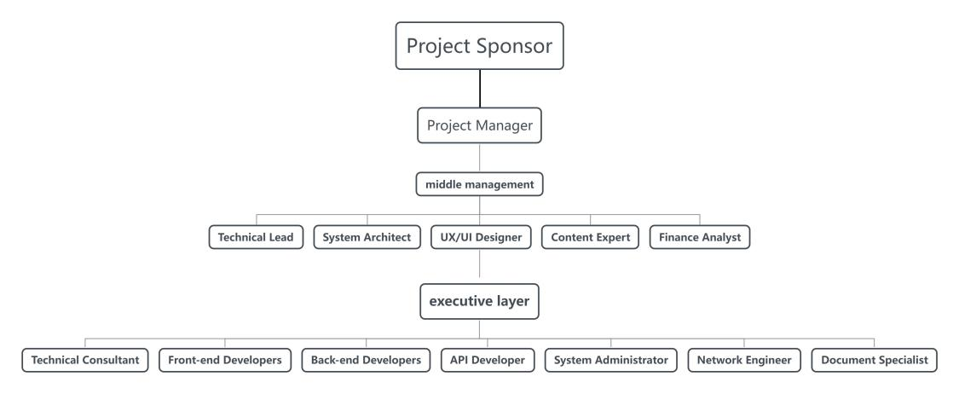

## 8.2 Roles and Responsibilities Table

|  |  |  |
| --- | --- | --- |
| Role | Responsibilities | Skills/Qualifications |
| Project Sponsor | Provides overall direction, funding, and resources | Senior management experience, decision-making |
| Project Manager | Manages project scope, schedule, and budget | Project management certification, leadership |
| Technical Lead | Oversees all technical aspects of the project | Technical expertise, team leadership |
| UX/UI Designer | Designs user-friendly interfaces and ensures accessibility | UI/UX design experience, knowledge of accessibility standards |
| Content Expert | Collects and organizes educational resources | Subject matter expertise, research skills |
| Finance Analyst | Manages project budget and financial planning | Financial analysis, budgeting, and reporting skills |
| System Architect | Designs system architecture and database schema | System architecture, database design experience |
| Technical Consultant | Provides technical guidance and support | Technical expertise, problem-solving skills |
| Front-end Developers | Develops the front-end of the platform | Proficiency in HTML, CSS, JavaScript, front-end frameworks |
| Back-end Developers | Develops the back-end of the platform and APIs | Server-side programming, database management |
| API Developer | Designs and develops APIs | API design and development experience |
| System Administrator | Manages and configures servers and cloud services | System administration, network management |
| Network Engineer | Manages network configuration and maintenance | Networking skills, network security knowledge |
| Document Specialist | Creates project documentation and reports | Technical writing, documentation skills |

## 8.3 Position Descriptions

Position: Project Sponsor

* **Purpose**: To provide overall direction, funding, and resources for the project.
* **Key Responsibilities**:
  + Provide strategic guidance and high-level decision-making.
  + Allocate necessary resources and budget.
  + Resolve escalated issues and remove obstacles.
* **Qualifications**: Senior management experience, strong decision-making skills.

Position: Project Manager

* **Purpose**: To oversee the successful completion of the project within the defined scope, time, and budget.
* **Key Responsibilities**:
  + Develop and maintain the project plan and schedule.
  + Coordinate project activities and resources.
  + Monitor project progress and performance, and adjust plans as needed.
  + Communicate with stakeholders and manage expectations.
* **Qualifications**: PMP certification, 5+ years of project management experience, leadership skills.

Position: UX/UI Designer

* **Purpose**: To design user-friendly interfaces and ensure accessibility.
* **Key Responsibilities**:
  + Create wireframes, prototypes, and UI designs.
  + Conduct user research and usability testing.
  + Ensure the platform complies with accessibility standards.
  + Collaborate with developers to implement designs.
* **Qualifications**: UI/UX design experience, knowledge of WCAG standards, proficiency in design tools (e.g., Adobe XD, Sketch).

Position: Content Expert

* **Purpose**: To collect and organize educational resources.
* **Key Responsibilities**:
  + Research and curate relevant educational content.
  + Ensure content accuracy and quality.
  + Update and maintain the content repository.
* **Qualifications**: Subject matter expertise, research skills, excellent organizational skills.

Position: System Architect

* **Purpose**: To design the system architecture and database schema.
* **Key Responsibilities**:
  + Develop and document system architecture and design.
  + Create database schemas and ensure data integrity.
  + Ensure system scalability, security, and performance.
  + Collaborate with developers to implement the architecture.
* **Qualifications**: Experience in system architecture and database design, strong analytical skills, knowledge of software development methodologies.

Position: Technical Consultant

* **Purpose**: To provide technical guidance and support.
* **Key Responsibilities**:
  + Advise on technical decisions and solutions.
  + Assist in resolving technical issues.
  + Stay updated with the latest technologies and best practices.
  + Support the development team with technical expertise.
* **Qualifications**: Technical expertise, problem-solving skills, experience in consulting or technical advisory roles.

Position: Front-end Developer

* **Purpose**: To develop the front-end of the platform.
* **Key Responsibilities**:
  + Implement UI designs into functional front-end code.
  + Ensure cross-browser compatibility and responsive design.
  + Optimize front-end performance.
  + Collaborate with UX/UI designers and back-end developers.
* **Qualifications**: Proficiency in HTML, CSS, JavaScript, and front-end frameworks (e.g., React, Angular).

Position: Back-end Developer

* **Purpose**: To develop the back-end of the platform and APIs.
* **Key Responsibilities**:
  + Develop server-side logic and integrate with front-end components.
  + Create and maintain APIs.
  + Ensure data security and integrity.
  + Collaborate with front-end developers and system architects.
* **Qualifications**: Server-side programming skills, experience with databases and API development, knowledge of security best practices.

Position: API Developer

* **Purpose**: To design and develop APIs.
* **Key Responsibilities**:
  + Design and develop RESTful APIs.
  + Ensure API security and documentation.
  + Integrate APIs with front-end and back-end systems.
  + Monitor and optimize API performance.
* **Qualifications**: API design and development experience, knowledge of RESTful principles, proficiency in relevant programming languages.

Position: System Administrator

* **Purpose**: To manage and configure servers and cloud services.
* **Key Responsibilities**:
  + Configure and maintain servers and cloud infrastructure.
  + Monitor system performance and ensure availability.
  + Implement security measures and backup solutions.
  + Troubleshoot and resolve system issues.
* **Qualifications**: System administration experience, knowledge of server and cloud technologies, proficiency in scripting and automation tools.

Position: Network Engineer

* **Purpose**: To manage network configuration and maintenance.
* **Key Responsibilities**:
  + Design and manage network configurations.
  + Ensure network security and performance.
  + Troubleshoot and resolve network issues.
  + Monitor network traffic and optimize performance.
* **Qualifications**: Networking skills, experience with network security, knowledge of network protocols and hardware.

Position: Document Specialist

* **Purpose**: To create and maintain project documentation.
* **Key Responsibilities**:
  + Prepare user manuals, technical guides, and project reports.
  + Ensure documentation is clear, concise, and up-to-date.
  + Collaborate with team members to gather information.
  + Maintain documentation standards and templates.
* **Qualifications**: Technical writing skills, attention to detail, experience with documentation tools and software.

## 8.4 Project Staffing Strategy

### 8.4.1. Recruitment Plan

**Objective:** Identify and hire qualified candidates for each role within the project.

**Roles and Responsibilities:**

**1.HR Team**

* Oversee the entire recruitment process
* Handle job postings, screenings, and initial interviews

**2.Project Manager**

* Participate in final interviews
* Involved in the selection of candidates

**3.Technical Lead**

* Assist with technical evaluations of candidates

**Recruitment Process:**

**1.Job Analysis**

* Define detailed job descriptions and requirements for each role

**2.Job Posting**

* Advertise open positions on job boards, the company website, and professional networks

**Screening**

* Review applications
* Shortlist candidates based on qualifications

**Interviewing**

* Conduct initial HR interviews
* Follow up with technical interviews

**Selection**

* Choose the best candidates
* Extend job offers

### 8.4.2 Onboarding Plan

**Objective:** Ensure new hires are effectively integrated into the project team and understand their roles and responsibilities.

**Roles and Responsibilities:**

* **HR Team**: Facilitate the onboarding process and provide necessary resources.
* **Project Manage**r: Introduce new hires to the project and team members.
* **Technical Lead**: Provide technical orientation and assign initial tasks.

**Process:**

* **Welcome Kit:** Provide new hires with a welcome kit including company information, project overview, and necessary tools.
* **Orientation:** Conduct orientation sessions covering company policies, project goals, and team structure.
* **Training:** Provide role-specific training and assign a mentor to help new hires settle into their roles.

### 8.4.3 Training and Development Plan

**Roles and Responsibilities:**

* **HR Team:** Oversee the recruitment process, including job postings, screenings, and interviews.
* **Project Manager:** Participate in final interviews and selection of candidates.
* **Technical Lead:** Assist in technical evaluations of candidates.

**Process:**

* **Job Analysis:** Define detailed job descriptions and requirements for each role.
* **Job Posting:** Advertise open positions on job boards, the company website, and professional networks.
* **Screening:** Review applications and shortlist candidates based on qualifications.
* **Interviewing:** Conduct initial HR interviews followed by technical interviews.
* **Selection:** Choose the best candidates and extend job offers.

### 8.4.4 Performance Management Plan

**Roles and Responsibilities:**

* **Project Manager:** Conduct regular performance reviews and provide feedback.
* **Technical Lead:** Monitor technical performance and provide guidance.

### **Process:**

* **Performance Reviews:** Conduct quarterly performance reviews to assess progress and provide feedback.
* **KPIs:** Define key performance indicators (KPIs) for each role to measure performance.
* **Feedback Mechanism:** Implement a feedback mechanism to address issues and recognize achievements.

### 8.4.5 Retention Plan

**Objective:** Retain top talent by fostering a supportive and rewarding work environment.

**Roles and Responsibilities:**

* **HR Team:** Develop and implement retention strategies.
* **Project Manager:** Foster a positive team culture and address team concerns.

**Process:**

* **Compensation:** Offer competitive salaries and benefits packages.
* **Career Development:** Provide opportunities for career advancement and professional growth.
* **Work-life Balance:** Promote work-life balance through flexible working arrangements.
* **Recognition:** Implement a recognition program to reward outstanding performance.