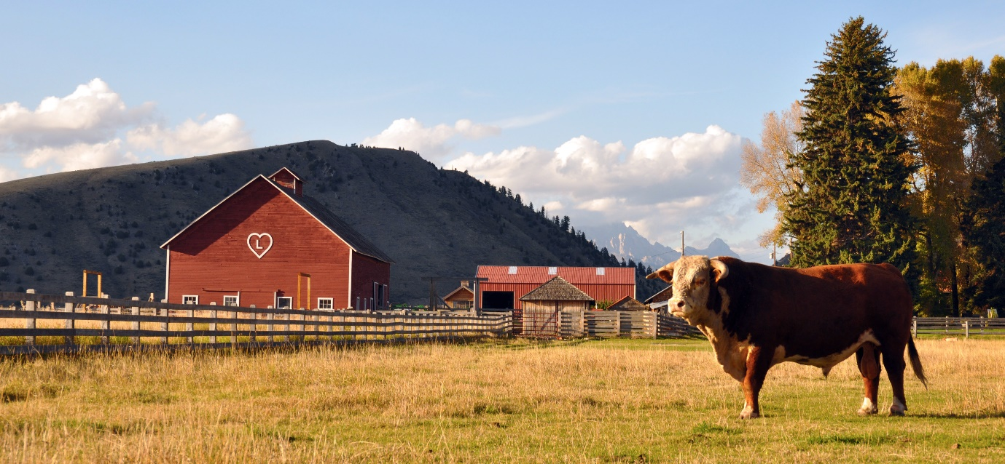

**PROPOSAL: Ranch**

A ranch (a large farm) that is bordered by borders, hills, forests and a lake/pond.

**PART 1:**

* Sky Plane
  + Cloudy Skies
    - Day/Night Cycle
      * Will be achieved by moving textures or animation
* Terrain
  + Higher ground at borders to block edges of sky plane
    - Extra: collision with terrain
* Multitexture
  + Used to add detail for buildings, fences, trees.
* Lights
  + 1 light; sun, sunlight
    - Extra: if day/night cycle is completed, add additional light source to represent moon, moonlight
* Fog
* Sprite Sheet
  + (With animation) Smoke coming out of a chimney of one of the buildings

**PART 1 EXTRAS:**

* Water in scene
  + Animated texture
    - Extra: waves along water plane
    - Extra: blue-ish filter, blue fog when looking from under water.   
      E.g: 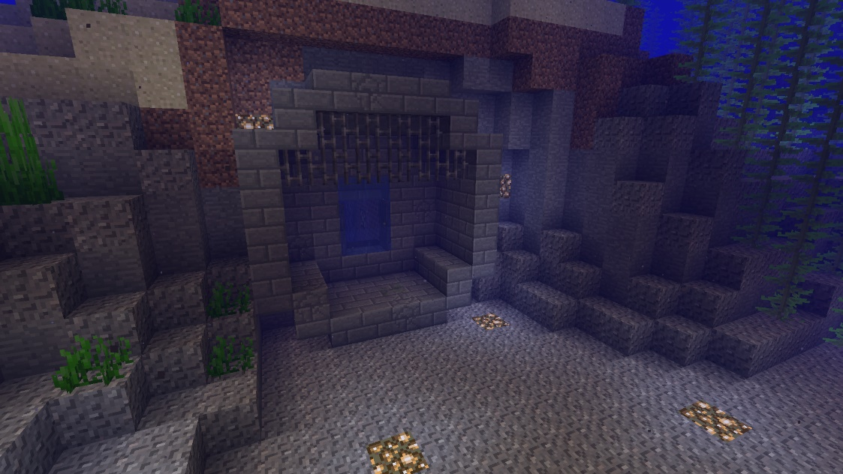
* Sky Dome
  + Day/night cycle may be implemented by animation for the dome if it cannot be with moving textures

**PART 2:**

* Billboards
  + Semi-transparent clouds
* Particle Effects
  + Rain
    - Billboarded
    - When it lands (collides with terrain, maybe even other objects?) it will create a different quad that animates the raindrop hitting the ground (splashing)
* Advanced Lighting
  + Day/night cycle: sun/moon moves along the cycle
    - Shadows are made, adjusts according to the position of the light source

**PART 2 EXTRAS:**

* Extra features
  + Seasonal Cycle
    - Spring: Flowers (either as objects or billboards) will grow on the grass
    - Summer: Standard scene
    - Fall: Tree leaves will gradually turn orange, leaves (particle effects) will spawn and fall from the trees.
    - Winter: snow (particle effects) falling from the sky, snow can be accumulated in the grassland, roofs (multitexture? as an object rising from underneath the terrain?)
      * Extra: snow can follow irregular pattern while falling.
  + Campfire
    - Fire is a 2d quad, animated, billboarded
    - Fire is a light source
      * Extra: irregular movement from light source to simulate
    - Particle effects (smoke) emitted from the fire, billboarded.
  + Animals and interactions
    - * Animals (objects) that can follow the player, interactable with the player (via keyboard, mouse, or in-game interactions)
        + E.g. when walking, can create particle effects