Assignment 3: Sorting and Searching Algorithm Analysis System

1. Project Overview
In this project, three algorithms were implemented and analyzed:
- Bubble Sort (Basic Sorting)
- Merge Sort (Advanced Sorting)
- Binary Search (Searching)
The purpose of this experiment is to compare algorithm performance using different array sizes and input types. Execution time was measured using System.nanoTime() to analyze practical efficiency and compare results with theoretical Big-O complexity.

2. Algorithm Descriptions

2.1 Bubble Sort
Bubble Sort works by repeatedly comparing adjacent elements and swapping them if they are in the wrong order. After each full pass, the largest element moves to the end of the array.
Time Complexity:
- Best Case: O(n)
- Average Case: O(n^2)
- Worst Case: O(n^2)
Bubble Sort is simple but inefficient for large datasets.

2.2 Merge Sort
Merge Sort uses the divide-and-conquer strategy. The array is divided into two halves recursively until single elements remain. Then, the halves are merged back together in sorted order.
Time Complexity:
- Best Case: O(n log n)
- Average Case: O(n log n)
- Worst Case: O(n log n)
Merge Sort is much more efficient than Bubble Sort for large arrays.

2.3 Binary Search
Binary Search works only on sorted arrays. It repeatedly checks the middle element of the array and eliminates half of the remaining elements each time.
Time Complexity:
- Best Case: O(1)
- Average Case: O(log n)
- Worst Case: O(log n)
Binary Search is very efficient because it reduces the search space by half at every step.

3. Experimental Setup
Experiments were performed using three different array sizes:
- Small (10 elements)
- Medium (100 elements)
- Large (1000 elements)
For each size, the following tests were conducted:
- Sorting random arrays
- Sorting already sorted arrays
- Searching for an element using Binary Search
Execution time was measured using System.nanoTime().

4. Experimental Results

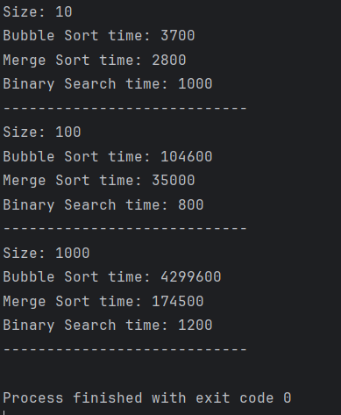

Bubble Sort was significantly slower than Merge Sort for medium and large arrays. This matches the theoretical complexity because O(n^2) grows much faster than O(n log n).
As the array size increased, execution time increased significantly for Bubble Sort, while Merge Sort scaled much better.
Binary Search was extremely fast because it eliminates half of the array at each step. It requires a sorted array; otherwise, the algorithm cannot correctly decide which half to eliminate.
The experimental results matched the expected Big-O complexity.

6. Reflection
Through this assignment, I learned how algorithm efficiency affects real performance. Although theoretical complexity gives an estimation, practical results show clear differences when array size increases.
The biggest challenge was implementing Merge Sort correctly and organizing the project using proper OOP structure. This project helped strengthen understanding of sorting, searching, and performance measurement.

