BeamScan: A Particle-Beam Material Classifier — From Recycling to Heritage Science
Los Topos Cósmicos · Instituto San Francisco de Asís Santa Rosa de Calamuchita, Córdoba, Argentina 🇦🇷

1. Motivation to Participate (~100 words)
We are students and teachers from the Instituto San Francisco de Asís in Santa Rosa de Calamuchita, Córdoba, Argentina. On the banks of the Río Santa Rosa, two materials defy identification without destroying them: Comechingón morteros carved in rock two thousand years ago, and mixed plastic waste arriving at local recycling cooperatives. The first is untouchable archaeological heritage. The second determines whether recycling is viable. Both pose the same challenge: compositional characterisation without destroying the sample. We want to demonstrate that particle physics can solve both problems with the same non-destructive technique. Participating in BL4S would let us validate this method with a real beam and bring the results home to our communities.

2. Experiment Idea (~800 words)

The Question
Can we build a “BeamScan Atlas” — a classification chart that identifies materials by measuring how charged particles scatter through them? We aim to demonstrate this for two real-world domains in one experiment: identifying plastics for recycling quality control and classifying geological reference materials relevant to heritage science.

The Physics
When a GeV-scale charged particle traverses matter, it undergoes many small deflections from atomic nuclei — multiple Coulomb scattering (MCS). The resulting angular spread θ₀ depends on the material’s radiation length X₀, a fundamental property set by elemental composition. From the Highland formula, θ₀ ∝ √(x/X₀) / p, where x is target thickness and p is beam momentum. Materials with heavier atoms scatter the beam more.

Predicted Separation
Using the Highland formula with PDG radiation lengths, we calculated expected scattering angles at 3 GeV/c through 10 mm targets:
Polyolefins PE and PP (θ₀ ≈ 0.56 mrad): pure carbon–hydrogen baseline. Oxygen-containing plastics PS, PMMA, PET (θ₀ = 0.60–0.74 mrad): progressively heavier effective composition. PVC (θ₀ ≈ 0.90 mrad): the chlorine atom (Z = 17) dramatically increases scattering — detecting PVC contamination in recycling streams is our primary industrial application. Geological materials — quartz, calcite, alumina, iron oxide (θ₀ = 1.17–2.38 mrad): minerals built from silicon, calcium, aluminium, and iron scatter even more.
A natural gap separates the plastics cluster from the minerals cluster, reflecting a fundamental divide in chemistry: organic matter (C, H, O, N) versus inorganic matter (Si, Ca, Al, Fe). This gap is itself the scientific result — it proves MCS naturally sorts materials into compositional families. Our Geant4 simulations confirm that even the closest useful pairs (PS vs PMMA) need fewer than 2,000 events to distinguish at 3σ — seconds of beam time. PVC versus PE needs only ~50 events. The full atlas requires under one hour of data.

Experimental Setup (facility-agnostic)
Our core measurement requires only tracking detectors and trigger scintillators — standard equipment at all BL4S facilities:
Beam (1–6 GeV/c) → scintillator S₁ → trackers 1, 2 → TARGET → trackers 3, 4 → scintillator S₂.
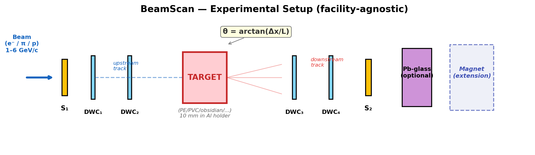
Figure 1: Facility-agnostic BeamScan layout. Trackers 1–4 measure incoming and outgoing directions. Magnet and calorimeter are optional extensions.
Two trackers upstream record the incoming direction; two downstream record the direction after the target. We subtract the no-target angular width in quadrature to extract the material scattering signal. This layout works at CERN T9 (Delay Wire Chambers), at DESY (beam telescope), and at ELSA.

Targets and Facility Considerations
CERN and DESY accept only non-combustible targets; ELSA also permits combustible materials. Our plan adapts accordingly: at ELSA we run the full set — plastics (PE, PP, PS, PMMA, PET, Nylon, PVC) plus geological references (quartz, calcite, alumina, iron oxide), including the PVC “hero result.” At CERN or DESY we run the non-combustible set — geological references plus graphite and metal foils as low-Z anchors — still spanning a wide X₀ range and demonstrating the full classifier concept.
All targets are solid samples in an aluminium holder. We will provide safety data sheets and coordinate with facility safety officers.

Measurement Program
Phase 1 — Calibration: No-target runs at both momenta to measure beam divergence and angular resolution. Phase 2 — Core atlas: Measure θ₀ for all permitted materials at two momenta (e.g. 3 and 6 GeV/c), 10 mm thickness, ≥10⁴ events each. The second momentum validates the expected 1/p scaling and controls systematics — alignment shifts affect both settings similarly, providing a built-in consistency check. Phase 3 — Systematics: Vary thickness (5, 10, 20 mm) for selected materials to validate √(x/X₀) dependence and extract X₀. Phase 4 — Extensions: Contaminant sensitivity (thin metal foil inside a sample), composite materials, and — if the facility offers additional observables such as dE/dx or calorimeter response — a genuinely independent second classification axis.

The Deliverable: BeamScan Atlas
A classification table and plot of measured θ₀ (and extracted X₀) for each target. The two-momentum data cross-check Highland scaling. Where the facility offers additional observables, we add a second axis (e.g. dE/dx from a TPC, or energy deposit in Pb-glass). The atlas is simultaneously a scientific result, a practical lookup table, and a memorable visualisation.
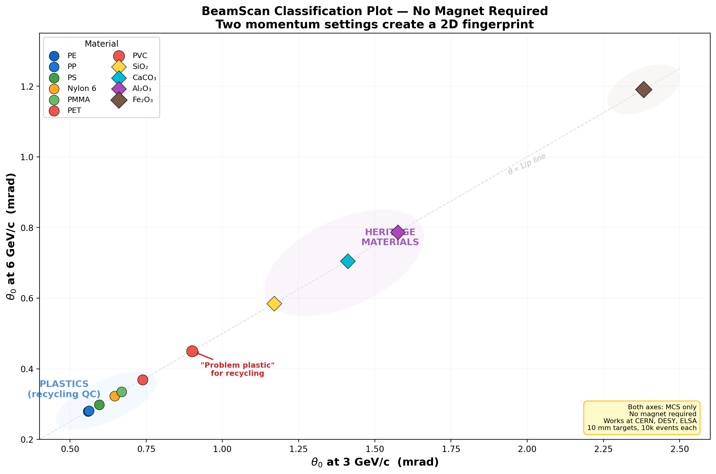
Figure 2: Predicted BeamScan Atlas (Highland formula, corrected X₀). Plastics cluster bottom-left, minerals top-right. PVC bridges the gap. Both axes are MCS-only — no magnet required.

Simulation and Open Science
We have built a Geant4 Monte Carlo simulation of the full experiment, published in a public GitHub repository with automated CI workflows. Students contribute by adding materials via pull requests and instantly seeing updated predictions — no C++ or Geant4 installation needed. Every figure in this proposal can be reproduced from the repository.

3. What We Hope to Take Away (~100 words)
We want to return to Córdoba with three things: a validated BeamScan Atlas proving that particle beams can classify materials non-destructively; the experience of designing, running, and analysing a real experiment at a world-class facility; and a story to share. If students from Argentina can use a CERN beamline to help solve recycling challenges and study their country’s archaeological heritage, it shows that fundamental physics belongs to everyone. We will share our results with local recycling cooperatives, schools, and museums — and publish everything openly so others can build on our work.

Outreach Activity (optional, ~200 words)
Before submitting this proposal, our team organised a “Physics Meets the Street” event at a recycling cooperative in Córdoba. We brought samples of different plastics and demonstrated — using simple density-sorting and light-transmission tests — how difficult it is to distinguish PE from PP or detect PVC contamination by eye. We explained our BL4S idea: that accelerator particles can “see” the atoms inside a material, not just the surface. Workers were fascinated that CERN science could connect to their daily sorting challenges.
If selected, we will expand this into a bilingual workshop series: “Del acelerador al reciclaje” (From the Accelerator to Recycling). We will bring our BeamScan Atlas to schools and cooperatives across Córdoba, explaining the physics behind each data point. We will publish the Geant4 simulation and Spanish-language tutorials so students across Latin America can run their own predictions and extend the atlas with new materials.

