VALIDATIONS:

1. HAS_MANY

Realtionships connect models together.   
* A relationship will join the data in *seat and flight tables* by MATCHING the data in the seat.flight_id and flight_id columns.   
* In other words - relationship works by connecting the id field of one table with another field ‘ending_id’ in the other table. (It means that the field in the seats table **must be** called flight_id, and the field must be an integer.)  
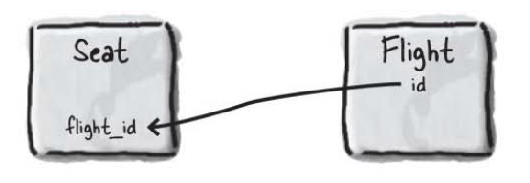 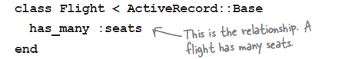  
In my app it looks like this [left – seat table, right – flight table]

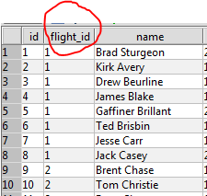 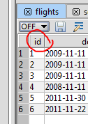

With the realtionship in place you can use **@flights.seats**   
Rails will treat it like this – as a finder: Seat.find_all_for_flight_id(@flight.id)  
( в таблице seat найди все entries в столбце flight_id, которые соответствуют определенному id из (стр 246)

has_many attributes return arrays.