A string is a:
a. sequence of characters enclosed by quotes.
b. “String” is the name Ruby gives to a sequence of alphabetic characters.
Array
You can think of an array as a bunch of objects arranged in a row.
The \n - shows that an end-of-line character is treated like all the others when it’s typed into the unclosed string. For example:
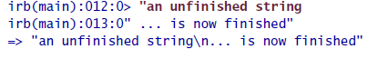
The Ruby universe, in essence, contains only three kinds of things: nouns, verbs, and names.
Objects – nouns (существительные) [They are the objects “things” in the Ruby universe. Objects just sit there until they’re told to do something.]
All the verbs in the Ruby universe are imperative: verbs like “sit!” and “stay!” and “roll over!” In Ruby, these verbs are called messages, and telling an object to do some- messages thing is called sending a message.
Everything is done by sending messages to objects
[You don’t have direct access to the objects inside the Ruby universe. To get at one of them, you have to use a name that refers to it. It’s similar name in our universe: I am an object. My children refer to me as “Dad,” my wife refers to me as “hubster” or even more embarrassing names, and a clerk at the Philadelphia airport referred to me as “31” and “hey, you.” All of them used names to talk about the object that is me.]

File.open
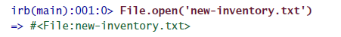
File.open [as in File.open('new-inventory.txt')]
File names a particular object in the Ruby universe. It’s the object that knows how to open files and prepare them for use. The open message commands it to do so. Since File needs to know which file to open, open takes an argument, which is the string 'new-inventory.txt'.
Upon receipt of the message, File does the work to open a file. That involves creating another object that is the open file (as far as Ruby is concerned). File then returns that newly created object to whatever returns object sent the message (usually called the sender). In this case, the sender sender happens to be irb. (Since irb is a Ruby script, it lives as an object in the Ruby universe.) When irb gets the return value, it prints to the screen in a form intended to be useful to people writing scripts. Here, #<File:new-inventory.txt> says the object was created by File to give access to the filesystem’s file new-inventory.txt. Other objects print out in different ways; in fact, each object can choose how it wants to be printed.

Ruby naming conventions:
A Ruby name may contain letters, numbers, and the underscore character (not a hyphen). Names can’t begin with a number, nor may they include spaces.
When a name begins with a capital letter, you’re telling Ruby that you expect it always to refer to the same object. Ruby will complain if you try to use the same name for a different object:
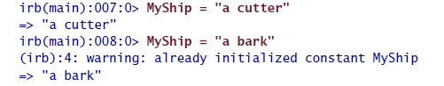
Iterators:
An iterator lets you work with each element of an array.
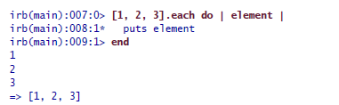
The each message tells the array to do something to each of its elements. You tell the array what to do by giving it a block delimited by do. . . end. The block contains Ruby code of your choosing, and the array hands it each element, one after the other. The block will want to do something to the element, so it needs to give the element a name. That’s the variable, element, within the vertical bars.
“collect” and “each” are examples of polymorphic messages. That means different kinds of objects accept them, and each kind does something appropriate with the block. Open files apply the block to each of their lines, and arrays apply it to each of their elements. Polymorphic iterators reduce the size of the vocabulary you need to know: whenever an object can be seen as composed of pieces, you can be pretty sure it responds to each and friends

Command line arguments
Command-line arguments are available as strings in the array named ARGV. (Most likely translated as Argument Vector)
This array contains all the command-line arguments; so if you run this:
ruby script.rb first second third
… then ARGV.length is 3, ARGV[0] is “first”, ARGV[1] is second, and ARGV[2] is third.
You don’t need to hardcode the lines nside the array – ARGV[0] simply means “refer to the first argument after the command is given, ARGV[1] – “refer to the second argument in the comand line” and so on.
Methods:
Ruby methods let you create new verbs (messages) in the Ruby language.

