**EXPERIMENT-12**

**AIM**: **Advanced visualization tools: using filters, using the detail panel, using the size panels, customizing filters, using and customizing tooltips, formatting data with colors**.

Assign colors to marks

To assign a color to marks in the view, do one of the following:

* On the Marks card, click **Color**, and then select a color from the menu.

This updates all marks in the view to the color you choose. All marks have a default color, even when there are no fields on **Color** on the **Marks** card. For most marks, blue is the default color; for text, black is the default color.

* From the **Data** pane, drag a field to **Color** on the Marks card.

Tableau applies different colors to marks based on the field’s values and members. For example, if you drop a discrete field (a blue field), such as Category, on Color, the marks in the view are broken out by category, and each category is assigned a color.

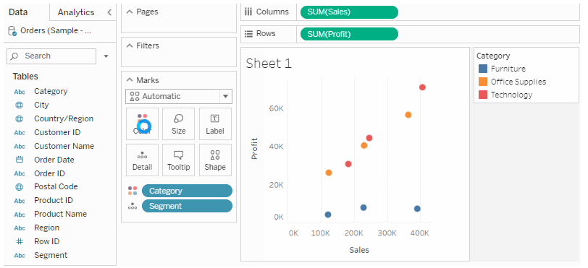

## Add tooltips to marks

Tooltips are details that appear when you hover over one or more marks in the view. Tooltips are also convenient for quickly filtering or removing a selection, or viewing underlying data. You can edit a tooltip to include both static and dynamic text. You can also modify which fields are included in a tooltip and whether you want to be able to use those fields to select marks in the view..

### Add a tooltip

1. Drag a field to **Tooltip** on the **Marks** card.
2. Click **Tooltip** on the **Marks** card to open the Edit Tooltip dialog box, where you can add text, rearrange the tooltip contents, and insert more fields.

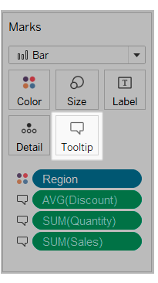

## Change the size of marks

To change the size of marks in the view, do one of the following:

On the Marks card, click **Size**, and then move the slider to the left or right.

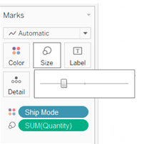

## Separate marks in the view by dimension members

To separate marks in the view (or add more granularity):

* From the **Data** pane, drag a dimension to **Detail**on the Marks card.

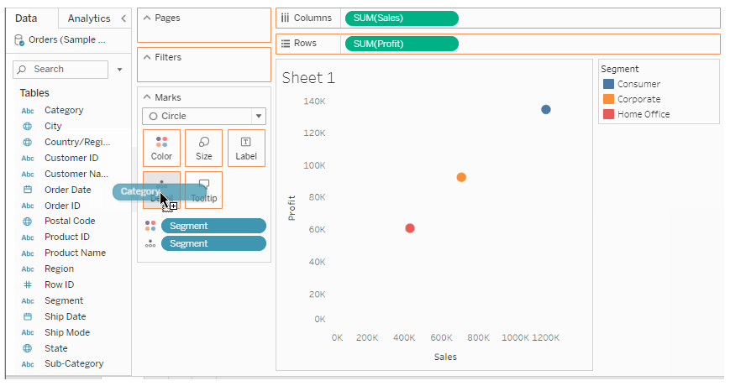

When you drop a dimension on **Detail**on the Marks card, the marks in a data view are separated according to the members of that dimension. Unlike dropping a dimension on the **Rows** or **Columns** shelf, dropping it on **Detail**on the Marks card is a way to show more data without changing the table structure.

# Filter Data from Your Views

Tableau performs actions on your view in a very specific order; this is called the Order of Operations. Filters are executed in the following order:

1. Extract filters
2. Data source filters
3. Context filters
4. Filters on dimensions (whether on the Filters shelf or in filter cards in the view)
5. Filters on measures (whether on the Filters shelf or in filter cards in the view)

### Filter categorical data (dimensions)

Dimensions contain discrete categorical data, so filtering this type of field generally involves selecting the values to include or exclude.

When you drag a dimension from the Data pane to the Filters shelf in Tableau Desktop, the following Filter dialog box appears:

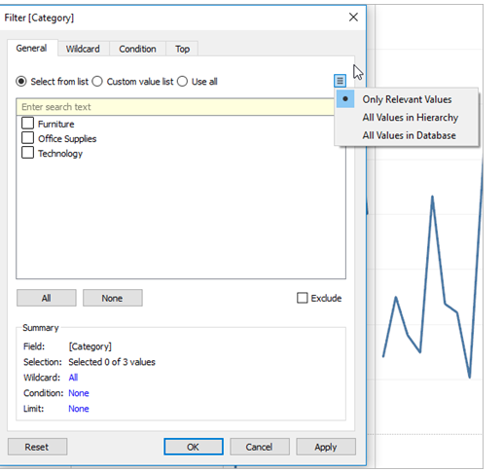

* **General**: Use the General tab to select the values you want to include or exclude.
* **Wildcard** (Tableau Desktop only): Use the Wildcard tab to define a pattern to filter on. For example, when filtering on email addresses you might want to only include emails from a specific domain. You can define a wildcard filter that ends with "@gmail.com" to only include Google email addresses.
* **Condition**: Use the Condition tab in the Filter dialog box to define rules to filter by. For example, in a view showing the average Unit Price for a collection of products, you may want to only show the Products that have an average unit price that is greater than or equal to $25. You can use the built-in controls to write a condition or you can write a custom formula.
* **Top**: Use the Top tab in the Filter dialog box to define a formula that computes the data that will be included in the view. For example, in a view that shows the average Time to Ship for a collection of products, you can decide to only show the top 15 (or bottom) products by Sales. Rather than having to define a specific range for Sales (e.g., greater than $100,000), you can define a limit (top 15) that is relative to the other members in the field (products).