Project Timeline – Total Eclipse of the Heart

Team Members: Luke Osborne, Isaac Goldman, Nick Rodriguez, Sami Shahin

Gantt Chart: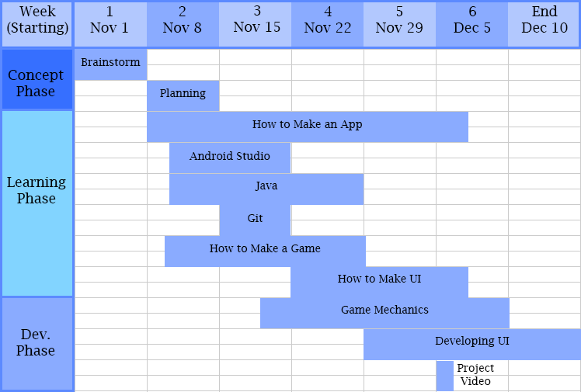

Timeline Log:

Week One of Project – November 4th – 7th 2015

Brainstorming stage begins. Made a list of app ideas on google spreadsheets. Scheduled our first meeting for that Sunday.

First Meeting – Sunday, November 8th 2015

Brainstorming stage ends; decided on game idea. Began planning and worked up a rough description of the game and its mechanics.

Week Two – November 9th – 14th 2015

Began learning phase, familiarizing ourselves with Java, write the "hello world" app, as described in the project assignment sheet. Scheduled meeting next Sunday to outline our main classes and start implementing a development plan. Began using Android Studio.

Hello World App Team Meeting – Friday, November 13th

Luke and Isaac met with Tim to make sure Android studio was working

Second Meeting – Sunday, November 15th 2015

Introduced to some tutorial videos on apps.

Week 3 – November 16th – 21st 2015

Goal for the week: Get comfortable using android studio to make simple apps and following tutorials

Scheduled a meeting for Sunday (Nov 22) with the goal of getting the first level of our game working and testable on our phones.

Third Meeting – Sunday November 22nd 2015

Met at Isaac’s place. Followed a game tutorial on Youtube, getting used to making a simple Android game. Setup Git repository for project “TheREKTangle” Using tutorial to get started, we began developing our app and implementing our ideas.

Week 4 and 5 – November 23rd – December 4th 2015

Continued developing our app, getting the player square to follow where the user touches, and having enemies appear from the sides of the screen at random positions.

Fourth Meeting – Saturday December 5th 2015

At this point we have an app where you can move your square and enemies spawn. Got enemies to spawn from all sides of the screen. Beginning to get graphics for character and enemies and background and Android Icon (all sizes). Working on menus and UI, such as main menu and game over screen.

Week 6 – December 6th – 10th 2015

Worked on displaying score and having a high score display with game over screen.

Friday December 11, 2015

Finalized the PowerPoint.